Student name:__________ group number ................. Class n
1) Which of the following does not require sophisticated quantitative forecasts?
1) ______
A) State highway planners require peak load forecasts for planning purposes.
B) Money managers use of interest rate forecasts for asset allocation decisions.
C) Accounting revenue forecasts for tax purposes.
D) All of the options require sophisticated quantitative forecasts.
E) Managers of power plants using weather forecasts in forecasting power demand.

2) What methods seem suited to forecasting new-product sales?
2) ______
A) Subjective or judgmental methods
B) Time series methods
C) Extrapolative methods
D) Inductive methods

3) Forecasts based solely on the most recent observation of the variable of interest
3) ______
A) are consistent with the "random walk" hypothesis in finance, which states that the optimal forecast of today's stock rate of return is yesterday's actual rate of return.
B) All of the options are correct.
C) are the simplest of all quantitative forecasting methods.
D) are called "naïve" forecasts.
E) lead to loss of one data point in the forecast series relative to the original series.

4) Which of the following is not an argument for the use of subjective forecasting models?
4) ______
A) None of the options are correct.
B) They are useful when data for using quantitative models is extremely limited
C) They are easy for management to understand
D) They provide valuable information that may not be present in quantitative models
E) They are quite useful for long-range forecasts

5) Which subjective sales forecasting method may have the most information about the spending plans of customers for a specific firm?
5) ______
A) Jury of Executive Opinion
B) None of the options are correct.
C) Index of consumer sentiment
D) Sales Force Composites
E) Delphi Method

6) Because of different units being used for various data series, which fit statistic can be used across different series that are in fact measured in different units?
6) ______
A) RMSE
B) MAE
C) MAPE
D) None of the options are correct.
E) MSE

7) This figure in Chapter One was used to discuss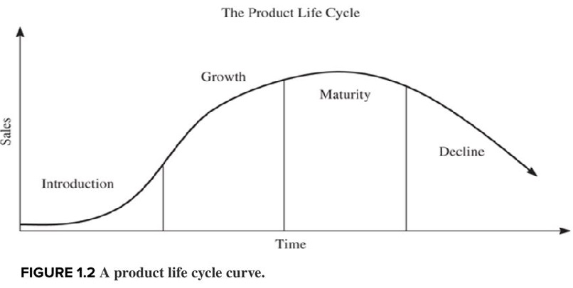
7) ______
A) the effect of price decreases.
B) the exponential effect of advertising.
C) the introduction of new products.
D) the use of a naïve model.

8) Which measure of forecast accuracy is analogous (i.e., calculated very much like) the standard deviation?
8) ______
A) Root Mean Squared Error
B) Mean Absolute Error
C) Mean Squared Error
D) Mean Absolute Percentage Error

9) The disadvantages of subjective forecasting methods includes the consideration that
9) ______
A) they are non consistently accurate over time.
B) they are almost always biased.
C) it takes years of experience for someone to learn how to convert intuitive judgment into good forecasts.
D) All of the options are correct.

10) Subjective or qualitative forecasting methods may be used effectively in
10) ______
A) only a small set of forecasting situations.
B) situations where accuracy measures are impossible to calculate.
C) very long-range forecasting.
D) place of quantitative methods because they are generally more accurate.

11) Which of the following forecasting methods requires use of large and extensive data sets?
11) ______
A) Naïve methods
B) Delphi methods
C) Exponential smoothing methods
D) None of the options are correct.
E) Multiple regression

12) Under what circumstances may it make sense not to prepare a business forecast?
12) ______
A) There is no consensus among informed individuals.
B) The future will be no different from the past.
C) The forecast horizon is 40 years.
D) No data is readily available.
E) The industry to forecast is undergoing dramatic change.

13) Qualitative or subjective forecasting methods include
13) ______
A) the Bass Model.
B) surveys of customers.
C) exponential smoothing.
D) the naïve model.

14) Which of the following measures is a poor indicator of forecast accuracy, but useful in determining the direction of bias in a forecasting model?
14) ______
A) Root Mean Squared Error
B) Mean Absolute Percentage Error
C) None of the options are correct.
D) Mean Percentage Error
E) Mean Squared Error

15) Which of the following is/are incorrect? Evaluation of forecast accuracy
15) ______
A) is important since the production of forecasts is costly to the firm and requires the use of symmetric error cost functions.
B) is important since the production of forecasts is costly to the firm.
C) is important since it may reduce business losses from inaccurate forecasts.
D) requires the use of symmetric error cost functions.
E) is done by averaging forecast errors.

16) Which of the following would not be an appropriate use of forecast errors to assess the fit of a particular forecasting model?
16) ______
A) Examine the average squared value of the errors.
B) Examine a time series plot of the errors and look for a pattern.
C) Examine the average absolute value of the errors.
D) Examine the average level of the errors.
E) None of the options are correct.

17) Which of the following measures of forecast fit can correctly be used to compare "goodness of fit" across different sized random variables?
17) ______
A) None of the options are correct.
B) Mean Percentage Error
C) the Durbin Watson statistic
D) Mean Absolute Percentage Error
E) Mean Error

18) Which of the following is not typically part of the traditional forecasting textbook?
18) ______
A) Discussion of probability distributions
B) Attention to statistical inference
C) Classical statistics applied to business forecasting
D) Attention to simplifying assumptions about the data
E) Use of computationally intensive forecasting techniques

19) Some helpful hints on judging forecast accuracy include:
19) ______
A) Do not judge model adequacy based on large one-time errors.
B) Be wary when the forecast outcome is not independent of the forecaster.
C) Do not placed unwarranted faith in computer-based forecasts.
D) All of the options are correct.
E) Keep in mind what exactly you are trying to forecast.

20) The notion of a product life cycle can be applied to
20) ______
A) a product form.
B) All of the options are correct.
C) a brand.
D) a product class.

21) Which of the following is not considered a subjective forecasting method?
21) ______
A) Juries of executive opinion
B) Naïve methods
C) Sales force composites
D) Consumer surveys
E) Delphi methods

22) A "product life cycle" includes what different stages?
22) ______
A) Growth
B) Maturity
C) Decline
D) All of the options are correct.
E) Introduction

23) Consider the calculation of Root Mean Square Error (RMSE) used as a measure of forecast fit. RMSE applied to the analysis of model forecast errors, treats
23) ______
A) every forecast error with the same penalty.
B) large and small forecast errors equally on the margin.
C) levels of large and small forecast errors equally.
D) large and small forecast errors unequally on the margin.

24) 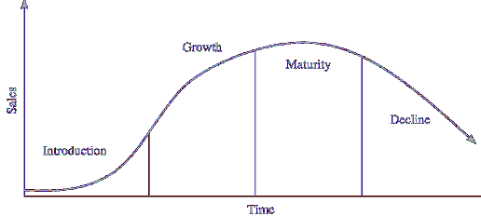The diagram immediately above represents
24) ______
A) a normal distribution.
B) the pre-introductory product development stage.
C) a Student’s t-test distribution.
D) a product life cycle.
E) the purchase intentions of hypothetical individuals.

Answer Key
Test name: Homework ch 1
1) D
2) A
3) B
4) A
5) D
6) C
7) C
8) A
9) D
10) C
11) E
12) B
13) B
14) D
15) A
16) D
17) D
18) E
19) D
20) B
21) B
22) D
23) D
24) D

