1)
Consider the following uniformly distributed random numbers:
a) Generate a uniformly distributed random number with a minimum of 12 and a maximum of 22 using U8.
b) Generate 1 random variate from an Erlang(r = 2, β = 3) distribution using U1 and U2
c) The demand for magazines on a given day follows the following probability distribution
Using the supplied random numbers for this problem starting at U1, generate 4 random variates from this distribution.
Solution
a) X = 22 + 0.3734*(22-12) = 25.734
b) Use convolution to generate 2 exponential random variables
X1 = -3ln(1-0.9559) = 9.364
X2 = -3ln(1-0.5814) = 2.612
X = X1 + X2 = 11.976
c)

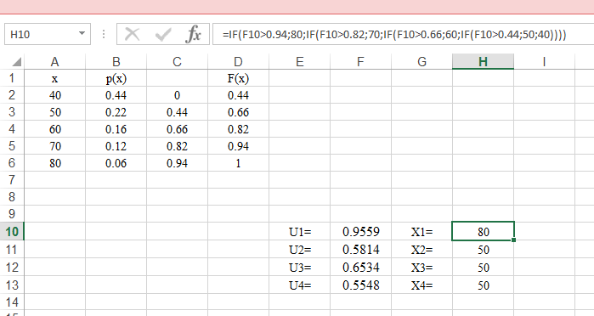
U1 = 0.9559 X = 80
U2 = 0.5814 X = 50
U3 = 0.6534 X = 50
U4 = 0.5548 X = 50
.............................................................................................................................................

2)
Consider the following set of pseudo-random numbers.
0.2379 | 0.7551 | 0.2989 | 0.247 | 0.3237
0.2972 | 0.8469 | 0.4566 | 0.6146 | 0.6723
0.9496 | 0.2268 | 0.8699 | 0.9084 | 0.5649
0.3045 | 0.6964 | 0.1709 | 0.3387 | 0.9804
0.1246 | 0.842 | 0.6557 | 0.9672 | 0.3356
0.3525 | 0.8075 | 0.9462 | 0.9583 | 0.3807
0.1489 | 0.5480 | 0.9537 | 0.9376 | 0.8364
0.5095 | 0.4047 | 0.9058 | 0.3795 | 0.6242
0.5195 | 0.6545 | 0.1117 | 0.3258 | 0.8589
0.6536 | 0.3427 | 0.6653 | 0.7864 | 0.5824

a) Test the hypothesis that these numbers are drawn from a U (0, 1) at a 95% confidence level using the Chi-squared goodness of fit test using 10 intervals.
b) Test the hypothesis that these numbers are drawn from a U (0, 1) at a 95% confidence level using K-S Test.
Solution
a)
Chi-squared test for given probabilities

X-squared = 17.2, df = 9, p-value = 0.04567

Since the p-value = 0.04567 <= 0.5, the hypothesis should be rejected.

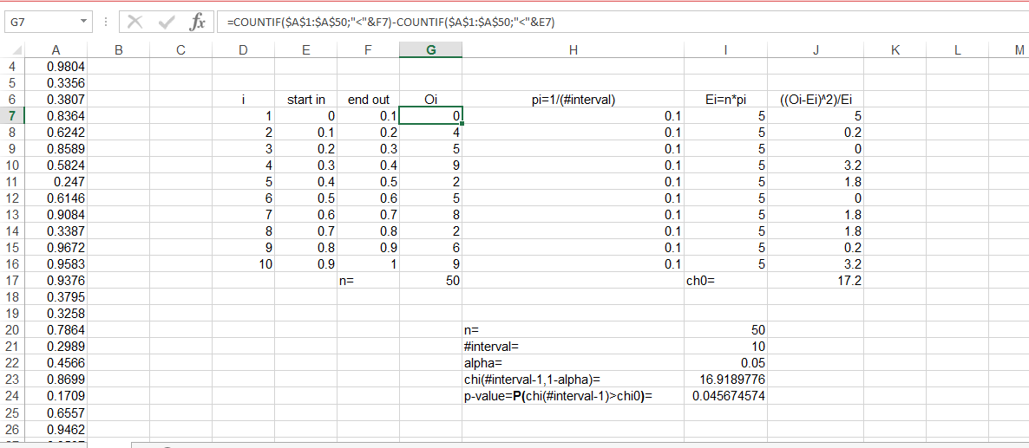

b)
One-sample Kolmogorov-Smirnov test

D = 0.1572, p-value = 0.1516

Since the p-value = 0.1516 >= 0.05, the hypothesis should not be rejected.

.....................................................................................................................................................

3)
Consider the following discrete distribution of the random variable X whose probability mass function is p(x).
a) Determine the CDF F(x) for the random variable, X.
b) Generate 3 values of X using the sequence of (0,1) random numbers in Exercise 2. (starting with the first row, reading across).
Solution
a) and b)

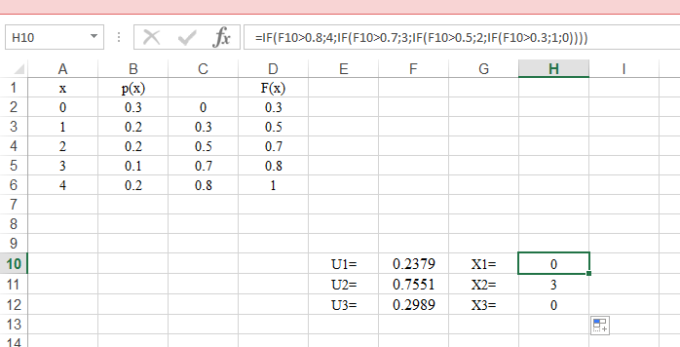

.....................................................................................................................................................

4)
Suppose that customers arrive at an ATM via a Poisson process with mean 7 per hour. Determine the arrival time of the first 6 customers using the data given in the following (starting with the first row).
0.943 | 0.398 | 0.372 | 0.943 | 0.204 | 0.794
0.498 | 0.528 | 0.272 | 0.899 | 0.294 | 0.156
0.102 | 0.057 | 0.409 | 0.398 | 0.400 | 0.997
Use the inverse transformation method.
Solution

Customers arrive at an ATM via a Poisson process with mean 7 per hour (λ = 7). The CDF of the exponential distribution is:

F(x) = 0 x < 0
1-e^{-λx} x ≥ 0

The inverse CDF is computed as follows:
F(x) = 1-e^{-λx}
U = 1-e^{-λx}
F⁻¹(U) = -1/λ * ln(1-U)

Using the data that given and the above inverse CDF, the arrival time for the first six customers can be calculated.

Inverse CDF of Poisson dis.

Arrival Times of First Six Customers (in hours)

Customer | U_{i} | Inter-Arrival Time | Arrival time
1 | 0.943 | 0.4092 | 0.4092
2 | 0.498 | 0.0985 | 0.4092+0.0985=0.5077
3 | 0.102 | 0.0154 | 0.5077+0.0154=0.5231
4 | 0.398 | 0.0725 | 0.5231+0.0725=0.5956
5 | 0.528 | 0.1073 | 0.5956+0.1073=0.7029
6 | 0.057 | 0.0084 | 0.7029+0.0084=0.7113

.....................................................................................................................................................

5)
Consider the following probability density function:
a) Derive an inverse transform algorithm for this distribution.
b) Using the first row of random numbers from Exercise 4 generate 2 random numbers using your algorithm.
Solution
a) For $x<2, F\left(x\right)= 0$
For $2≤x≤4, F\left(x\right)=\frac{x^{2}}{4}-x+1$
For $x>4, F\left(x\right)=1$
Solve the following equation for x:
$$x^{2}-4x+4\left(1-u\right)=0$$
Using the quadratic equation:

$$x=\frac{-b±\sqrt{b^{2}-4ac}}{2a}$$
Yields
$$x=\frac{4±\sqrt{16-4*4(1-u)}}{2}$$

$$x=\frac{4±4\sqrt{u}}{2}=2±2\sqrt{u}$$
Since the final number must be $2≤x≤4$, we have
$$x=2+2\sqrt{u}=2(1+\sqrt{u})$$
b) $F^{-1}\left(0.943\right)=3.94216$
$F^{-1}\left(0.398\right)=3.2617$

