ge-ol-o-gy
1. A science that deals with the history of the earth and its life, especially as recorded in rocks.
Oil On My Shoes will help you understand the science of Petroleum Geology
(Using geology to find oil and gas in the earth).
Discover rocks, fossils, drilling for oil and gas, and more!
Learn about sandstone, how to find oil, and the exciting world of Petroleum Earth Science!

Drilling an Oil or Gas Well
(There Are Five Steps)
And the Geologist Wears a Different Hat for Each of Them!

Step 1 - Prospecting -- (Geologist = Scientist)
"Prospecting" is the process the geologist goes through to locate a place to drill a well. Most petroleum geologists work in an office, where they have access to well logs, core records, drilling records, and other data that they need to work. They construct maps and cross-sections to help them locate the best places to drill wells.
The geologist is interested in anything that happens in his area, particularly news of new discoveries by other companies, success producing hydrocarbons from a previously-untested zone, and any drilling activity that is close to his leased acreage. If he sees a promising new area, he will recommend to his Land Department that they attempt to lease the acreage.
He studies his maps and cross-sections and runs computer simulations that help him select the next best location to drill. He is always thinking about the next drilling location! This is the primary job of the Petroleum Geologist. The geologist will want to know what type of trap he is dealing with, and the composition of the sedimentary rocks he will be drilling through. He wants to estimate the porosity of his prospective "pay zone", and know whether or not he can expect to encounter very high pressure in the hole. If seismic is involved in the prospect, he will consult with the geophysicist and get his opinion of the prospect.
When he has finally found the correct spot, he spends much time cross-checking to ensure that he has not missed anything. He wants to make sure that he is not "surprised" later by finding out that his location was drilled by another company 30 years ago (and was dry), discovering that his company has no legal right to drill on the location (lease problems), that the well has been drilled in the wrong place (it happens!), or that faulting or other geologic conditions (or plain old human error) will not spoil his prospect.
Step 2 - Packaging -- (Geologist = Artist/Designer)
The geologist has huge amounts of data available that he has used to define and select his prospect. Now, he must condense this data into a set of presentation materials that can be shown to non-geologists in the oil business. These people may include managers, investors, bankers, engineers, or others who will help to approve and get financing for the drilling deal.
If the geologist works for an oil company, these people will usually be fellow employees of the business. If he works for himself (as an "Independent" geologist), various people unrelated to each other may be involved. In any case, his objective is to condense his work into a form that be easily and quickly understood by many people from different backgrounds.
For this task, he may prepare sets of simplified maps and cross-sections, often highly-colored and attractive to the eye. He may package his deal using Powerpoint, or other presentation software. But the objective is to produce a set of useful reference materials he can present and demonstrate to others involved in the project. Creativity, design sense, and art skills are very important during this phase. He also needs to anticipate all questions, and be prepared to answer every one of them. He must be very sure of himself and his facts before he moves to the next step.
Step 3 - Selling the Deal -- (Geologist = Salesman)
Now the geologist must step into a role that is sometimes foreign and often uncomfortable for him ... selling his prospect. This is because geologists are scientists, with scientific backgrounds and schooling. They are used to talking to other scientists. But now the geologist must sell the deal to other people who are not geology experts or scientists.
He is looking to convince others that his prospect is worth drilling, that investors will get a good return on their money, and that the financing they provide for the deal will be money well-spent. Don't forget that even an inexpensive test well can cost more than a million dollars, and some exploration tests may easily run into tens of millions! So the geologist wants to be sure of his facts, and everyone else involved must believe that the well has a reasonable chance of being successful.
If he works for an oil company, the geologist will meet with the landman, who will ensure the company has the legal right to drill the well. He will consult with the engineer, who will determine the (nearly) exact cost of drilling the well, and recognize any special drilling problems that might develop. Marketing personnel will ensure that the company has a market (buyer) for the oil, or a pipeline for the gas. Managers, responsible for ensuring that the company's drilling budget is spent wisely, will also approve the well. If outside financing will be used, the geologist will go over the prospect with representatives of the bank or other individuals or partnerships putting up the money.
When he's done, the geologist will have "sold" his prospect to anywhere from a few to several dozen people.
Step 4 - Drilling -- (Geologist = Supervisor)
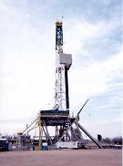
Next comes the part that every geologist enjoys the most! Drilling the well! It has now been several months since the geologist started working on his idea...which then became his prospect. Now the surface owners have been paid, permits acquired, the money raised, roads and drilling location built, pipe and supplies ordered, and the company has engaged a drilling contractor who owns the drilling rig, and will drill the well in the manner specified. The contractor will often select the type of drill bits to be used that his experience tells him will work best, hire a crew, and make other decisions concerning the drilling.
Drilling a well is a very complex procedure involving many people where nearly everything must go right, and there is no room for error. Dangerous and powerful machinery, bad weather, and mechanical failures must be faced daily. The work goes on for weeks to months, 24 hours a day, nonstop. A slip-up at any point can ruin the expensive hole, cost a fortune, get people killed, or all three.
The geologist will closely monitor all aspects of the drilling as it takes place. He will hire a mud logger to "sit" the well day and night, study the well cuttings, report shows of oil and gas, and keep track of other things on the location. The geologist will monitor the formation tops as they are encountered and discuss the progress of the drilling with the investors. The geologist will decide where and when to takes cores or DST's. When the hole has been drilled, the geologist will select a logging company and the proper logging tools to evaluate the hole. Finally, when the well is logged, he will examine the logs and recommend that the well be either completed or plugged.
Step 5 - Completion -- (Geologist = Advisor)
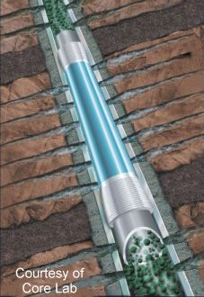
The job of completing the well is mainly in the hands of the petroleum engineer. He will decide what type of casing to run, what type and method of cementing will be used, and design and implement the completion procedure itself (which may involve perforating, breakdowns, acid jobs, or fracs), However, he will depend on the geologist at this time to advise him at each step of the way. To start, the geologist will give the engineer a list of formation tops and tell the engineer which zones will be tested.
The geologist is usually the person most familiar with the area and the practices of other oil companies. He may suggest a certain style or method of perforation, or offer advice on cementing techniques. He may be familiar with the most successful fracturing or breakdown procedures in the area. He will relay this information to the petroleum engineer, who will usually be thankful for the help! Working as a team, the geologist and petroleum engineer will get the well completed and put it to work making money for the company.

Drill Bits and Well Samples (cuttings)
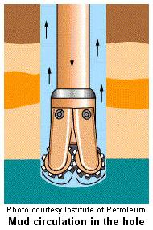
Well Samples
Every time a well is drilled, PG's watch the drilling of the well and make careful records of all the rocks and formations that the well drills through. A PG is able to examine the rocks cut by a well because wells are drilled using a "mud system". It's quite simple. Look at the picture on the left. The drill bit and pipe are hollow. A chemical that looks like mud (that's why we call it "mud") is forced down the drill pipe to the bottom of the hole. As the rock bit grinds its way down, it cuts off small pieces of rock. The mud comes out the drill bit and flows back to the surface, carrying the well samples, or "cuttings", with it. The mud serves to lubricate and cool the bit, and also bring the important rock cuttings to the surface..
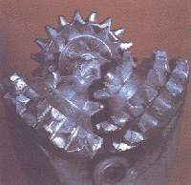
At the right is a picture of a typical drill bit, called a "three-coned bit". As the bit rotates at the end of the drill pipe, the sharp teeth cut pieces of rock from the hole.
After the cuttings reach the surface, the PG or his assistant look at them through a microscope to see whether the rocks being drilled are sandstone, limestone, or shale, whether they have porosity, and whether any oil can be seen in them. They also do some simple chemical tests to help them decide what they are seeing. Usually, a sample is examined every 10 feet.
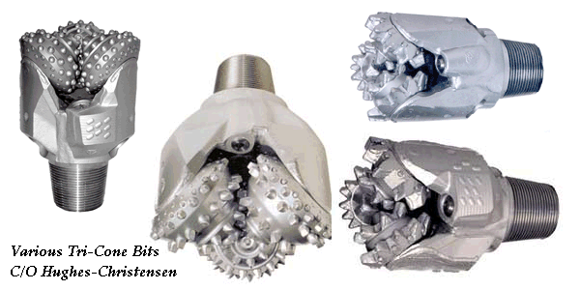

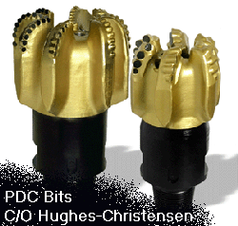
For very fast penetration, particularly in shales, a special (and expensive) bit called a "PDC" (polycrystalline diamond compact) is sometimes used. This bit has carbide or man-made industrial diamonds set in fixed blades. The cutters simply scrape the rock away during drilling, and do not rotate and grind the way the cones of a tri-cone bit do.

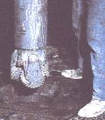
A well may be only a few hundred feet deep, or over 20,000 feet deep. The 20,000-footers cut through a lot of rocks that have to be examined carefully, and it takes months to drill a deep well!
The PG's assistant records all the information on a very long piece of paper called a "mud log" (what else?). He uses special symbols to illustrate what he sees in the rock samples. Once a PG has several mud logs, he can compare one to another and start deciding where the tops and bottoms of the rocks he is interested in (the ones with oil in them) are located.
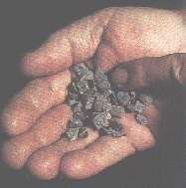
At the right are well samples, or "cuttings", from the bottom of the hole. The cutting are carried to the surface by the drilling mud. These samples have had the mud washed off of them.

Most photos, A Primer of Oil Well Drilling

Sedimentary Rocks
Geologists Start With Rocks
And, the main type of rocks they study are called sedimentary (sed-a-mentree) rocks. Most sedimentary rocks are formed in lakes, rivers, or oceans.
Rivers and streams carve out tiny bits of solid rock and carry them downstream. If the rock bits are fairly coarse (about the size of salt grains, or larger), they are called "sand". If they are a little finer, they are called "silt". If the rock bits are really fine (like flour) they are called "mud". Remember, "sand", "silt", and "mud" refer to the size of the grains, not what they are made of.
At some point in their travel, the rivers slow down. This may be because the surrounding land is very flat, or the river may enter a lake, or (usually), the river enters the ocean. When the water slows down, the grains of sand, silt, or mud being carried by the river drop to the bottom and form layers of sediment. Usually a layer will be mostly sand, mostly silt, or mostly mud, but they may be mixed up.
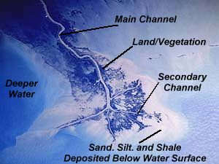
Take a look at the satellite photo of the Mississippi River
Delta. A "delta" is a fancy word for a big pile of sand that forms in an ocean or lake at the end of a stream or river.
In this case, the Mississippi River is bringing down a HUGE amount of sediment that has been scoured from all over eastern North America, and is forming new land (many miles long) right before our eyes, south of the City of New Orleans.
Note the main channel of the Mississippi River snaking down through the delta. The darker areas on the picture show where land sticks up (just barely, no more than a couple of feet) above the surface of the ocean and allows plant life to grow. The lighter, whitish areas show sediments (sand, silt, and shale) that are just under the surface of the water. The darker blue to the left shows deeper water.
A Natural Sandbox
If you have been to a beach, you stood on a pile of sand that was eroded by the forces of rain and wind from rocks many hundreds of miles away, was transported by a stream or river for a long distance, was broken into TINIER and TINIER bits as it traveled, and was then then spread out in a long bar by the work of waves, tides, and wind.
Click here to see a neat animation of the sedimentary process.
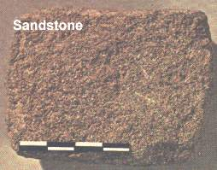
A beach is just one type of many sand deposits that may become deeply buried and later become an excellent oil or gas field.
As the sediments pile up, the oldest ones are buried deeper and deeper. When they are buried deep enough, heat and pressure and other workings of the earth make the soft sediments hard, and turn them into rock. This is called "lithification", and sediments that have become hard are said to be "lithified".
SANDSTONE is formed when sand-sized sediments are turned into rock, SILTSTONE is formed when silt-sized sediments are turned into rock, and SHALE is formed when the tiniest mud-sized sediments are turned into rock. See the grain size chart for more information.
Sandstone is a rock made up of grains that are 1/16 millimeter to 2 millimeters in size. The largest sand grains would be about 1/2 the size of a grain of rice. Grains larger than this are called PEBBLES or even COBBLES.
Even though sandstone is hard, and appears very solid, it is really very much like a sponge. Between the grains of sand, enough space exists to trap fluids like oil or natural gas! The "holes" in sandstone are called "porosity" (from the word "porous").
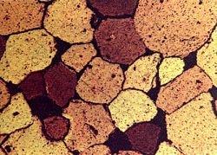
The picture at the right shows a very thin slice (thinner than a human hair) of actual sandstone as seen through a microscope. The larger brown and yellow pieces are grains of "quartz", a common mineral. Between the grains, you can see the "holes", or porosity, in the rock; it shows up as black.
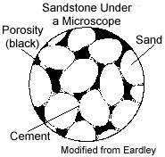
Look at the picture below. This is is a drawing of a typical sandstone under a microscope.
The porosity is shown as black. Oil or gas could fill these holes in the rock. What percentage of this sample could be filled with oil or gas? I would estimate at least 15%. What do you think?
The ocean, lake, and river environments were ideal for the formation of sedimentary rocks like sandstone, but they also supported a very abundant and diverse collection of living things. 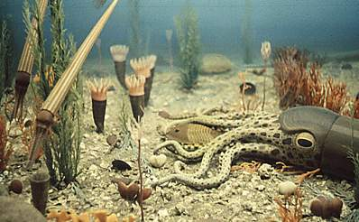
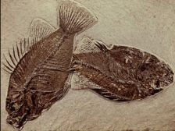
These animals, whether smaller than a grain of sand or larger than the biggest whale alive today, eventually died and contributed their bodies to the sediments forming below their habitat. When these animals were buried beneath thousands of feet of sediments, heat and pressure in the earth "cooked" their bodies into oil and natural gas. These hydrocarbons either became trapped in the sediment layers that the animal died in, or moved some distance and ended up in a hydrocarbon trap.
Look again at the photo of the Mississippi River Delta near the top of this page. Imagine if that gigantic pile of sand and silt were eventually buried thousands of feet deep. We would have the potential for a tremendous oil or gas field!
Sandstone hand sample photo: Laboratory Manual for Physical Geology
Sandstone photomicrograph: AAPG Color Guide To Sandstones

Sandstones and Similar Rocks
Sandstones contain many of the oil and gas deposits of the world. So, here is a special page devoted to sandstones....

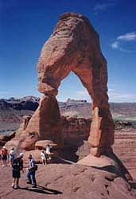  Sandstone is often formed into strange shapes by the action of the wind. The wind picks up individual sand grains and "blasts" them against rock outcrops. The harder parts of the sandstone are left standing.  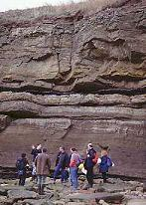  Sandstone forms very steep, near-vertical cliffs  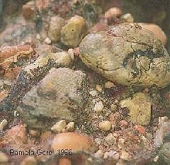  Here is a sedimentary rock called "conglomerate". The grains are too big to call this rock sandstone. However, it is made of the same materials as most sandstones. Conglomerate is very "poorly sorted". This means it contains both larger and smaller grains. Also note that the grain shapes range from rounded with high sphericity to angular with low sphericity. See chart below.  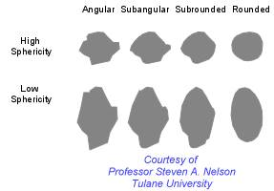  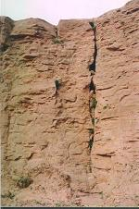  Steep cliffs of sandstone  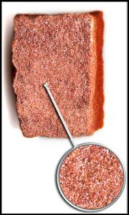  A well-sorted, coarse-grained sandstone  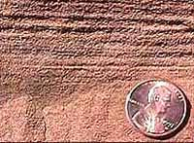  Laminations, or very small layers, in sandstone |  | 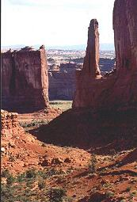  More wind-blown sandstone shapes in Arches National Park, USA.  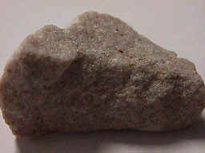  This is a coarse-grain sandstone which is made up mostly of the mineral quartz. This sandstone is "well-sorted". That means most of the grains are about the same size. See sorting diagrams below.  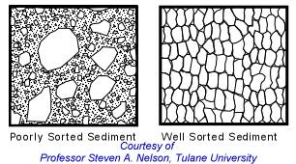  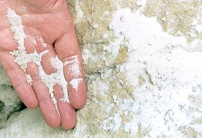  Many sandstones are "friable". This means that the grains are not well-cemented to each other. They can be broken apart in your hands.  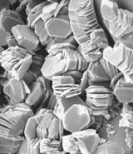  Here is a rock similar to sandstone, but the grains are much, much smaller. The grains are clay-sized. This rock is kaolinite, seen at high power under a scanning electron microscope  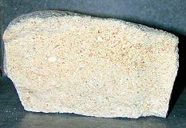  This sandstone is "poorly sorted". This means it contains both larger and smaller grains  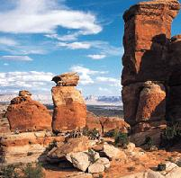  More wind-shaped sandstone monoliths. The red color is always caused by small amounts of iron minerals in the rock. The iron minerals "rust" when exposed to air, and stain the surface of the sandstone  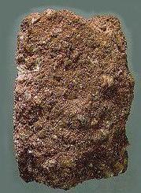  A coarse-grained, poorly-sorted sandstone containing lots of mica and clay minerals is called "graywhacke" (gray-wacky)
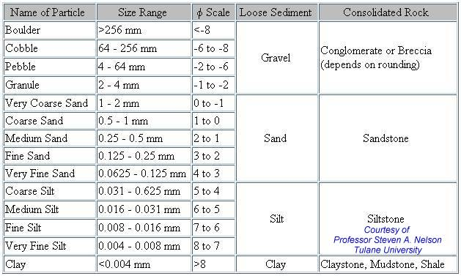
The Absolute Geologic Time Scale
By modern scientific calculations, the earth is many millions of years old. The Absolute Geologic Time Scale has been developed by using a process called "Isotopic Dating", in which the decay rates of certain radioactive materials are established and measured, then used as "clocks" to calculate the ages of various rocks.
The chart below shows how old certain rocks are in millions of years. For example, look at the "Pliocene". Under "Dates" you will see that the Pliocene was deposited 2 to 5 million years ago. The Cambrian was approximately 505-570 million years ago.
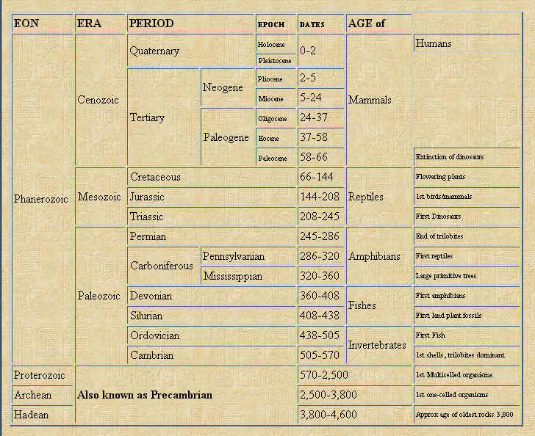
The PG is not as interested in the age of rocks in years as she is in the relative sequence of their deposition, and the time period to which they belong. That is because the PG knows that certain conditions existed on earth during each of the geologic time periods. Knowing that a certain rock was deposited in the "Pennsylvanian", for example, may help the PG to interpret rocks in a certain area.
Also, petroleum geologists are mainly interested in rocks from the Mesozoic and Paleozoic Eras. This is because almost all of the oil and gas found so far is contained within these rocks...60 to 600 million years old, approximately. These rocks represent only a small fraction of the total age of the earth, which is measured in billions of years.
The Geologic Time Scale is illustrated here to help you see the way geologists have broken down geologic time into sections, each with an interesting name, and each containing a package of rocks deposited during a certain time period....all over the world.
Time Scale taken from: MODERN PHYSICAL GEOLOGY, Graham R. Thompson Ph.D., Jonathan Turk Ph.D., Saunders College
Words on this chart: neogene, paleogene, cretaceous, jurassic triassic permian carboniferous pennsylvanian mississippian devonian silurian ordovician cambrian ecocambrian cenozoic mesozoic paleozoic prepaleozoic precambrian algae bacteria protoplanet meteorite

Rock Cores

Open-Hole Rotary Coring

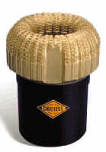
Sometimes, Petroleum Geologists want to get a better look at the rocks deep in a well than they can get by looking at the small drilling chips called well samples. In this case, the PG will order that a "core" be taken from the well.
A core is a solid cylinder of rock about 4-5 inches in diameter, and a single core will usually be about 30 feet long. Often, a PG will order several cores in a well, so the total amount of cored rock may amount to hundreds of feet.
Computer Data Examples
Taking a core requires that the regular drill bit be removed from the hole. It is replaced with a "core bit", which is capable of grinding out and retrieving the heavy cylinder of rock. The core bit is usually coated with small, sharp diamonds that can grind through the hardest rock. A core bit cuts very slowly.

To the left is a picture of a coring bit. The gold-colored part is studded with natural diamonds. These diamonds, the hardest substance known to man, grind away the rock in tiny chips. Notice the large hole in the center of the bit. This hole contains the core. As the bit moves down through the rock, the bit and the drilling pipe above it encase the core inside the steel core "barrel".
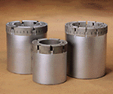
The next picture shows three core bits of a different type.

Coring is very expensive, because of the slowness of coring and the expensive diamond bits that must be used. So, PG's only take cores when it is absolutely necessary. No doubt about it though, the PG enjoys coring a well because she can can get closer to the rocks that are so important.

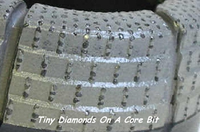
Cores are very valuable sources of information. The big hunks of rock let the PG find out exactly what rocks are present, instead of guessing, as must be done with well samples. The PG can clearly see the boundaries between sandstone, limestone, and shale. If one of the formations contains oil, the PG can usually tell by looking at the core.

The core is taken back to a laboratory and tested in many ways. Accurate measurements of the actual porosity of the rock, as well as the amount of oil and water in the pores, can be obtained. If desired, parts of the core can be sliced thinner than a hair and viewed under a microscope to determine the exact rock type and microfossils present. This is all very precise data that is very useful to the PG.

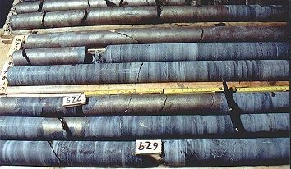
Here is a picture of a "whole core", just as it comes from the core barrel, loaded into storage boxes. The core is carefully labeled as to depth. The core can (and usually will be) examined by the petroleum geologist at this time, but the core is usually "slabbed" first.

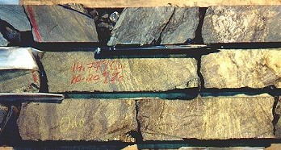
A "slabbed" core is simply a core that is sawn down the middle by a powerful rock saw. Cutting the fresh, flat, surface allows the PG to see things in the core much more clearly. He is usually looking for indicators that will tell him what environment the rock was formed in, such a beach, a sand bar, or a river system. He will also note grain sizes, small fossils, and burrows caused by worms or other marine life. He will look very closely for the presence of oil in the rock or any hint of gas bubbles. A slabbed core is shown at the left.

Sidewall Coring

Another type of coring technology is available. This method is cheaper than the rotary coring methods shown above, but does not give the PG as much data. But cores can be taken in hours, instead of days. This technique is called sidewall coring.

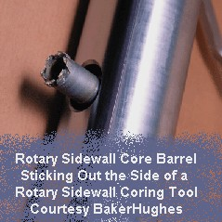
In sidewall coring, a slim wireline coring tool is run into the hole, usually when the well is logged. The tool may be of two general types; either "rotary sidewall" or "percussion".

The rotary sidewall method uses a small robotic core bit (about one inch in diameter) to bore a core sideways into the formation. The core is then "popped" loose and withdrawn into the main coring tool for retrieval. Then the tool is moved to another spot in the hole, and the robotic bit is again extended and used.

The rotary sidewall coring tool recovers up to 50 sidewall cores in one trip. Each sample is isolated for positive identification, and a summary output at the surface lists all the samples with the exact depth and time each was taken.

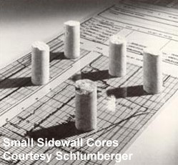
The percussion method uses a high explosive charge to propel a short core barrel into the formation at extremely high speed. The core barrel is embedded in the rock, then withdrawn by a strong wire. Typically, cores about 1" in diameter and 1" to 2" long can be retrieved with this method. Several dozen "shots" will be available on a percussion-core wireline tool. This type of sidewall coring is very fast.

Oil and Gas Under Pressure
Oil and gas exist in underground traps under great pressure. When the sandstone or limestone containing the oil or gas is penetrated by the drill bit, , the oil and gas can blast out of the well with great force.
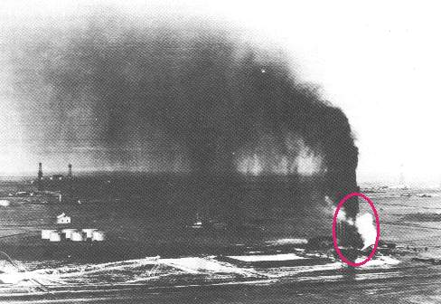
In the early days of oil drilling, there was no good way to drill holes and keep this great force under control. In the picture at the right, a well is shown "blowing wild". This means that the tremendous gas pressure in the reservoir thousands of feet below the ground is forcing huge amounts of oil up the hole, blowing it into the air.
The circled well in the black-and-white pic above is the Mary Sudik #1, drilled by the Indian Territory Illuminating Oil Company (ITIO) in Oklahoma. On March 26, 1930, this well blew out at 6,470 feet. The force blew 20 pieces of heavy 30-foot drill pipe out of the hole!
The "Wild Mary Sudik" was finally plugged off 11 days after blowing out, through the heroic efforts of dozens of people. Six years later, the Sudik lease had produced five million barrels of oil !
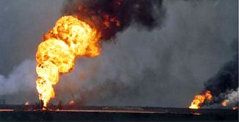
During the 1991 Gulf War, the retreating Iraqi soldiers dynamited the wellheads off more than six hundred Kuwati oil wells, creating one of the biggest man-made environmental disasters in history (left). Since most Kuwati wells flow without pumps under their own great pressure, the oil and gas erupted from the ground with tremendous force. It was first estimated that it would take 2 years to repair all the wells, however the heroic job was actually done in about six months.
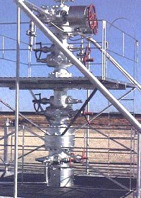
"Blowouts" (except for the ones deliberately started in the Gulf War) have been extremely rare for over 60 years. Equipment was invented later that allowed the drilling crew to keep the well under total control at all times. In addition to being one of the most dangerous situations on earth, a blowout is considered bad for the environment and bad for business. Great effort is made to avoid spilling a single drop of oil on the ground, or in the water.
At the right is a modern wellhead capping a well on a clean, well-maintained, and earth-friendly oil property.
Below left is a modern, portable drilling rig used for drilling on land.
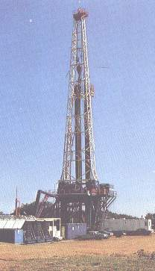
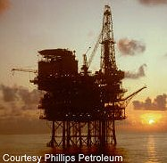
Of course, many wells these days are drilled in the ocean. For this job, an offshore rig, shown above, is used.

Identification of Sedimentary Rocks
Tools You Need
You need three things to start identifying sedimentary rocks: A magnifying glass, a small piece of glass with smooth edges for scratch-testing your samples, and a small amount of DILUTED Hydrochloric Acid (HCL) in a 2-ounce plastic squeeze bottle or dropper bottle (with screw cap). A used squeeze-type medicine, eye drop, or lens solution bottle will work, but be SURE to deface the label and write "ACID" on your bottle in big letters!!
If you're a kid, print out this page and take it with you. You can get the magnifyer from a drug store or a WalMart. Go to any window glass shop and ask for a scrap of glass with smooth edges. About 2 inches X 3 inches will be about right. For the hydrochloric acid, try your science teacher, or your local high school chemistry teacher. If you tell 'em what you're doing, and ask nicely, I'll bet you get it it.
To make a weak acid solution for testing rocks, ASK AN ADULT to add one (1) part concentrated HCL to nine (9) parts water. For instance, 1 ounce of acid is added to 9 ounces of water. This amount will be more acid than you can use up in a long time.
ALWAYS ADD ACID TO WATER, NOT THE OTHER WAY AROUND!
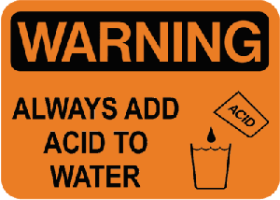
Why is acid always added to water instead of water being added to acid? When acid and water are mixed, a large amount of heat is generated. Adding acid to water minimizes the heat that is produced. Adding water to acid may result in a dangerous explosive-type boiling of the solution, splashing the stuff everywhere. ALWAYS ADD ACID TO WATER, NOT THE OTHER WAY AROUND!
WEAR GOGGLES AND PROTECTIVE CLOTHING! DO NOT SPLASH ACID IN EYES OR ON SKIN! IF ACID GETS IN EYES OR ON SKIN, FLUSH UNDER COLD RUNNING WATER FOR AT LEAST 15 MINUTES! GET MEDICAL HELP! Concentrated acid is dangerous, so be careful. After it is diluted, it's not so dangerous, but still avoid getting it in your eyes, on your skin, or on your clothes.
Fill up your squeeze bottle or dropper bottle and store the extra diluted acid in a glass bottle or jar. Mark the extra bottle or jar clearly: "HCL ACID - POISON" and store it in a cool, dry place.
How To Test a Rock
Start by placing a few drops of DILUTED HCL on your rock sample. Look closely for bubbles. If you see bubbles, use the lower part of the chart to identify your rock sample. If you don't see bubbles, use the top part of the chart.
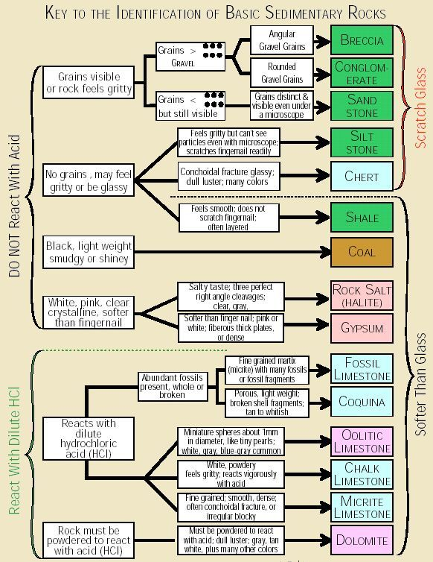
Here are pictures of some common sedimentary rocks:
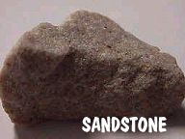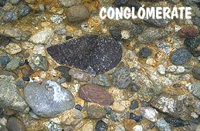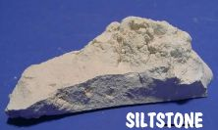
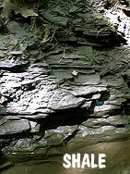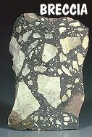
Don't worry about color when you identify your rocks. Sedimentary rocks can be almost any color! Use the chart above instead!
Porosity and Permeability in Sedimentary Rocks
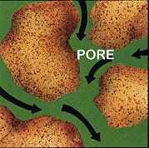
Porosity and permeability are related properties of any rock or loose sediment. Porosity and permeability are absolutely necessary to make a productive oil or gas well.
Specifically, porosity of a rock is a measure of its ability to hold a fluid. Mathematically, porosity is the open space in a rock divided by the total rock volume (solid + space or holes).
Permeability is a measure of the amount of flow of a fluid through a rock.
Most oil and gas is produced from sandstones. Both porosity and permeability are needed for production. Porosity creates the spaces to hold the oil or gas. Permeability allows the oil and gas to flow out of the rock.
Porosity is normally expressed as a pecentage of the total rock which is taken up by pore space. For example, a sandstone may have 8% porosity. 8% is about the minimum porosity that is required to make a decent oil well.
Permeability in petroleum-producing rocks is usually expressed in units called millidarcys (one millidarcy is 1/1000 of a darcy). A petroleum reservoir may have permeability in the range of a few millidarcys up to several darcys. Most oil and gas reservoirs produce from rocks that have 10-100 millidarcys.
The Mud Log
This is a relatively simple example of a "mud log", prepared by the PG's assistant during the drilling of a well (the assistant is called a "Mud Logger"). This is an old-style mud log, drawn by hand. As the well cuttings come up from the bottom of the hole, they are examined and identified. The mud log is updated each day of drilling.
On the right side of the mud log, the Mud Logger writes his interpretation of the rocks drilled. There are two types of interpretation shown, a drawing (called "Litho") and a "Sample description".
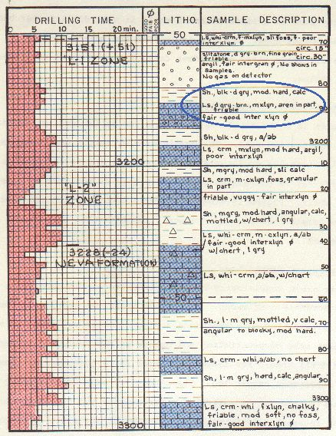
Let's talk first about the section called "Litho" (lithology, or rock type). The logger makes a drawing down the middle of the page. He uses standard symbols and colors to illustrate the different kinds of rocks, textures, fossils, and bedding. Limestones are shown as blue blocks on the log, shales are shown as short black horizontal lines, and sandstones/siltstones are shown as a dotted pattern. He looks at the small well cuttings under a microscope to figure out what the rock types are. It takes a lot of experience and know-how to figure out what rocks are being drilled just by looking at the tiny well samples.
The "sample description" is a more detailed summary of what the logger sees. Abbreviations are used because so much detail must be recorded. For example, look at the words inside the blue circle. This reads: "shale, black to dark-gray, medium hard, calcareous (containing limestone, or calcium carbonate).
Right below the shale is a limestone described as dark-gray to brown, medium-crystalline (medium grained), arenaceous (containing quartz sand), with fair to good inter-crystalline porosity.
On the left side of the log, "Drilling Time" is recorded. This is a precise record of the time it takes the drill bit to drill the rock. Drill-time is recorded in increments of 2 feet. The numbers across the top indicate how long it took to drill that two feet, in "minutes per foot". For instance, the depth from 3200' to 3202' (1 block), drilled at 7 minutes per foot, or a total of 14 minutes for the two feet.
Making a chart of drill time is very important, because it gives the PG one more hint to help figure out what rocks are being drilled. Remember that the well has not been logged at this point. Notice that in this well, the shales tend to drill "slow" (5-10 minutes per foot), while the limestones drill "fast" (2-6 minutes per foot). This is because the soft shales are ground into a thick, sticky mud by the drill bit, and "ball up" on the end of the bit. This causes the bit to cut through the rock slower.
Usually the slow-drilling formations will be extremely hard and non-porous sandstones or limestones. For these types of formations, a special (and expensive) bit called a PDC (click to see PDC bit) is sometimes used. This special bit is named for the Prairie du Chien Formation, which can be extremely tough to drill, and for which the PDC bit was developed.
Porous sandstones and limestones don't ball up, so they usually drill really fast...just as seen on this log. In fact, one of the things a Petroleum Geologist likes to see is a good "drilling break" in his target sand. This means the sand drills very fast (3 minutes per foot or less), indicating it is soft or porous.
Finally, the mud logger will note formation tops he has picked. On this log, the "L-1", L-2", and "Neva" formations are picked.
These days, most mud logs are made with a computer. The mud logger still does all the sample and gas-monitoring work he did before, but he no longer needs to be a draftsman. Here is an example:
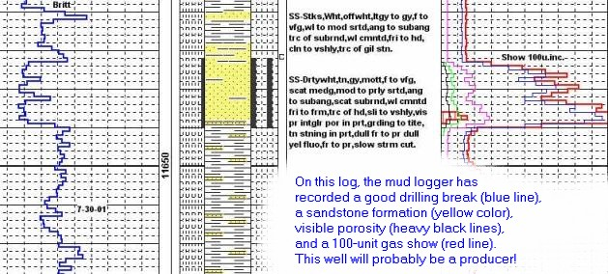

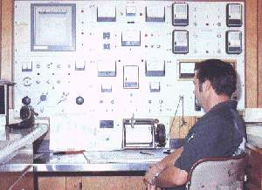
If the logger sees any oil in the well samples, it will be very clearly noted on the mud log. Oil and gas "shows" are the most important thing the mud logger will find.
At the right is a picture of the complex mud-monitoring equipment inside a portable mud-logging trailer. This equipment's main job is to detect oil and gas in the mud.
The mud log will be used in combination with the electric logs run on the well to make a decision about whether to complete the hole (try to produce oil or gas from it) or "plug" the well. Mud logs are a very important tool to the petroleum geologist..
Below is a chart of common symbols used on mud logs:
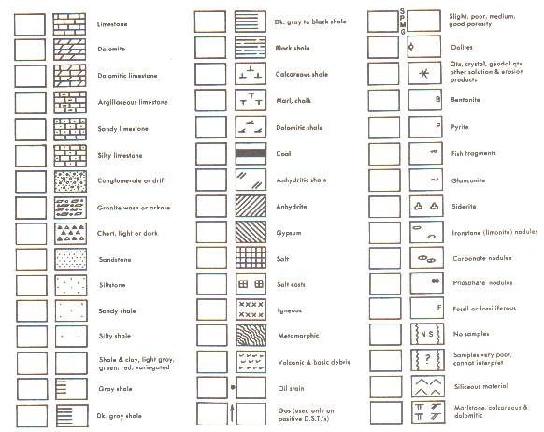

Oil and Gas Traps
Oil and Gas in Rocks
You may have heard that oil is found underground in "pools", or "lakes", or "rivers". Maybe someone told you there was a "sea" or "ocean" of oil underground. This is all completely wrong, so don't believe everything you hear.
Almost all oil and gas is found within the tiny spaces in sedimentary rocks, mainly sandstone and coarse-grained limestones. Imagine that a sponge is a hunk of sandstone or limestone. The sponge is full of holes, or "pores", that can contain water or oil or gas. Limestone and sandstone, even though hard, also contain lots of holes. The holes are much tinier than sponge holes, but they are still holes, called "porosity". The oil and gas become trapped in these holes, and they stay there, for millions of years, until Petroleum Geologists come to find it and get it out.
When you hold a piece of sandstone containing oil in your hand, the rock may look and smell oily, but the oil usually won't run out, and you can't squeeze sandstone like a sponge! The oil is trapped inside the rock's porosity.
How do oil and natural gas get into the rocks in the first place? There are several ideas about how this happens, but one idea is very popular , and it is called...
The Big Idea of Oil Formation and Oil Movement
This sounds very important, and it is, but it's not hard to understand. If you know this, you will know more than most everyone else about where oil comes from, and how it gets there.
The very fine-grained shale we talked about previously is one of the most common sedimentary rocks on earth. In many places, thousands upon thousands of feet of shale are stacked up like the pages in a book, deep underground. It is not unusual to have layers in the earth's crust made up mostly of shale that are 4 miles thick. These shales were deposited in deep, quiet ocean waters over millions of years time.
During much of the earth's history, the land areas we now know as continents were covered with water. This situation allowed tremendous piles of sediment to cover huge areas. The oceans may have gone away from the land we now live on, but the great deposits of shale and sandstone remain deep underground....right under our feet!
The Tiny Gigantic Kingdom
But what about the oil and gas? For the answer, we need to move to the ancient oceans that once covered almost all of the earth.
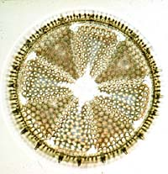
We often think of sharks and whales as being the kings of the deep oceans. Actually, there are other animals that have established giant kingdoms in the sea...the largest and most impressive kingdoms of all! These animals are various kinds of microscopic creatures....both plant and animal. Most of them would fit on the head of a pin. They are tiny, but there are trillions upon trillions of them. When these creatures die, they sink to the bottom and become part of the shale sediments there.
The animals die and rain down on the ocean floor all the time. And since the beginning of life on earth, they have been living their exciting lives in the ocean, dying, sinking to the bottom, and becoming part of the once-living matter that is part of all shale rocks.
Sea-Floor Gunk
Of course, whales, sharks, and fish die too, and their bodies end up on the ocean bottom, where they rot, and also become part of the shale. And, over the long periods of geologic time, animals that are now extinct, like Trilobites and Ammonoids, lived and died in the oceans.
But, it is the trillions of tiny animals that have made up most of the living gunk (the scientific name for this gunk is "ooze") deposited on the ocean floor. You have probably heard of the Ozone Layer. You probably did not know there was an "OOZONE LAYER", too! Well, it's not really called that, but that's what it is! Just a mixture of sand, silt, mud, and the bodies of ocean animals piled up on the sea floor. Sea-floor gunk!
Later, when thousands of feet of shale have piled up over millions of years, and the animal bodies are buried very deep (more than two miles down), an amazing thing happens. The heat from deep inside the earth "cooks" the animals, turning their bodies into what we call hydrocarbons......oil and natural gas.
Movin' Out
At first, the oil and gas only exist between the shale particles as extremely tiny blobs. Then, the intense pressure of the earth squeezes the oil and gas out of the shale, and the oil and gas fluids move sideways many, many miles. On their way, they may meet up with other traveling oil fluids.
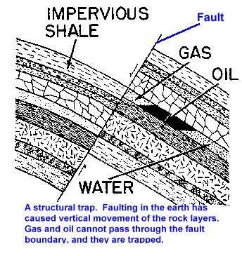
Finally, the oil and gas may become "trapped" in a rock formation like sandstone or limestone....a trap they can't escape! The oil and gas stay there, under tremendous pressure, until the PG comes to get it. After they are formed, oil and gas must be "trapped" in order to remain in place until it can be found. Without a trap, the PG has no place to drill. All oil and gas deposits are held in some sort of trap.
There are two basic types of traps:
Structural traps hold oil and gas because the earth has been bent and deformed in some way. The trap may be a simple dome (or big bump), just a "crease" in the rocks, or it may be a more complex fault trap like the one shown at the right.
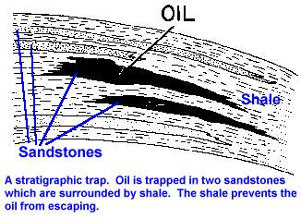
Stratigraphic traps are depositional in nature. This means they are formed in place, usually by a sandstone ending up enclosed in shale. The shale keeps the oil and gas from escaping the trap.

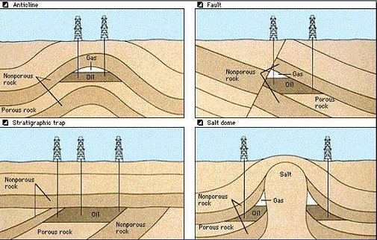
Here are four traps. The anticline is a structural type of trap, as is the fault trap and the salt dome trap.
The stratigraphic trap shown was formed when rock layers at the bottom were tilted, then eroded flat. Then more layers were formed horizontally on top of the tilted ones. The oil moved up through the tilted porous rock and was trapped underneath the horizontal, nonporous rocks.

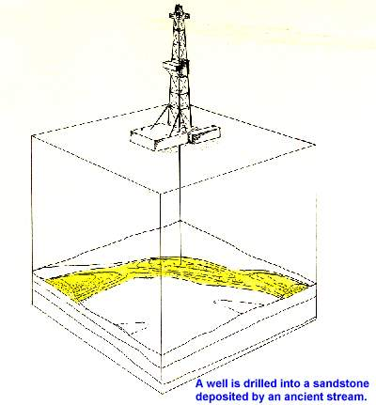
The hole at the right has been drilled into a sandstone that was deposited in a stream bed. This type of sandstone follows a winding path, and can be hard to hit with a drill bit!
This type of sandstone is usually enclosed in shale, making this a stratigraphic trap.
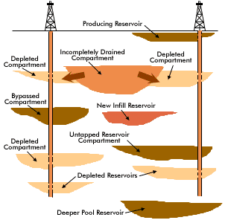
Just because you drill for oil or gas does not mean that you will find it! Oil and gas reservoirs all have edges. If you drill past the edge, you will miss it !
Your well may find a producing reservoir very near the surface. Or you might drill into a reservoir that has been depleted (all the oil and gas removed) by another well. There may ne a new infill reservoir between two wells that could be developed with a third well. Or one that was incompletely drained. Maybe if you drill a little deeper you might hit a deeper pool reservoir! You might be able to back up and produce a bypassed compartment. The Petroleum Geologist has to think of all these things when planning a new well.
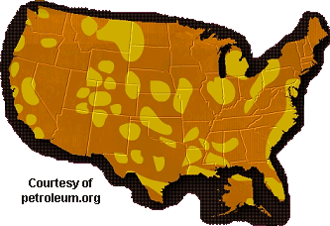
Even though oil and gas are not easy to find, they are found in commercial quantities in many areas of the United States. This map shows most of these areas. It's really a crummy map, and not very accurate, and I need to replace it sometime. But for now, this is the map.

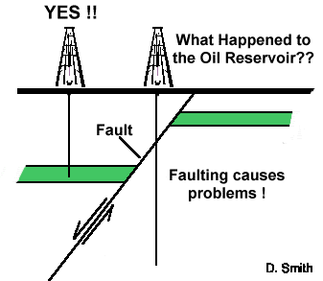
Finally, structures in the earth can give the PG many challenges. Look at the diagram to the right. Imagine you first drilled the hole on the left into the green layer which represents a nice oil and gas-bearing rock. YES! You have a great well, producing lots of oil and gas!
Then you drilled your second hole to the east (right) of the first one. What happened to that hole?
Answer below.

Answer:
The oil reservoir has been split in two by the fault, which is nothing but a place in the earth where rock layers break in two. The arrows on the diagram show that the rocks moved DOWN on the left side of the fault and UP on the RIGHT side of the fault. This created a GAP in the oil field......right where you drilled your second well!
Too bad. Your second well is a DRY HOLE.

First 3 diagrams, A Primer of Oil and Gas Production , 4th diagram, Pennsylvanian Sandstones of the Mid-Continent
Correlating Rocks With Microfossils
Sometimes, in certain areas, the well samples that are returned to the surface from the drill bit do not consist of various alternating beds of shale, limestone and sandstone. The offshore Texas Gulf Coast is one of these places.
Instead of rocks that are fairly easy for the Petroleum Geologist to identify, the well may drill through thousands and thousands of feet of rocks that are made up only of shale. This makes it very hard for the PG to tell what exactly what rock layers are being drilled, since most shale looks like most other shale.
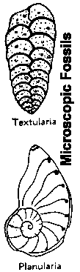
But, the PG has an answer for this. In these difficult areas, the rocks are identified by the tiny "microfossils" they contain. These microfossils are the skeletons of the tiny animals or plants that have lived in the ocean for millions of years. Eventually, they died, and were buried in the shale on the ocean floor. The animals changed and evolved through time, and PG's have learned how to identify rock layers by looking at the types of microfossils contained in them. This kind of work is always done with a microscope
A PG that studies microfossils through a microscope is doing very specialized work. This type of geologist is called a micropalentologist (my-crow pale-lee-on-tall-o-jist).
If a PG finds a certain microfossil in a rock layer (call it "Fossil A") that is 9,000 feet deep, and then finds the exact same microfossil in another well at a depth of only 8,000 feet, he may decide that the rocks containing Fossil A in each well are the same layer. He may then name these rocks the "Fosssil A Layer".
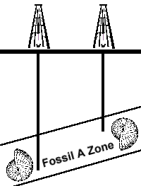
Other PG's can then use pictures of Fossil A to identify the Fossil A Layer in their own wells. If enough PG's learn to recognize Fossil A, it becomes an important tool to identify certain rocks, and PG's can talk with each other about the Fossil A Zone....and other PG's will know what they are talking about.
The drawings of microfossils on this page like planularia and textularia are expanded many times! These tiny fossils would fit on the head of a pin!

Stratigraphic Cross-Sections
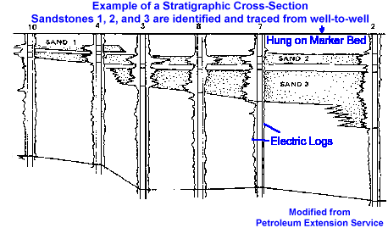
Stratigraphic (strat-i-GRAPH-ic) cross-sections differ from structural cross-sections in that underground structure or elevation is ignored in the stratigraphic type. "Strat" cross-sections allow the PG to see some things more clearly. Geologists make a whole lot of stratigraphic cross-sections as they try to figure out what the rocks are doing.
The stratigraphic cross-section shown here illustrates a vertical view through six wells. Electric logs are laid out in a line with paper and ruler or (much more likely these days) a computer.
The PG has identified an easily-picked formation or marker-bed (at the top of the cross-section), and has drawn a straight line called a "datum" (day-dum) through it. Then, each electric log is "hung" on the datum line. Even though the formations in each well are at different depths, due to the underground structure, "hanging" the line on the marker-bed datum allows the PG to see the relationship of the formations more clearly, and proceed to the important work of connecting them properly. This kind of cross-section does not show a true representation of the vertical depth change between wells. For that, the geologist must make a structural cross section.
The PG then looks at the various formations that she can identify on the electric logs. In this case, several sandstones are visible. The PG tries to connect the formations so the cross-section will look similar to real geology she has observed on field trips, or studied in school. This process of showing on paper what we think the real world looks like is called "modeling", because we are making a model of what we think we would see if we could dig it up!
The most interesting thing about this particular cross-section is the way sand 3 disappears between wells 3 and 4. This is called a pinch-out, and is a very common thing in petroleum geology. This is one of the things that makes geology interesting, puzzling, and challenging!
If the oil or gas is contained only within sandstone 3, the two wells on the left (10 and 4) would be dry holes, because no sand 3 was present
Below is a modern stratigraphic cross-section generated using a computer and image files of the well logs. In this case, the petroleum geologist has chosen a "hot" shale (high gamma-ray reading) for his datum . All of the well logs are "hung" on the datum. The green and yellow areas represent "pay zones". These "pay zones" are intervals that the petroleum geologist believes may produce oil or gas. The red bars show where some of the zones have been perforated for production.
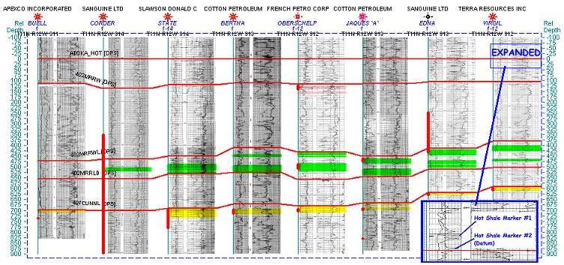
The next stratigraphic cross-section was generated with a computer using digital well logs. Notice how the rocks are displayed between the well logs as the geologist believes they lie underground. The brighter yellow colors represent the better sand quality in the well. This kind of display is especially useful to help explain things to non-geologists.
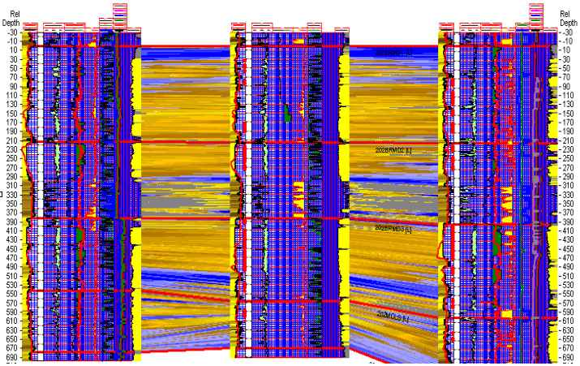

A Completed Well
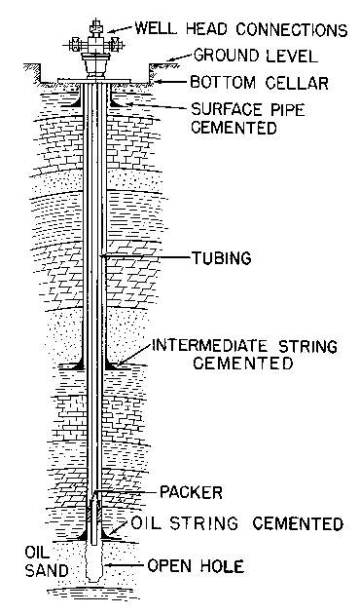
An Open-Hole Completion
The main parts of a completed well are the oil or gas-bearing formation, the drilled hole, several lengths of steel pipe, cement to hold the pipe in place, and a surface well-head connection.
This well is completed "open-hole", meaning there is no casing over the oil or gas zone. This is a very primitive way to complete a well.
A modern well is completed with steel casing set over the oil zone. Holes are shot through it to let the oil and gas in. See the picture immediately below.
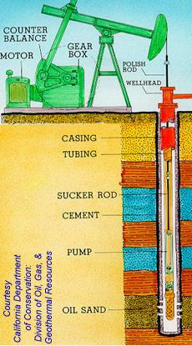

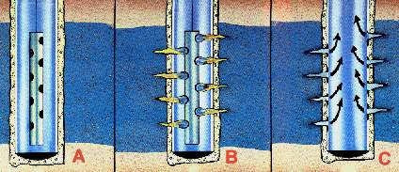
A Normal Through-Casing Completion
Look at the picture to the left. Usually, steel pipe is run all the way to the bottom of the hole and cemented in place. This stops oil, gas, and salt water from coming into the hole from formations above the pay zone.
Then a device called a "perforating gun" (A) is lowered into the hole at the depth where the oil or gas formation is found. This may be anywhere from several hundred feet down to tens of thousands of feet.
After the gun is lined up properly, powerful explosive charges are fired (B) from the control panel in the truck...up at ground level. These explosives blast a hole in the steel casing and cement, up to several feet out into the rock. Finally, the oil and gas fluids flow into the holes and up the well to the surface (C).
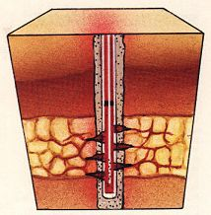
This method of completion is much better than the old open-hole method shown in the first picture. The PG is able to control exactly where the perforations go. This helps her to limit the amount of undesirable fluids, like salt water, entering the hole, and maximize the amount of hydrocarbons that can be removed from the well.

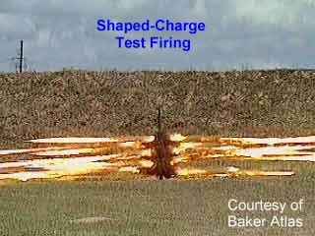

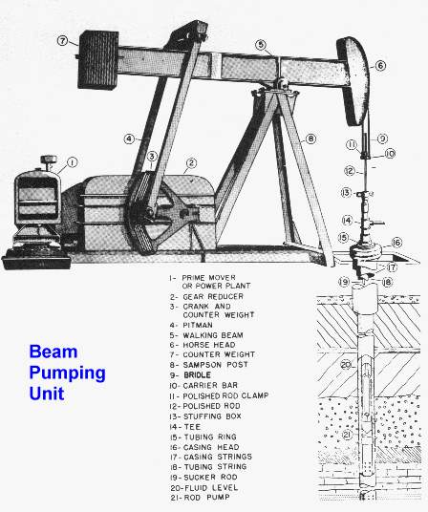
If the workers feel the well is capable of producing oil, a Beam Pumping Unit (left) will be placed on the well.

Completed Well and Perforation diagrams, Primer of Oil and Gas Drilling
Beam Pumping Unit Diagram, Modern Petroleum

The Interactive Scout Ticket
The "scout ticket" is a paper or (these days) computer file that summarizes all the information available on a single well. Basic information like the well name, location, depth, and date completed will be found here. Also, there will be a record of the major formation tops encountered in the well, what "treatments", if any were used, and how much oil or gas the well produced initially.

This particular scout ticket is from the "Carrel #1-11", a well located in Roger Mills County, Oklahoma. The Carrel produces oil and gas from the deltaic Red Fork sand. During the time of deposition of the Red Fork, most of Roger Mills county was under water.
Click on an area of the scout ticket for an explanation of that information. The definition will appear at the very top of your browser window.
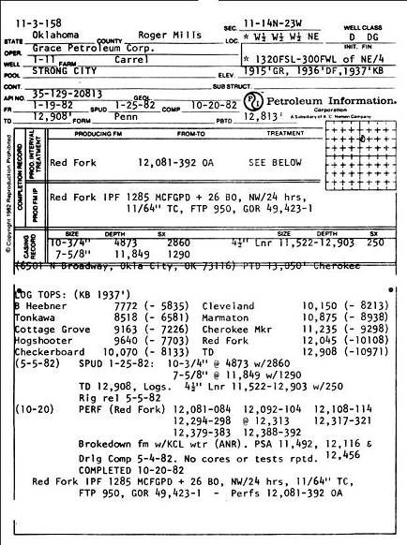
This paper scout ticket is from 1982. These days, this kind of data is accessed through a computer. For examples, click HERE.

Locating Oil or Gas Wells
Using The Federal Township and Range System

Section: The basic unit of the system, a square tract of land one mile by one mile containing 640 acres.
Township: 36 sections arranged in a 6 by 6 system, measuring 6 miles by 6 miles. Sections are numbered beginning with the northeast-most section, proceeding west to 6, then south along the west edge of the township and to the east.
Range: Assigned to a township by measuring east or west of a Principal Meridian
Range Lines: The north to south lines which mark township boundaries.
Township Lines: The east to west lines which mark township boundaries.
Principal Meridian: The reference or beginning point for measuring east or west ranges. Map of meridians & base lines from the BLM web server
Base line: Reference or beginning point for measuring north or south townships.

Understanding Land Descriptions
We'll start with the largest grouping, the township and range. The township is named in reference to a Principal Meridian (P.M.) and a Baseline. Here is an example, T2N R1E. The T2N refers to Township 2 North (of the Baseline), and the R1E refers to Range 1 East (of the Principal Meridian). | 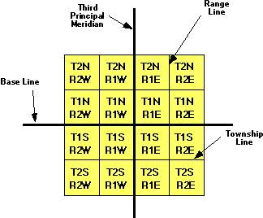
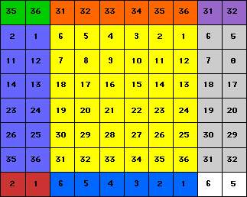 | Next, each township is divided into 36 sections. Each section is one mile square and contains 640 acres. The sections are numbered from 1 to 36 in the order shown in the chart to the left.
Within each section, the land is referred to as half and quarter sections. A one-sixteenth division is called a quarter of a quarter, as in the NW1/4 of the NW1/4. The descriptions are read from the smallest division to the largest. | 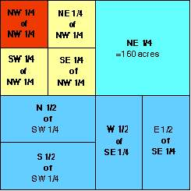
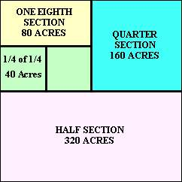  ONE SECTION = 640 ACRES | A section is also broken down into acres.  Sample descriptions are in the ( )s.  A full section contains 640 Acres.  A half section (S1/2) contains 320 Acres.  A quarter section (NE1/4) contains 160 Acres.  An eighth section (N1/2 of NW1/4) contains 80 Acres.  A sixteen section (SW1/4 of NW1/4) contains 40 Acres.
Locating a Well Using Land Descriptions
A land description generally starts with the smallest part of the description and proceeds to the largest definition. For example, NW1/4 of NE1/4 of Section 8, T2N, R1E would be the northwest quarter of the northeast quarter of section 8 in township 3 north and range 2 east. To locate a well using a land description, you need to work from the largest part to the smallest part.
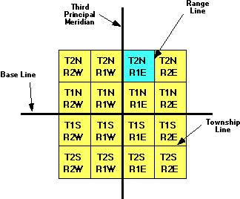 | Step 1  As mentioned above, to locate the well given as an example above you would need to work backward and locate the largest part using the township and range supplied in the description first. In this case T2N, R1E. Remember the T2N refers to Township 2 North (of the Baseline), and the R1E refers to Range 1 East (of the Principal Meridian).
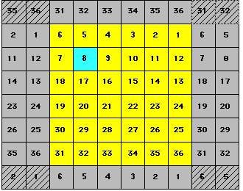 | Step 2  After you have located the correct township, you will next need to find the correct section within that township. Using the example given above the land description states Section 8, T2N, R1E. So you would look in the township found in step 1 for section 8.
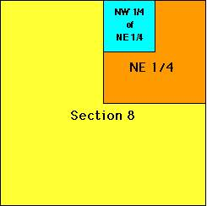 | Step 3  Now that you have located the correct section you need to find where in this section your well is located. Our example says NW1/4 of NE1/4 of Section 8, T2N, R1E. So you would first look in section 8 for the NE1/4 of the section (shown as orange in the chart to the left.) After locating the NE1/4 of the section your last step will be to find the NW1/4 of that NE1/4 (shown in aqua in the chart to the left.) The well is generally located at or near the center of the last unit given.
Congratulations!
You've successfully located the oil or gas well
described in the land description example given above.
Good luck in your search for other wells!
This page courtesy of Brenda Schnurrer
Structural Cross-Sections
Once the PG has electric logs from two or more wells, he usually will make a "Cross-Section". With a "structural" (STRUK-sure-all) cross-section, he will attempt to show the various positions of the rock formations as they actually look underground.
The PG knows the elevation above sea level for each of the wells. He wants to show a model of the way the wells would line up if they could be viewed from the side! Like viewing the layers in a cake that has been cut.
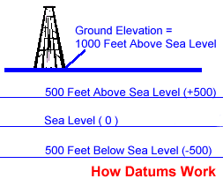
The PG may choose a "datum" (day-dum), or an artificial elevation, that is 500 feet below sea level (-500'). The PG wants to take his electric logs and "hang" them so that they are all "hung", or lined up, on the same datum, 500 feet (-500') below sea level.
The PG has 4 wells to work with:
Well #1 has a ground level elevation of +1000 feet (1000 feet above sea level. Well #2 has a ground level elevation of +1050 feet. Well #3 has a ground level elevation of +1045 feet. Well #4 has a ground level elevation of +1060 feet.
The PG takes each well's electric log and determines where the -500-foot datum will be located on each one. Well #1 has a ground level elevation of +1000 feet. In order to get to -500 feet, the PG must go down the log to a drilled depth of 1500 feet (+1000 minus 1500 feet equals -500 feet). The PG makes a mark on the first log at a depth of 1500 feet. He follows the same method for each of the remaining logs, until they each have a mark on them at the -500-foot datum...wherever it lies on the well log.
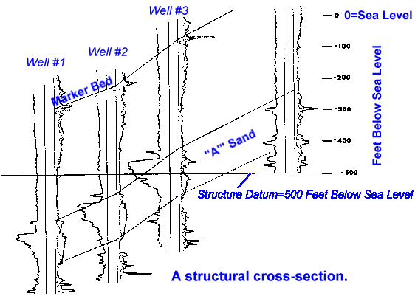
Then, the -500 datum is drawn as a horizontal straight line on paper. See the datum at 500' below sea level on the cross-section to the right. The PG places each log on the paper so that the mark on the log lines up with the datum line on the paper.
After the logs are placed correctly, the PG draws lines between the formations he believes are the same in each well. On the cross-section at the right, the PG has picked a "Marker Bed" and an "A Sand". He draws pencil lines connecting the Marker Bed and the top and bottom of the A sand.
Notice how the formations picked on the cross-section are tilted. This shows the actual way the formations are tilted in the earth. Rock formations below the surface of the earth are almost never perfectly flat. It is the tilting and and folding of the rock layers that creates so many oil and gas traps for the PG to find.
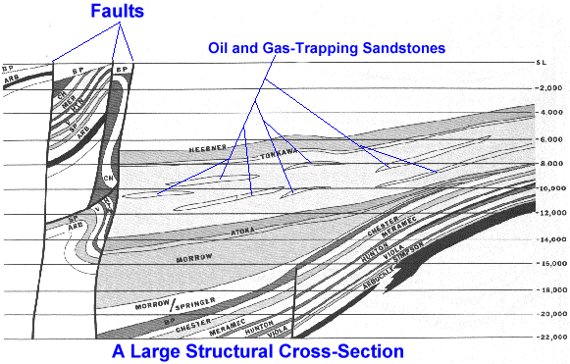
Finally, a very large structural cross-section is shown at right. This type of cross-section is more like a "cartoon", and shows rock layers over a horizontal distance of several hundred miles

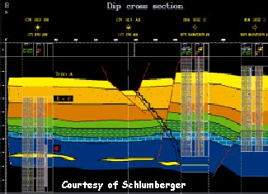
Most cross-sections are now generated using computers:

Finally, the green and yellow areas on this structural cross-section (hung on the sea-level datum) represent "pay zones". These "pay zones" are intervals that the petroleum geologist believes may produce oil or gas. The red bars show where some of the zones have been perforated for production.
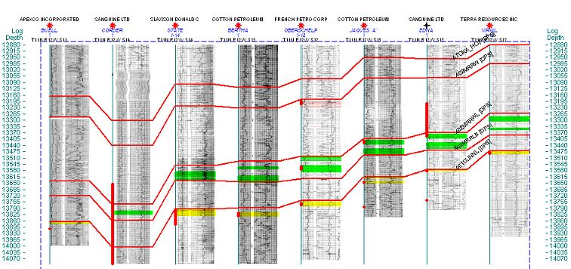

Geologic Maps
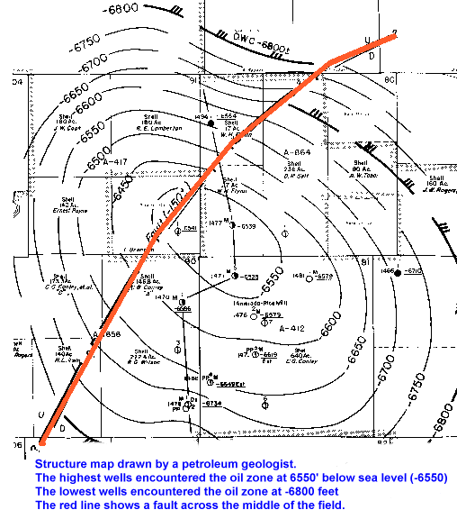
Geologists draw dozens of types of geologic maps. They want to show the earth as it is deep underground.
The map at the left is called a "structure map". It is drawn on the top of an oil zone that is approximately 8000 feet deep. The map is about two miles across.
The PG picks the top of the oil zone in every well that is drilled. She knows the elevation of the ground at the drilling site. For example, if the elevation of the ground is 1000 feet above sea level, and the top of the oil zone is found at 7700 feet, she subtracts 7700 feet from 1000 feet to get a "subsea" elevation of -6700 feet.
These subsea elevations are posted on the structure map. Then "contour lines" are drawn on the map to create her picture of the underground structure.
In this case, the structure is shaped like a broad dome...or hill....with the top of the hill at -6550 feet and the base of the hill at -6800 feet. So, the top of the hill is about 250 feet higher than the base!

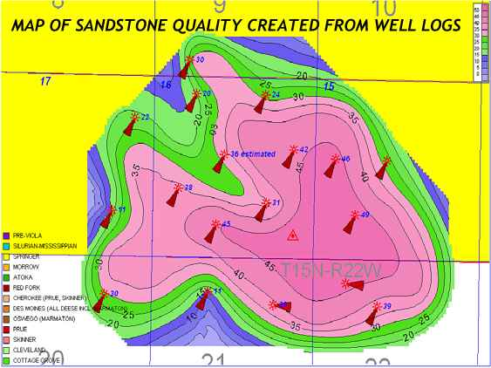
Here is a different type of map called an "isopach (eye-so-pak) map", constructed over a small gas field. The squares (or "sections") are one mile in length on each side.
In this map, the petroleum geologist contours the thickness of an individual sandstone. This sandstone is about 45 feet thick in the middle and thins to 20 feet or less around the edges of the gas field.

Below is a colorful map (an isopach, like above) contoured on one of the Springer (Pennsylvanian) sands in Oklahoma. This particular sandstone was deposited in the ocean, as a sand bar. That gave it a lot of porosity, and now it is a pretty nice gas field. The PG made this map by looking at the porosity of the sandstone in the electric logs of all the wells. Then the PG determined how many feet of the sandstone was producible, or "pay". The pay amount is posted in blue alongside the wells.
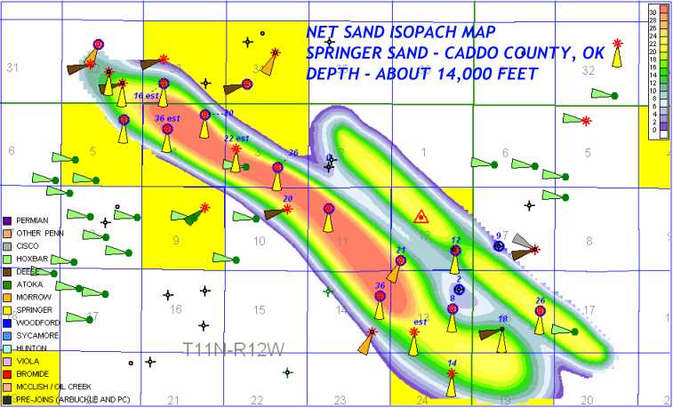
One more map. This one shows an ancient stream or river channel. The sandstone is about 30 feet thick in the middle of the channel. Production charts have been placed on the map. These show graphically how much oil and gas was produced from each well over the years. The large red numbers indicate the amount of produced gas. For example, the Soar 1-18 (top middle) has made 3,267,524 thousand cubic feet of gas, or 3.2 billion cubic feet. That's a good well !
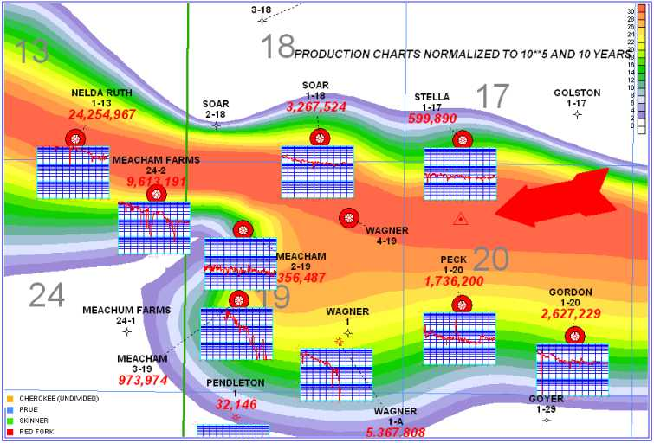
Amount of Gas Abbbreviation used in the Oil Industry
1000 cubic feet of gas = 1 MCF
1 million cubic feet of gas = 1 MMCF or 1000 MCF
1 billion cubic feet of gas = 1 BCF or 1,000,000 MCF
A typical house might use only about 4 MCF of gas per month for heating. Assuming 6 months of heating per year, that's 24 MCF used per year. That means the Soar has produced enough gas in it's lifetime to heat 136,000 houses for one year !

How to Contour A Map
Geologists make all kinds of contour maps. Contouring is not hard, but it takes lots of practice and patience to make a nice-looking map.
You start by "spotting", or drawing, all the wells on a map. In a large part of the United States, the Township and Range System is used to spot wells.
Let's assume we are making a map in one the western states that uses the Township and Range system. In this area, a "section" of land is one mile on each side (one mile square). This also happens to be exactly 640 acres.
Here's a section of land to the right, with wells spotted on it.
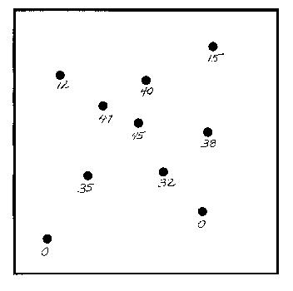
Next, you look at the electric logs for each well. We are going to make an "isopach" (eye-so-pak) map. An isopach map is a map that shows the thickness of something. In this case, it is the thickness of a sandstone formation.
Count the number of feet of sand in the zone you are interested in. Then, put the number of feet of sand below each well spot.

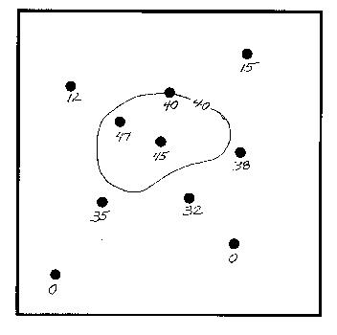
Start contouring with the highest values. Use a "contour interval" that is slightly less than the biggest values. In this case, the first line drawn is the 40-foot contour.
As you draw your line, look carefully when you pass between two wells. Try to use your eye like a "ruler", and position the line at the proper distance between the two wells. Notice the well with a footage of "38". Since 38 is very close to 40 (the contour we are drawing, you should "pull" the 40-foot contour over close to the 38-foot line, like I did here.
If there is a "40" on the map (there is on this one), you will draw the 40-foot line right through that well.
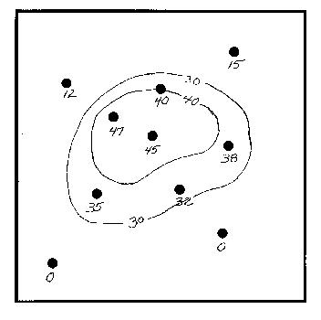
Now draw the 30-foot contour. "Eyeball" the map and be sure to leave the proper amount of room for the remaining contour lines. Use a pencil, because you have to erase a lot!!

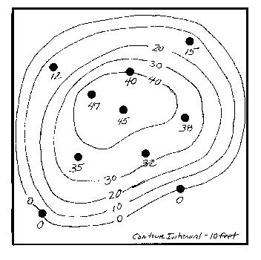
Finish the map by drawing the 20-foot, 10-foot, and zero contour lines. Label the "contour interval" you used at the bottom of the map. In this case, the contour interval is 10 feet.
You're done! It takes quite a bit of practice to draw decent contour maps by hand. The one we just did was a "quickie". Normally, you would draw this in pencil and then go back and make it better with ink.
It's important to know how to contour a map, but these days, geologists use computers to do a lot of their contouring. The computer can't do it all, however. It still requires quite a bit of "help" from the petroleum geologist to make a decent-looking map.
The map on the right would still require some erasing and reworking to get it looking right.

