- Delete from BST the specified key and redraw the
- Remove 19 – 7
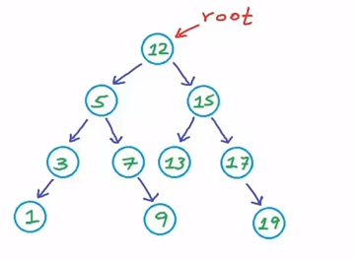
- Remove 15

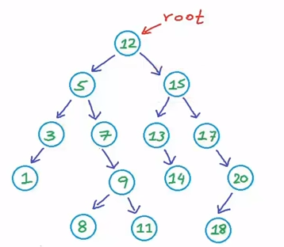

- delete from the following BT and show the results: 99- 50 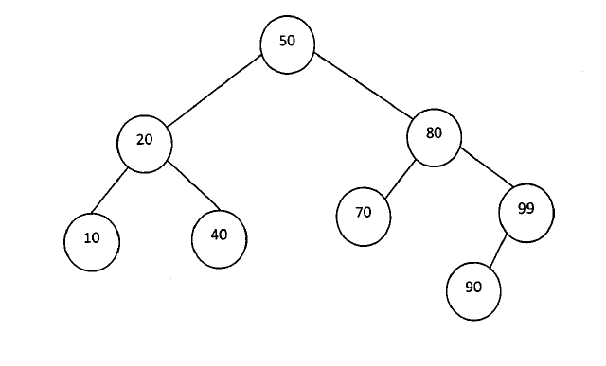

- Insert following Keys in a Binary Search Tree. The tree is initially empty
{d,a,t,s,m,p,l,e}
NOTE: {A,B,C,D,E,F,G,H,L,J,K,L,M,N,O,P,Q,R,S,T,U,V,W,X,Y,Z}

