KING SAUD UNIVERSITY
COLLEGE OF COMPUTER AND INFORMATION SCIENCES
COMPUTER SCIENCE DEPARTMENT
CSC 329: Computer Network | Tutorial 2 |  | 1st Semester 1437-1438
Name: |  | Student ID:
Serial Number: |  | Section Number:

Part1: Multiple-Choice Questions

- Which of the following can be determined from a frequency-domain graph of a signal?
a. Bandwidth
b. Phase
c. Power
d. All the above

- In a time-domain plot, the vertical axis measures the ________
- Amplitude
- Frequency
- Phase
- Slope

- A periodic signal can always be decomposed into _______
- Exactly an odd number of sine waves
- A set of sine waves.
- A set of sine waves, one of which must have a phase of 0º
- None of the above

- A sine wave is ______
a. Periodic and continuous
b. Aperiodic and continuous
c. Periodic and discrete
d. Aperiodic and discrete

- If the maximum amplitude of a sine wave is 2 V, the minimum amplitude is___ V.
a. 2
b. 1
c. -2
d. Between -2 and 2

- Given two sine waves A and B, if the frequency of A is twice that of B, then the period of B is _________ that of A.
a. One-half
b. Twice
c. The same as
d. Indeterminate from

- As frequency increases, the period
  - Decreases
  - Increases
  - Remains the same
  - Doubles

- A periodic signal completes one cycle in 0.001 s. What is the frequency?
a. 1Hz
b. 100Hz
c. 1KHz
d. 1MHz

- If the bandwidth of a signal is 5 KHz and the lowest frequency is 52 KHz, what is the highest frequency?
- 5KHz
- 10KHz
- 47KHz
- 57KHz

- What is the bandwidth of a signal that ranges from 40 KHz to 4 MHz?
- 36 MHz
- 360 KHz
- 3.96 MHz
- 396 KHz

- Twisted-Pair and coaxial cable are used
- copper
- light
- unwired
- wireless

- Cable that accepts and transports signals in form of light is
- Unwired
- fiber optic cable
- coaxial cable
- twisted pair cable

- A repeater takes a weakened or corrupted signal and ______________it.
a. Amplifies
b. Regenerates
c. Re-samples
d. Reroutes
Part2: Exercises
- What is the phase shift for the following?
a. A sine wave starts at time Zero with minimum amplitude. The amplitude is increasing.
b. A sine wave with minimum amplitude after 3/4 cycle.
c. A sine wave with zero amplitude after 1/2 cycle and increasing.

- What is the bit rate for each of the following signals?
- A signal in which 1 bit lasts 2 ms.
- A signal in which 10 bits last 20 μs.

- A device is sending out data at the rate of 500 bps.
- How long does it take to send out a single character (8 bits)?
- How long does it take to send a file of 100,000 characters?

- What is the bit rate for the signal in the following figure?
30 ns
Time

- What is the frequency of the signal in the following figure?
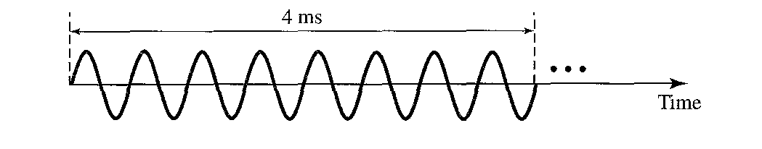

- What is the bandwidth and the lowest frequency of the composite signal shown in the figure?
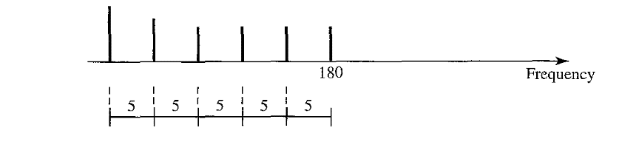

- A periodic composite signal with a bandwidth of 200 Hz is composed of constant signal of 10 V and three sine waves: The first one has a frequency of 40 Hz with a maximum amplitude of 5V; the second one has a frequency of 120 Hz with a maximum amplitude of 20 V and the third one has a maximum amplitude of 10 V. Draw the frequency spectrum of the signal.
- A non-periodic composite signal contains frequencies from 10 to 30 KHz. The amplitude is 10 V for the extreme (min and max) frequencies and 30 V for middle frequency. Assuming that the amplitudes change gradually from the minimum to the maximum. Draw the frequency spectrum of the signal.

