Experiment #6
Title of experiment: Determination of the solubility products of sparingly soluble salt
Aim:
Use a concentration cell made from two Ag(s) /Ag⁺ (aq) electrodes to determine the solubility product of the three silver halides AgCl, AgBr and AgI.
Introduction:
A concentration cell is constructed from two half-cells which are identical, except that the concentration of the ionic species to which the electrode is sensitive is different on the two sides of the cell. Such a cell can be used to measure the solubility product of a sparingly soluble salt. In one half-cell the concentration
of these ions is known, in the other it is determined by the solubility product of the salt under investigation. The ratio of the two concentrations (more accurately, activities) determines the potential of the cell.
A concentration cell used here can be expressed as:
Ag(s) / AgX(s) / KX(aq)⁞ KNO3(aq, satd.) / AgNO3(aq) / Ag(s)
where X refers to the halide ion.
The cell potential is the difference between the cathode potential (right half-cell R) and the anode potential (left half-cell L) and is always positive, otherwise the process runs in the other direction. The cathode is the electrode with the higher potential. It is the positive pole in a galvanic cell. The processes which take place at the cathode are always reductions. Cations are deposited, non-metals go into solution as anions, oxidizing agents are reduced.
The potential E is generally calculated from the two standard potentials E_ by subtracting them, together with a second expression, which takes the activities a of the participating substances into account. As in the law of mass action, the substance on the right appears in the numerator, the substance on the left in the denominator. In this case, we have:
$E=E_{Ag}^{o}+\frac{RT}{F}lna_{{Ag}^{+},R}$- $E_{Ag}^{o}-\frac{RT}{F}lna_{{Ag}^{+},L}=\frac{RT}{F}ln\frac{a_{{Ag}^{+},R}}{a_{{Ag}^{+},L}}$ (1)
Where $a$_{Ag+},_{R} is the activity of the silver ions in the silver nitrate solution of known concentration and $a$_{Ag+},_{L} is the activity of the silver ions in the potassium halide / silver halide solution.
Measurement of potential of a concentration cell such as the above, can be used to determine solubility products. For this purpose, one half-cell containing a saturated solution of the substance is connected to a second half-cell containing a solution of known activity. The connection is made via a switch which is filled with an electrolyte that is inert with regard to the saturated solution.
$a$_{Ag+,L} is controlled by the solubility product Ksp of the silver halide AgX
Ksp = $a$_{Ag+,L} · $a$_{X -,L} (2)
where $a$_{X -,L}, the activity of the halide ions in the left half-cell, is assumed to arise from the fully dissociated potassium halide, whereas the contribution from the sparingly soluble silver halide being negligible in comparison.
Substituting equation (2) into equation (1) allows the cell potential to be expressed as:
$E=\frac{RT}{F}ln\frac{a_{Ag+,R} .a_{X-,L}}{K_{sp}}$ (3)
$lnK_{sp}=ln⁡(a_{Ag+,R}$.$a_{X-,L})-\frac{EF}{RT}$ (4)

The solubility product of the silver halide may therefore be calculated by measuring the potential of the cell E if $a$_{Ag+,R} and $a$_{X -,L} are known.
The activity of an ion in solution is given by
$a_{i}=f_{±}$.$C_{i}$ (5)
where c_{i} is the concentration of the species i and $a_{i}$ is the mean activity of the electrolyte. The electrolyte concentrations required for this experiment are listed in Table 1.

Table 1: Mean activity coefficients $f_{±}$ for AgNO3, KCl, KBr, KI at 25°C
C, mol/l | AgNO₃ | KCl | KBr | KI
0.001 | 0.945 | 0.965 | 0.965 | 0.965
0.01 | 0.897 | 0.902 | 0.903 | 0.905
0.1 | 0.734 | 0.770 | 0.772 | 0.778

Using these values the ion concentrations can be converted to activities and the solubility products calculated from equation (5). By measuring the potential of the above cell, the solubility product of the corresponding sparingly soluble salt can calculated from equation (4).
Materials:
Beakers, salt bridge, digital voltmeter, silver metal sheet, temperature probe, stand and clamps.
Ag salts solution shown in table 1.

Procedure:
1) Prepare a slat bridge using saturated KNO₃ solution.
2) Cut silver electrodes (50 x 10 mm) from the silver sheet and clean them by polishing
3) To form a thin layer of the silver halide on Ag metal surface, soak Ag sheets in the corresponding silver halide solution overnight.
4) Place one of a clean silver electrode in the silver nitrate solution and connect it to the input socket of the voltmeter with a connecting cord.
5) Dip the Ag electrode with formed Ag halide into the potassium halide / silver halide solution and connect it to the anod potential.
6) Connect the two electrode solutions by means of the salt bridge.
7) Measure the temperature using the temperature probe.
8) Record the cell potential for the given concentration cells.

Results:
By using the mean activity coefficient value for the various silver halides for the corresponding concentration, measure the potential of the cells, record it in the following tables, and calculate the solubility product of Ag halides.
Table 2: Experimental data
[AgNO₃], mol/l | [KCl], mol/l | $a$_{Ag+,R} | $a$_{Cl-,L} | E, mV | Ksp
0.001 | 0.001 | 9.64·10⁻⁴ | 9.65·10⁻⁴
0.01 | 0.01 | 8.97·10⁻³ | 9.02·10⁻³
0.1 | 0.1 | 7.34·10⁻² | 7.70·10⁻²

[AgNO₃], mol/l | [KBr], mol/l | $a$_{Ag+,R} | $a$_{Br-,L} | E, mV | Ksp
0.001 | 0.001 | 9.64·10⁻⁴ | 9.65·10⁻⁴
0.01 | 0.01 | 8.97·10⁻³ | 9.03·10⁻³
0.1 | 0.1 | 7.34·10⁻² | 7.72·10⁻²

[AgNO₃], mol/l | [KI], mol/l | $a$_{Ag+,R} | $a$_{I-,L} | E, mV | Ksp
0.001 | 0.001 | 9.64·10⁻⁴ | 9.65·10⁻⁴
0.01 | 0.01 | 8.97·10⁻³ | 9.05·10⁻³
0.1 | 0.1 | 7.34·10⁻² | 7.78·10⁻²

Report:

Experiment # 7
Title of experiment:
Galvanic corrosion
Aim:
To observe and explain the galvanic corrosion of metals.
Introduction:
In reality, the material from which a product is made can deteriorate as a result of interaction with the service environment; in the limit, the product may fail. Examples of this interaction in metals include the corrosion of steel by sea water, the stress corrosion cracking of brass, and the high temperature oxidation of nickel. In this experiment, two experiments will be performed. The first experiment will examine the galvanic corrosion of steel. In the second experiment, the high
temperature oxidation of steel and aluminium will be studied and compared. Galvanic corrosion is the process which causes the surface of metals and alloys to deteriorate. It occurs when the metal or alloy loses electrons and becomes a positive ion in solution.
M →Mn⁺+ ne
For the reaction to proceed, a complete electrical circuit must exist so that the
electrons and the metal ions are removed. The location of the electron-loss
reaction is called the anode. Here, the electrons are supplied to the external
circuit. Electron gain occurs at the cathode; this electrode receives electrons from
the external circuit. In the air think of the following cathodic equation:
O₂ (g) +2H₂O (aq) + 4 e− → 4OH⁻¹
Anode and cathode locations and the external circuit for the electron schematically in Figure 1.
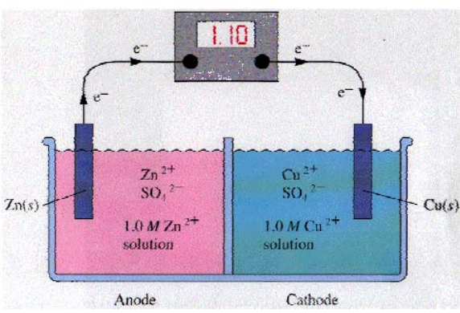
Figure 1 : Galvanic cell consisting of Zn and Cu electrodes

Materials:
Iron nails ,Aluminum foil ,Copper electrical wire , zinc sheet,
Sand paper ,Ceramic or glass dish
10% w/w NaCl solution .
Procedure:
- Clean each nails with sandpaper.
- Clean the metals .
- Wrap a piece of aluminium foil tightly around the head of the first nail.
- Wrap a piece of copper wire around the second nail. Make sure that the end of the copper wire do not touch the nail.
- Wrap a piece of zinc sheet tightly around the head of the third nail.
- The fourth nail must have no contact with another metal.
- Pour the NaCl (10% w/w) solution into the dish)..
- Place the dish where it can remain for 24 hours without being disturbed, but be easily observed without moving it.
- Gently place each nail into the dish so that they are not touching each other.
- Make sure all the nails are covered with the solution (see Figure 2). Label the samples properly. Cover your dish.

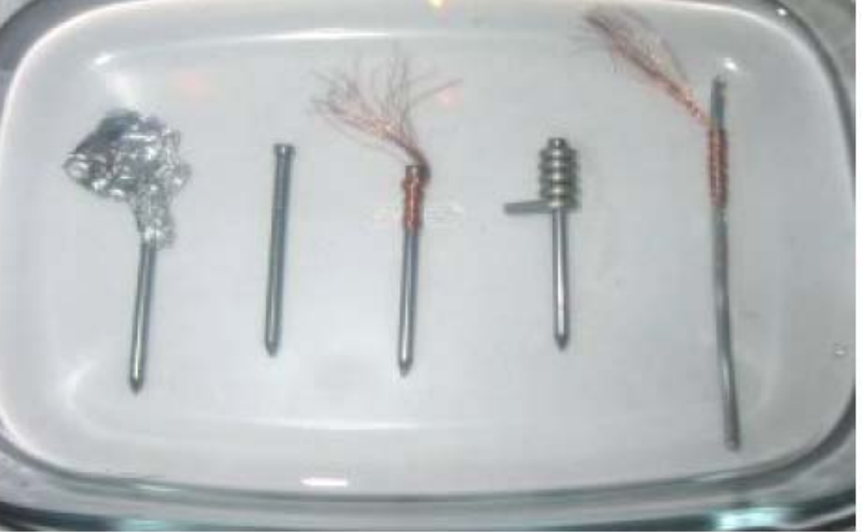
Figure 2 Test materials
Results:
- Observe the nails every 24 hours for 1 week and take notes on what you see.
- Rate the level of corrosion for each metal from 1 to 10 with no corrosion
- being 0 and fully corroded being 10. Arrange the level of corrosion from high
- to low.
- Compare and contrast the differences after 24 hours. What changes do you
observe in the metals?
- Compare your results in No. (1) with galvanic series. What can you conclude
- about the level of corrosion in this experiment from the galvanic series?
- Compare the four metals with the iron nail that was not protected with any
- metals in the NaCl solution; are there any differences? Which nails with what metals have corroded, and by how much?
- Have some nails corroded faster than others?
Report:
Make a table and conclude which coating provides the best protection of the iron against galvanic corrosion.

