Exercises

Exercise 1:
- Using Switch case statement , write C++ program to determine if a letter is vowel or consonant (not using break).

Exercise 2:
- Using Switch case statement, write C++ program to check percentage of a student and display division(distinction, first, second, third or fail)

Exercise 3:
- Using instead if statement, write a program to check whether an integer is positive, negative or zero.

Exercise 4:
- What is the output for the following codes:

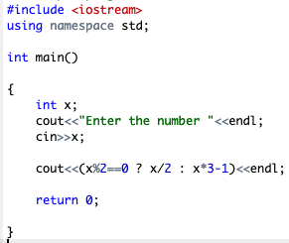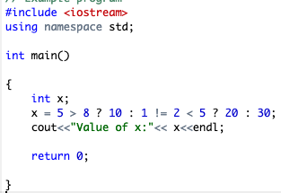
By: T.Elham Sunbu

