Example 1: ( one sample T-test)
Suppose that an engineer is interested in testing the bias in a pH meter. Data are collected on a neutral substance (pH= 7.0). A sample of the measurements were taken with the data as follows:
7.07 , 7 , 7.10 , 6.97, 7 , 7.03 , 7 , 7.01 , 6.98 , 7.08
It is, then, of interest to test $H_{0}:μ=7$ vs $H_{1}: μ≠7$

Output:
Stat > Display Descriptive statistic >
نضع اسم الملف ونضغط
Statistic--------- Mean , standard deviation

Variable Mean SE Mean StDev
PH 7.0240 0.0141 0.0445

Then,
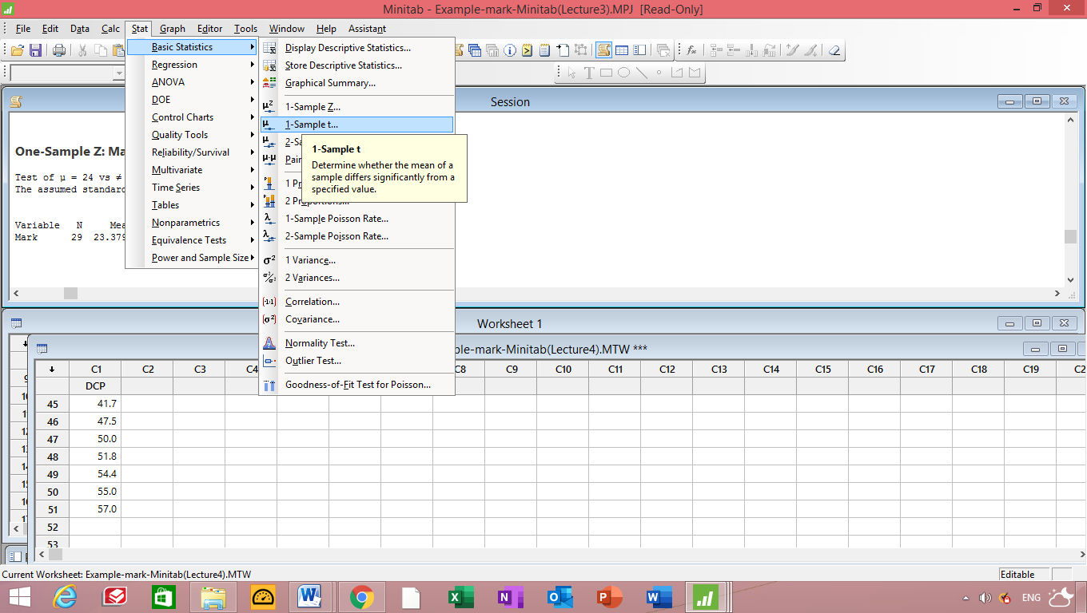
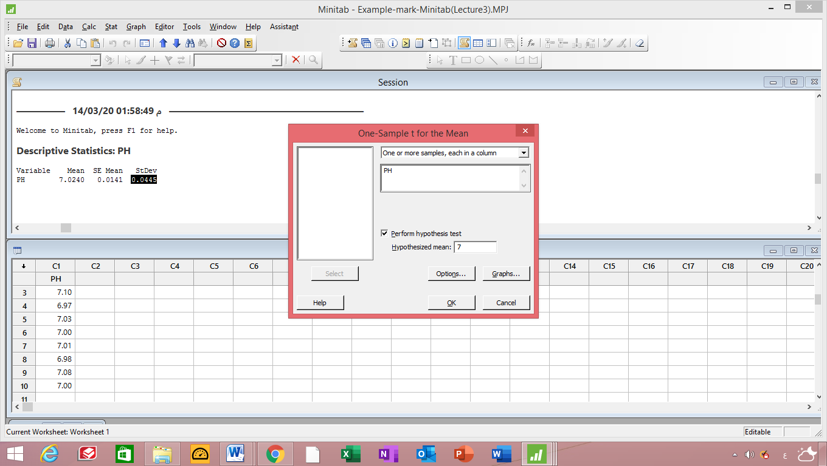

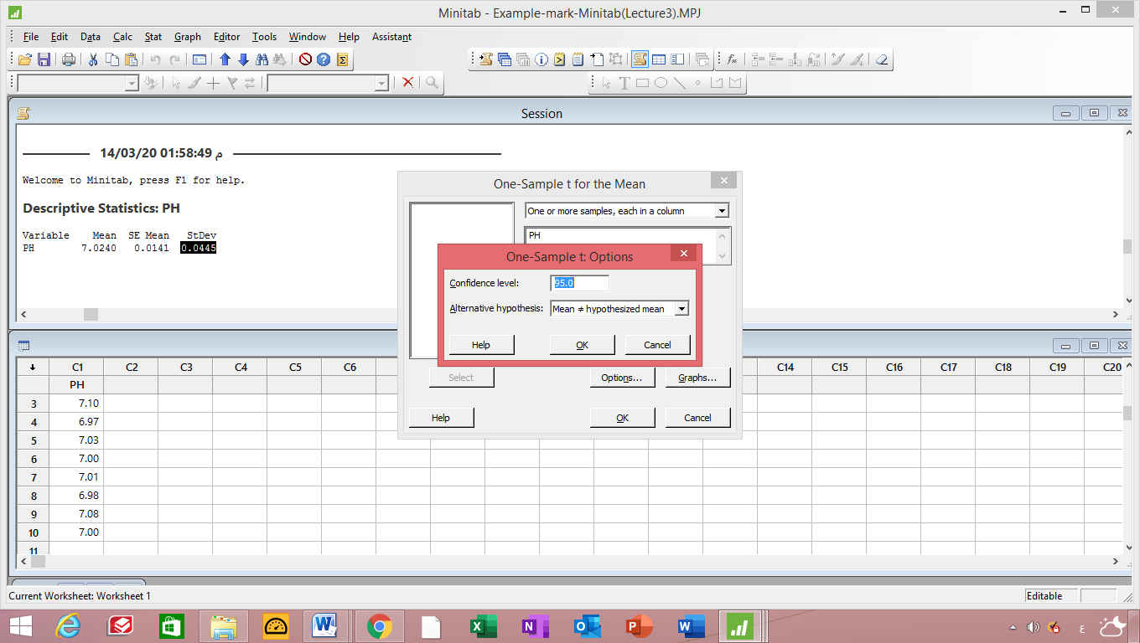
One-Sample T: PH

Test of μ = 7 vs ≠ 7

Variable N Mean StDev SE Mean 95% CI T P
PH 10 7.0240 0.0445 0.0141 (6.9922; 7.0558) 1.70 0.122

Example 2 : ( one sample Z-test)
A dynamic cone penetrometer (DCP) is used for measuring material resistance to penetration (mm/blow) as a cone is driven into pavement or sub grade. Suppose that for a particular application, it is required that the true average DCP value (µ) for a certain type of pavement be less than 30. The pavement will not be used unless there is conclusive evidence that the specification has been met. Let’s state and test the appropriate hypotheses using the following data (“Probabilistic Model for the Analysis of Dynamic Cone Penetrometer Test Values in Pavement Structure Evaluation,” J. of Testing and Evaluation, 1999: 7–14): Test $H_{0}:μ=26 , H_{1}:μ<30 , where population standard deviation is 11.95$
[saved as Example 2 -DCP-Minitab(Lecture4) ]
14.1 14.5 15.5 16.0 16.0 16.7 16.9 17.1 17.5 17.8
17.8 18.1 18.2 18.3 18.3 19.0 19.2 19.4 20.0 20.0
20.8 20.8 21.0 21.5 23.5 27.5 27.5 28.0 28.3 30.0
30.0 31.6 31.7 31.7 32.5 33.5 33.9 35.0 35.0 35.0
36.7 40.0 40.0 41.3 41.7 47.5 50.0 51.0 51.8 54.4
55.0 57.0
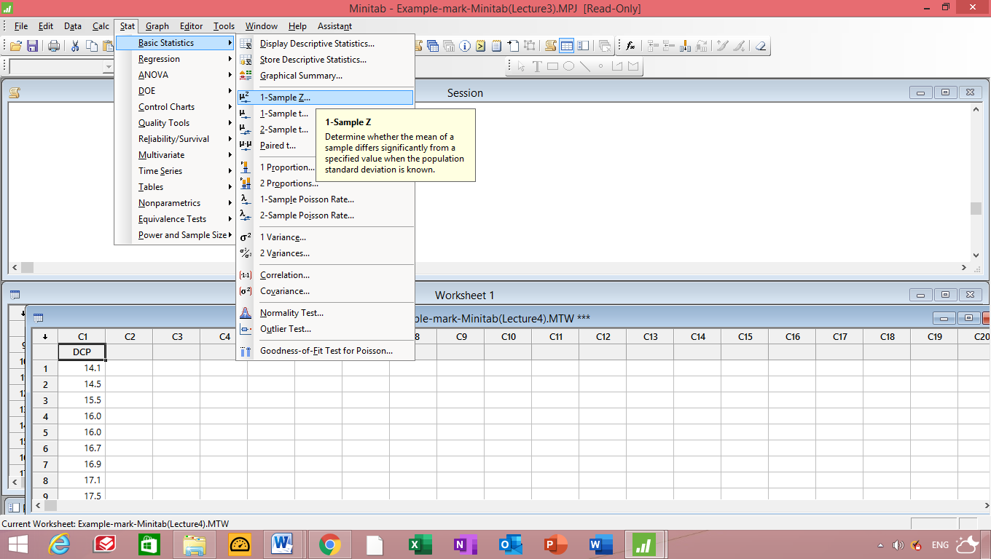
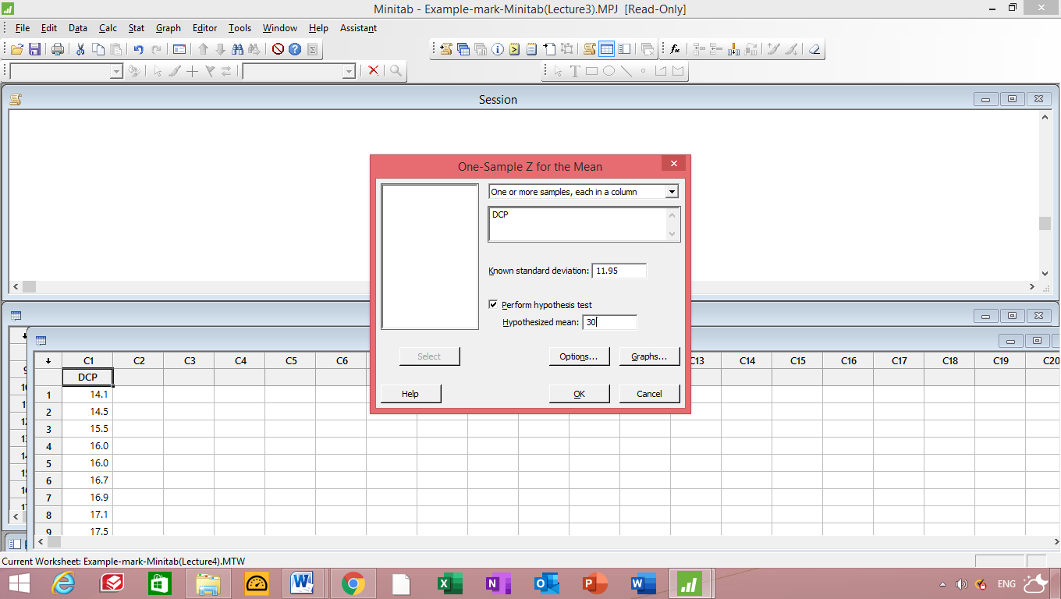
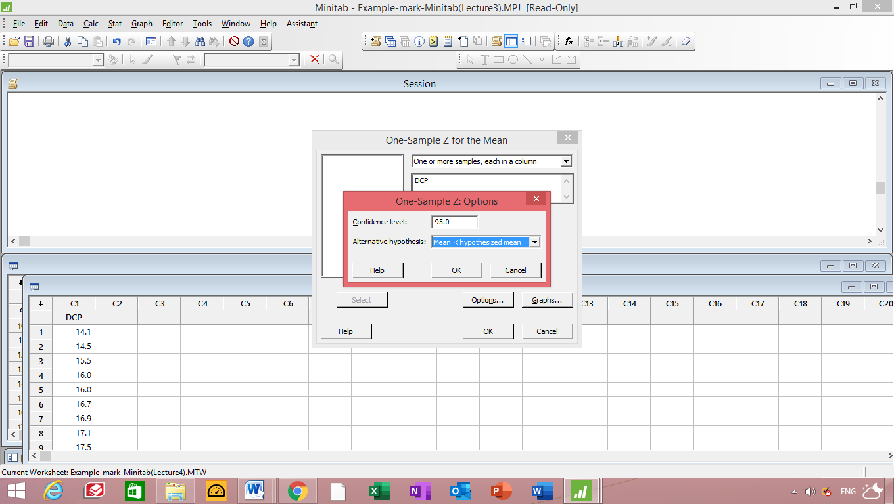
One-Sample Z: DCP

Test of μ = 30 vs < 30
The assumed standard deviation = 11.95

Variable N Mean StDev SE Mean 95% Upper Bound Z P
DCP 51 28.36 11.95 1.67 31.11 -0.98 0.164

Since P-value = 0.164 > 0.05 , Then accept H₀

Example 3 : (Two sample t-test )
The following data represent the running times of ﬁlms produced by two motion-picture companies.
Company | Time (minutes)
I | 103 | 94 | 110 | 87 | 98
II | 97 | 82 | 123 | 92 | 175 | 88 | 118

Compute a 90% conﬁdence interval for the diﬀerence between the average running times of ﬁlms produced by the two companies. Assume that the running-time differences are approximately normally distributed with unequal variances. Ant test the difference between the mean of two company
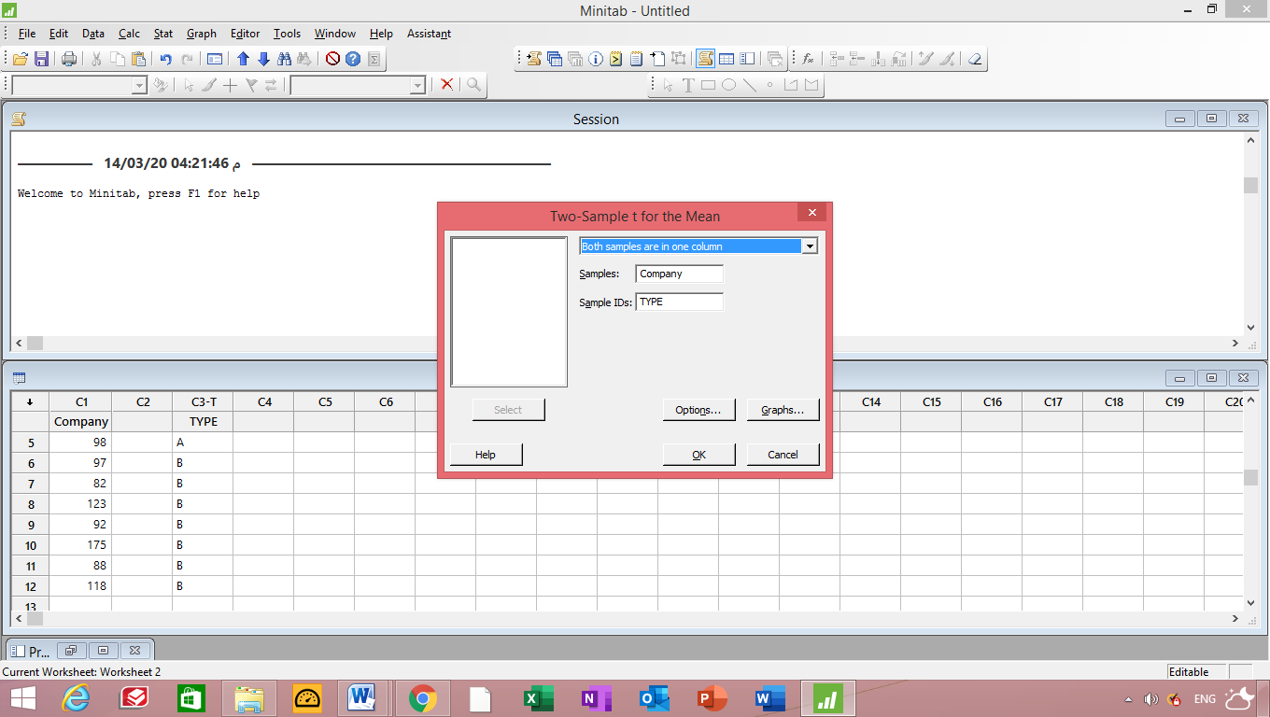
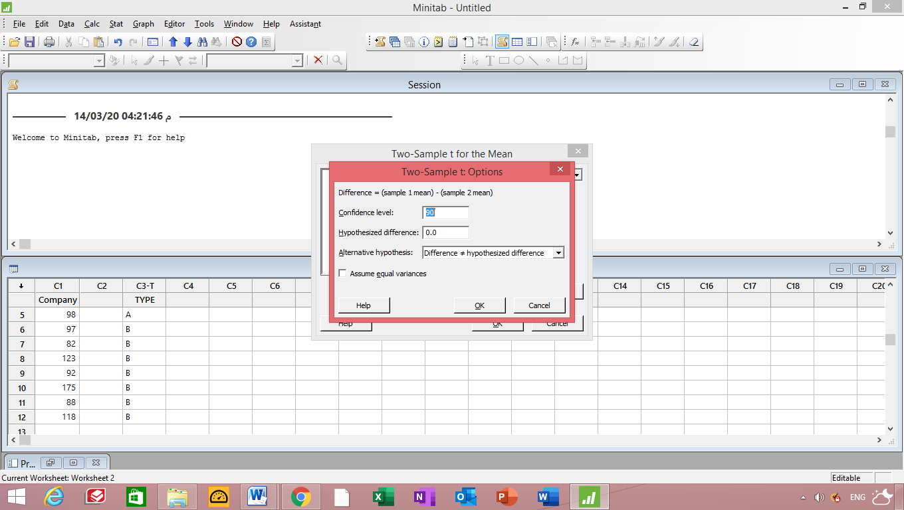
p

Two-Sample T-Test and CI: Company; TYPE

Two-sample T for Company

TYPE N Mean StDev SE Mean
A 4 97.25 9.64 4.8
B 7 110.7 32.2 12

Difference = μ (A) - μ (B)
Estimate for difference: -13.5
90% CI for difference: (-38.3; 11.3)
T-Test of difference = 0 (vs ≠): T-Value = -1.03 P-Value = 0.338 DF = 7

90% Confidence interval is (-38.3; 11.3)
T-table = -1.03
T-test = 0
P-value =0.338
Accept H₀ since P-value > 0.10
Accept H₀ since T-test > - t-table

Example 4 : (Two sample T-Test with equal variances)
To find out whether a new serum will arrest leukemia, 9 mice, all with an advanced stage of the disease, are selected. Five mice receive the treatment and 4 do not. Survival times, in years, from the time the experiment commenced are as follows:
Treatment 2.1 5.3 1.4 4.6 0.9
No Treatment 1.9 0.5 2.8 3.1
At the 0.05 level of significance, can the serum be said to be effective? Assume the two populations to be normally distributed with equal variances.
Test $H_{0}:μ_{1}=μ_{2}$ vs $H_{1}: μ_{1}>μ_{2}$
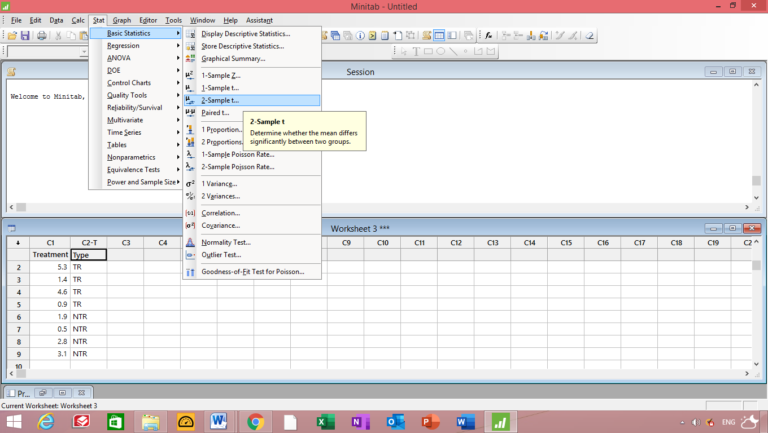
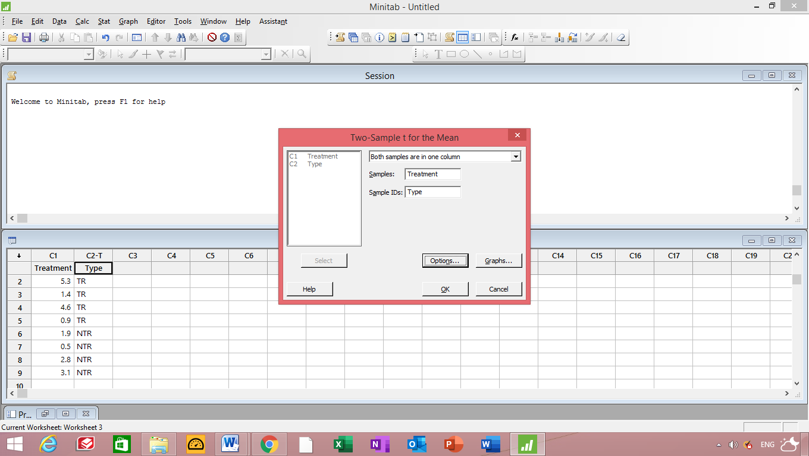
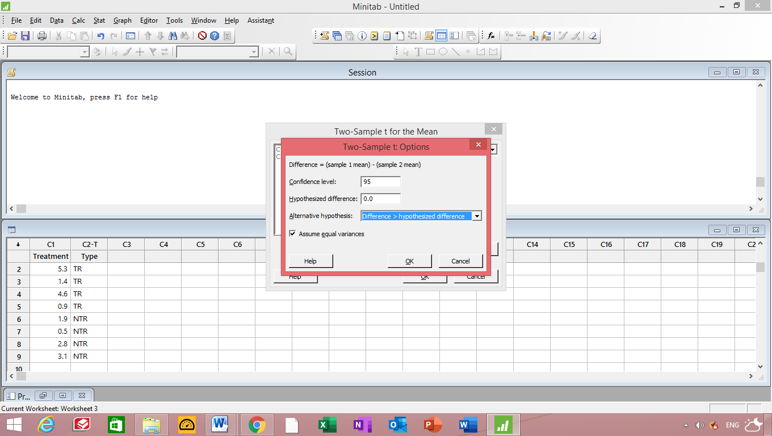
Results for: Worksheet 3

Two-Sample T-Test and CI: Treatment; Type

Two-sample T for Treatment

Type N Mean StDev SE Mean
NTR 4 2.07 1.17 0.58
TR 4 3.05 2.22 1.1

Difference = μ (NTR) - μ (TR)
Estimate for difference: -0.98
95% lower bound for difference: -3.41
T-Test of difference = 0 (vs >): T-Value = -0.78 P-Value = 0.767 DF = 6
Both use Pooled StDev = 1.7747

T-Table = -0.78
P-Value = 0.767
Accept H₀ since P-value > 0.05
Pooled StDev = S_{P} = 1.7747

Example 5 : (Paired T-test )
A clinic provides a program to help their clients lose weight and asks a consumer agency to investigate the effectiveness of the program. The agency takes a sample of 15 people, weighing each person in the sample before the program begins and 3 months later to produce the table below
Person | Before | After
1 | 210 | 197
2 | 205 | 195
3 | 193 | 191
4 | 182 | 174
5 | 259 | 236
6 | 239 | 226
7 | 164 | 157
8 | 197 | 196
9 | 222 | 201
10 | 211 | 196
11 | 187 | 181
12 | 175 | 164
13 | 186 | 181
14 | 243 | 229
15 | 246 | 231

Determine whether the program is effective?
Paired T-Test and CI: Before, After
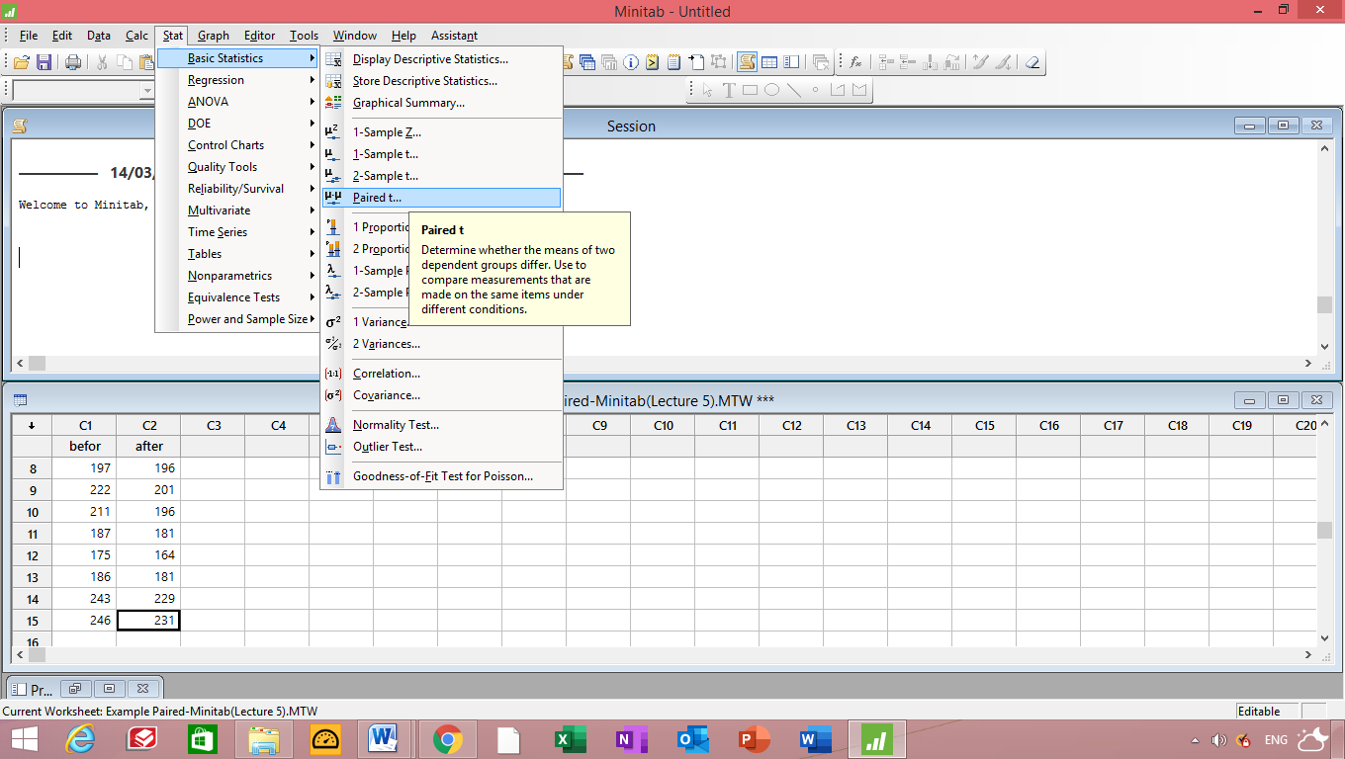

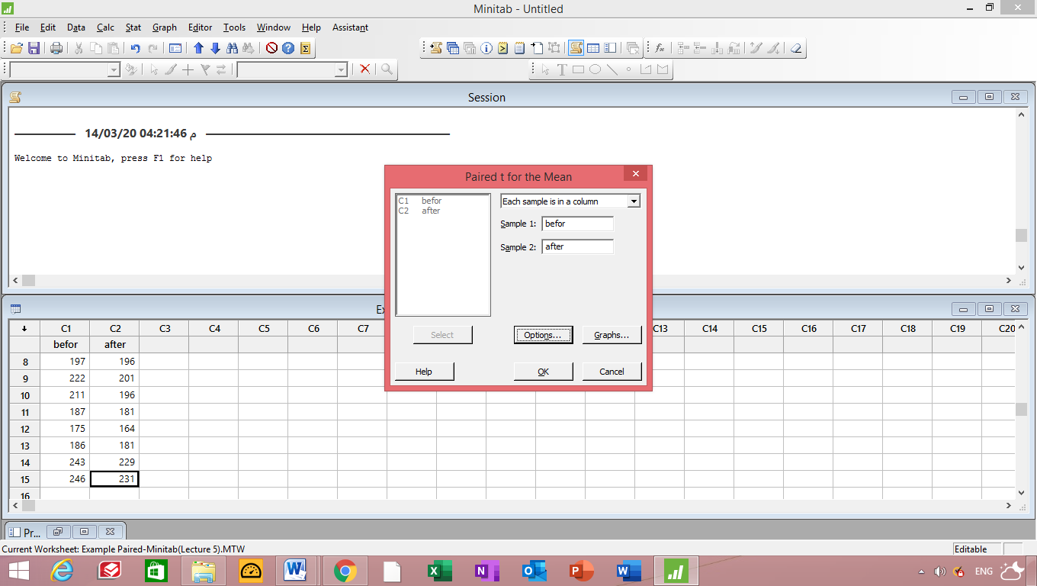

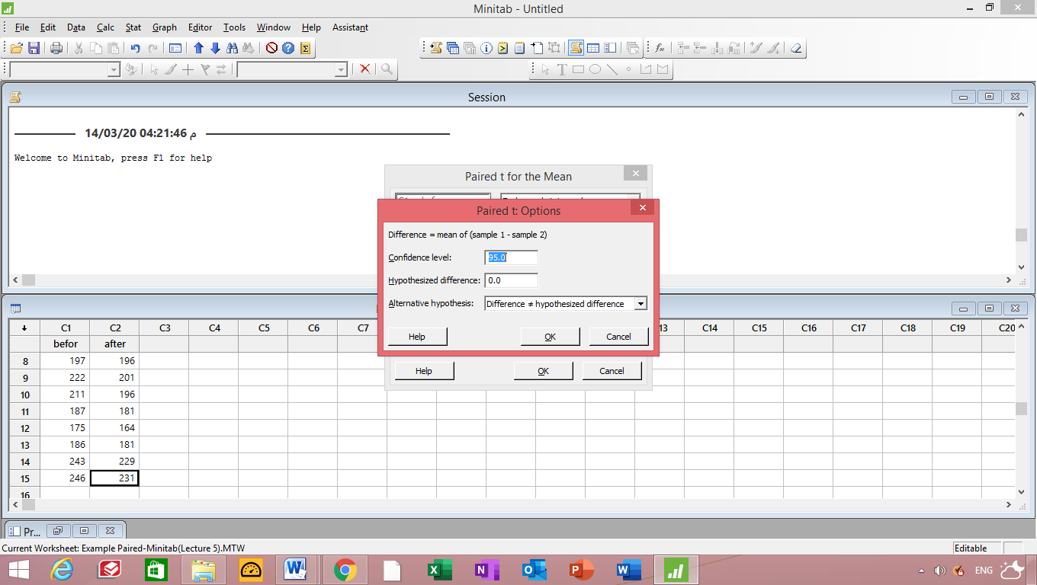
Paired T-Test and CI: befor; after

Paired T for befor - after

N Mean StDev SE Mean
befor 15 207.93 28.56 7.37
after 15 197.00 24.39 6.30
Difference 15 10.93 6.33 1.63

95% CI for mean difference: (7.43; 14.44)
T-Test of mean difference = 0 (vs ≠ 0): T-Value = 6.69 P-Value = 0.000

95% CI for mean difference: (7.43; 14.44)
P-Value = 0.000 < 0.05 ,then reject H₀

Example 8
Hydrocarbon emissions from cars are known to have decreased dramatically during the 1980s. A study was conducted to compare the hydrocarbon emissions at idling speed, in parts per million (ppm), for automobiles from 1980 and 1990. Twenty cars of each model year were randomly selected, and their hydrocarbon emission levels were recorded. The data are as follows:
1980 models:
141 359 247 940 882 494 306 210 105 880
200 223 188 940 241 190 300 435 241 380
1990 models:
140 160 20 20 223 60 20 95 360 70
220 400 217 58 235 380 200 175 85 65
Assume both populations are normal.
- Test the hypothesis that $σ_{1}=275$ against the alternative that $σ_{1}≠275$.
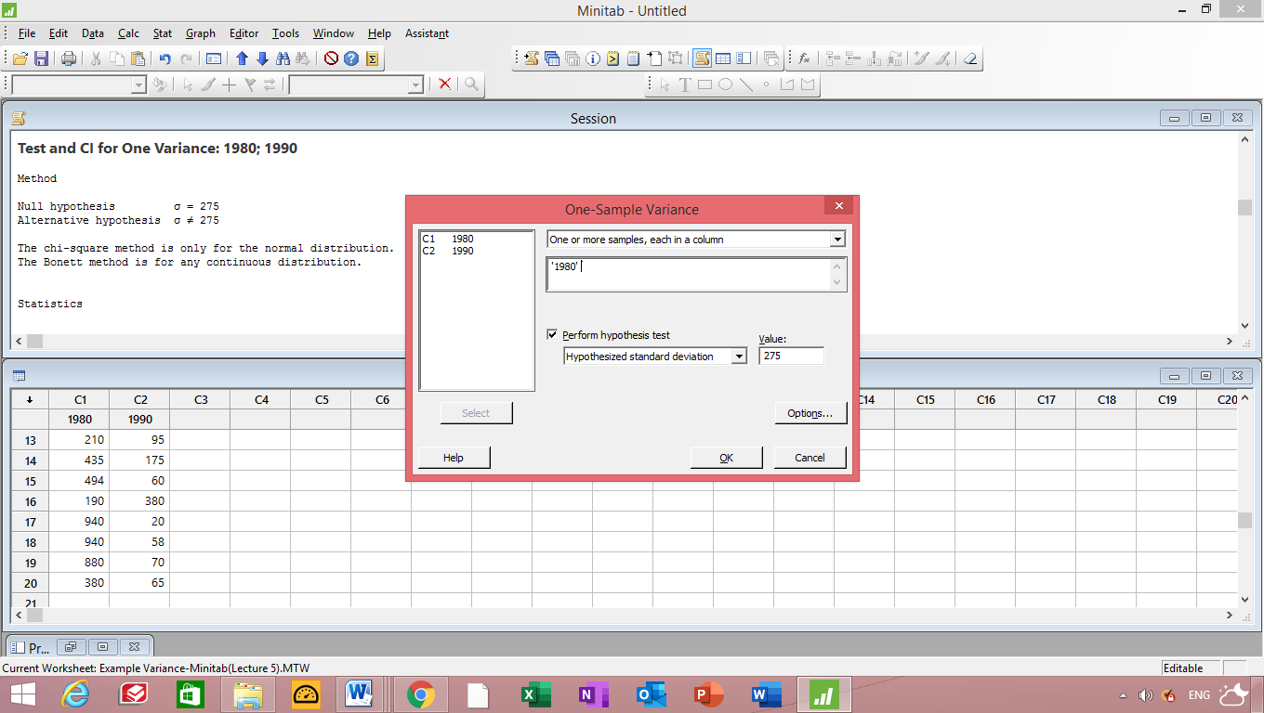
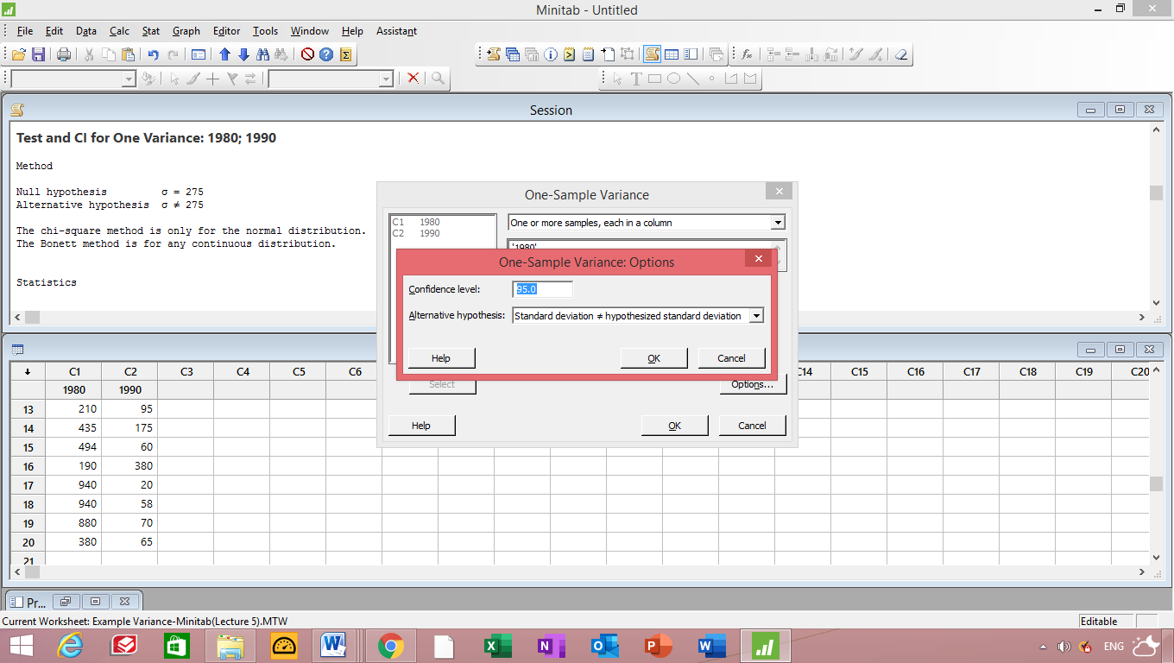
Test and CI for One Variance: 1980; 1990

Method

Null hypothesis σ = 275
Alternative hypothesis σ ≠ 275

The chi-square method is only for the normal distribution.
The Bonett method is for any continuous distribution.

Statistics

Variable N StDev Variance
1980 20 281 78999
1990 20 119 14255

95% Confidence Intervals

CI for CI for
Variable Method StDev Variance
1980 Chi-Square (214; 411) (45688; 168525)
Bonett (195; 449) (37996; 201874)
1990 Chi-Square ( 91; 174) ( 8244; 30410)
Bonett ( 89; 178) ( 7843; 31844)

Tests

Test
Variable Method Statistic DF P-Value
1980 Chi-Square 19.85 19 0.808
Bonett — — 0.897
1990 Chi-Square 3.58 19 0.000
Bonett — — 0.000

Test and CI for One Variance: 1980

Method

Null hypothesis σ = 275
Alternative hypothesis σ ≠ 275

The chi-square method is only for the normal distribution.
The Bonett method is for any continuous distribution.

Statistics

Variable N StDev Variance
1980 20 281 78999

95% Confidence Intervals
CI for CI for
Variable Method StDev Variance
1980 Chi-Square (214; 411) (45688; 168525)
Bonett (195; 449) (37996; 201874)

Tests
Test
Variable Method Statistic DF P-Value
1980 Chi-Square 19.85 19 0.808
Bonett — — 0.897
Accept H₀ since p-value > 0.05
____________________________________________________________________________

- Test the hypothesis that $σ_{1}=σ_{2}$ against the alternative that $σ_{1}≠σ_{2}$.
Test and CI for Two Variances: 1980 models:, 1990 models:
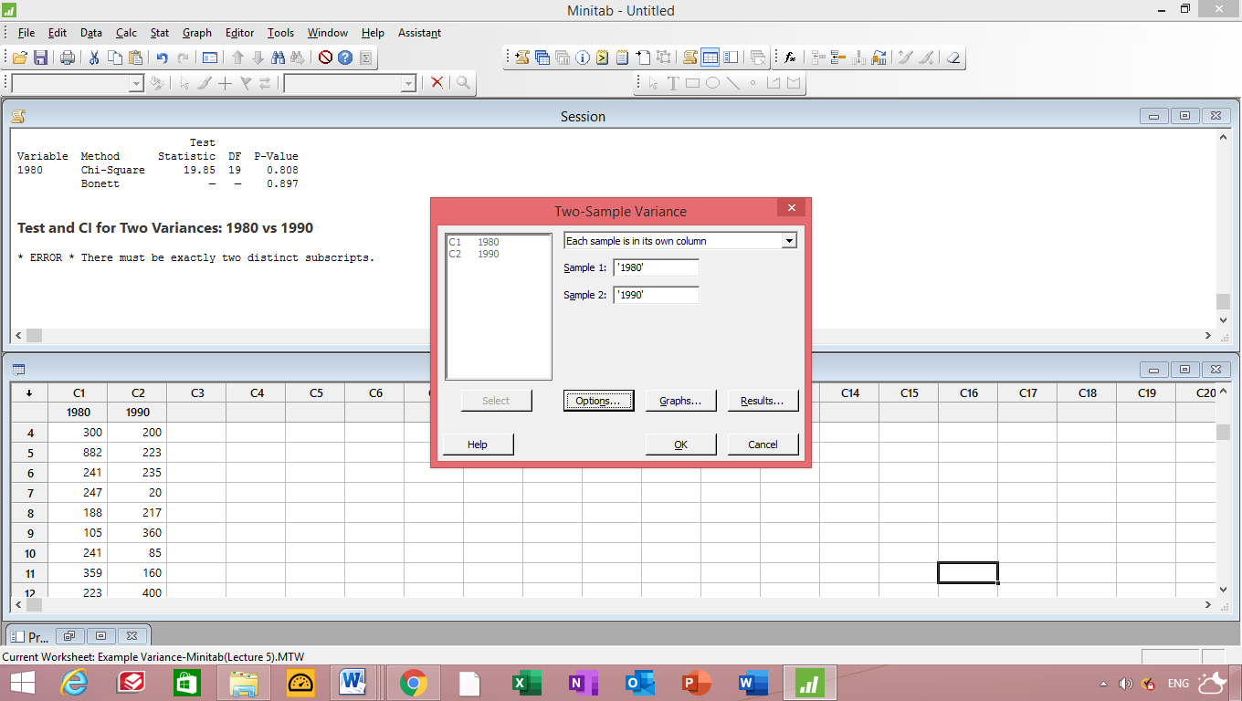

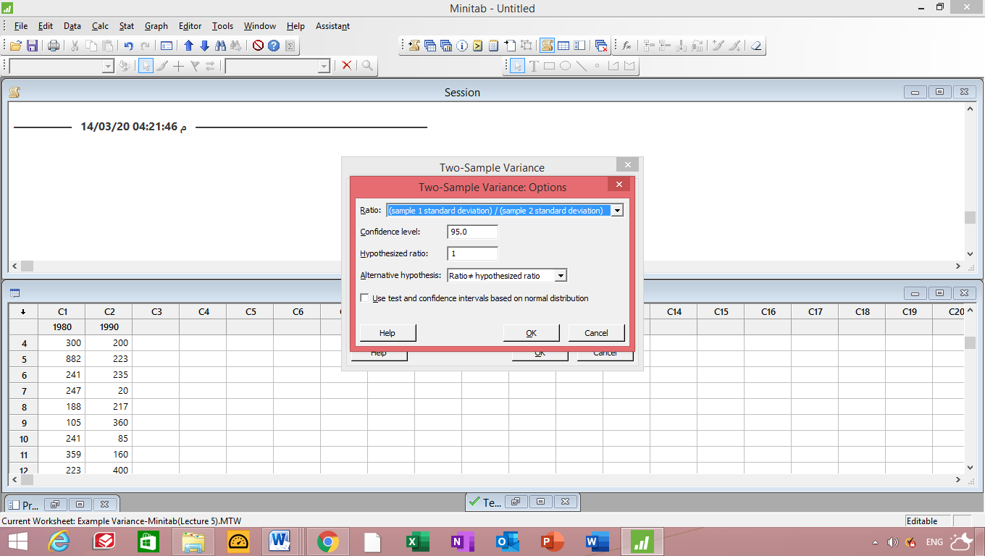

Test and CI for Two Variances: 1980; 1990

Null hypothesis σ(1980) / σ(1990) = 1
Alternative hypothesis σ(1980) / σ(1990) ≠ 1
Significance level α = 0.05

F method was used. This method is accurate for normal data only.

Statistics

95% CI for
Variable N StDev Variance StDevs
1980 20 281.067 78998.516 (213.749; 410.518)
1990 20 119.395 14255.082 ( 90.798; 174.384)

Ratio of standard deviations = 2.354
Ratio of variances = 5.542

95% Confidence Intervals

CI for
CI for StDev Variance
Method Ratio Ratio
F (1.481; 3.742) (2.194; 14.001)

Tests

Test
Method DF1 DF2 Statistic P-Value
F 19 19 5.54 0.000

Test and CI for Two Variances: 1980; 1990
F-test =5.54
95% C.I for ratio of variance (2.194,14.001)
P-value =0 < 0.05 ---------- Reject H₀
Example 6: (Test of variance).H.W
A flotoxins produced by mold on peanut crops in Virginia must be monitored. A sample of 64 batches of peanuts reveals levels of 24.17 ppm, on average, with a variance of 4.25 ppm. Test the hypothesis that $σ^{2}=4.2$ ppm against the alternative that $σ^{2}≠4.2$ ppm.
Test and CI for One Variance

Method

Null hypothesis σ-squared = 4.2
Alternative hypothesis σ-squared ≠ 4.2

The chi-square method is only for the normal distribution.
The Bonett method cannot be calculated with summarized data.

Statistics

N StDev Variance
64 2.06 4.25

95% Confidence Intervals

CI for CI for
Method StDev Variance
Chi-Square (1.76, 2.50) (3.08, 6.23)

Tests

Test
Method Statistic DF P-Value
Chi-Square 63.75 63 0.900

Example 7: One Way ANOVA

Suppose in an industrial experiment that an engineer is interested in how the mean absorption of moisture in concrete varies among 5 different concrete aggregates. The samples are exposed to moisture for 48 hours. It is decided that 6 samples are to be tested for each aggregate, requiring a total of 30 samples to be tested. The data are recorded in Table 13.1.
The model for this situation may be set up as follows. There are 6 observations taken from each of 5 populations with means μ₁, μ₂, . . . , μ₅, respectively. We may wish to test
H0: μ₁ = μ₂ = · · · = μ₅,
H1: At least two of the means are not equal.
Table 13.1: Absorption of Moisture in Concrete Aggregates
Aggregate | 1 | 2 | 3 | 4 | 5
 | 551 | 595 | 639 | 417 | 563
 | 457 | 580 | 615 | 449 | 631
 | 450 | 508 | 511 | 517 | 522
 | 731 | 583 | 573 | 438 | 613
 | 499 | 633 | 648 | 415 | 656
 | 632 | 517 | 677 | 555 | 679

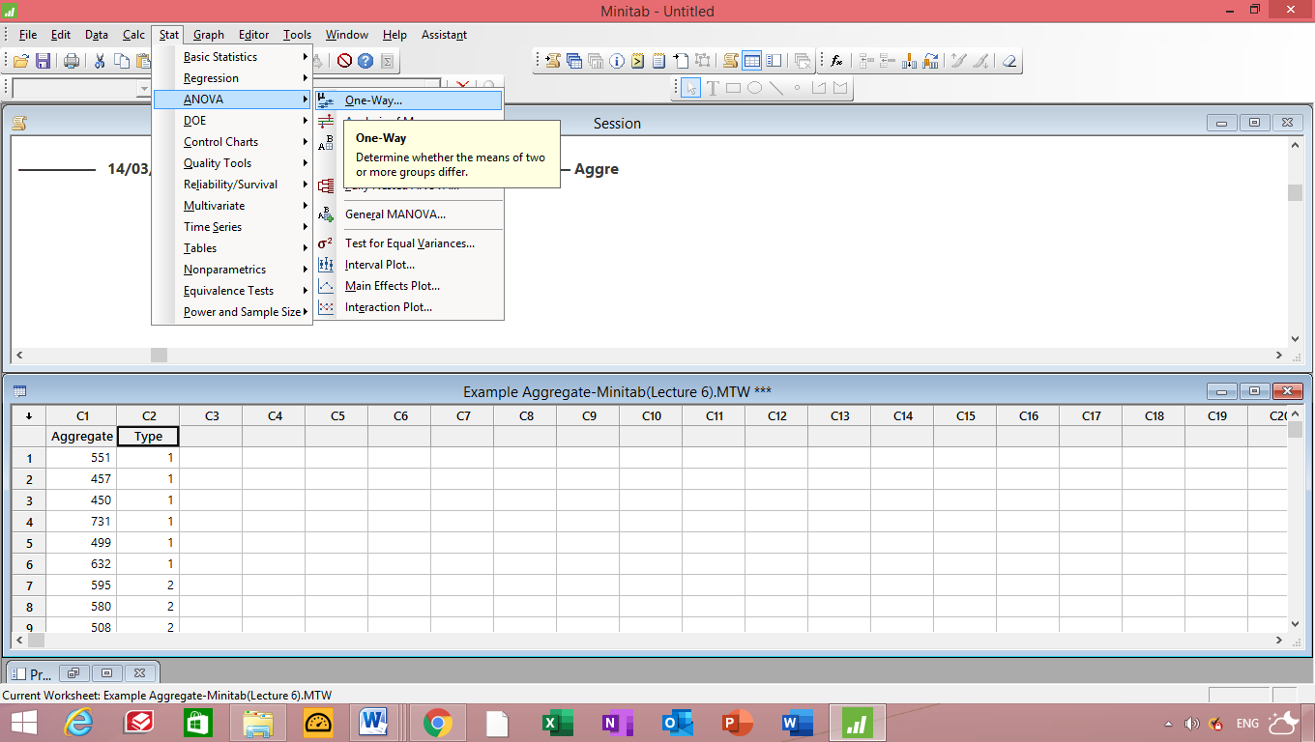

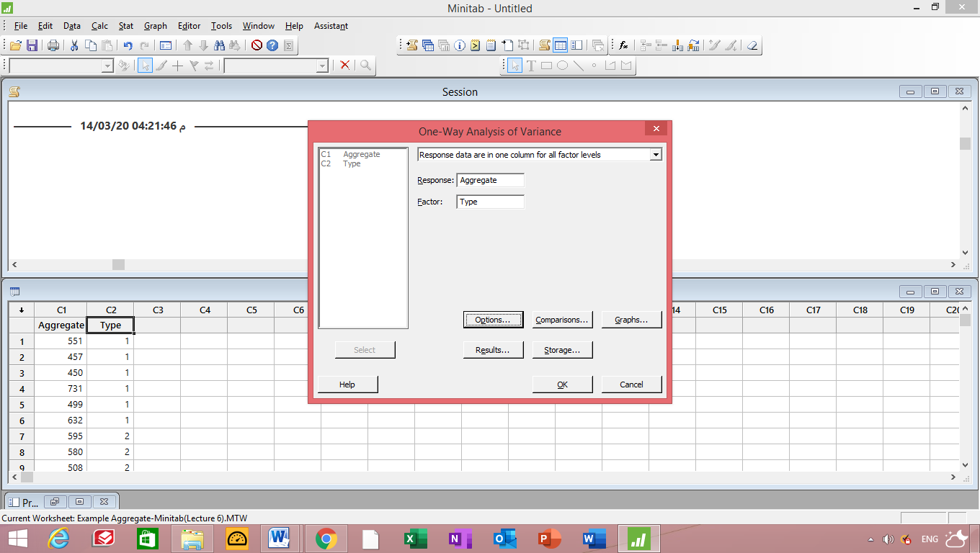

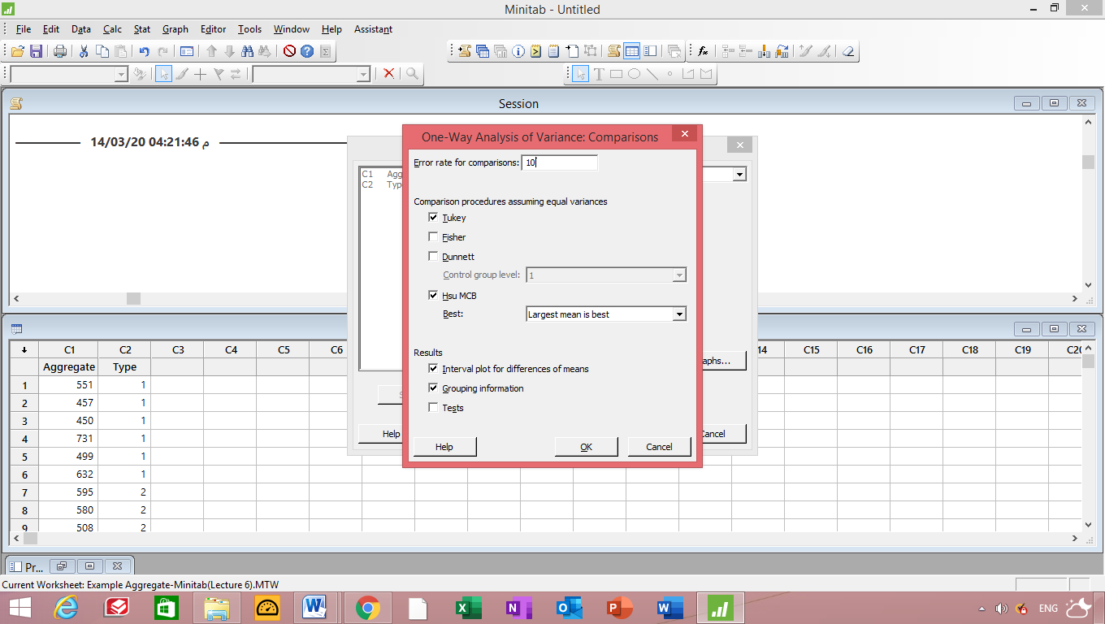

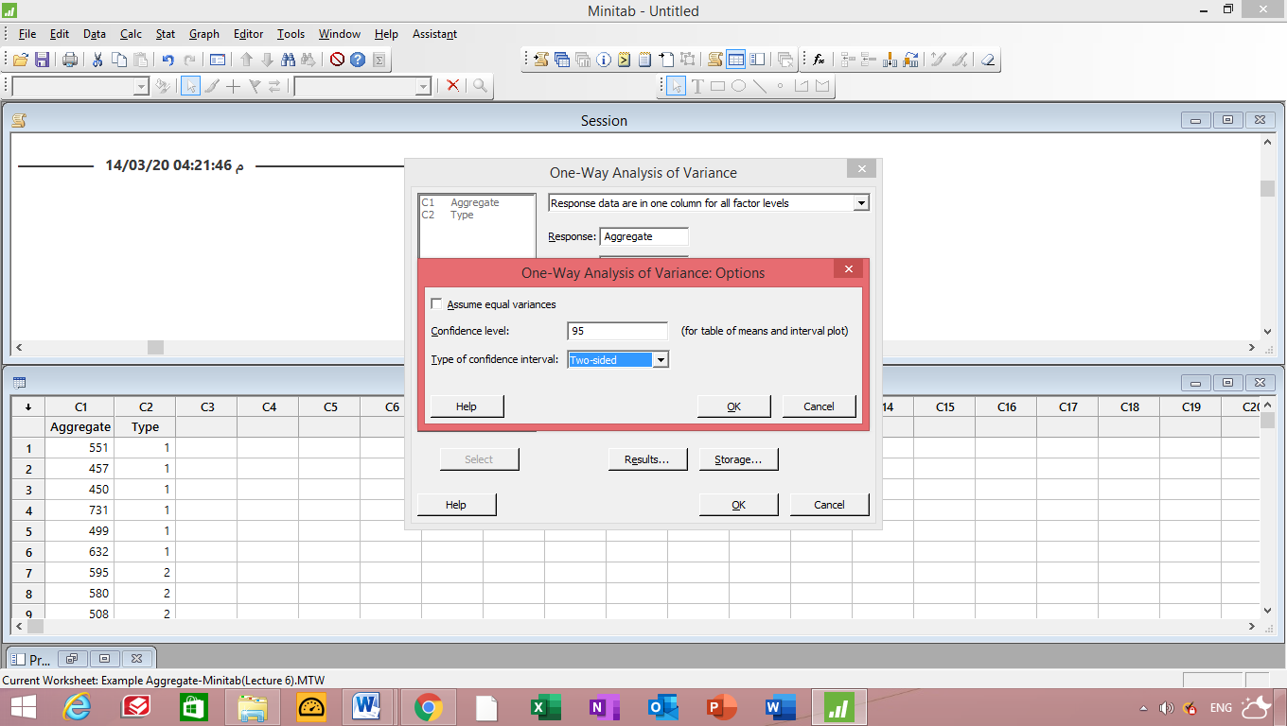

One-way ANOVA: t1, t2, t3, t4, t5
Method

Null hypothesis All means are equal
Alternative hypothesis At least one mean is different
Significance level α = 0.05

Equal variances were assumed for the analysis.

Factor Information

Factor Levels Values
Factor 5 t1, t2, t3, t4, t5

Analysis of Variance

Source DF Adj SS Adj MS F-Value P-Value
Factor 4 85356 21339 4.30 0.009
Error 25 124020 4961
Total 29 209377

Model Summary

S R-sq R-sq(adj) R-sq(pred)
70.4330 40.77% 31.29% 14.70%

Means

Factor N Mean StDev 95% CI
t1 6 553.3 110.2 (494.1, 612.6)
t2 6 569.3 48.0 (510.1, 628.6)
t3 6 610.5 59.9 (551.3, 669.7)
t4 6 465.2 57.6 (405.9, 524.4)
t5 6 610.7 58.8 (551.4, 669.9)

Pooled StDev = 70.4330

Tukey Pairwise Comparisons

Grouping Information Using the Tukey Method and 95% Confidence

Factor N Mean Grouping
t5 6 610.7 A
t3 6 610.5 A
t2 6 569.3 A B
t1 6 553.3 A B
t4 6 465.2 B

Means that do not share a letter are significantly different.

Tukey Simultaneous Tests for Differences of Means

Difference Difference SE of Adjusted
of Levels of Means Difference 95% CI T-Value P-Value
t2 - t1 16.0 40.7 (-103.3, 135.3) 0.39 0.995
t3 - t1 57.2 40.7 ( -62.2, 176.5) 1.41 0.630
t4 - t1 -88.2 40.7 (-207.5, 31.2) -2.17 0.224
t5 - t1 57.3 40.7 ( -62.0, 176.7) 1.41 0.627
t3 - t2 41.2 40.7 ( -78.2, 160.5) 1.01 0.847
t4 - t2 -104.2 40.7 (-223.5, 15.2) -2.56 0.109
t5 - t2 41.3 40.7 ( -78.0, 160.7) 1.02 0.845
t4 - t3 -145.3 40.7 (-264.7, -26.0) -3.57 0.012
t5 - t3 0.2 40.7 (-119.2, 119.5) 0.00 1.000
t5 - t4 145.5 40.7 ( 26.2, 264.8) 3.58 0.012

Individual confidence level = 99.29%

Tukey Simultaneous 95% CIs

Fisher Pairwise Comparisons

Grouping Information Using the Fisher LSD Method and 95% Confidence

Factor N Mean Grouping
t5 6 610.7 A
t3 6 610.5 A
t2 6 569.3 A
t1 6 553.3 A
t4 6 465.2 B

Means that do not share a letter are significantly different.

Fisher Individual Tests for Differences of Means

Difference Difference SE of Adjusted
of Levels of Means Difference 95% CI T-Value P-Value
t2 - t1 16.0 40.7 ( -67.8, 99.8) 0.39 0.697
t3 - t1 57.2 40.7 ( -26.6, 140.9) 1.41 0.172
t4 - t1 -88.2 40.7 (-171.9, -4.4) -2.17 0.040
t5 - t1 57.3 40.7 ( -26.4, 141.1) 1.41 0.171
t3 - t2 41.2 40.7 ( -42.6, 124.9) 1.01 0.321
t4 - t2 -104.2 40.7 (-187.9, -20.4) -2.56 0.017
t5 - t2 41.3 40.7 ( -42.4, 125.1) 1.02 0.319
t4 - t3 -145.3 40.7 (-229.1, -61.6) -3.57 0.001
t5 - t3 0.2 40.7 ( -83.6, 83.9) 0.00 0.997
t5 - t4 145.5 40.7 ( 61.7, 229.3) 3.58 0.001

Simultaneous confidence level = 73.15%
Example 8: Correlaion
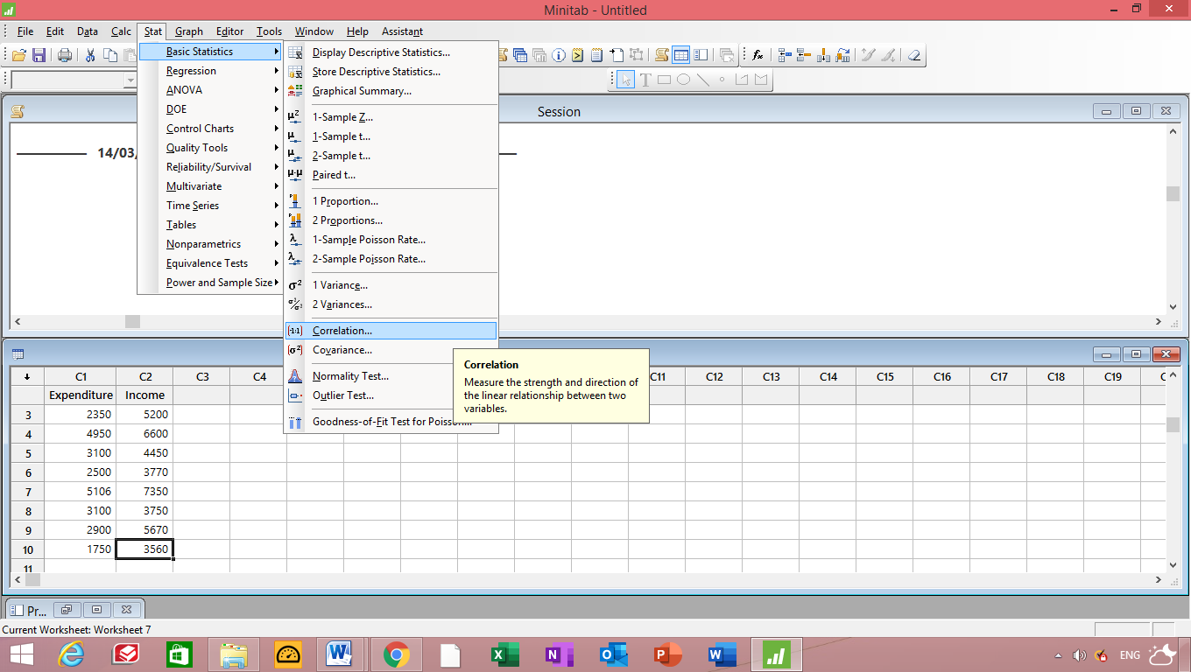

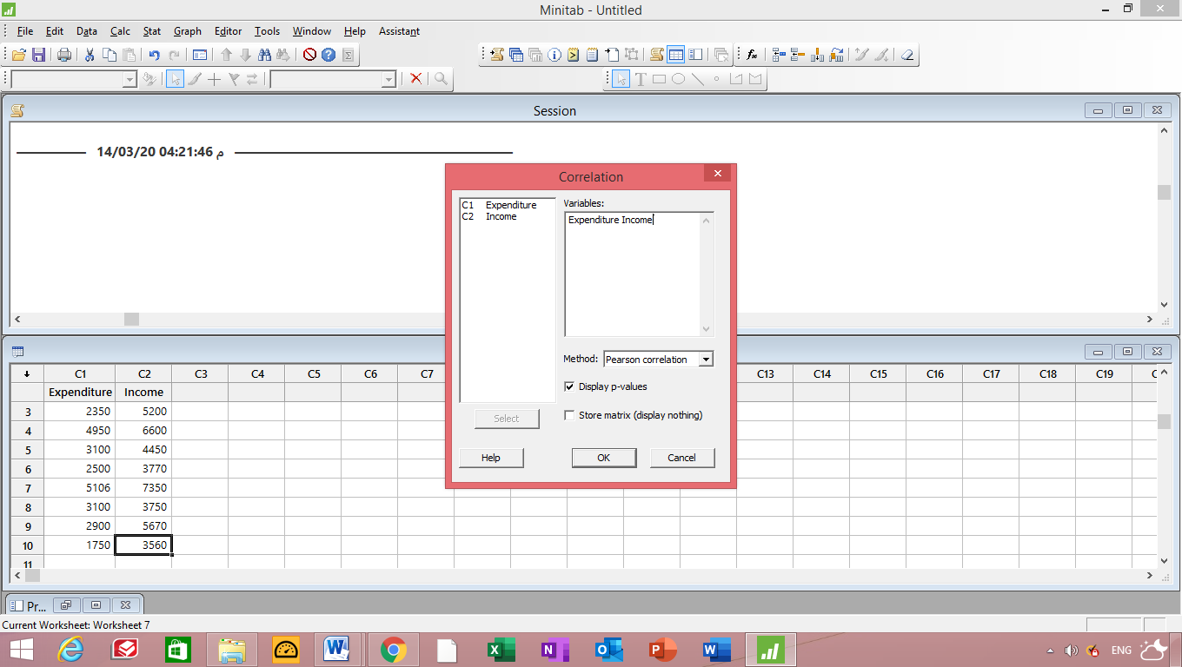

Pearson correlation of Expenditure and Income = 0.840
P-Value = 0.002

.r = 0.840 , Strong positive relation

Regression :
Regression Analysis: Expenditure versus Income

Analysis of Variance

Source DF Seq SS Contribution Adj SS Adj MS F-Value P-Value
Regression 1 7713005 70.63% 7713005 7713005 19.24 0.002
Income 1 7713005 70.63% 7713005 7713005 19.24 0.002
Error 8 3207268 29.37% 3207268 400908
Total 9 10920272 100.00%

Model Summary

S R-sq R-sq(adj) PRESS R-sq(pred)
633.173 70.63% 66.96% 4895956 55.17%

Coefficients

Term Coef SE Coef 99% CI T-Value P-Value VIF
Constant -495 839 (-3312, 2322) -0.59 0.572
Income 0.723 0.165 (0.170, 1.275) 4.39 0.002 1.00

Regression Equation

Expenditure = -495 + 0.723 Income

Correlation: Expenditure, Income

Pearson correlation of Expenditure and Income = 0.840
P-Value = 0.002

Tabulated Statistics: R, C

Using frequencies in C1

Rows: R Columns: C

High
Bechelors School Masters PhD All

F 54 60 46 41 201
49.87 50.89 50.38 49.87

M 44 40 53 57 194
48.13 49.11 48.62 48.13

All 98 100 99 98 395

Cell Contents: Count
Expected count

Pearson Chi-Square = 8.006, DF = 3, P-Value = 0.046
Likelihood Ratio Chi-Square = 8.045, DF = 3, P-Value = 0.045

