Estimation of Bilirubin
- Label 4 tubes as TT (total test), TB (total blank), DT (direct test), DB (direct blank).
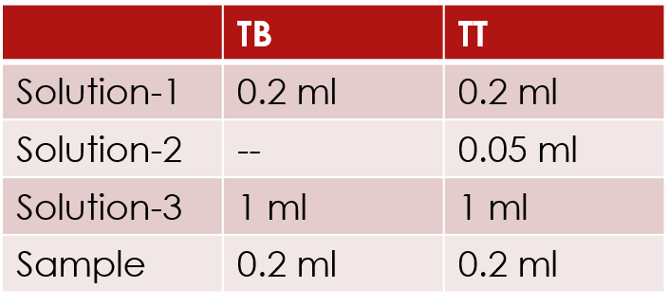
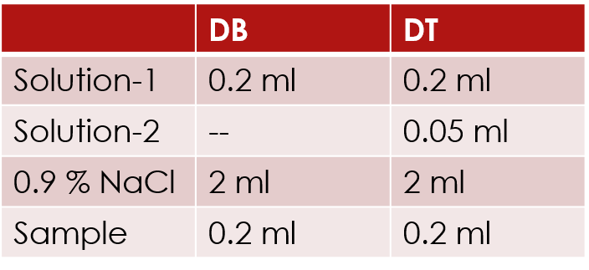
- Direct bilirubin
Mix and let stand for 15 min and read the absorbance at 578 nm against blank (A_{TB}).
- Total bilirubin

