Estimation of Bilirubin
- Label 4 tubes as TT (total test), TB ( total Blank), DT (direct test), DB (direct Blank).
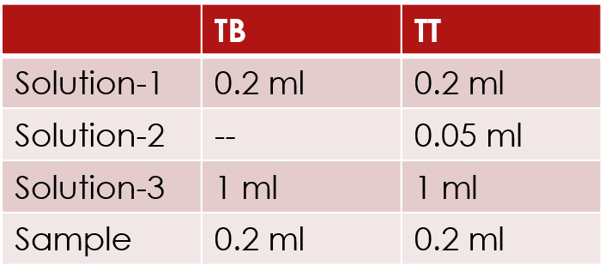
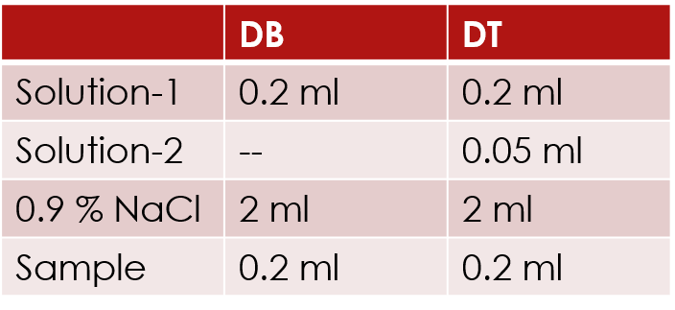
- Direct bilirubin
Mix and let stand for 15 min and read the absorbance at 546 nm against blank (ATB).
- Total bilirubin

