[BCH 322]
The Effect of Enzyme Concentration on the Rate of an Enzyme Catalyzed Reaction
Method:
- Label 7 test tubes (A, B, C, D, E, F, and G) and blank.
- Follow the following addition protocol to all the tubes:
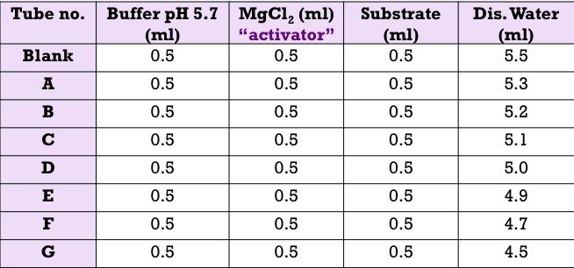
- Place all the tubes in a test rack situated in a water bath maintained at 37 ºC and let the temperature equilibrate for 5 minutes.
- Start the reaction by adding different volumes of the enzyme and stop it by adding 0.5 ml KOH as in the following table:
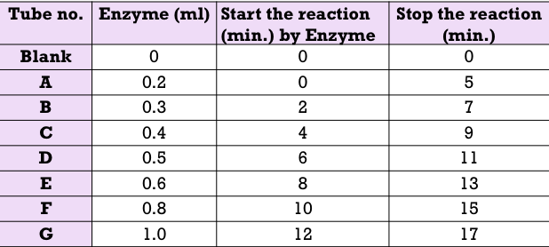

- After all the reactions have been terminated, determine the absorbance at 405 nm for each sample.

Results:
