Tutorial 5
- Trace the following:
- int main ()
{
int firstvalue = 5, secondvalue = 15;
int * p1, * p2;

p1 = &firstvalue;
p2 = &secondvalue;
*p1 = 10;
*p2 = *p1;
p1 = p2;
*p1 = 20;
cout << "firstvalue is " << firstvalue << endl;
cout << "secondvalue is " << secondvalue << endl;
return 0;
}

#include <iostream>
using namespace std;

int main ()
{
int numbers[5];
int * p;
p = numbers; *p = 10;
p++; *p = 20;
p = &numbers[2]; *p = 30;
p = numbers + 3; *p = 40;
p = numbers; *(p+4) = 50;
for (int n=0; n<5; n++)
cout << numbers[n] << ", ";
return 0;
}

#include <iostream>
using namespace std;

int main ()
{
int anArray[5] = { 9, 7, 5, 3, 1 };
cout << *(anArray+1) << endl;

system("pause");
return 0;
}

- #include <iostream>
using namespace std;
void Deposit(int s, int p);
int main()
{
int shirts = 3, pants = 5;
cout << "When starting, within main():\n";
cout << "\tShirts = " << shirts << endl;
cout << "\tPants = " << pants << endl;
Deposit(Shirts, Pants);
cout << "\n\nAfter calling Deposit(), within main():\n";
cout << "\tShirts = " << shirts << endl;
cout << "\tPants = " << pants << endl;
cout << endl;
return 0;
}

void Deposit(int s, int p)
{
s = 8;
p = 12;
cout << "Within Deposit()" << "\n\tShirts = " << s << "\n\tPants = " << p;

}

- Find the errors:
#include <iostream>
using namespace std;

int main(){
int nValue = 5;
double dValue = 7.0;

int *pnPtr = &nValue; // ….
double *pdPtr = &dValue; // ….
pnPtr = &dValue; // ……..
pdPtr = &nValue; //………

system("pause");
}

- Create a dynamic variable to the following class using the pointer then try to set the class members to 10 and ‘b’ respectively.

class MyClass
{
public:
int m_Number;
char m_Character;
};

- Write the code fragment
  - Create pointer p to an array of string a
  - How to access the first element of array using the pointer
  - How to change the pointer address to be pointed to the second element of the array a.
- Write a code fragment

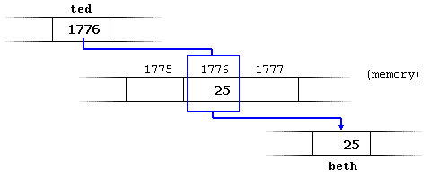

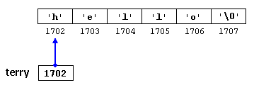

- Show the difference between the following programs:

//Program l:

include <iostream>
using namespace std;

int *pPointer;

void SomeFunction();
{
int nNumber;
nNumber = 25;

pPointer = &nNumber;
}

void main()
{
SomeFunction();

Cout<<" Value of *pPointer: "<< *pPointer;
}

//program 2
include <iostream>
using namespace std;

int *pPointer;

void SomeFunction()
{
pPointer = new int;
*pPointer = 25;
}

void main()
{
SomeFunction();
Cout<<" Value of *pPointer: "<< *pPointer;
}

