Chapter 2
We assume that the normal error regression model is applicable. This model is:
$$Y_{i}=β_{0}+β_{1}X_{i}+ε_{i}$$
where:
$β_{0}$ and $β_{1}$, are parameters
$X_{i}$ are known constants
$ε_{i}$ are independent $N (0, σ^{2})$
$$E\left(Y_{i}\right)=β_{0}+β_{1}X_{i}$$
Sampling Distribution of $\hat{β_{1}}$
$$\hat{β_{1}}=b_{1}=\sum_{i=1}^{n}{\frac{\left(X_{i}-\overline{X}\right)\left(Y_{i}-\overline{Y}\right)}{\sum_{i=1}^{n}{{\left(X_{i}-\overline{X}\right)}^{2}}}}$$
$$E\left(\hat{β_{1}}\right)=β_{1}$$
$$σ^{2}\left(\hat{β_{1}}\right)=\frac{σ^{2}}{\sum_{i=1}^{n}{{\left(X_{i}-\overline{X}\right)}^{2}}}$$
$$s^{2}\left(\hat{β_{1}}\right)=\frac{MSE}{\sum_{i=1}^{n}{{\left(X_{i}-\overline{X}\right)}^{2}}}$$

$$\frac{b_{1}-β_{1}}{s\left(b_{1}\right)}\sim t_{\left(n-2\right)}$$
Confidence Interval for $β_{1}$
$$P\left[b_{1}-t_{\left(1-\frac{α}{2},n-2\right)}s\left(b_{1}\right)≤β_{1}≤b_{1}+t_{\left(1-α/2,n-2\right)}s\left(b_{1}\right)\right]=1-α$$
C.I $\left(1-α\right)\%$ for $β_{1}$
$$b_{1}-t_{\left(1-\frac{α}{2},n-2\right)}s\left(b_{1}\right)≤β_{1}≤b_{1}+t_{\left(1-α/2,n-2\right)}s\left(b_{1}\right)$$

Tests Concerning $β_{1}$
1. Hypothesis
$$H_{0}:β_{1}=β_{10}$$  $$H_{1}:β_{1}≠β_{10}$$ | $$H_{0}:β_{1}=β_{10}$$  $$H_{1}:β_{1}>β_{10}$$ | $$H_{0}:β_{1}=β_{10}$$  $$H_{1}:β_{1}<β_{10}$$
2. Test statistic
$$T_{0}=\frac{b_{1}-β_{10}}{s\left(b_{1}\right)}$$
3. Decision: Reject $H_{0}$ if
$$\left|T_{0}\right|>t_{\left(1-\frac{α}{2},n-2\right)}$$ | $$T_{0}>t_{\left(1-α,n-2\right)}$$ |  | $$T_{0}<t_{\left(α,n-2\right)}$$
P-value: Reject $H_{0}$ if $p-value<α$
p-value=$2P\left(t_{\left(n-2\right)}>\left|T_{0}\right|\right)$ | $$p-value=P\left(t_{\left(n-2\right)}>T_{0}\right)$$ |  | $$p-value=P\left(t_{\left(n-2\right)}<T_{0}\right)$$

Page 114
Q2.4. Refer to Grade point average Problem 1.19.
a. Obtain a 99 percent confidence interval for $β_{1}$. Interpret your confidence interval. Does it include zero? Why might the director of admissions be interested in whether the confidence interval includes zero?

Solution:
By using Minitab:
$$Stat→Regression→Regression→Fit Regression Mode$$
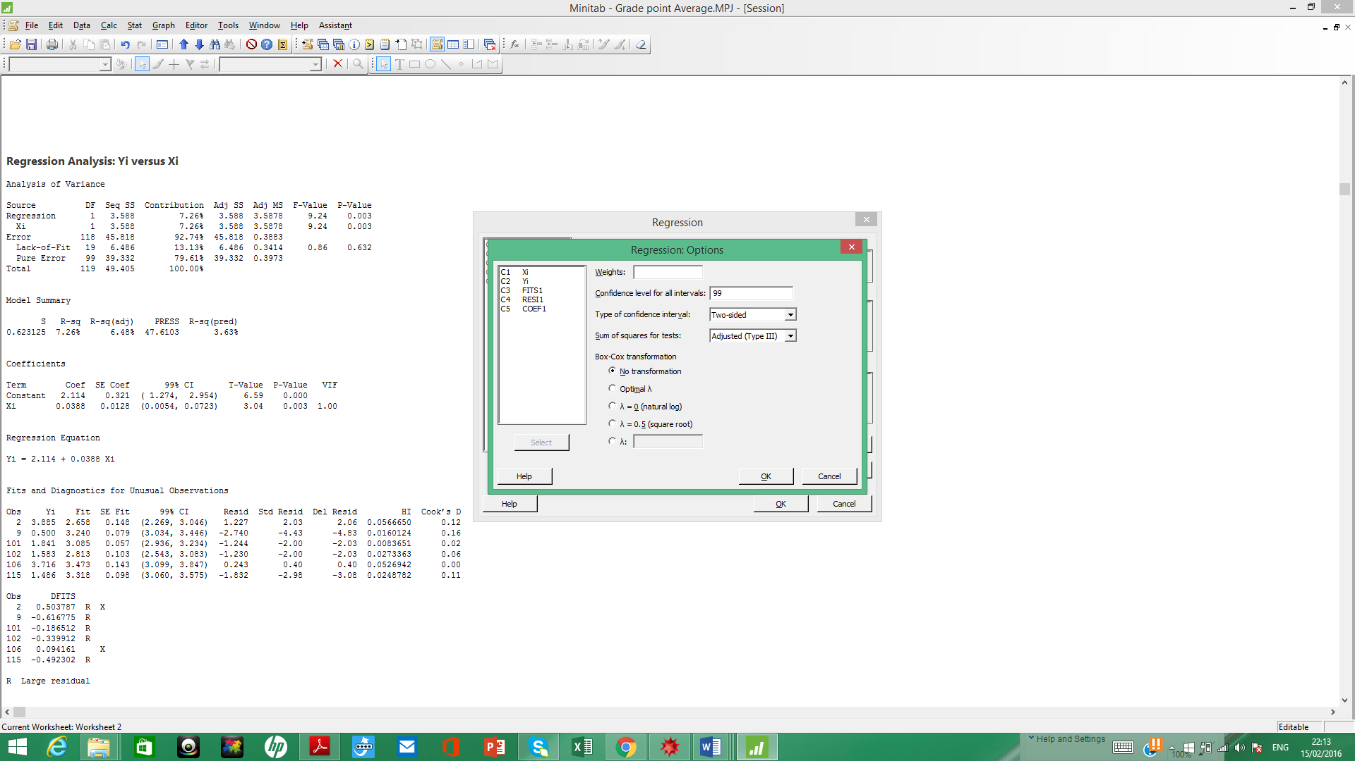

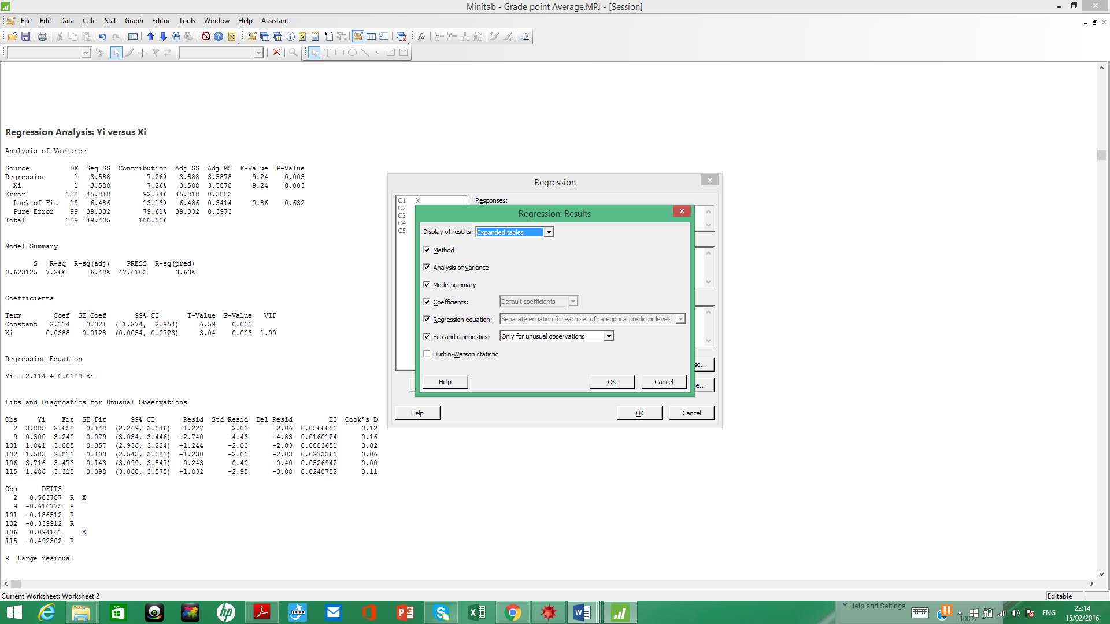
Regression Analysis: Yi versus Xi

Analysis of Variance

Source DF Seq SS Contribution Adj SS Adj MS F-Value P-Value
Regression 1 3.588 7.26% 3.588 3.5878 9.24 0.003
Xi 1 3.588 7.26% 3.588 3.5878 9.24 0.003
Error n-2=118 45.818 92.74% SSE=45.818 MSE=0.3883
Lack-of-Fit 19 6.486 13.13% 6.486 0.3414 0.86 0.632
Pure Error 99 39.332 79.61% 39.332 0.3973
Total 119 49.405 100.00%

Model Summary

S R-sq R-sq(adj) PRESS R-sq(pred)
0.623125 7.26% 6.48% 47.6103 3.63%

Coefficients

Term Coef SE Coef 99% CI T-Value P-Value VIF
Constant 2.114 0.321 ( 1.274, 2.954) 6.59 0.000
Xi 0.0388 0.0128 (0.0054, 0.0723) 3.04 0.003 1.00

Regression Equation

Yi = 2.114 + 0.0388 Xi

99% C.I for $β_{1}$: $b_{1}-t_{\left(1-\frac{α}{2},n-2\right)}s\left(b_{1}\right)≤β_{1}≤b_{1}+t_{\left(1-α/2,n-2\right)}s\left(b_{1}\right)$
$$0.0054≤β_{1}≤0.0723$$

Interpret your confidence interval. Does it include zero? No
Why might the director of admissions be interested in whether the confidence interval includes zero?
If the C.I of $β_{1}$ include zero, then $β_{1}$ can tack zero and $β_{1}=0$
b. Test, using the test statistic t*, whether or not a linear association exists between student's ACT score (X) and GPA at the end of the freshman year (Y). Use a level of significance of 0.01 State the alternatives, decision rule, and conclusion.
$$α=0.01$$
1. Hypothesis
$$H_{0}:β_{1}=0$$
$$H_{1}:β_{1}≠0$$
2. Test statistic
$$T_{0}=\frac{b_{1}-β_{10}}{s\left(b_{1}\right)}=\frac{b_{1}}{s\left(b_{1}\right)}=\frac{0.0388}{0.0128}=3.04$$
3. Decision: Reject $H_{0}$ if $\left|T_{0}\right|>t_{\left(1-\frac{α}{2},n-2\right)}$, $3.04>t_{\left(0.995,118\right)}=$2.61814

Then reject $H_{0}$

c. What is the P-value of your test in part (b)? How does it support the conclusion reached in part (b)?
p-value= 0.003<0.01, then we reject $H_{0}$.

Q2.5. Refer to Copier maintenance Problem 1.20.

$$n=45, \sum_{i=1}^{n=45}{X_{i}}=230, \sum_{i=1}^{45}{Y_{i}}=3432, \sum_{i=1}^{45}{X_{i}^{2}}=1516, \sum_{i=1}^{45}{X_{i}Y_{i}}=22660$$
$$SSE=3416.377$$

a. Estimate the change in the mean service time when the number of copiers serviced increases by one. Use a 90 percent confidence interval. Interpret your confidence interval.
90% C.I for $β_{1}$: $b_{1}-t_{\left(1-\frac{α}{2},n-2\right)}s\left(b_{1}\right)≤β_{1}≤b_{1}+t_{\left(1-α/2,n-2\right)}s\left(b_{1}\right)$
$$α=1-0.9=0.1$$
$$b_{1}=\sum_{i=1}^{n}{\frac{\left(X_{i}-\overline{X}\right)\left(Y_{i}-\overline{Y}\right)}{\sum_{i=1}^{n}{{\left(X_{i}-\overline{X}\right)}^{2}}}}=\sum_{i=1}^{n}{\frac{\left(X_{i}Y_{i}-\overline{X}Y_{i}-X_{i}\overline{Y}+\overline{X}\overline{Y}\right)}{\sum_{i=1}^{n}{\left({X_{i}}^{2}-2\overline{X}X_{i}+{\overline{X}}^{2}\right)}}}=\frac{\sum_{i=1}^{n}{X_{i}Y_{i}}-n\overline{X}\overline{Y}}{\sum_{i=1}^{n}{{X_{i}}^{2}}-n{\overline{X}}^{2}}=\frac{22660-45*5.1111*76.2667}{1516-45*{5.1111}^{2}}=15.035$$
$$s^{2}\left(b_{1}\right)=\frac{MSE}{\sum_{i=1}^{n}{{\left(X_{i}-\overline{X}\right)}^{2}}}=\frac{3416.377/(45-2)}{1516-45*{5.1111}^{2}}=0.23337$$
$$s\left(b_{1}\right)=\sqrt{0.2337}=0.48308$$

$$t_{\left(1-\frac{α}{2},n-2\right)}=t_{\left(0.95,43\right)}=1.68107$$
$$b_{1}-t_{\left(1-\frac{α}{2},n-2\right)}s\left(b_{1}\right)=15.035-1.68107*0.48308=14.222$$
$$b_{1}+t_{\left(1-\frac{α}{2},n-2\right)}s\left(b_{1}\right)=15.035+1.68107*0.48308=15.84709$$
$$14.222≤β_{1}≤15.847$$

b. Conduct a t test to determine whether or not there is a linear association between X and Y here; control the $α$ a risk at 0.01. State the alternatives, decision rule, and conclusion. What is the P-value of your test?
$$α=0.01$$
1. Hypothesis
$$H_{0}:β_{1}=0$$
$$H_{1}:β_{1}≠0$$
2. Test statistic
$$T_{0}=\frac{b_{1}-β_{10}}{s\left(b_{1}\right)}=\frac{b_{1}}{s\left(b_{1}\right)}=\frac{15.035}{0.48308}=31.123$$
3. Decision: Reject $H_{0}$ if $\left|T_{0}\right|>t_{\left(1-\frac{α}{2},n-2\right)}$, $31.123>t_{\left(0.995,43\right)}=2.695$
Then reject $H_{0}$
p-value=$2P\left(t_{\left(n-2\right)}>\left|T_{0}\right|\right)=2\left(1-P\left(t_{\left(43\right)}<31.123\right)\right)=2\left(1-1\right)$
$0.00<0.01$, then we reject $H_{0}$.

c. Are your results in parts (a) and (b) consistent? Explain.
Yes, the C.I of $β_{1}$ does not include zero, and we reject $H_{0}$.

d. The manufacturer has suggested that the mean required time should not increase by more than 14 minutes for each additional copier that is serviced on a service call. Conduct a test to decide whether this standard is being satisfied by Tri-City. Control the risk of a Type I error at 0.05. State the alternatives, decision rule, and conclusion. What is the P-value of the test?

$$α=0.05$$
1. Hypothesis
$$H_{0}:β_{1}≤14$$
$$H_{1}:β_{1}>14$$
2. Test statistic
$$T_{0}=\frac{b_{1}-β_{10}}{s\left(b_{1}\right)}=\frac{b_{1}-14}{s\left(b_{1}\right)}=\frac{15.035-14}{0.48308}=2.143$$
3. Decision: Reject $H_{0}$ if $T_{0}>t_{\left(1-α,n-2\right)}$, $2.143>t_{\left(0.95,43\right)}=1.861$
Then reject $H_{0}$
p-value=$P\left(t_{\left(n-2\right)}>T_{0}\right)=\left(1-P\left(t_{\left(43\right)}<2.143\right)\right)=\left(1-0.981\right)=0.019<0.05$
, then we reject $H_{0}$.

Q2.6. Refer to Airfreight breakage Problem 1.21.
$\overline{X}=1, \overline{Y}=14.2$, $\sum_{i=1}^{n=10}{\left(X_{i}-\overline{X}\right)}\left(Y_{i}-\overline{Y}\right)=40$
$\sum_{i=1}^{10}{{\left(X_{i}-\overline{X}\right)}^{2}}=10$, $MSE=2.2$

a. Estimate $β_{1}$ with a 95 percent confidence interval. Interpret your interval estimate.
95% C.I for $β_{1}$: $b_{1}-t_{\left(1-\frac{α}{2},n-2\right)}s\left(b_{1}\right)≤β_{1}≤b_{1}+t_{\left(1-α/2,n-2\right)}s\left(b_{1}\right)$
$$α=1-0.95=0.05$$
$$b_{1}=\hat{β_{1}}=\sum_{i=1}^{n=120}{\frac{\left(X_{i}-\overline{X}\right)\left(Y_{i}-\overline{Y}\right)}{\sum_{i=1}^{n=120}{{\left(X_{i}-\overline{X}\right)}^{2}}}}=4$$

$$s^{2}\left(b_{1}\right)=\frac{MSE}{\sum_{i=1}^{n}{{\left(X_{i}-\overline{X}\right)}^{2}}}=\frac{2.2}{10}=0.22$$
$$s\left(b_{1}\right)=\sqrt{0.22}=0.469$$

$$t_{\left(1-\frac{α}{2},n-2\right)}=t_{\left(0.975,8\right)}=2.306$$
$$b_{1}-t_{\left(1-\frac{α}{2},n-2\right)}s\left(b_{1}\right)=4-2.306*0.469=2.918$$
$$b_{1}+t_{\left(1-\frac{α}{2},n-2\right)}s\left(b_{1}\right)=4+2.306*0.469=5.081$$
$$2.918≤β_{1}≤5.081$$

b. Conduct a t test to decide whether or not there is a linear association between number of times a carton is transferred (X) and number of broken ampules (Y). Use a level of significance of 0.05. State the alternatives, decision rule, and conclusion. What is the P-value of the test?
$$α=0.05$$
1. Hypothesis
$$H_{0}:β_{1}=0$$
$$H_{1}:β_{1}≠0$$
2. Test statistic
$$T_{0}=\frac{b_{1}-β_{10}}{s\left(b_{1}\right)}=\frac{b_{1}}{s\left(b_{1}\right)}=\frac{4}{0.469}=8.528$$
3. Decision: Reject $H_{0}$ if $\left|T_{0}\right|>t_{\left(1-\frac{α}{2},n-2\right)}$, $8.528>t_{\left(0.975,8\right)}=2.308$
Then reject $H_{0}$
p-value=$2P\left(t_{\left(n-2\right)}>\left|T_{0}\right|\right)=2\left(1-P\left(t_{\left(8\right)}<8.528\right)\right)=2\left(1-0.9999\right)$
$0.0002<0.05$, then we reject $H_{0}$.

Analysis of Variance

Source DF Seq SS Contribution Adj SS Adj MS F-Value P-Value
Regression 1 160.000 90.09% 160.000 160.000 72.73 0.000
Xi 1 160.000 90.09% 160.000 160.000 72.73 0.000
Error 8 17.600 9.91% 17.600 2.200
Lack-of-Fit 2 0.933 0.53% 0.933 0.467 0.17 0.849
Pure Error 6 16.667 9.38% 16.667 2.778
Total 9 177.600 100.00%

Model Summary

S R-sq R-sq(adj) PRESS R-sq(pred)
1.48324 90.09% 88.85% 25.8529 85.44%

Coefficients

Term Coef SE Coef 95% CI T-Value P-Value VIF
Constant 10.200 0.663 (8.670, 11.730) 15.38 0.000
Xi 4.000 0.469 (2.918, 5.082) 8.53 0.000 1.00

Regression Equation

Yi = 10.200 + 4.000 Xi

H.W:
Q2.7 Refer to Plastic hardness Problem 1.22.
a. Estimate the change in the mean hardness when the elapsed time increases by one hour. Use a 99 percent confidence interval. Interpret your interval estimate.
b. The plastic manufacturer has stated that the mean hardness should increase by 2 Brinell units per hour. Conduct a two-sided test to decide whether this standard is being satisfied; use $α=0.01$. State the alternatives, decision rule, and conclusion. What is the P-value of the test?

