CHAPTER 16
Speech acts
- Introduction
According to an American language philosopher J.R. Searle speaking a language is performing speech acts, acts such as making statements, giving commands, asking questions or making promises. Searle states that all linguistic communication involves linguistic (speech) acts. In other words, speech acts are the basic or minimal units of linguistic communication. The problem of speech acts was pioneered by a British language philosopher J.L. Austin. His observations were delivered at Harvard University in 1955 as the William James Lectures which were posthumously published in his famous book How to Do Things with Words. It is Austin who introduces basic terms and areas to study and distinguishes locutionary, illocutionary and perlocutionary acts. As Lyons puts it: Austin’s main purpose was to challenge the view that the only philosophically (and also linguistically) interesting function of language was that of making true or false statements.(Lyons, 173). Austin proves that there are undoubtedly more functions language can exercise. The theory of speech acts thus comes to being and Austin’s research becomes a cornerstone for his followers.
It is Austin who introduces basic terms and areas to study and he also comes up with a new category of utterances – the performatives.
Performatives are historically the first speech acts to be examined within the theory of speech acts. Austin defines a performative as an utterance which contains a special type of verb (a performative verb) by force of which it performs an action. In other words, in using a performative, a person is not just saying something but is actually doing something (Wardhaugh: 1992: 283). Austin further states that a performative, unlike a constative, cannot be true or false (it can only be felicitous or infelicitous) and that it does not describe, report or constate anything. He also claims that from the grammatical point of view, a performative is a first person indicative active sentence in the simple present tense. This criterion is ambiguous though and that is why, in order to distinguish the performative use from other possible uses of first person indicative active pattern, Austin introduces a hereby test since he finds out that performative verbs only can collocate with this adverb.
1. a. I hereby resign from the post of the President of the Czech Republic.
b. I hereby get up at seven o’clock in the morning every day.

While the first sentence would make sense under specific conditions, uttering of the second would be rather strange. From this it follows that (1a) is a performative, (1b) is not. Having defined performatives, Austin then draws a basic distinction between them. He distinguishes two general groups - explicit and implicit performatives.

2. Explicit and implicit performatives

An explicit performative is one in which the utterance inscription contains an expression that makes explicit what kind of act is being performed (Lyons, 1981: 175). An explicit performative includes a performative verb and mainly therefore, as Thomas (1995: 47) claims, it can be seen to be a mechanism which allows the speaker to remove any possibility of misunderstanding the force behind an utterance.
2. a. I order you to leave.
b. Will you leave?
In the first example, the speaker utters a sentence with an imperative proposition and with the purpose to make the hearer leave. The speaker uses a performative verb and thus completely avoids any possible misunderstanding. The message is clear here.
The second utterance (2b) is rather ambiguous without an appropriate context. It can be understood in two different ways: it can be either taken literally, as a yes/no question, or non-literally as an indirect request or even command to leave. The hearer can become confused and he does not always have to decode the speaker’s intention successfully. (2b) is an implicit or primary performative. Working on Lyon’s assumption, this is non-explicit, in terms of the definition given above, in that there is no expression in the utterance-inscription itself which makes explicit the fact that this is to be taken as a request rather than a yes/no question (Lyons, 1981: 176).
The explicit and implicit versions are not equivalent. Uttering the explicit performative version of a command has much more serious impact than uttering the implicit version (Yule, 1996: 52). Thomas adds to this that people therefore often avoid using an explicit performative since in many circumstances it seems to imply an unequal power relationship or particular set of rights on the part of the speaker (1995: 48).
Austin later realizes that the category of performatives and constatives is not sufficient and thus, in an attempt to replace it by a general theory of speech acts, he ‘isolates three basic senses in which in saying something one is doing something, and hence three kinds of acts that are simultaneously performed’ (Levinson: 236): the locutionary, illocutioanary and perlocutionary acts.

3. The locutionary, illocutionary and perlocutionary acts

The locutionary, illocutionary and perlocutionary acts are, in fact, three basic components with the help of which a speech act is formed. Leech (Leech, 1983: 199) briefly defines them like this:
locutionary act: performing an act of saying something
illocutionary act: performing an act in saying something
perlocutionary act: performing an act by saying something
The locutionary act can be viewed as a mere uttering of some words in certain language, while the illocutionary and perlocutionary acts convey a more complicated message for the hearer. An illocutionary act communicates the speaker’s intentions behind the locution and a perlocutionary act reveals the effect the speaker wants to exercise over the hearer.
This can be demonstrated on a simple example:
4. Would you close the door, please?
The surface form, and also the locutionary act, of this utterance is a question with a clear content (Close the door.) The illocutionary act conveys a request from the part of the speaker and the perlocutionary act expresses the speaker’s desire that the hearer should go and close the door.
But the individual elements cannot be always separated that easily. Bach and Harnish say that they are intimately related in a large measure (Bach and Harnish, 1979: 3). However, the focus of this chapter will be on the issue of illocutionary speech acts.

4. Illocutionary acts
Illocutionary acts are considered the core of the theory of speech acts. As already suggested above, an illocutionary act is the action performed by the speaker in producing a given utterance. The illocutionary act is closely connected with speaker’s intentions, e.g. stating, questioning, promising, requesting, giving commands, threatening and many others. As Yule (Yule, 1996: 48) claims, the illocutionary act is thus performed via the communicative force of an utterance which is also generally known as illocutionary force of the utterance.
5. Classifying speech acts
Performative verbs fall fairly naturally under a small number of headings. Consider, for example, the following:

Assertives
Assertives commit the speaker to the truth of the expressed proposition:
state, suggest, claim, report, warn (that)

Directives
Directives have the intention of eliciting some sort of action on the part of the hearer:
order, command, request, beg, beseech, advise (to), warn (to), recommend, ask, ask (to)

Commissives
Commissives commit the speaker to some future action:
promise, vow, offer, undertake, contract, threaten

Expressives
Expressives make known the speaker's psychological attitude to a presupposed state of affairs:
thank, congratulate, condole, praise, blame, forgive, pardon

Declaratives
Declaratives are said to bring about a change in reality: that is to say, the world
is in some way no longer the same after they have been said. The following examples are illustrative:
resign, dismiss, divorce (in Islam), christen, name, open (e.g. an exhibition),
excommunicate, sentence (in court), consecrate, bid (at auction), declare (at
cricket)

6. Conditions for the successful performance of speech acts
There are normally contextual conditions which must be fulfilled before a speech act can be said to have been properly performed. These are usually called happiness conditions or felicity conditions. Some of these are of course conditions on any sort of linguistic communication, such as the fact that speaker and hearer understand one another (usually speak the same language),
can hear one another, and so on.
Preparatory conditions
Preparatory conditions do not define the speech act, but are necessary in the sense that if they do not hold, the act has not been carried out (it is said to have misfired). In the case of declarative speech acts, the person performing the act must have authority to do it, and must do it in appropriate circum stances and with appropriate actions. For instance, it is not enough for someone to break a bottle of champagne on the bows of a ship, and say I name this ship Venus, for the ship either to acquire an official name, or to change its name. A proper ceremony must be enacted, with officially recognized participants. The same is true of christening a baby. Even in the case of resigning from a job or position, just saying the words / resign, at breakfast, say, does not constitute a resignation: there are proper ways of resigning and channels for communicating such a decision.

Sincerity conditions
For sincerity conditions to be fulfilled, the person performing the act must have appropriate beliefs or feelings. For instance, in performing an act of asserting, the speaker must believe the proposition they are expressing; when thanking someone, one ought to have feelings of gratitude; when making a promise, one should sincerely intend to carry it out, and so on. If the sincerity conditions are not met, the act is actually performed, but there is said to be an abuse.

Essential conditions
Essential conditions basically define the act being carried out. Thus, for a promise, the speaker must intend his utterance to put him under an obligation to carry out the act which corresponds to its propositional content. For a request, the speaker must intend that the utterance count as an attempt to get the hearer to do what is requested; for a statement, the hearer must intend that the utterance count as a guarantee of the truth of the statement; for a question, the hearer must intend that the utterance count as an attempt to elicit the appropriate answer from the hearer, and so on. If the essential conditions are not met, the act has not really been carried out.

7. Direct and indirect speech acts
Apart from distinguishing speech acts according to their general function, they can also be distinguished with regard to their structure. Austin argued that what is said (the locutionary act) does not determine the illocutionary act(s) being performed. Thus, we can perform a speech act directly or indirectly, by way of performing another speech act. For example, we can make a request or give permission by way of making a statement (e.g. by uttering I am getting thirsty or It doesn't matter to me), and we can make a statement or give an order by way of asking a question (e.g. such as Will the sun rise tomorrow? or Can you clean up your room? When an illocutionary act is performed indirectly, it is performed through the use of another which is direct.

How to make a direct speech act
- Use the typical association between sentence forms and speech acts.
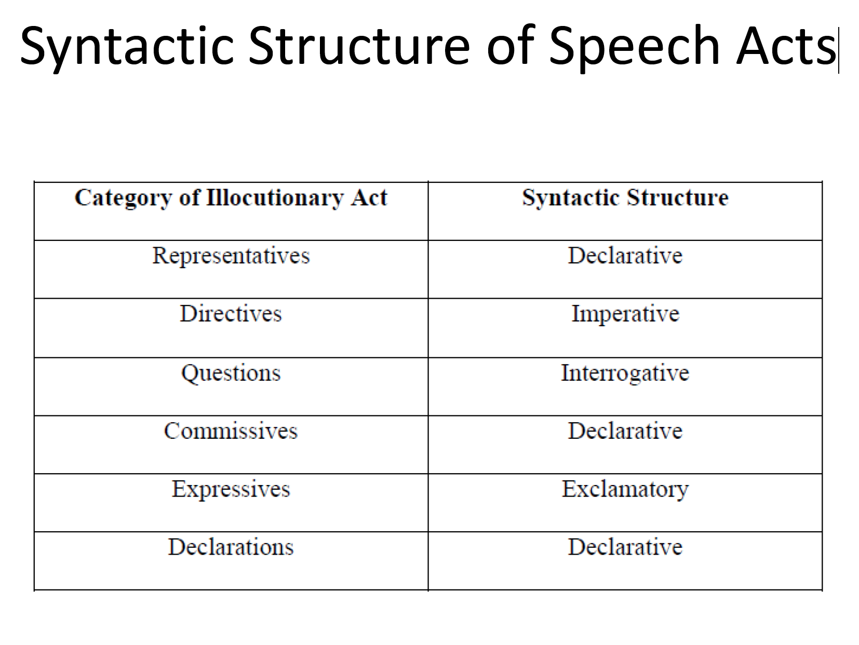
The following are illustrative examples.
 | declarative | interrogative | imperative
assertion | He washed the dishes
question |  | Who washed the dishes?
order/request |  |  | Do the dishes (please)!
2. Use the performative verbs performatively.
speech act | verb that names the speech act | example
assertion | assert | I assert that he washes the dishes.
question | ask | I ask who will wash the dishes.
order | order | I order you to wash the dishes.
request | request | I request that you wash the dishes.
promise | promise | I promise that I’ll wash the dishes.
advice | advise | I advise you to wash the dishes.
You see, whenever there is a direct relationship between the function of a speech act and its structural form, we have a direct speech act.

How to make an indirect speech act
When there is no direct relationship between a structure and a form but rather an indirect one, the speech act is considered indirect.
 | declarative | interrogative | imperative
assertion |  | 1. Is the pope Catholic?  2. Is ice old?
question | 1. I want to know who washed the dishes.  2. I do not know who washed the dishes. |  | 1. Why don’t you leave?
request | 1. The dishes are not washed yet.  2. I would like for you to wash the dishes. | 1. Can you wash the dishes?  2. Would you mind washing the dishes?

