Ch 11
11.4
Use the following contingency table:
 | A | B | Total
1 | 20  25 | 30  25 | 50
2 | 30  25 | 20  25 | 50
Total | 50 | 50 | 100

- Compute the expected frequency for each cell?
$$f_{e}=\frac{rowtotal X columntotal}{n}$$

$f_{11}=\frac{50 X 50}{100}$ $=$ 25 $f_{12}=\frac{50 X 50}{100}=25$
$f_{21}=\frac{50 X 50}{100} {=25 f}_{22}=\frac{50 X 50}{100}$ $=$ 25
$$\sum{f_{o =20+30+30+20=100}}$$
$$\sum{f_{e =25+25+25+25=100}}$$
- Compute${}_{stat}-$ Is it significant at α = 0.05?
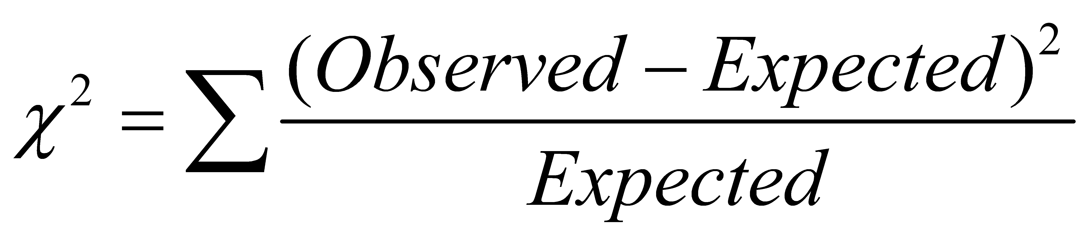
$=\frac{(20-25 )²}{25}+\frac{(30-25 )²}{25}+\frac{(30-25 )²}{25}+ \frac{(20-25 )²}{25}=4$
*${}_{α},\left(r-1\right)\left(c-1\right)$= 3.841

11.5
An online survey of 1,000 adults asked, “What do you buy from a mobile device?” The results indicated that 61% of the females said clothes as compared to 39% of the males. (Data extracted from _Ebates.com 2014 Mobile Shopping Survey: Nearly Half of Americans Shop from a Mobile Device_). The sample sizes of males and females were not provided. Suppose that the results were as shown in the following table:

 | GENDER
 | Male | Female | Total
Yes | 195  250 | 305  250 | 500
No | 305  250 | 195  250 | 500
Total | 500 | 500 | 1000

Is there evidence of a significant difference between the portion of males and females who say they buy clothing from their mobile device at the 0.01 level of significance?

Solution:
Step 1: state the hypothesis:
$H_{0}: There is no different between the proportion of male and females.$
$H_{01}: There is different between the proportion of male and females.$

Step2: Select the level of significance and critical value( α = 0.01):
${}_{α},\left(r-1\right)\left(c-1\right)={}_{0.01},\left(2-1\right)\left(2-1\right)=6.635$

Step 3: Find the appropriate test statistic.
$$=\frac{(195-250 )²}{250}+\frac{(305-250)²}{250}+\frac{(305-250)²}{250}+ \frac{(195-250 )²}{250} =48.4$$
Step 4: State the decision rule
Reject $H_{0}$ if ${}_{stat} >{}_{α}$

Step 5: Decision Reject $H_{0}$
$$There is different between the proportion of male and females$$

11.12
Use the following contingency table:
 | A | B | C | Total
1 | 10  20 | 30  30 | 50  40 | 90
2 | 40  30 | 45  45 | 50  60 | 135
Total | 50 | 75 | 100 | 225

a. Compute the expected frequency for each cell.
$$f_{e}=\frac{rowtotal X columntotal}{n}$$

$f_{11}=\frac{90 X 50}{225}$ $=$ 20 $f_{12}=\frac{90 X 75}{225}=30 f_{13}=\frac{90 X 100}{225}=40$
$f_{21}=\frac{135 X 50}{225} {=30 f}_{22}=\frac{135 X 75}{225}=$ 45${ f}_{23}=\frac{135 X 100}{225}=$ 60
$$\sum{f_{o =10+30+50+40+45+50 =225}}$$
$$\sum{f_{e =20+30+40+30+45+60+225}}$$
b. Compute ${}_{stat}$. Is it significant at α = 0.05?
$${}_{stat}=\frac{(10-20 )²}{20}+\frac{(30-30)²}{30}+\frac{(50-40)²}{40}+ \frac{(40-30 )²}{30}+ \frac{(45-45 )²}{45}+ \frac{(50-60 )²}{60} =12.5$$
$${}_{α},\left(r-1\right)\left(c-1\right)={}_{0.05},\left(2-1\right)\left(3-1\right)=5.991$$
${}_{stat}$ > ${}_{α}$ Then the result is deemed significsnt

11.25
Where people look for news is different for various age groups. A study indicated where different age groups primarily get their news:
 | AGE GROUP
MEDIA | Under 36 | 36-50 | 50+ | Total
Local TV | 109 | 118 | 138 | 365
National TV | 73 | 105 | 125 | 303
Radio | 77 | 98 | 111 | 286
Local newspaper | 52 | 78 | 101 | 231
Internet | 93 | 87 | 75 | 255
Total | 404 | 486 | 550 | 1440

At the 0.05 level of significance, is there evidence of a significant relationship between the age group and where people primarily get their news? If so, explain the relationship.
Step 1: state the hypothesis:
$H_{0}: The Age Group and Media are independent .$
$H_{01}: The Age Group and Media are dependent.$
Step2: the level of significance ( α = 0.05):
${}_{α},\left(r-1\right)\left(c-1\right)={}_{0.05},\left(3-1\right)\left(5-1\right)=15.507$
Degree of freedom = (2)(4)=8
Step 3: Compute the expected frequency for each cell.
$$f_{e}=\frac{rowtotal X columntotal}{n}$$

$f_{11}=\frac{365 X 404}{1440}$ $=$ 102.40 $f_{12}=\frac{365 X 486}{1440}=123.19 f_{13}=\frac{365 X 550}{1440}=139.41$
$f_{21}=\frac{303 X 404}{1440} {=85.01 f}_{22}=\frac{303 X 486}{1440}=$ 102.26${ f}_{23}=\frac{303 X 550}{1440}=$ 115.73
$f_{31}=\frac{286 X 404}{1440} {=80.24 f}_{32}=\frac{286 X 486}{1440}=$ 96.53${ f}_{33}=\frac{286 X 550}{1440}=$ 109.24
$f_{41}=\frac{231 X 404}{1440} {=64.81 f}_{42}=\frac{231 X 486}{1440}=$ 77.96${ f}_{43}=\frac{231 X 550}{1440}=$ 88.23
$f_{51}=\frac{255 X 404}{1440} {=71.57 f}_{52}=\frac{255 X 486}{1440}=$ 86.06${ f}_{53}=\frac{255 X 550}{1440}=$ 97.39
$$\sum{f_{o =1440 }} \sum{f_{e =1440}}$$

Find the appropriate test statistic.
$$=19.34$$
Step 4: State the decision rule
Reject $H_{0}$ if ${}_{stat} >{}_{α}$
$=19.34$ > ${}_{α}=15.507$
Reject $H_{0}$
That mean $The Age Group and Media are dependent$

