**Chapter 6**

**Insurance Company Operations**

After studying this chapter, the student has to able to answer the following questions:

* Explain the ratemaking function of insurers
* Explain the steps in underwriting process
* Explain, what do you mean production in insurance companies?
* What is difference between agents and claim adjusters?
* Why investments in both life insurance and property and liability insurance are different?
* Define Reinsurance, and then indicate its types in detail.
* What are the benefits of reinsurance?
* How can measure the performance of insurance company?

We have studied the various kinds of insurance i.e. Privateinsurance and Generalinsurance, but the following question may be raised about insurance:

*How does the insurance system operate?* In other words,

What is the operational side of insurance business? Or *what are insurance companies operation’s*? ***Answer*** of this question will be illustrated in brief by studying *some important concepts of insurance operations* such as insurance pricing ( rating or ratemaking), marketing, underwriting, claim settlement ----etc as follow**:**

***6.1-Insurance pricing* (rating or ratemaking)**

It is worthwhile to mention that insurance industry is different than other industries. Consequently, the fundamental difference between insurance pricing and the pricing in other industries is that the price for insurance must be based on *a predication*. Now we ask, **what is the rating or ratemaking**? ***The answer*** Ratemaking refers to *the pricing of insurance and the calculation of insurance premiums.*

Also, the following question may be raised about insurance pricing. *Why does insurance pricing differ than pricing in other industries?*

***The answer***, insurance, unlike other industries, *the cost of production* is not known when insurance contract is sold and it will not be known until some time in future, when the policy has expired.

****It is known, *the price* of an insurance policy is its **premium**. Hence, we can ask this question. *How can we determine the premium?*

*Answer*, the premium can be determined based upon:-

a) rate ) claim frequency and claim severity), and b) exposure units , where ***the rate*** is the price per unit of insurance and ***the exposure unit*** is the unit of measurement used in insurance pricing which vary by line of insurance

Therefore, premiums are determined by multiplying rates by the number of exposure units that is:

**Pure Premium** ((Risk **premium**) = Rate × number of exposure units

*For example:* when you buy Gas for your car , how much you pay? The answer ***the amount paid = the rate per gallon * number of gallon***

Likewise, in Property and liability insurance

***The premium paid = the rate * number of exposure units***. Also, in life Insurance if the exposure units is the number of thousands of Egyptian pounds of coverage. And, if **the life policy** provides 100,000 L.E. of coverages and the rate is 10 L.E per thousand, ***the policy's premium = 10 X 100 = 1000 L.E per year.***

***In conclusion***, *Ratemaking* Is the process of predicting future losses and future expenses and allocating these costs among the various classes of insured is called *rate-making* or insurance pricing.

**Insurance pricing** has *some basic objectives*, some of these objectives are required by statue and some other considered desirable. The objectives required by statue are:

1. insurance rates must not be excessive
2. insurance rates must be adequate

In addition to the statutory requirements, there are other characteristics considered desirable, they are:

1. Insurance rates should be relatively stable over time, so that, the public (insurance buyers) is not subject to wide variation in cost from year to year.
2. Insurance rates should be sufficiently responsive to changing economic conditions to avoid inadequacies and changing loss exposure
3. Insurance rate should provide some encouragement for insured to prevent loss.
   * It is worthwhile to mention that ***rate***should be distinguished from ***premium***. As we have seen, the exposure unit to which a rate applies differs for the various lines of insurance. In any insurance company Total premiums charged must be adequate for paying all claims and expenses during the policy period

**\*\*\*\*\*\*\*\*\*An example for knowing, how can calculate the Rate?**

**The rate may be calculated by more methods, one of them is Class Rates**

**(مثل الدرجات في الامتحان أ+ و ب و ج---الخ)**

***Class rate*s** are the most common approach in use by insurance industry today and are used in life insurance and most property and liability fields.

***Class rates*** mean that, the loss exposure units to be insured are classified on the basis of certain characteristics and all of the loss exposures in each classification are subject to the same rate.

*For example*, the rating classifications in life insurance are based on the *age* and *sex* of insured persons. All 40 years old males who are in good health are in the classification, while, those who are not of that age or sex are in different classifications and are subject to different rates. The same thing in car insurance, the rating classifications are based on several characteristics of each driver, including age, place of residence …. etc.

*Regardless of the kind insurance,* **the company's premium income** *must be sufficient to cover all losses and expenses*. To obtain the premium income, the insurance company must predict *the claims* and *expenses* and then allocate these expected costs among the *various classes of policyholder*. In other words, each insured should pay his fair share. **That is**, older people are charged higher rates for life insurance than younger people, because a higher percentage of older insured die in any given year. In other words, death probabilities of older insured greater than their counter part for younger people.

***The premium*** that the insured pays is called the ***gross premium***. The gross premium is composed of two parts, one to provide for payment of losses is called ***pure premium(net premium – Risk Premium***) and a second called a ***loadings*** to cover expenses of operation (commission, administrative expenses, taxes ,profit of insurer … etc)

**That is** **the *gross premium = pure premium (net premium – Risk Premium***) + ***loadings***

Rates and premiums are determined by **an actuary**, using the company’s past loss experience and industry statistics.

**Actuary** is professional person trained in the technical aspects in insurance and related fields, particularly in mathematics of insurance, finance and economy (determining financial reserve – projecting future claims, expenses – developing new forms of insurance to meet the changing needs of consumers).

***6.2- Underwriting***

**Underwriting** is the process of selecting and classifying applicants and pricing applicants for insurance. *In other words*, it is the process by which **insurers** decide which ***loss exposure units*** to accept or to reject and how much the premium, if, they accepted. The main objective of underwriting process is to select those *applicants for insurance that meet the insurance company's standards of acceptance.* Hence, the underwriter's job is to avoid insuring too many below average risks. Unless this is done, ***adverse selection*** will result.

Adverse selection means too many of the insurance company's insureds will have losses and the company may not have enough income to cover all of its costs. *Hence, the underwriter* ***struggle*** *to select certain types of applicants and to reject others to produce a profitable volume of business.* **To achieve objective of the underwriting** **three important principles** are followed. They are:

* Selection of insured according to company's underwriting standards
* Proper balance within each rate classification
* Equity among policyholders.

***In Conclusion*** , the underwriting policy is stated in an **underwriting guide**, which specifies:

* + Acceptable, borderline, and prohibited classes of business
  + Amounts of insurance that can be written
  + Territories to be developed
  + Forms and rating plans to be used
  + Business that requires approval by a senior underwriter

***6-2-1-Basic Underwriting principles***

Underwriting is based on number of principles, they are-

* + - *Attain an underwriting profit* i.e the underwriter strive to select certain types of applicants and reject others in order to obtain a profitable portfolio of business.
    - *Select prospective insureds according to the company’s underwriting standards* that is, reduce ***adverse selection*** against the insurer, so what is Adverse selection?

***Adverse selection*** is the *tendency of people with a higher-than-average chance of loss to seek insurance at standard rates*. If not controlled by underwriting, this will result in higher-than-expected loss levels.

* + - *Provide equity among the policyholders* that is, an equitable rates should be charged and each group of policyholders should pay its own pay in terms of losses and expenses. In other words, one group of policyholders should not unduly subsidize another group.

***Notice:*** *After the insurer`s Underwriting policy is established, initial Underwriting starts with the agent*

**6-2-2- Sources of Underwriting**

The underwriter require certain information in deciding whether to accept or reject an applicant. This information comes from:

1. The application, where too much information in application but, differs according different lines of insurance.

2. The agent’s report i.e. The agent has to make an evaluation of the prospective insured.

3. An inspection report, i.e. the insurance company may require an inspection report by outside agency, if the underwriter suspect moral hazard.

4. Physical inspection i.e. an underwriter may require a Physical inspection before the application is approval, for example in workers compensation insurance, inspection may reveal dangerous machinery.

5. A physical examination and attending physician’s report that is very important because, in *life insurance* for example, a physical examination may reveal that applicant has high blood pressure.

6- Medical information bureau report (MIB) for example if applicant has high blood pressure. This information would be recorded in the MIB files

***6-2-3-making an underwriting decision***

After the underwriter reviewing and evaluating the information, the underwriter can take a decision. with respect to, the decision will be one of these:

* + Accept the application and recommend that the policy be issued
  + Accept the application subject to restrictions or modifications
  + Reject the application

***6-2-4-Other underwriting consideration***

Other factors are considered in underwriting include:

* + Rate adequacy and underwriting
  + Availability of reinsurance
  + Whether policy can or should be cancelled or renewed

***6-3- Production ( Marketing and selling of Insurance Policies)***

* **Production** in insurance companies refers to the ***sales*** and ***marketing******activities*** of insurers. Hence, **the agents** are referred to as ***Producers.***
* ***In effect*** , the insurance company `s success is depending on **an effective sales force**. Consequently,
  + *Life insurers* have an agency or **sales department** for recruiting ,training new agents and branch office managers,
  + *Property and liability insurers* have **marketing departments** for assisting agents and to make *technician agents* who are able to explain a new policy form or special rating plan.
* **The marketing of insurance** has been characterized by a distinct trend toward professionalism, this means
  + ***An agent*** should be *a competent professional* with a high degree of technical knowledge in a particular area of insurance and who also places the needs of his or her clients first. The *professional agent* can identify potential insureds, analize their insurance needs and recommends a product to meet their needs.

*Now,* **Professionalism of agents and insurance personnel** *may be devolped by* ***programs*** *are developed by several organization for example:*

* + The American College: CLU, ChFC
  + The American Institute for Chartered Property and Casualty Underwriters: CPCU
  + Certified Financial Planner Board of Standards, Inc.: CFP
  + National Alliance for Insurance Education & Research: CIC

***6-4-Claim Settlement***

It is worthwhile to mention that every insurance company has ***claim division*** or *department for adjusting claim*. That is due to that main purpose of insurance is indemnification to pay the indemnity for insured who suffer losses. **That is**, when insured losses are reported, the policyholders (insureds) are entitled to prompt and fair payment for them. The payment of losses that have occurred is *responsibility of the* ***claim department****. (****claim division*** *)*

1. In **life insurance companies**, the employees who settle the losses are called **benefit representatives** or **claim representatives** and they have no problem because, it is known in life insurance most of losses are *total loss* (i.e. sum insured) except disability cases (temporary disability, permanent disability) the losses are ***partial***.
2. **Unlike** life insurance, **general insurance** has difficulty for claim adjusting. Hence, we can ask this question. ***What are Claim adjusting and basic objectives in adjusting claims ( claim settlement ) ?*** The answer

***6-4-1 -Claim adjusting*** means, the process of investigating, evaluating and settling claims. The employees who settle the losses are called **adjusters.** The adjuster determines the liability and the amount of payment to be made. The adjusters include agents for settlement small claim, as well staff (company adjuster), independent adjustor, adjustment bureau and public adjuster.

**From insurer's viewpoint**, there are ***several basic objectives in settling claims (loss adjustment),*** they are:

* Verification of a covered loss
* Fair and prompt payment of claim
* Personal assistance to the insured after a covered loss occurs.

**Furthermore**, ***the settlement of a claim has four steps***, they are:

1. *Notice of the loss*: The first step is the notice by insured to insurance company that a loss has occurred either immediately or as soon as possible. For example in *car insurance policy*, the insurance company must be notified promptly of how, when and where the accident or loss happened.
2. *Investigation of claim*: After notice is received, the next step is to investigate the claim. The investigation is designed to determine if there was actually a loss covered by policy, and if so, what is the amount of loss. **Consequently**, a series of questions should be answered before the claim is approved for example.
   * Did the loss occur while the policy was in force?
   * Does the policy cover the peril that caused the loss?
   * Does the policy cover the property destroyed or damaged in the loss?
3. *Filling a proof of loss*: Within a specified time, after giving notice, *a proof of loss* may be required from insured before the claim is paid. A proof of loss is a sworn statement by insured that the loss has taken place and the circumstances surrounding the loss.

*For example*: Under **the homeowners policy**, the insured may be required to file *a proof of loss* that indicated *the time* and *cause of the loss*, *interest of the insured* and others in the damaged property …. etc.

1. *Decision concerning payment*: After the claim is investigated, **the adjuster** should make ***a decision concerning payment***. There are three possible decisions, they are:
   1. The claim can be paid according to the terms of the policy
   2. The claim can be denied if it is fraudulent
   3. The claim may be valid but, there may be a ***dispute*** between the insured and insurance company. The solution of this dispute is solved according to the policy provisions.

***6-4-2-Types of Claims Adjustors***

As we have already mentioned, the employees who settle the losses are called **adjusters**. Hence, we ask ***what types of* the adjusters?**

**The answer**, The Major types of claims adjustors include:

* + *An insurance agent* often has authority to settle small first-party claims up to some maximum limit.
  + *A company adjustor* is usually a salaried employee who will investigate a claim, determine the amount of loss, and arrange for payment.
  + *An independent adjustor* is an organization or individual that *adjusts claims* for *a fee*
  + *A public adjustor* represents ***the insured*** and is paid a fee based on the amount of the claim settlement

***6-5-Reinsurance***

As we have already mentioned **the insurance** is a system for reducing the risk for insured. Also, ***Reinsurance*** is a system for reducing the risk for an insurer, particularly, natural disaster, and commercial airline disasters. Hence, reinsurance is a method by virtue of it **an insurer** transfer (buys insurance) rather than charges risk (sell insurance). ***In effect***, reinsurance expands ***risk sharing*** and makes the insurance business **more safety** for both the original insurer and the original consumer (insured).

The following questions may be raised about reinsurance:

* 1. *What is reinsurance system and how reinsurance work?*
  2. *What are the benefits of reinsurance?*
  3. *What are the kinds of reinsurance?*

6-5*.****1****-Definition of reinsurance*

Reinsurance is "an arrangement by which an insurance company transfer or shift all or a part of its risk (insurance originally written) under a contract (or contracts) of insurance to another insurance company.

The company transferring the risk is called ***the ceding company*** or accepting company and the company that accepts part or all risk (from the ceding company) is called ***reinsurer*.**

By contemplating **the arrangement** between the ceding company and the reinsurer company we notice that:

* The first company purchases insurance protection from the second company.
* The second company assumes responsibility for part of losses under an insurance contract or may be assume full responsibility for the original insurance contract.
* Reinsurance involves risk transfer from party to another.
* Reinsurance distributes the losses between two parties (the ceding company and reinsurer).

**Notice**: The amount of insurance retained by the ceding company is called *the net retention* or retention limit. But, the amount of insurance ceded to the reinsurer is called the ***cession***. If the reinsurer, in turn may reinsure part or all of the risk with another insurer this is known as ***a retrocession***. The second reinsurer, in this case is called a ***retrocessionaire***

6-5-*.****2*** *-Benefits of reinsurance (reasons of reinsurance)*

In effect, reinsurance has many benefits whether for companies (ceding company – reinsurer) or original insured or agent. These benefits may be summarized as follows:

1. Reinsurance ***increases*** ***the financial stability of insurer*** by spreading risk and therefore the insurer will be able to pay its claims.
2. Reinsurance ***facilitates placing large exposure unit with one company*** and consequently, it reduces the time spent for seeking insurance and it eliminates the needs for numerous policies to cover one exposure unit.
3. Reinsurance ***helps small insurance companies to stay and to continue in business,*** thus increasing competition in insurance industry.
4. Reinsurance ***increases insurance company's underwriting capacity****.*
5. Reinsurance ***stabilizes profits*** because; the insurer may wish to avoid large fluctuations (as a result of social and economic conditions, and disasters) in annual financial results.
6. Reinsurance ***provides financial protection against a catastrophic loss*** because of natural disaster, industrial explosions, commercial airlines disasters … etc.

6-5*.****3****-Kinds of reinsurance*

In fact, Reinsurance may be classified into *three* kinds (see figure 3.2). They are

1. Facultative reinsurance
2. Treaty reinsurance
3. Facultative treaty reinsurance

**Furthermore** any type of the previous three types may be further classified as proportional or no proportional.

**1-Facultative reinsurance**

**Facultative reinsurance** is an arrangement between the original insurer (the ceding company) and the reinsurer by which *every party retains full decision making powers with respect to each insurance control*. **That is,** for each insurance contract is issued, the original insurer decides whether or not to seek reinsurance and in the same time, *the reinsurer retains the flexibility to accept or refuse each application for reinsurance on* **a case by case basis**.

By contemplating the **Facultative reinsurance**, we may say it is ***an optional*** and **not automatic** but it is case by case and consequently it has some advantages and some disadvantages, they are:

*Advantages of Facultative reinsurance:*

* It is used when ***a larger amount of insurance*** is desired.
* It has ***flexibility*** because a reinsurance contract can be arranged to fit any case.

*Disadvantages of Facultative reinsurance:*

* It is uncertain because the ceding company does not know in advance, if the reinsurer will accept any part of the insurance.
* It needs time, because, the policy will not be issued until reinsurance is obtained.

2-Treaty reinsurance

Treaty reinsurance is an arrangement between the original insurer (the ceding company) and the reinsure by which, *the original insurer is* ***obligated automatically to reinsure*** any new underlying insurance contract and ***the reinsurer is obligated to accept*** certain responsibilities for specified insurance.

By contemplating **the treaty reinsurance**, we may say, ***all business*** that fall within the scope of the arrangement is ***automatically reinsured*** ***according to the terms of the treaty***. Consequently, it has some advantages and some disadvantages.

*Advantages of Treaty reinsurance:*

* It is ***automatic*** and no uncertainty or delay, in particular to the ceding company.
* It ***does not need time***, so there no delay for writing the treaty between the ceding company and reinsurer.

*Disadvantages of Treaty reinsurance:*

* It is *unprofitable to the reinsurer*, in particular, if the ceding company has written bad business and then reinsures it.
* *The premium received by the reinsurer may be* *inadequate*, in particular, if the ceding company has accepted risks by inadequate rates.
* ***Methods for Sharing Losses ( between the ceding company and reinsurer)***
* There are ***two basic methods*** for sharing losses:
  + Under ***the Pro rata method***, the ceding company and reinsurer agree to share losses and premiums based on *some proportion*
  + Under ***the Excess method***, the reinsurer pays only *when covered losses exceed a certain level*

***The following reinsurance methods for the Sharing of Losses are examples of both methods****. In other words,* several types, including, can arrange ***Treaty reinsurance:( Cassification of Treaty Reinsurance)***

* *Quota-share treaty*: By virtue of this treaty, both the ceding company and reinsurer agree to share premiums and losses based on a prespecified percentage (for example 60%).
* *Surplus-share treaty*: by virtue of this treaty the reinsurer agrees to accept amount of insurance in excess of the ceding insurer's retention limit, up to some maximum

**For example**: Given that ABC insurance company has ***homeowner policy*** at sum insured 500,000 S.R and it has ***surplus –share treaty*** with Spanish reinsurance company. Assume that ABC insurance company has *retention limit* 100,000 S.R (retention limit = line = 100,000). It takes the first 100,000 S.R of homeowner insurance policy or one fifths and Spanish reinsurance company takes the remaining 400,000 S.R or four –fifths.

So, if the premium income equals 5000 S.R and the loss 10,000 S.R. According to the surplus share treaty the premiums and losses can be distributed as follows:

500,000 S.R policy

ABC insurance company 100,000 (on line) = (1/5)

Spanish reinsurance company 400,000 (4 on line) = (4/5)

5,000 S.R premium income

ABC insurance company 1,000

Spanish reinsurance company 4,000

10,000 S.R loss

ABC insurance company 2000 (1/5)

Spanish reinsurance company 8000 (4/5)

* *Excess of loss treaty*: By virtue of this treaty, the reinsurer is required to accept amount of insurance that exceed the ceding insurance company's retention limit. This method is designed largely for protection against **a catastrophic loss***, so* it is used to cover a single exposure or a single occurrence as a catastrophic loss, from a tornado.

***For example:***

Given that Misr insurance company wants protection for all Egyptian airline disaster losses in excess of 5 million Egyptian pounds. Assume that *excess of loss treaty* is written with Swiss reinsurance company to cover single occurrences during one year. According to this treaty, Swiss Reinsurance Company agrees to pay all losses exceeding 5 Million Egyptian pounds, but only to a maximum of 10 Million L.E. Hence, if an Egyptian aircraft had exposed to crash and loss 20 Million; Misr insurance Company will pay 5 Million L.E

* *Reinsurance Pool*: By virtue of this treaty, two or more than two insurers may agree altogether to establish an organization of insurers for underwriting insurance on ***a joint basis***.

This reinsurance pool can be formed, if there is a group of insurers would like to combine their financial resources to obtain the necessary capacity.

**For example:**

A reinsurance pool for ***aviation insurance*** can provide the necessary capacity for covering the *hull of aircraft and liability loss on a commercial jet that exceed 600 million S.R if the jet should crash*. Also, a reinsurance pool for ***marine insurance*** can provide the necessary capacity for covering vessels and their cargo loss, if vessel exposed to drowning.

**A notice**: Sharing losses and premiums varies depending on the type of reinsurance pool.

3-Facultative treaty reinsurance

By virtue of this treaty, **the ceding company** is obligated to reinsure specified contract (like treaty) while the reinsurer has *freedom to decide whether to accept or reject reinsurance on each contract* (like the facultative). **Alternatively**, this treaty as well, means **the ceding company** may give the option to reinsure but the reinsurer should automatically accept all contracts offered for reinsurer.

Figure (6.0) Kinds of Reinsurance

6-5-4-***Alternatives to Traditional Reinsurance***

Many insurers and reinsurers are now using ***the capital markets*** as an alternative to traditional reinsurance

* ***Securitization of risk*** means that an insurable risk is transferred to the capital markets through the *creation of a financial instrument*, such as a catastrophe bond or futures contract
* ***Catastrophe bonds*** are **corporate bonds** that permit the issuer of the bond to skip or reduce the interest payments if a catastrophic loss occurs

***Notice:-***

**Catastrophe bonds** are growing in importance and are now considered by many to be a standard supplement to traditional reinsurance.

***6-6-Investments***

In effect, *the investment function* is *extremely important in the overall operations of insurance companies.* Because ***premiums are paid in advance***, they can be invested until needed to pay claims and expenses

We take a *simple idea* about both 1- life insurance investment 2- Property and casualty insurance investment as follows:-

***6-6-1- life insurance investment***

Since, the assets held by life insurers in AMERICA have increased over time (1990-2010) as indicated in figure (6-1)

**Figure 6.1 Growth of Life Insurers’ Assets**

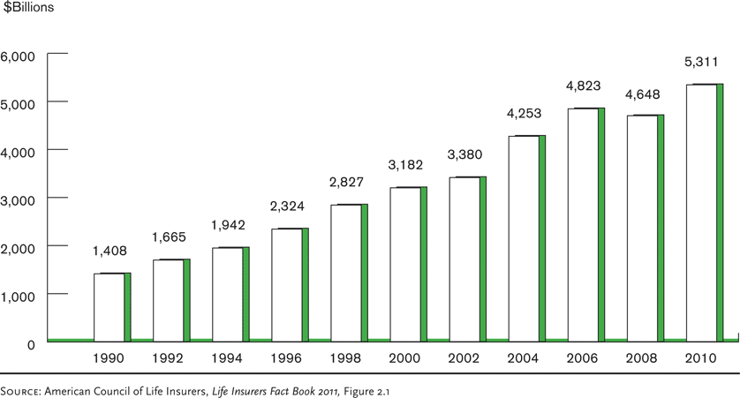

**Life insurance investments** have *an important economic and social impact on the nation* for several reasons:-

* Life insurance contracts are long-term; thus, safety of principal is a primary consideration
* Life insurance investments is extremely important in reducing ***the cost of insurance to policyowners*** and offsetting unfavourable underwriting experience
* **In America** , **laws** place restrictions on the types of assets because of long- term nature of life insurance products, so, we find most investments in ***bonds*** as indicated in **Figure 6.2**

**Figure 6.2** Asset Distribution of Life Insurers, 2010

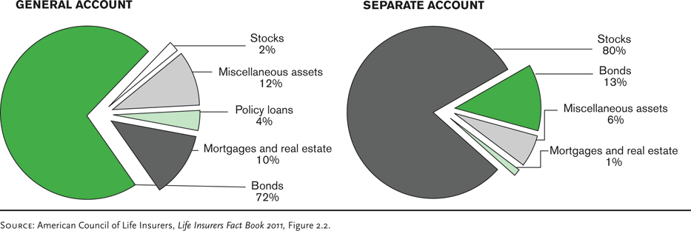

***6-6-2- Property and causality insurance investment***

In contrast to life insurance, *property insurance contracts* are *short-term in nature,* and **claim payments** can vary widely depending on catastrophic losses, inflation, medical costs, etc. So, investments should be in ***securities*** that can be quickly sold to pay claims if a major of catastrophe occurs– primarily in *high quality stocks*, *bond*s rather *than real estate* as indicated in Figure 6.3

Figure **6.3 Investments**, Property/Casualty Insurers, 2010

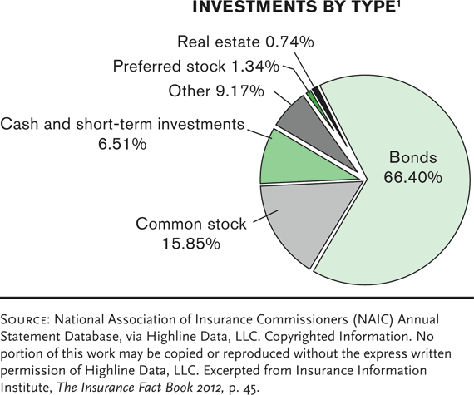

***6-7- Other Insurance Company Functions***

Insurance companies also perform ***other functions***. They include

* ***Information systems*** are extremely important in the *daily operations of insurers.*
  + C***omputers*** are widely used in many areas, including policy processing, simulation studies, market analysis, and policyholder services.
* ***The accounting department*** prepares financial statements and develops budgets
* In ***the legal department***, attorneys are used in advanced underwriting and estate planning
* Property and liability insurers also provide many ***loss control services***

***6-8- Measuring Profit or Loss for Insurance company***

So far, we had studied ***some insurance company operations*** but, we did not know **the performance of insurance company**. So, the following question may be raised about any insurance company. ***How* can measure the performance of insurance company?** In other words, **what can measure the operational side of insurance company**? The *Answer*

**Measurement of the performance of insurance company** can be illustrated by simple measurements as follows:-

1. *Insurance company`s loss ratio*

The **loss ratio** is the ratio of incurred losses and loss adjustment expenses to premiums earned. ***For example***, if we have *income and expense statement* for company ABC, we can calculate as below



It is worthwhile, to mention that loss ratio can be determined for any line of insurance or for the whole company. The loss ratio is often in 64 percent to 75 percent range

1. *Insurance company`s expense ratio*

Expense ratio is considered a second important performance measure . It is equal to *the company’s underwriting expenses* divided by *written premiums*. Expense ratio for company ABC can be calculated by the following equation



Likewise the loss ratio, the expense ratio can be determined for an individual line of insurance and as well for whole insurance company. The expense ratios are usually in the 25 percent to 40 percent range

1. *Insurance company`s* combined *ratio*

For an overall measure of underwriting performance, **the combined ratio**, for insurance company can be calculated. **The combined ratio** is the sum of the loss ratio and the expense ratio. So, the combined ratio for company ABC can be calculated by the following equation

Combined ratio = loss ratio + expense ratio

The Combined ratio is one of the most common measures of **underwriting profitability**, that is , if the combined ratio *exceeds 1 (or 100 %)* , it indicate underwriting loss. If the combined ratio is *less than 1 (or100 %),* it indicate underwriting profit.

1. *Insurance company`s investment income ratio*

The **investment income ratio** compares net investment income to earned premiums. The formula and the ratio for ABC insurance company are provided below



To determine **the company`s total performance** (underwriting and investment), **the overall operating ratio** can be calculated .The overall operating ratio is equal to the combined ratio minus the investment income ratio. The ratio and the result for insurance company ABC are presented below

Overall operating ratio = Combined ratio - Investment income ratio

***An important notice***: If the **Overall operating ratio** is less than 100 %, that is, indicate that company, overall, is **profitable**. If the Overall operating ratio exceeds 100 %, it means that investment income was not enough to offset the underwriting loss.

***An applied example :***

Given that ABC insurance company has *the income and expense statement* as provided in figure 6. 4 below

Figure 6. 4 ABC Insurance Company

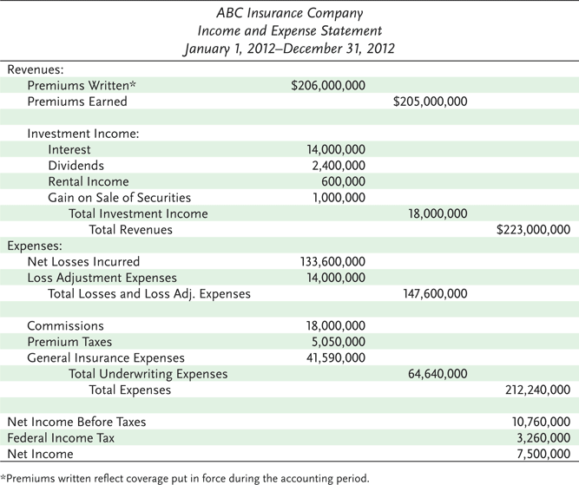

***Required***: Calculate the following ratios for insurance company ABC indicating your opinion in this company .

1- Loss ratio 2- Expense ratio 3- Combined ratio 4- Overall operating ratio

And comment?