Planning and preparing to write assignments

Course: ZOO 630
Deadline: 12 November 2019

Before you start, read these important tips:

- Be prepared for writing - you may want to 'grow' your writing from a plan, which may be in outline, visual or diagrammatic form, or you may want to start with an idea for a sentence or paragraph.
- Plan to write regularly - getting into the habit of writing can help you find ways of managing it.
- Set aside blocks of time which match your concentration span and try to gradually build on your ability to focus.
- Make a realistic time plan for your pieces of writing and stick to it. Acknowledge that there are many stages to producing a written assignment including reading, writing and editing/revising for final submission.
- Write up a section or paragraph as it becomes ready - but remember that you do not have to write everything in order.
- For longer assignments and reports, you may begin by writing a section that comes part way through e.g. you may begin by writing the methodology section and end by writing the introduction before checking the whole piece links together smoothly.
- When you are writing, stop at a point when you could carry on writing. Make a quick note about the next point you will make. This can make it easier to settle back down to writing next time.
- Find out where and when you find writing easiest and try to maximise these benefits
- Take breaks, a breath of fresh air, a chat with friends, but make sure you set times and keep to these for when you plan to re-start writing.

Preparing to write:

These are some points that are important when approaching writing tasks at university:

- Be clear about the task - what is expected of you, what is needed to answer the question
- Identify and use available resources and written advice
- Listen and respond to guidance offered while producing your work
- Keep focused on your question or task - keep asking yourself whether any material you plan to include is really relevant
- Be clear, concise and to the point in what you write
- Present your ideas in a clear and logical way
- Make sure you clearly reference any sources or data that you use as evidence and that your examples are appropriately justified
- Take note of feedback on completed tasks. In particular, academic writing should be clear and reasoned, with conclusions based on evidence. This evidence should be sound - derived by robust and reliable methods, so you are expected to be critical of evidence available and consider its strengths and weaknesses.

Assignment (ZOO 630):

You have to write 500 words about your title that include the following points:

- Introduction

You have to outline the basic information about your topic such as (the background statement, topic statement, the significant importance of this topic, target (children, women …etc), why you choose this topic?, what is the relationship between this topic and our course content. (See Figure 1).

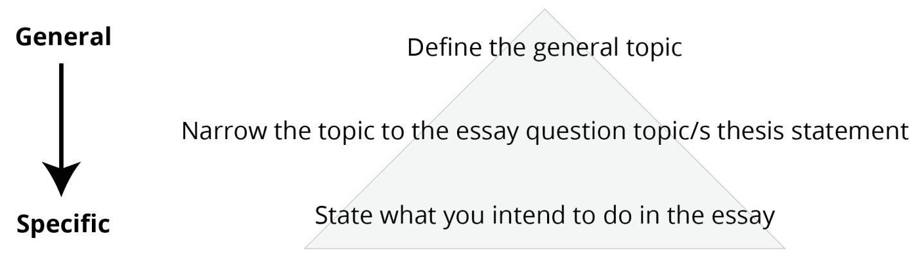

Figure 1: the outline of introduction sections.

- Main body:

- The body of your essay is where you detail your ideas. It usually makes up approximately 80% of your essay.
- It is important to remember that the evidence you provide supports your writing, rather than the other way around!
- Structure your body paragraphs by beginning with a topic sentence – this is the topic of your paragraph.
- Provide supporting evidence with citations, but also ensure that you paraphrase and summaries your sources more often than you quote.
- Consider how you will conclude your paragraphs and how your paragraphs link to each other.
- Remember to be formal, objective and cautious in your writing. (See Figure 2).

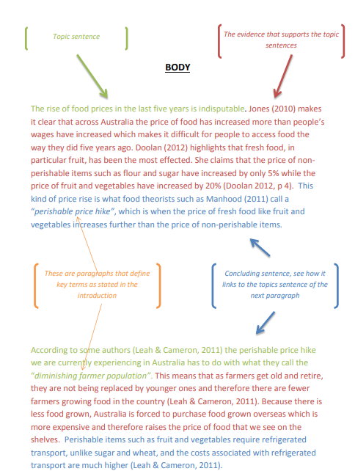

Figure 2: the outline of Body sections.

- Conclusion
Summary of main points; final comment by paraphrasing what is in the introduction (Restatement) and explain your opinion (Border context) in this issue or problem, suggest directions for further research and find some solutions and technique that will help in future by adding some scientific contribution to this field. (see Figure 3).

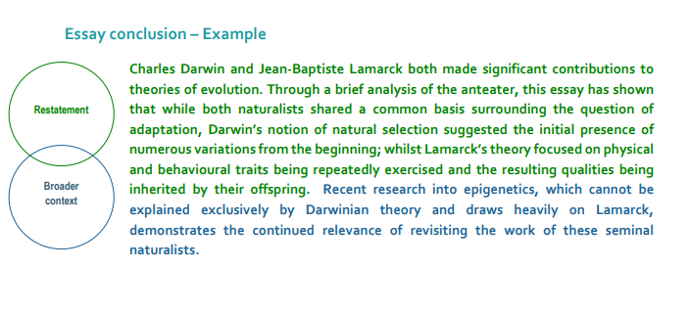
Figure 3: the outline of conclusion sections.

