205NET
2nd semester 1439 /1440
Assignment # 5

Q1) Calculate the value of the signal rate for each case in the following figure , if the data rate is 1 Kbps and c = 1/2.

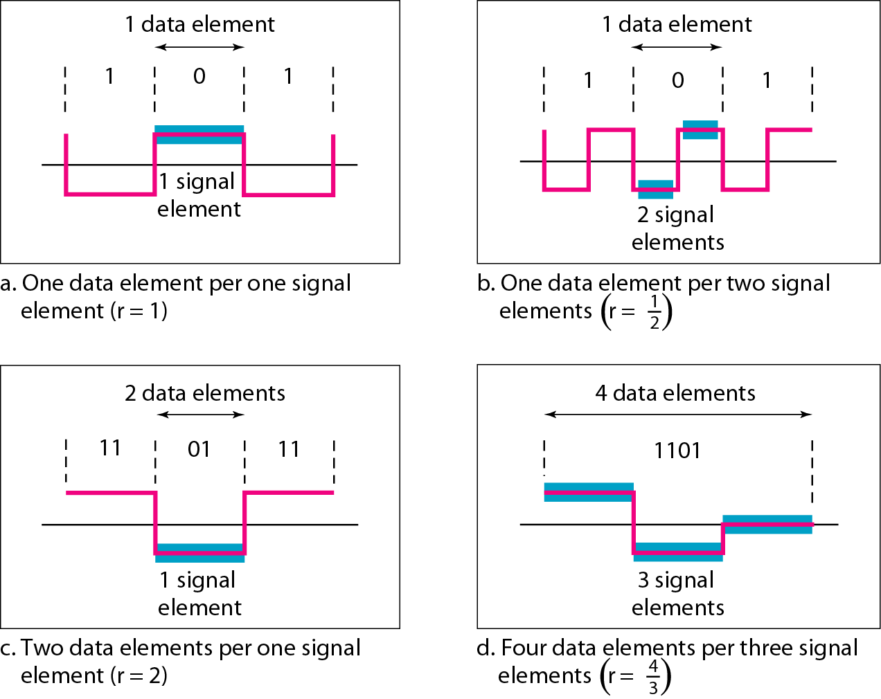

Q2) Find the 8-bit data stream for the following digital signal

Differential Manchester schemes using the following data streams

 | 1 | 1 | 0 | 0 | 1 | 0 | 1 | 0
Unipolar
Differential Manchester
NRZ-L
Manchester
RZ
NRZ-I

