Ambhibia:- There are a total of 6771 amphibian species
Amphibians are ectothermic, tetrapod vertebrates of the class Amphibia. Modern amphibians are all Lissamphibia. They inhabit a wide variety of habitats, with most species living within terrestrial, fossorial, arboreal or freshwater aquatic ecosystems. Thus amphibians typically start out as larvae living in water, but some species have developed behavioural adaptations to bypass this. The young generally undergo metamorphosis from larva with gills to an adult air-breathing form with lungs. Amphibians use their skin as a secondary respiratory surface and some small terrestrial salamanders and frogs lack lungs and rely entirely on their skin. They are superficially similar to lizards but, along with mammals and birds, reptiles are amniotes and do not require water bodies in which to breed. With their complex reproductive needs and permeable skins, amphibians are often ecological indicators; in recent decades there has been a dramatic decline in amphibian populations for many species around the globe.
The earliest amphibians evolved in the Devonian period from sarcopterygian fish with lungs and bony-limbed fins, features that were helpful in adapting to dry land. They diversified and became dominant during the Carboniferous and Permian periods, but were later displaced by reptiles and other vertebrates. Over time, amphibians shrank in size and decreased in diversity, leaving only the modern subclass Lissamphibia.
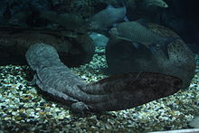

Giant salamander 1.8m long

The three modern orders of amphibians are Anura (the frogs and toads), Urodela (the salamanders), and Apoda (the caecilians). The number of known amphibian species is approximately 7,000, of which nearly 90% are frogs. The smallest amphibian (and vertebrate) in the world is a frog from New Guinea (Paedophryne amauensis) with a length of just 7.7 mm (0.30 in). The largest living amphibian is the 1.8 m (5 ft 11 in) Chinese giant salamander (Andrias davidianus), but this is dwarfed by the extinct 9 m (30 ft) Prionosuchus from the middle Permian of Brazil. The study of amphibians is called batrachology, while the study of both reptiles and amphibians is called herpetology.
It is fully aquatic and is endemic to rocky mountain streams and lakes in China. It has been introduced to Kyoto Prefecture in Japan and Taiwan.^{[3][4]} It is considered critically endangered in the wild due to habitat loss, pollution, and overcollection, as it is considered a delicacy and used in traditional Chinese medicine. On farms in central China is extensively farmed and on some farms bred, although many of the salamanders on the farms are wild caught.^{[5]} It has been listed as one of the top 10 "focal species" in 2008 by the Evolutionarily Distinct and Globally Endangered (EDGE) project.
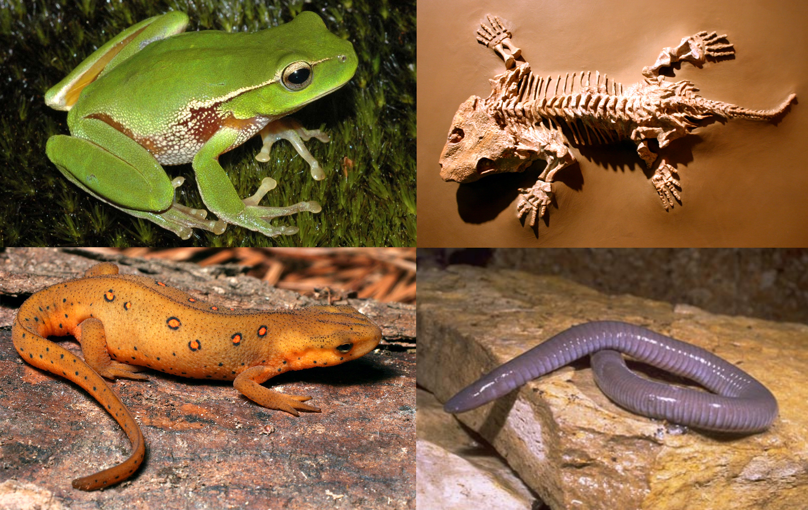Clockwise from top right: Seymouria, Mexican burrowing caecilian, eastern newt and leaf green tree frog
The word "amphibian" is derived from the Ancient Greek term ἀμφίβιος (amphíbios), which means "both kinds of life", ἀμφί meaning "of both kinds" and βιος meaning "life". The term was initially used as a general adjective for animals that could live on land or in water, including seals and otters.^{[2]} Traditionally, the class Amphibia includes all tetrapod vertebrates that are not amniotes. Amphibia in its widest sense (sensu lato) was divided into three subclasses, two of which are extinct:^{[3]}
- Subclass Lepospondyli† (small Paleozoic group, which may actually be more closely related to amniotes than Lissamphibia)
- Subclass Temnospondyli† (diverse Paleozoic and early Mesozoic grade)
- Subclass Lissamphibia (all modern amphibians, including frogs, toads, salamanders, newts and caecilians)
  - Salientia (frogs, toads and relatives): Jurassic to present—6,200 current species in 53 families
  - Caudata (salamanders, newts and relatives): Jurassic to present—652 current species in 9 families
  - Gymnophiona (caecilians and relatives): Jurassic to present—192 current species in 10 families
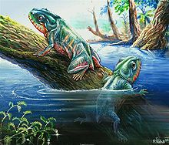
Triadobatrachus massinoti, a proto-frog from the Early Triassic of Madagascar
The actual number of species in each group depends on the taxonomic classification followed. The two most common systems are the classification adopted by the website AmphibiaWeb, University of California, Berkeley and the classification by herpetologist Darrel Frost and the American Museum of Natural History, available as the online reference database "Amphibian Species of the World".^{[4]} The numbers of species cited above follows Frost and the total number of known amphibian species is over 7,000, of which nearly 90% are frogs.^{[5]}

Contents
- 1Class Amphibia
  - 1.1Order Anura: Frogs and Toads
The order Anura (from the Ancient Greek a(n)- meaning "without" and oura meaning "tail") comprises the frogs and toads. They usually have long hind limbs that fold underneath them, shorter forelimbs, webbed toes with no claws, no tails, large eyes and glandular moist skin.^{[7]} Members of this order with smooth skins are commonly referred to as frogs, while those with warty skins are known as toads. The difference is not a formal one taxonomically and there are numerous exceptions to this rule. Members of the family Bufonidae are known as the "true toads"
    - 1.1.1 Suborder Archaeobatrachia
The suborder Archaeobatrachia contains four families of primitive frogs. These are Ascaphidae, Bombinatoridae, Discoglossidae and Leiopelmatidae which have few derived features and are probably paraphyletic with regard to other frog lineages.[
    - 1.1.2 Suborder Mesobatrachia
The six families in the more evolutionarily advanced suborder Mesobatrachia are the fossorial Megophryidae, Pelobatidae, Pelodytidae, Scaphiopodidaeand Rhinophrynidae and the obligatorily aquatic Pipidae. These have certain characteristics that are intermediate between the two other suborders.
1.1.3 Suborder Neobatrachia :
Neobatrachia is by far the largest suborder and includes the remaining families of modern frogs, including most common species. Ninety-six percent of the over 5,000 extant species of frog are neobatrachians.
  - 1.2Order Caudata: Salamanders:
  - The order Caudata (from the Latin cauda meaning "tail") consists of the salamanders—elongated, low-slung animals that mostly resemble lizards in form. This is a symplesiomorphic trait and they are no more closely related to lizards than they are to mammals.^{[39]} Salamanders lack claws, have scale-free skins, either smooth or covered with tubercles, and tails that are usually flattened from side to side and often finned.
    - 1.2.1Suborder Cryptobranchoidea
    - The suborder Cryptobranchoidea contains the primitive salamanders. A number of fossil cryptobranchids have been found, but there are only three living species, the Chinese giant salamander (Andrias davidianus), the Japanese giant salamander (Andrias japonicus) and the hellbender (Cryptobranchus alleganiensis) from North America. These large amphibians retain several larval characteristics in their adult state; gills slits are present and the eyes are unlidded. A unique feature is their ability to feed by suction, depressing either the left side of their lower jaw or the right.[
    - 1.2.2Suborder Salamandroidea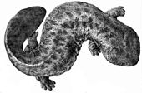
    - The suborder Salamandroidea contains the advanced salamanders. They differ from the cryptobranchids by having fused prearticular bones in the lower jaw, and by using internal fertilisation. In salamandrids, the male deposits a bundle of sperm, the spermatophore, and the female picks it up and inserts it into her cloaca where the sperm is stored until the eggs are laid.
A newt is a salamander in the subfamily Pleurodelinae, also called eft during its terrestrial juvenile phase. Unlike other members of the family Salamandridae, newts are semiaquatic, alternating between aquatic and terrestrial habitats over the year, sometimes even staying in the water full-time. Not all aquatic salamanders are considered newts, however. More than 100 known species of newts are found in North America, Europe, North Africa and Asia. Newts metamorphose through three distinct developmental life stages: aquatic larva, terrestrial juvenile (eft), and adult. Adult newts have lizard-like bodies and return to the water every year to breed, otherwise living in humid, cover-rich land habitats.
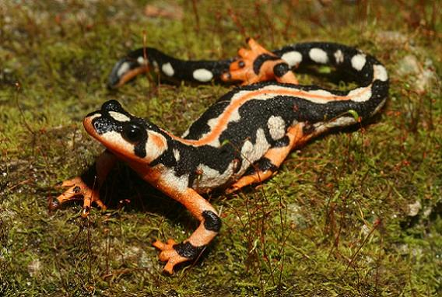

    - 1.2.3Suborder Sirenoidea
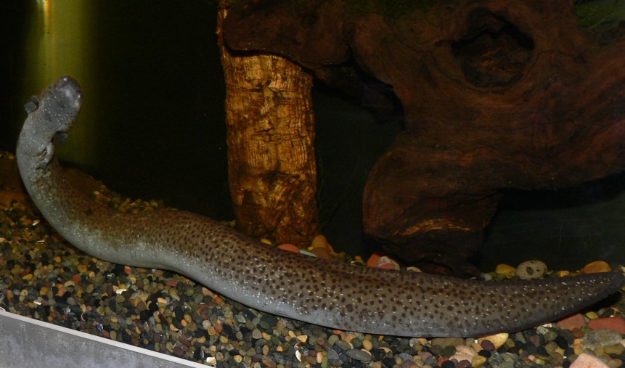
The third suborder, Sirenoidea, contains the four species of sirens, which are in a single family, Sirenidae. Members of this order are eel-like aquatic salamanders with much reduced forelimbs and no hind limbs.
Successive stages in the development of common toad (Bufo bufo) tadpoles, finishing with metamorphosis

Gymnophiona
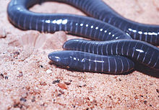
The limbless South American caecilian Siphonops paulensis
The order Gymnophiona (from the Greek gymnos meaning "naked" and ophis meaning "serpent") or Apoda (from the Latin an- meaning "without" and the Greek podameaning "legs") comprises the caecilians. These are long, cylindrical, limbless animals with a snake- or worm-like form. The adults vary in length from 8 to 75 centimetres (3 to 30 inches) with the exception of Thomson's caecilian (Caecilia thompsoni), which can reach 150 centimetres (4.9 feet). A caecilian's skin has a large number of transverse folds and in some species contains tiny embedded dermal scales. It has rudimentary eyes covered in skin, which are probably limited to discerning differences in light intensity. It also has a pair of short tentacles near the eye that can be extended and which have tactile and olfactory functions. Most caecilians live underground in burrows in damp soil, in rotten wood and under plant debris, but some are aquatic.^{[49]} Most species lay their eggs underground and when the larvae hatch, they make their way to adjacent bodies of water. Others brood their eggs and the larvae undergo metamorphosis before the eggs hatch. A few species give birth to live young, nourishing them with glandular secretions while they are in the oviduct.^{[50]} Caecilians have a mostly Gondwanan distribution, being found in tropical regions of Africa, Asia and Central and South America.^{[51]}

Skeletal system and locomotion
Amphibians have a skeletal system that is structurally homologous to other tetrapods, though with a number of variations. They all have four limbs except for the legless caecilians and a few species of salamander with reduced or no limbs. The bones are hollow and lightweight. The musculoskeletal system is strong to enable it to support the head and body. The bones are fully ossified and the vertebrae interlock with each other by means of overlapping processes. The pectoral girdle is supported by muscle, and the well-developed pelvic girdle is attached to the backbone by a pair of sacral ribs. The iliumslopes forward and the body is held closer to the ground than is the case in mammals.^{[56]}
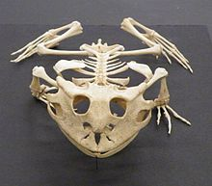
Skeleton of the Surinam horned frog
(Ceratophrys cornuta)
In most amphibians, there are four digits on the fore foot and five on the hind foot, but no claws on either. Some salamanders have fewer digits and the amphiumas are eel-like in appearance with tiny, stubby legs. The sirens are aquatic salamanders with stumpy forelimbs and no hind limbs. The caecilians are limbless. They burrow in the manner of earthworms with zones of muscle contractions moving along the body. On the surface of the ground or in water they move by undulating their body from side to side.^{[57]}

Circulatory system
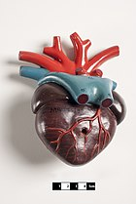
Didactic model of an amphibian heart.
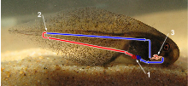
Juvenile amphibian circulatory systems are single loop systems which resemble fish.
1 – Internal gills where the blood is reoxygenated
2 – Point where the blood is depleted of oxygen and returns to the heart via veins
3 – Two chambered heart.
Red indicates oxygenated blood, and blue represents oxygen depleted blood.
Amphibians have a juvenile stage and an adult stage, and the circulatory systems of the two are distinct. In the juvenile (or tadpole) stage, the circulation is similar to that of a fish; the two-chambered heart pumps the blood through the gills where it is oxygenated, and is spread around the body and back to the heart in a single loop. In the adult stage, amphibians (especially frogs) lose their gills and develop lungs. They have a heart that consists of a single ventricle and two atria. When the ventricle starts contracting, deoxygenated blood is pumped through the pulmonary artery to the lungs. Continued contraction then pumps oxygenated blood around the rest of the body. Mixing of the two bloodstreams is minimized by the anatomy of the chambers.^{[59]}
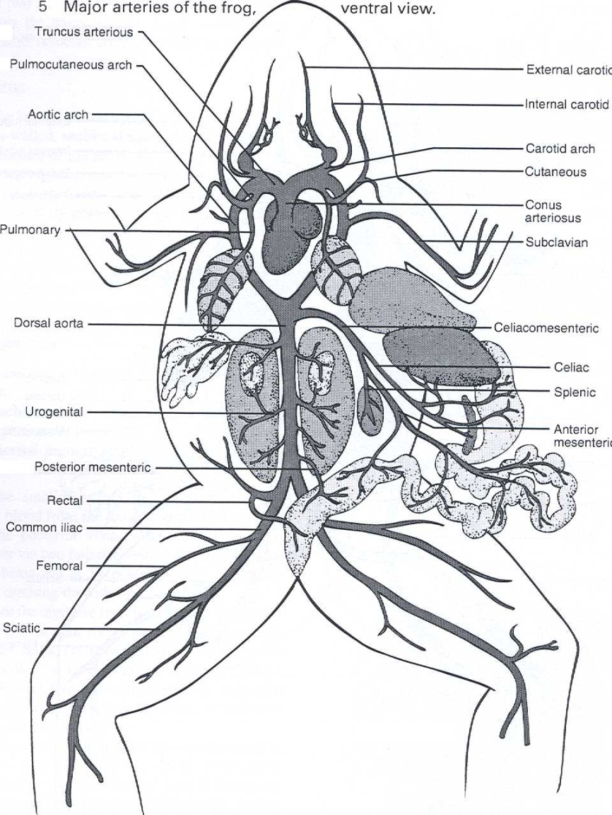

Nervous and sensory systems
The nervous system is basically the same as in other vertebrates, with a central brain, a spinal cord, and nerves throughout the body. The amphibian brain is less well developed than that of reptiles, birds and mammals but is similar in morphology and function to that of a fish. It is believed amphibians are capable of perceiving pain. The brain consists of equal parts, cerebrum, midbrain and cerebellum. Various parts of the cerebrum process sensory input, such as smell in the olfactory lobe and sight in the optic lobe, and it is additionally the centre of behaviour and learning. The cerebellum is the center of muscular coordination and the medulla oblongata controls some organ functions including heartbeat and respiration. The brain sends signals through the spinal cord and nerves to regulate activity in the rest of the body. The pineal body, known to regulate sleep patterns in humans, is thought to produce the hormones involved in hibernation and aestivation in amphibians.^{[60]}

Digestive and excretory system

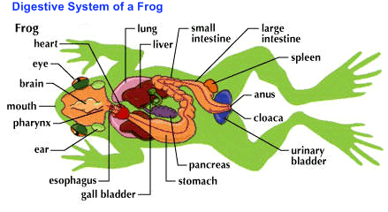
Many amphibians catch their prey by flicking out an elongated tongue with a sticky tip and drawing it back into the mouth before seizing the item with their jaws. Some use inertial feeding to help them swallow the prey, repeatedly thrusting their head forward sharply causing the food to move backwards in their mouth by inertia. Most amphibians swallow their prey whole without much chewing so they possess voluminous stomachs. The short oesophagus is lined with cilia that help to move the food to the stomach and mucus produced by glands in the mouth and pharynx eases its passage. The enzyme chitinase produced in the stomach helps digest the chitinouscuticle of arthropod prey.^{[63]}
Amphibians possess a pancreas, liver and gall bladder. The liver is usually large with two lobes. Its size is determined by its function as a glycogen and fat storage unit, and may change with the seasons as these reserves are built or used up. Adipose tissue is another important means of storing energy and this occurs in the abdomen (in internal structures called fat bodies), under the skin and, in some salamanders, in the tail.^{[64]}

Respiratory system
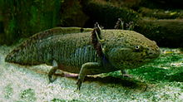
The axolotl (Ambystoma mexicanum) retains its larval form with gills into adulthood
The lungs in amphibians are primitive compared to those of amniotes, possessing few internal septa and large alveoli, and consequently having a comparatively slow diffusion rate for oxygen entering the blood. Ventilation is accomplished by buccal pumping.^{[66]} Most amphibians, however, are able to exchange gases with the water or air via their skin. To enable sufficient cutaneous respiration, the surface of their highly vascularised skin must remain moist to allow the oxygen to diffuse at a sufficiently high rate.^{[63]} Because oxygen concentration in the water increases at both low temperatures and high flow rates, aquatic amphibians in these situations can rely primarily on cutaneous respiration, as in the Titicaca water frog and the hellbender salamander. In air, where oxygen is more concentrated, some small species can rely solely on cutaneous gas exchange, most famously the plethodontid 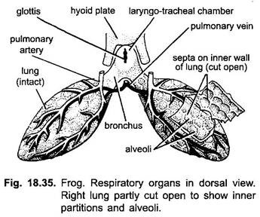salamanders, which have neither lungs nor gills. Many aquatic salamanders and all tadpoles have gills in their larval stage, with some (such as the axolotl) retaining gills as aquatic adults.^{[63]}

Reproductive system

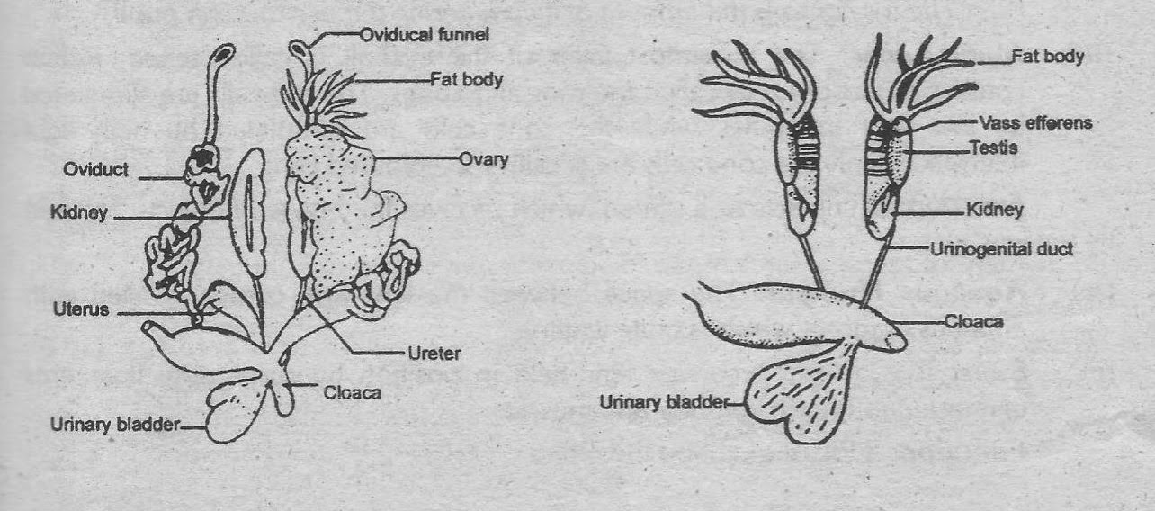
For the purpose of reproduction most amphibians require fresh water although some lay their eggs on land and have developed various means of keeping them moist. A few (e.g. Fejervarya raja) can inhabit brackish water, but there are no true marine amphibians.^{[67]} There are reports, however, of particular amphibian populations unexpectedly invading marine waters. Such was the case with the Black Sea invasion of the natural hybrid Pelophylax esculentus reported in 2010.^{[68]}
Several hundred frog species in adaptive radiations (e.g., Eleutherodactylus, the Pacific Platymantis, the Australo-Papuan microhylids, and many other tropical frogs), however, do not need any water for breeding in the wild. They reproduce via direct development, an ecological and evolutionary adaptation that has allowed them to be completely independent from free-standing water. Almost all of these frogs live in wet tropical rainforests and their eggs hatch directly into miniature versions of the adult, passing through the tadpole stage within the egg. Reproductive success of many amphibians is dependent not only on the quantity of rainfall, but the seasonal timing.^{[69]}
In the tropics, many amphibians breed continuously or at any time of year. In temperate regions, breeding is mostly seasonal, usually in the spring, and is triggered by increasing day length, rising temperatures or rainfall. Experiments have shown the importance of temperature, but the trigger event, especially in arid regions, is often a storm. In anurans, males usually arrive at the breeding sites before females and the vocal chorus they produce may stimulate ovulation in females and the endocrine activity of males that are not yet reproductively active.^{[70]}

