**STANDARDIZATION**

Comparing mortality and morbidity rates in two or more different geographic areas is important for the evaluation of community health status.

As there is a possibility of having different frequency distributions in different populations, a comparison between crude rates would be misleading since crude

rates are not very informative about the health status of a population. Standardization for the characteristic(s) responsible for the differences in comparison is necessary. Age and sex are two of the most common variables used for standardization and they are called standardized rates.

The difference between crude rates and standardized rates is that crude rates are calculated based on the population under study as a whole whereas standardized rates

are based on particular characteristic(s) as standard

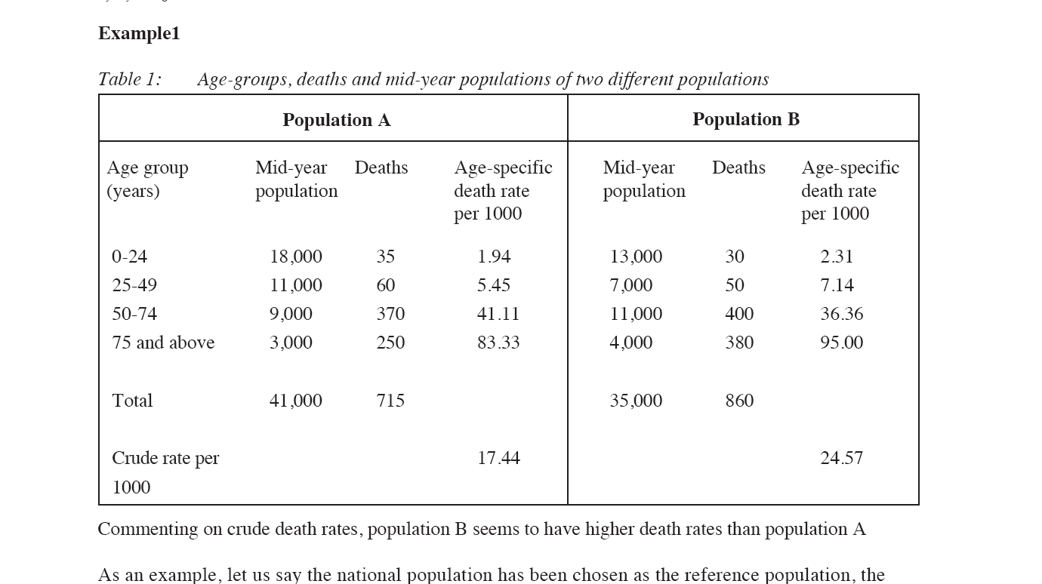

Commenting on crude death rates, population B seems to have higher death rates than population A



**Workshop**

**Calculate and Compare age adjusted marriage rate in males for both Population A and B**

|  |  |  |
| --- | --- | --- |
| **Age gp** | **Population A** | **Population B** |
| **15-** | Age specific marriage rate for males | Age specific marriage rate for males |
| **20-** | 0.99 | 0.004 |
| **25-** | 0.80 | 0.18 |
| **30-** | 0.46 | 0.52 |
| **35-** | 0.26 | 0.71 |
| **40-** | 0.15 | 0.81 |
| **45-** | 0.09 | 0.84 |
| **50-** | 0.06 | 0.82 |
| **55- and more** | 0.05 | 0.70 |
| **Crude marriage rate for males** | **43.7%** | **52.3%** |

**Using the following standard population:**

|  |  |
| --- | --- |
| **Age gp** | **Mid year male population** |
| **20-** | 9921 |
| **25-** | 8826 |
| **30-** | 9450 |
| **35-** | 10076 |
| **40-** | 22055 |
| **45-** | 16598 |
| **50-** | 10673 |
| **55- and more** | 13524 |
| **Total** | **101123** |