Speaking-4
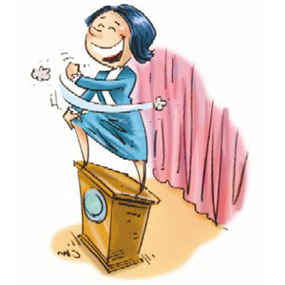
(272 NAJD)

L. Margo Arnold
glarnold57@yahoo.com
http://www.facebook.com/margo.arnold.7

Nada Al-Dekhayel

Ghyzayel Al-Otaibi
http://fac.ksu.edu.sa/galotaibi/home, galotaibi@ksu.edu.sa/ghyzayel@gmail.com
Twitter: @Ghyzayel / Twa9l: 91664

Speaking 4
Weekly Syllabus
1St semester (2012/2013)

Week | Date | Lesson
 | 7-10-33/25-8-12 | Registration Week (Dropping/Adding Courses)
1 | 14-10-33/1-9-12 | Registration Week (Dropping/Adding Courses)
2 | 21-10-33/8-9-12 | Course Introduction
3 | 28-10-33/15-9-12 | Chapter-1-  Public Speaking
4 | 6-11-33/22-9-12  National Day (7-11/23-9) | Chapter-1-  Public Speaking
5 | 13-11-33/29-9-12 | Midterm (1)  Presentation, individual work
6 | 20-11-33/6-10-12 | Midterm (1)  Presentation, individual work
7 | 27-11-33/13-10-12 | Chapter-2-  Idioms & Quotations
 | 4-12-33/20-10-12 | اجازة
 | 11-12-33/27-10-12 | إجازة
8 | 18-12-33/3-11-12 | Chapter-2-  Abstracts
9 | 25-12-33/10-11-12 | Midterm (2)
10 | 3-1-34/17-11-12 | Chapter-3-  Debate Skills
11 | 10-1-34/24-11-12 | Debate Skills  Debate Practice
12 | 17-1-34/1-12-12 | Midterm (3)  Group work
13 | 24-1-34/8-12-12 | Midterm (3)  Group work
14 | 2-2-34/15-12-12 | Activities
15 | 9-2-34/22-12-12 | Activities
16 | 9-2-34/22-12-12 | (ORAL-EXAM WEEK)
 | 16-2-34/29-12-12 | GENERAL-EXAM WEEK
 | 23-2-34/5-1-13 | FINAL-EXAM WEEK
Note: This Syllabus is subject to changes depending on class progress.
First in-term: 20 Second in-term: 20 Third in-term: 20 Final: 40

Speaking to Persuade
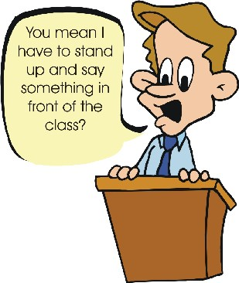

Persuasive speaking is all around us. Any speech is persuasive if its purpose is to convince others to change their feelings, beliefs, or behavior. A sales person trying to convince someone to buy a product, a political leader trying to get someone to vote certain way, a teacher lecturing about why a history class should be required are all speaking to persuade.
When do we make persuasive speeches? We make them all the time. When we ask a friend to lend us money, ask our teacher for a higher grade, try to convince a sibling to lose some weight, or try to persuade a parent to buy something, our goal is to try to change or influence others.
Preparing for the Persuasive Speech
The steps for preparing a persuasive speech are:
- Determining your specific purpose
- Choosing your topic
- Analyzing your audience
- Gathering information
- Preparing visual aids
- Organizing your speech

- Determining Your Specific Purpose
The general goal of persuasive speaking is to convince your listeners to change something. The first step is to decide what you want them to change- a belief, an opinion, or their behavior.

- Choosing Your Topic
Your first question may be “What should I talk about?” Several suggestions about how to choose appropriate topics for your persuasive speech follow.
Choose a topic that really interests you. It is easy to think of ideas if you choose a topic that you feel strongly about. Also, suggest a change that isn’t too large. It is much easier to convince an audience to change their opinion, feelings, or behavior a little than to persuade them to change their minds completely. Moreover, choose a topic that is controversial. Don’t choose a point of view that most people already agree with.

- Analyzing Your Audience
Audience analysis is especially important in persuasive speaking. It is necessary to learn as much as possible about your audience’s feelings and opinion toward your topic. You need to know how they feel and why they feel a certain way in order to prepare an effective persuasive speech.

- Gathering Information
Before you begin to organize your material, you must first collect it. A good way to begin this task is to write down what you already know about topic. Start by thinking about your own observations or experiences that relate to the point you wish to make. Once you’ve done this, you’re ready to gather additional information necessary for an effective presentation. When looking for information for a persuasive speech, the editorial pages of newspapers can be especially useful. They often include articles and letters that express different opinions about current controversial topics. You can also research your topic on the Internet.
Whenever you quote specific people or use information from newspapers, magazines, books, or the Internet in your speech, be sure to tell your audience the source of your information. This will make your evidence and arguments more believable and impress your listeners.

- Preparing Visual Aids if needed
Visual aids-pictures, graphs, or objects can make your speech more interesting and can be very powerful persuasive tools. An audience is more likely to be convinced if they can actually see the importance of what you are describing.

- Organizing Your Speech
The next step is to organize your speech. A good persuasive speech includes the following components:
- Opener building on areas of agreement
- Statement of purpose
- Body
- Memorable concluding remarks

Step 1: Prepare an Opener Building on Areas of Agreement
The introduction to a persuasive speech is very important. In order to convince listeners to agree with you, it is essential to first make them trust you and to see you as a person who thinks as they do. The best way to do this is to begin your speech by talking about common areas of agreement. You can do this by first discussing:
- Common goals (we all want the same basic things in life)
- Common problems (w are all concerned about this particular problem)
- Common experiences (we all know what it is like to….)
Example: ‘Highway Speed Limits Are Too High”
Most of us know people who have had friends or family injured or killed in terrible car accidents on the highways. Certainly we’ve all read or heard about these tragedies in the news. We all want to live long, happy, healthy lives and not worry about the possibility of accidents. No one wants to worry about whether they will arrive at their destination safely every time they get in a car.

Step 2: Prepare a Statement of Purpose
Now that you have shown your audience that you are a sensible person who shares their values and beliefs, the next step is to clearly state the specific purpose of your speech.
Example: “Highway Limits Are Too High”
The maximum speed limit on Saudi highways should be fifty miles per hour.

Step 3: Prepare the Body
Now that your listeners know your specific purpose, the next step is to present the evidence that will convince them to agree with you. Often, people are indifferent about a topic because they do not see how it relates to them. In order to persuade listeners with this attitude, you must convince them that your topic is interesting, important and relevant to them.

Step 4: Prepare Memorable Concluding Remarks
The last part of your speech to prepare is the conclusion. The conclusion of a persuasive speech should remind the audience why they should change a belief, opinion, or behavior. An effective way to do this is to make them think about the future and remind them that the best way to redirect the future to take some type of action.

Debate
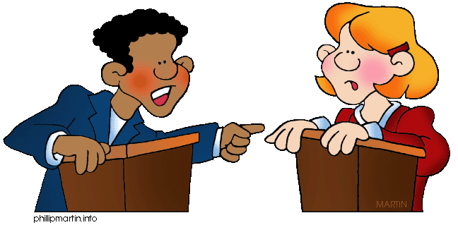
A debate is a discussion between sides with different views. People speak for or against something before making a decision. Debates are a means of encouraging critical thinking, personal expression, and tolerance of others' opinions. Today, debate still remains essential to democracy, held in lecture halls and public arenas, presented in schools and universities, written in newspaper and magazine columns, heard on radio, or seen on the television.

There are many types of debates:
- Classic debates
- Public Forum debates
- Lincoln-Douglas debate
- Policy debate
In speaking 4 we will focus on Classic debates.

Debate Basics
1. Basic Terms
• Debate: a competition in which two opposing teams make speeches to support their arguments and disagree with those of the other team.
• Resolution: the opinion about which two teams argue.
• Affirmative team: agrees with the resolution.
• Negative team: disagrees with the resolution.
• Rebuttal: explains why one team disagrees with the other team.
• Judges: decide the winner.

2. Opinions and Reasons
A resolution is an opinion about which there can be valid disagreement. The students either agree or disagree with the resolution regardless of what they personally believe. An opinion can be introduced by an opinion indicator:
"I think/believe that smoking should be banned in public places..."
A reason explains why that opinion is held and can be introduced by a reason indicator:
"...because/since secondhand smoke is harmful for nonsmokers."

3. Giving Support for Your Reasons
Support consists of evidence. The four kinds of evidence:
• Example: from your own experience or from what you heard or read.
• Common Sense: things that you believe everybody knows.
• Expert Opinion: the opinions of experts -- this comes from research.
• Statistics: numbers -- this also comes from research.

Smoking should be banned in all public places.
Example: For example / for instance / let me give an example
Whenever I go to a restaurant or bar and there are people smoking near me, I feel that I am breathing their smoke. This makes me a smoker even though I don't want to be.

Common Sense: Everyone knows / if...then / it's common knowledge that secondhand smoke is very unhealthy for nonsmokers.

Statistics:
Secondhand smoke causes about 250,000 respiratory infections in infants and children every year, resulting in about 15,000 hospitalizations each year.

Expert Opinion: According to.../ to quote.../ the book _____ says...
According to the Environmental Protection Agency, "secondhand smoke causes approximately 3,000 lung cancer deaths in nonsmokers each year."

Opinions, Preferences: I think..., In my opinion..., I'd like to..., I'd rather..., I'd prefer..., The way I see it..., As far as I'm concerned..., If it were up to me..., I suppose..., I suspect that..., I'm pretty sure that...,It is fairly certain that..., I'm convinced that..., I honestly feel that, I strongly believe that..., Without a doubt,...,

Disagreeing:
I don't think that..., Don't you think it would be better..., I don't agree, I'd prefer..., Shouldn't we consider..., But what about..., I'm afraid I don't agree..., Frankly, I doubt if..., Let's face it, The truth of the matter is..., The problem with your point of view is that...

Giving Reasons and offering explanations: To start with, The reason why..., That's why..., For this reason..., That's the reason why..., Many people think....Considering..., Allowing for the fact that...,When you consider that...

4. Actual Debate
The following debate structure, adapted from LeBeau, Harrington, Lubetsky (2000). Participants speak in order, alternating sides.
Speech 1: The first affirmative speaker greets the audience, the opponents and the judge. Then introduces the topic and states the affirmative team's first argument, present evidence (quoted materials from a nationally published source) to support your resolution. Be factual!
Remember that you must be respectful of the audience and your opponents.
Speech 2: The first negative speaker greets the audience, the opponents, the judge and states their first argument. Use evidence to support your stand against the resolution. Be factual!
Speech 3: The second affirmative speaker states their second argument.
Speech 4: The second negative speaker states their second argument.
One minute break for each team to prepare their rebuttal speech.
Head to head rebuttal The following diagram shows this.

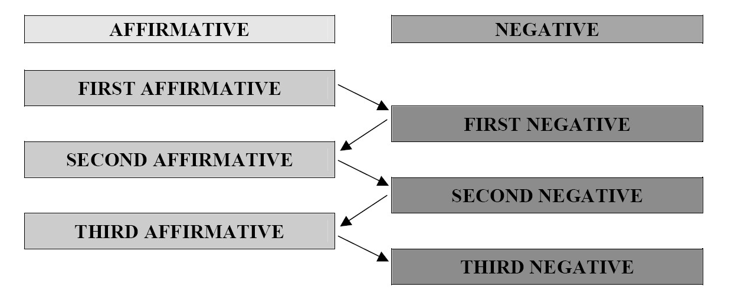

How to Rebuttal

Rebuttal is the process of defending and strengthening your arguments after they have been attacked by the opposing team. Get together with your team mates. Decide where your arguments look weakest and which arguments you can bolster with logic and evidence. During the other team’s rebuttal you must remain cool and silent. If you use exaggerated facial expressions or body language to indicate disapproval with what they say, your team will lose points. The best thing to do, if your opponent says something that you feel is incorrect, is to immediately write it down. You will get a chance to rebut them later.
- STEP 1: "They say ..."
  - State the argument that you are about to refute so that the judges can follow easily. Take notes during your opponent's speeches so you will be clear about what they argued.
    - "The other team said that smoking is harmful for nonsmokers."
- STEP 2: "But I disagree..." Or "That may be true, but..."
  - "That may be true, but I think that if nonsmokers want to avoid cigarette smoke, they can walk away from it."
- STEP 3: "Because ..."
  - "Because nonsmokers should look out for their own health."
- STEP 4: "Therefore..."
  - "Therefore it is not the responsibility of smokers to protect nonsmokers."
Ending the debate:
When the last speaker finishes she thanks the audience and the judge, both teams rise and shake hands all around. It is good to make a brief positive comment.
Every debate has a result – one team wins and one team loses. There cannot be a draw. The result is decided and announced by the adjudicator – somebody who has watched and followed the debate carefully in order to decide the result. Adjudicators are not allowed to make random or arbitrary decisions – they must follow clear guidelines about what is, and is not, good debating. Of course, debaters and audience members will often disagree with an adjudicator’s decision, and sometimes adjudicators disagree with each other. However, this is part of the challenge of debating: to debate well enough that you can persuade any adjudicator that you deserve to win the debate.

Example of a Student's Debate Speech
- Resolution: Personality is more important than looks. (Affirmative argument)
- Reason: People never lose interest in looking at a person who has a
good personality and living with them always makes us feel pleasant.
- Support:
  - Example
    - For example, my friendly neighbor in China has twin brothers. The elder brother married a very beautiful girl. But after the first month, he had a quarrel with her because the beautiful wife spent all of her time dressing herself up without doing any housework. And she always went out on dates with many boyfriends. Finally he divorced his beautiful wife last year. But the younger brother who married an ordinary looking girl with a good personality has a very happy married life now and they have a lovely 3 –year- old baby now.
  - Common sense
    - In China it is said, "Don't choose beautiful person to be your wife." Because the beautiful wife spends more time dressing herself up without doing housework or child care than the not beautiful wife. And the beautiful wife always spends a lot of money on clothing and cosmetics.

  - Expert opinion & Statistics
    - Psychologists at Yale University investigated 3,519 married men's life spans. According to the report, the men who married a beautiful wife had a shorter life than the men who married a not beautiful wife. The degree of beauty was in direct proportion to the husbands' life-spans. In the study, there was a scale of 1-20 points: 20 points is the most beautiful wife and 1 point the least beautiful wife. The result was that men who had a wife who scored 1-12 points lived 12 years longer than men whose wife scored 13-20 points

Debate Methods

Good debate methods:
1. Keep it civil. A debate without civility is merely bickering, a debate with insults, typically, quickly degenerates into what is called a ‘flame-war’ where the only competition is to see who can deliver the most grievous insult. As such, avoid insults in a debate so that your audience or opponent do not develop a distaste for you, as such can subconsciously alter their perception of your argument.
2. Demonstrate integrity. A debater without integrity is typically not trusted by the opponent or audience. If you are caught making something up, citing a faulty study, or plagiarizing, it immediately casts a shadow over all your other arguments. You will be far less likely to persuade anyone that way and likely just seed animosity towards yourself. Check your sources and make sure they are valid, write your own material or properly attribute quotes, and where you are wrong make sure you admit such. Nothing helps a debater’s integrity as much as admitting a mistake, although it is still better to not make the mistake at all.
3. Provide evidence. Any point you wish to make should have at least one piece of evidence supporting it, either empirical or logical. Do not rely on common sense, it does not have a good enough track record and your opponent will most likely point this out unless they are also relying upon common sense for their points. If you are caught saying something and are unable to provide evidence, make sure that the point is not one which supports your primary argument. If you provide the evidence as you are making the point, it makes your point stronger and leaves your opponent with fewer questions they can ask to challenge your argument, as you have already made their questions regarding your evidence pointless.
4. Know your limits. When you are wrong, admit it. Avoid baseless speculation and areas where you know nothing or very little. If you are an English teacher who has not researched quantum mechanics, do not use it as evidence for your metaphysical views, study quantum mechanics first. If you are a physicist who has not studied the nature versus nurture debate, do not use psychology as evidence for your views regarding human nature, study the psychology first. Make sure you know what you believe due to aesthetics, upbringing, and intuition and keep that out of the debate.
Bad debate methods:
1. Logical fallacies. Any opponent you face in a debate will usually be readily able to identify logical fallacies, the audience may not. If you use logical fallacies in such a way that your opponent takes longer to state how it is a fallacy than it takes you to state the fallacy many times over, your audience will remember your point more than the opponent’s counter point. It is an effective debate tactic, but not a good one. You would be winning the debate not because of being correct, but because of an audience’s inattentiveness.
2. Straw men. A straw man is when you distort your opponent’s argument in such a way as to make it easier to argue against. It is vital to note however, you are not actually arguing against your opponent’s argument. Depending on the audience, this might be effective. The less educated on the subject your audience is, the less likely they are to realize a misrepresentation. The straw man is a favored tactic of creationists because it appeals to the uneducated masses.
3. Appeals to emotion. By appealing to the audience’s emotions, such as fear, you make it all the harder for evidence to work. By doing this you are indeed more likely to win and even make those in the audience actively argue your position. The down side is that by introducing emotion to the equation, you make proper conduct of thought (proper being defined here as that which results in the most accurate knowledge) nigh impossible. Yes, you win, but in doing so you make problems that are all the harder to undo. Creationism has lasted so long due to this tactic.

Debate Advice and Suggestions
Advice on Debating with Others

- Avoid the use of Never.
- Avoid the use of always.
- Attack the idea not the person.
- Avoid exaggerations.
- Don’t let your emotions get the better of you.
- Don’t disagree with obvious truth.
- Use many rather than most.
- Use some rather than many.
- The use of often allows for exceptions
- The use of generally allows for exceptions.
- Quote sources and numbers.
- If it is just an opinion, admit it.
- Do not present opinion as facts.
- Smile when disagreeing.
- Stress the positive.
- Watch your tone of voice.
- Don’t win a debate and lose a friend.
- Keep your perspective-You’re just debating.

Sources:

- Speech Communication Made Simple A Multicultural Perspective by: Paulette Dale and James C. Wolf
- Krieger - Teaching Debate to ESL Students A Six-Class Unit (TESL TEFL).htm
- How to Conduct a debate. « Spike's Afternoon Tea.htm

