1. **Realization of Digital Filters** 
   1. **Direction-Form I Realization**

**The digital filter transfer function is given by**

$$H\left(z\right)=\frac{Y\left(z\right)}{X\left(z\right)}=\frac{b_{0}+b_{1}z^{-1}+…+b_{M}z^{-M}}{1+a_{1}z^{-1}+…+a_{N}z^{-N}}=\frac{B\left(z\right)}{A\left(z\right)}$$

**This expression can also be written as**

$$Y\left(z\right)=H\left(z\right)X\left(z\right)$$

**Or**

$$Y\left(z\right)=\left(\frac{b_{0}+b_{1}z^{-1}+…+b_{M}z^{-M}}{1+a_{1}z^{-1}+…+a_{N}z^{-N}}\right)X\left(z\right)$$

**Taking the inverse z-transform of the above equation yields the difference equation**

$$y\left(n\right)=b_{0}x\left(n\right)+b_{1}x\left(n-1\right)+…+b_{M}x\left(n-M\right)$$

$$-a_{1}y\left(n-1\right)-a_{2}y\left(n-2\right)-…-a_{N}y\left(n-N\right)$$

**This difference equation can be implemented by a direct-form I realization. We introduce the following notation:**

**Product / Scaling**

$$x\left(n\right)$$

$$b_{i}$$

$$b_{i}∙x\left(n\right)$$

**Delay**

$$z^{-1}$$

$$x\left(n\right)$$

$$x\left(n-1\right)$$

**The direct form I realization of the above difference equation is given in the figure below.**

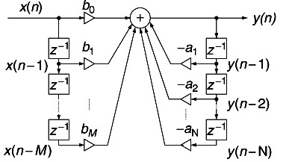

**The direct form I realization of the second order IIR filter ($N=M=2$) is given by**

$$y\left(n\right)=b_{0}x\left(n\right)+b_{1}x\left(n-1\right)+b_{2}x\left(n-2\right)-a_{1}y\left(n-1\right)-a_{2}y\left(n-2\right)$$

**is shown in the diagram below:**

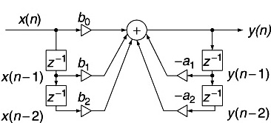

* 1. **Direction-Form II Realization**

**Using the digital filter transfer function, we can write**

$$Y\left(z\right)=H\left(z\right)X\left(z\right)=\frac{B\left(z\right)}{A\left(z\right)}X\left(z\right)=B\left(z\right)\left(\frac{X\left(z\right)}{A\left(z\right)}\right)$$

**This expression can also be written as**

|  |  |
| --- | --- |
| $$Y\left(z\right)=\left(b_{0}+b_{1}z^{-1}+…+b_{M}z^{-M}\right)\left(\frac{X\left(z\right)}{1+a_{1}z^{-1}+…+a_{N}z^{-N}}\right)$$ | **(1)** |

**By defining**

|  |  |
| --- | --- |
| $$W\left(z\right)=\frac{1}{1+a_{1}z^{-1}+…+a_{N}z^{-N}}X\left(z\right)$$ | **(2)** |

**We have**

|  |  |
| --- | --- |
| $$Y\left(z\right)=\left(b_{0}+b_{1}z^{-1}+…+b_{M}z^{-M}\right)W\left(z\right)$$ | **(3)** |

**The corresponding difference equations for equations (2) and (3) are**

|  |  |
| --- | --- |
| $$w\left(n\right)=x\left(n\right)-a_{1}w\left(n-1\right)-a_{2}w\left(n-2\right)-…-a_{N}w\left(n-N\right)$$ | **(4)** |

**and**

|  |  |
| --- | --- |
| $$y\left(n\right)=b_{0}w\left(n\right)+b_{1}w\left(n-1\right)+…+b_{M}w\left(n-M\right)$$ | **(5)** |

**These difference equations can be implemented by a direct-form II realization.**

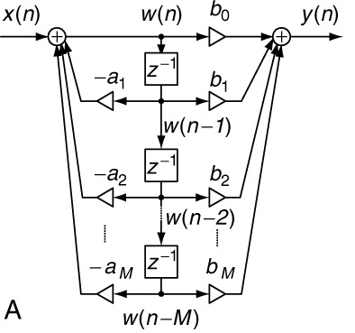

**The direct form II realization of the second order IIR filter ($N=M=2$) is given by the equations**

$$w\left(n\right)=x\left(n\right)-a_{1}w\left(n-1\right)-a_{2}w\left(n-2\right)$$

$$y\left(n\right)=b_{0}w\left(n\right)+b_{1}w\left(n-1\right)+b_{2}w\left(n-2\right)$$

**is shown in the diagram below:**

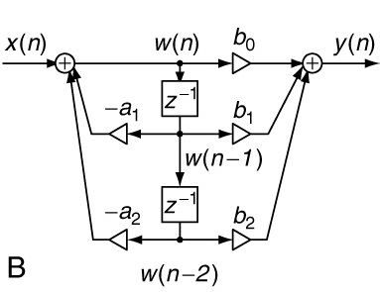

* 1. **Cascade (Series) Realization**

**The digital filter transfer function can be factorized and written as**

$$H\left(z\right)=H_{1}\left(z\right)∙H_{2}\left(z\right)⋯H_{k}\left(z\right)$$

**where $H_{k}\left(z\right)$ is chosen to be first- or second-order transfer function (section), defined as,**

|  |  |
| --- | --- |
| $$H_{k}\left(z\right)=\left(\frac{b_{k0}+b_{k1}z^{-1}}{1+a_{k1}z^{-1}}\right)$$ |  |

**Or**

|  |  |
| --- | --- |
| $$H_{k}\left(z\right)=\left(\frac{b_{k0}+b_{k1}z^{-1}+b_{k2}z^{-2}}{1+a_{k1}z^{-1}+a_{k2}z^{-2}}\right)$$ |  |

**The block diagram for the cascade (or series) realization is shown in figure below.**

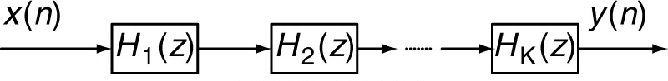

**For the individual first- or second-order transfer function (section), one can use either direct form I or direct form II realizations.**

* 1. **Parallel Realization**

**The digital filter transfer function can be written as**

$$H\left(z\right)=H_{1}\left(z\right)+H_{2}\left(z\right)+⋯+H_{k}\left(z\right)$$

**where $H_{k}\left(z\right)$ is chosen to be first- or second-order transfer function (section), defined as,**

|  |  |
| --- | --- |
| $$H_{k}\left(z\right)=\left(\frac{b_{k0}}{1+a_{k1}z^{-1}}\right)$$ |  |

**Or**

|  |  |
| --- | --- |
| $$H_{k}\left(z\right)=\left(\frac{b_{k0}+b_{k1}z^{-1}}{1+a_{k1}z^{-1}+a_{k2}z^{-2}}\right)$$ |  |

**The block diagram for the parallel realization is shown in figure below.**

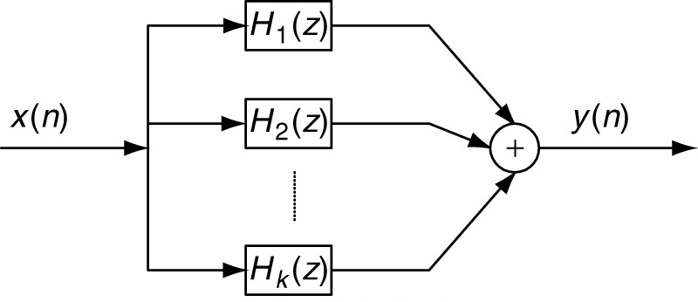

**Here again, for the individual first- or second-order transfer function (section), one can use either direct form I or direct form II realizations.**

**Example 13**

**Given a second-order transfer function**

$$H\left(z\right)=\frac{0.5 \left(1-z^{-1}\right)}{\left(1+1.3 z^{-1}+0.36 z^{-2}\right)}$$

**Perform the filter realizations and write the difference equations using the following realizations**

1. **Direct form I and direct form II**
2. **Cascade form via the first-order sections**
3. **Parallel form via the first-order sections**

**Solution**

**Part (1): The transfer function in its “delay” form can be written as**

$$H\left(z\right)=\frac{0.5-0.5 z^{-2}}{1+1.3 z^{-1}+0.36 z^{-2}}$$

**Comparing it with the standard delay form of the transfer function**

$$H\left(z\right)=\frac{b_{0}+b_{1}z^{-1}+…+b_{M}z^{-M}}{1+a_{1}z^{-1}+…+a_{N}z^{-N}}$$

**We identify, that $M=1, N=2$, and**

$$b_{0}=0.5, b_{1}=0.0, b_{2}=-0.5$$

$$a_{1}=1.3, a_{2}=0.36$$

**The difference equation form for the direct form I realization is given by**

$$y\left(n\right)=0.5 x\left(n\right)- 0.5 x\left(n-2\right)- 1.3 y\left(n-1\right)- 0.36 y(n-2)$$

**The direct form I realization for this filter is shown in figure below.**

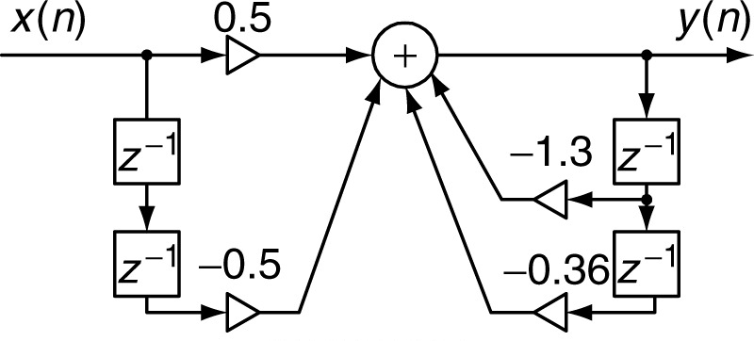

**For the direct form II realization, we write the difference equation as made up of the following two difference equations**

$$w\left(n\right)=x\left(n\right)- 1.3 w\left(n-1\right)- 0.36 w(n-2)$$

$$y\left(n\right)=0.5 w\left(n\right)- 0.5 w\left(n-2\right)$$

**The direct form II realization of the filter is shown below in the figure.**

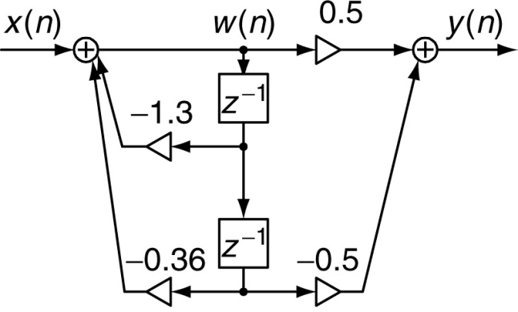

**Part (2): For the cascade realization, the transfer function is written in the product form. This is achieved by factorization of the numerator and the denominator polynomials. The given transfer function is**

$$H\left(z\right)=\frac{0.5\left(1-z^{-2}\right) }{1+1.3 z^{-1}+0.36 z^{-2}}$$

**The numerator polynomial can be factorized as**

$$B\left(z\right)= 0.5\left(1-z^{-2}\right)=0.5 \left(1-z^{-1}\right)\left(1+z^{-1}\right)$$

**The denominator polynomial can be factorized as**

$$A\left(z\right)= 1+1.3 z^{-1}+0.36 z^{-2}=1+0.4 z^{-1}+0.9 z^{-1}+0.36 z^{-2}=1\left(1+0.4 z^{-1}\right)+0.9z^{-1}\left(1+0.4 z^{-1}\right)=\left(1+0.4 z^{-1}\right)\left(1+0.9z^{-1}\right)$$

**Therefore, the transfer function can be written as**

$$H\left(z\right)=\frac{0.5 \left(1-z^{-1}\right)\left(1+z^{-1}\right) }{\left(1+0.4 z^{-1}\right)\left(1+0.9z^{-1}\right)}$$

**Or**

$$H\left(z\right)=\left(\frac{ 0.5-0.5 z^{-1} }{1+0.4 z^{-1}}\right)\left(\frac{ 1+z^{-1} }{1+0.9z^{-1}}\right)=H_{1}\left(z\right)∙H_{2}\left(z\right)$$

**Thus, in this case**

$$H_{1}\left(z\right)=\frac{ 0.5-0.5 z^{-1} }{1+0.4 z^{-1}}$$

$$H_{2}\left(z\right)=\frac{ 1+z^{-1} }{1+0.9z^{-1}}$$

**Each one of $H_{1}\left(z\right)$ and $H_{2}\left(z\right)$ can be realized in direct form I or direct form II. Overall, we get the cascaded realization with two sections. It should be noted that there could be other forms for $H_{1}\left(z\right)$ and $H_{2}\left(z\right)$, for example, we could have taken $H_{1}\left(z\right)=\frac{ 1+z^{-1} }{1+0.4 z^{-1}}$, $H_{2}\left(z\right)=\frac{ 0.5-0.5 z^{-1} }{1+0.9z^{-1}}$, to yield the same $H\left(z\right)$. Using the former $H_{1}\left(z\right)$ and $H_{2}\left(z\right)$, and using direct form II realizations for the two cascaded sections, we get the following difference equations:**

**Section 1: ($H_{1}\left(z\right)=\frac{ 0.5-0.5 z^{-1} }{1+0.4 z^{-1}}$)**

$$w_{1}\left(n\right)=x\left(n\right)- 0.4 w\left(n-1\right)$$

$$y_{1}\left(n\right)=0.5 w_{1}\left(n\right)- 0.5 w_{1}\left(n-1\right)$$

**Section 2: ($H_{2}\left(z\right)=\frac{ 1+z^{-1} }{1+0.9z^{-1}}$)**

$$w_{2}\left(n\right)=y_{1}\left(n\right)- 0.9 w_{2}\left(n-1\right)$$

$$y\left(n\right)= w_{2}\left(n\right)+w_{2}\left(n-1\right)$$

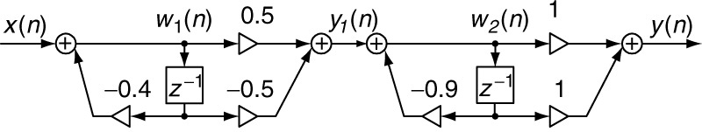

**Part (3): For the parallel realization, the transfer function is written in the partial fraction’s form. The given transfer function is**

$$H\left(z\right)=\frac{0.5\left(1-z^{-2}\right) }{1+1.3 z^{-1}+0.36 z^{-2}}$$

**Multiplying the numerator and denominator with $z^{2}$ we get**

$$H\left(z\right)=\frac{0.5\left(z^{2}-1\right) }{z^{2}+1.3 z+0.36 }$$

**The denominator polynomial can be factorized as**

$$A\left(z\right)= z^{2}+1.3 z+0.36=z^{2}+0.4 z+0.9 z+0.36 =1\left(z+0.4 \right)+0.9 z \left(z+0.4 \right)=\left(z+0.4\right)\left(z+0.9\right)$$

**Therefore, the transfer function can be written as**

$$H\left(z\right)=\frac{0.5\left(z^{2}-1\right) }{\left(z+0.4 \right)\left(z+0.9\right)}$$

**Or**

$$\frac{H\left(z\right)}{z}=\frac{0.5\left(z^{2}-1\right) }{z\left(z+0.4 \right)\left(z+0.9\right)}$$

**Writing it into partial fractions form,**

$$\frac{H\left(z\right)}{z}=\frac{A }{z}+\frac{B }{\left(z+0.4 \right)}+\frac{C }{\left(z+0.9\right)}$$

**where**

$$A={\left.z\left(\frac{0.5\left(z^{2}-1\right) }{z\left(z+0.4 \right)\left(z+0.9\right)}\right)\right|}_{z=0}={\left.\frac{0.5\left(z^{2}-1\right) }{\left(z+0.4 \right)\left(z+0.9\right)}\right|}_{z=0}=-1.39$$

$$B={\left.\left(z+0.4 \right)\left(\frac{0.5\left(z^{2}-1\right) }{z\left(z+0.4 \right)\left(z+0.9\right)}\right)\right|}_{z=-0.4}={\left.\frac{0.5\left(z^{2}-1\right) }{z\left(z+0.9\right)}\right|}_{z=-0.4}=-2.1$$

$$c={\left.\left(z+0.9 \right)\left(\frac{0.5\left(z^{2}-1\right) }{z\left(z+0.4 \right)\left(z+0.9\right)}\right)\right|}_{z=-0.9}={\left.\frac{0.5\left(z^{2}-1\right) }{z\left(z+0.4\right)}\right|}_{z=-0.9}=0.21$$

**Therefore,**

$$\frac{H\left(z\right)}{z}=\frac{-1.39 }{z}+\frac{-2.1 }{\left(z+0.4 \right)}+\frac{0.21 }{\left(z+0.9\right)}$$

**Or**

$$H\left(z\right)=-1.39-\frac{2.1z }{\left(z+0.4 \right)}+\frac{0.21z }{\left(z+0.9\right)}$$

**In delay form it can be written as**

$$H\left(z\right)=-1.39-\frac{2.1 }{\left(1+0.4 z^{-1} \right)}+\frac{0.21 }{\left(1+0.9 z^{-1}\right)}$$

**This can be written as**

$$H\left(z\right)=H_{1}\left(z\right)+H_{2}\left(z\right)+H_{3}\left(z\right)$$

**This shows that for this filter, there are three sections in the parallel realization. They can be individually realized using either direct form I or direct form II realizations. We use direct form II realization. The difference equations for each of three parallel sections are**

**Section 1: ($H_{1}\left(z\right)=-1.39$)**

$$y_{1}\left(n\right)=-1.39 x\left(n\right)$$

**Section 2: ($H_{2}\left(z\right)=-\frac{2.1 }{\left(1+0.4 z^{-1} \right)}$)**

$$w_{2}\left(n\right)=x\left(n\right)- 0.4 w_{2}\left(n-1\right)$$

$$y_{2}\left(n\right)= 2.1 w_{2}\left(n\right)$$

**Section 2: ($H_{3}\left(z\right)=\frac{0.21 }{\left(1+0.9 z^{-1}\right)}$)**

$$w_{3}\left(n\right)=x\left(n\right)- 0.9 w_{3}\left(n-1\right)$$

$$y_{3}\left(n\right)= -0.21 w_{3}\left(n\right)$$

**The output is $y\left(n\right)=y_{1}\left(n\right)+y_{2}\left(n\right)+y_{3}\left(n\right)$ and the parallel realization is shown below in the diagram.**

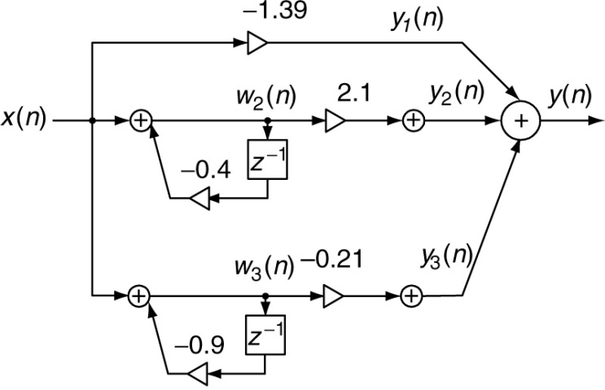

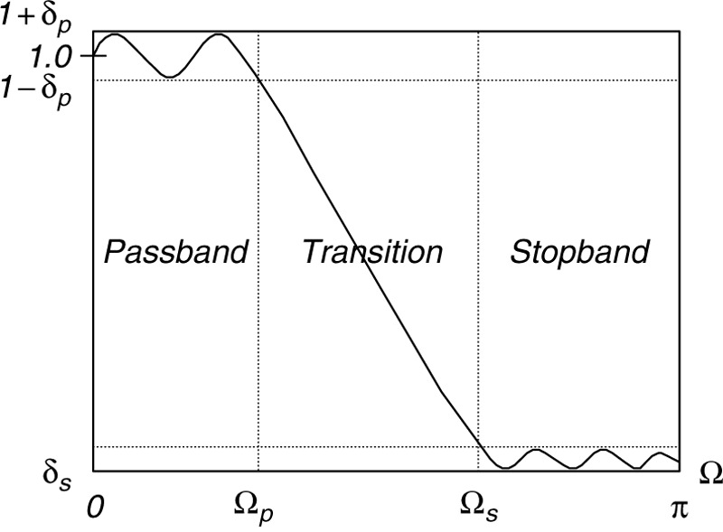

**Magnitude frequency response of a normalized lowpass filter.**

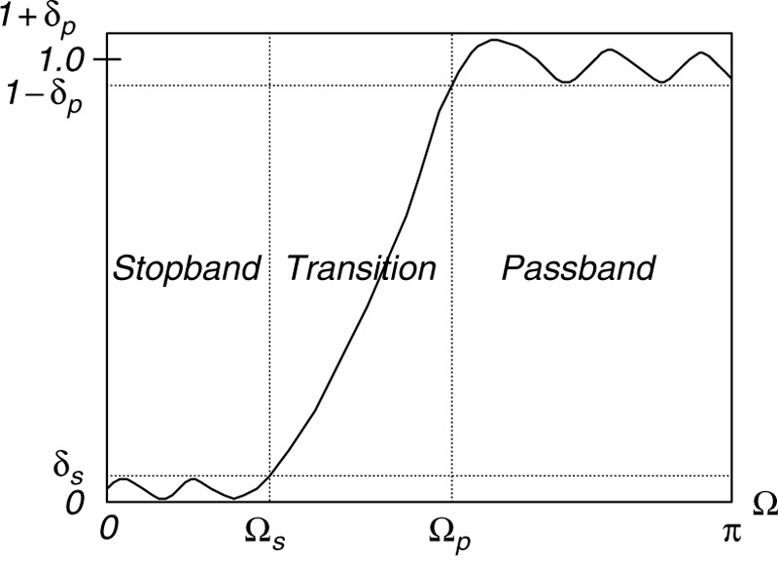

**Magnitude frequency response of a normalized highpass filter.**

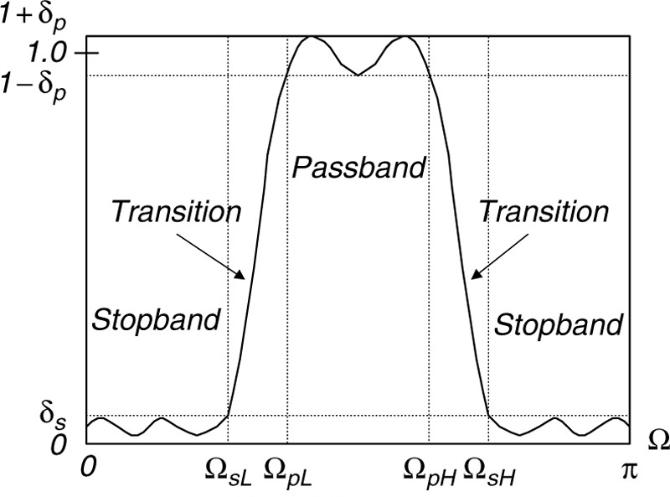

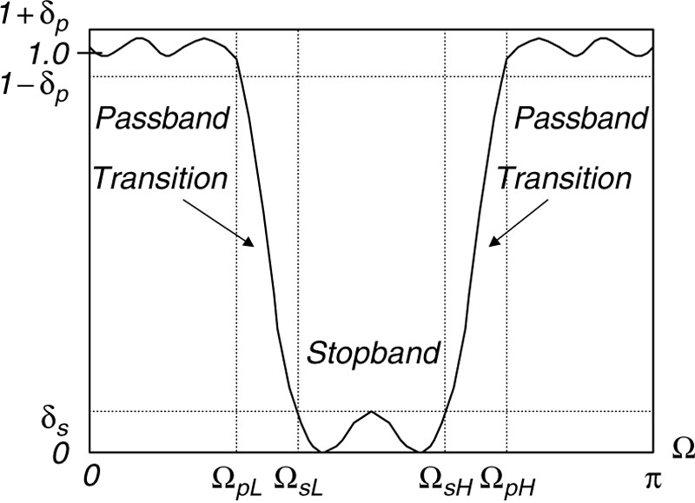

**Magnitude frequency response of a normalized bandreject filter.**

**Magnitude frequency response of a normalized bandpass filter.**

1. **Finite Impulse Response (FIR) Filter Design**

**An FIR filter is completely specified by the following difference equation (input-output relationship):**

|  |  |
| --- | --- |
| $$y\left(n\right)=b_{0}x\left(n\right)+b_{1}x\left(n-1\right)+…+b_{M}x\left(n-M\right)=\sum_{i=0}^{M}{b_{i}x\left(n-i\right)}$$ | **(7.1)** |

**The frequency response of an ideal lowpass filter is shown below in Figure (a).**

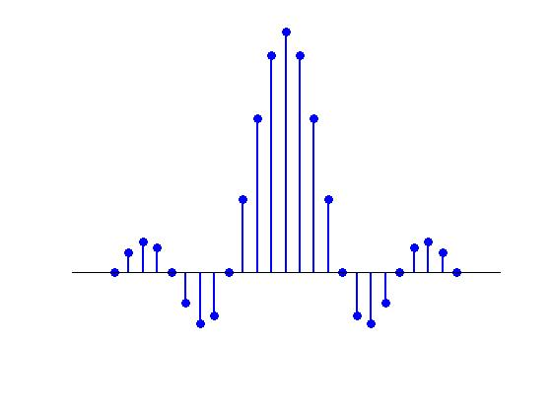

$$\left|H\left(e^{jΩ}\right)\right|$$

$$-π$$

$$π$$

$${-Ω}_{c}$$

$$Ω_{c}$$

**0**

**1**

(a) Ideal Lowpass Frequency Response

$$h(n)$$

(b) Impulse Response of an Ideal Lowpass Filter

**Mathematically it is given by**

$$H\left(e^{jΩ}\right)=\left\{\begin{matrix}1, & 0≤\left|Ω\right|≤Ω_{c} \\ 0, & Ω_{c}≤\left|Ω\right|≤π\end{matrix}\right.$$

**The frequency $Ω_{c}$ is the lowpass cutoff frequency. It can be shown that, the corresponding impulse response of the ideal lowpass filter is as shown in Figure (b) above. A truncated part of the impulse response is shown (the actual response extends to infinity on both sides) from $n=-M$ to $n=M$. It is given by**

$$h\left(n\right)=\left\{\begin{matrix}\frac{Ω_{c}}{π}, & n=0 \\ \frac{\text{sin}\left(Ω_{c} n\right)}{πn} & n≠0\end{matrix}\right.$$

**The impulse response is symmetric about $n=0$. It could further be shown that, in this case the z-transform of the impulse response is given by**

$$H\left(z\right)=h\left(M\right)z^{M}+h\left(M-1\right)z^{M-1}+⋯+h\left(1\right)z^{1}+h\left(0\right)+h\left(1\right)z^{-1}+⋯h\left(M-1\right)z^{-M+1}+h\left(M\right)z^{-M}$$

**To obtain a causal impulse response, we shift (delay) the non-causal impulse response by M samples, to yield the transfer function of a causal ideal lowpass FIR filter:**

$$H\left(z\right)=b_{0}+b_{1}z^{-1}+b_{2}z^{-2}+⋯+b_{2M}z^{-2M}$$

**where, $b_{n}=h\left(n-M\right) \text{for} n=0,1,2,⋯,2M$.**

**Similarly, we can obtain the design equations for the other types of FIR filters, such as highpass, bandpass and bandstop. Table 7.1 gives the formulas for these FIR filters for their filter coefficient calculations.**

**Table 7.1: Summary of ideal impulse responses for standard FIR filters**

|  |  |
| --- | --- |
| Filter Type | Ideal Impulse Response $h\left(n\right)$ (non-causal FIR coefficients) |
| Lowpass | $$h\left(n\right)=\left\{\begin{matrix}\frac{Ω_{c}}{π}, & n=0 \\ \frac{\text{sin}\left(Ω_{c} n\right)}{πn} & -M≤n≤M\end{matrix}\right.$$ |
| Highpass | $$h\left(n\right)=\left\{\begin{matrix}\frac{{π-Ω}_{c}}{π}, & n=0 \\ -\frac{\text{sin}\left(Ω_{c} n\right)}{πn} & -M≤n≤M\end{matrix}\right.$$ |
| Bandpass | $$h\left(n\right)=\left\{\begin{matrix}\frac{Ω_{H}-Ω_{L}}{π}, & n=0 \\ \frac{\text{sin}\left(Ω_{H} n\right)}{πn}-\frac{\text{sin}\left(Ω_{L} n\right)}{πn} & -M≤n≤M\end{matrix}\right.$$ |
| Bandstop | $$h\left(n\right)=\left\{\begin{matrix}\frac{π-Ω_{H}+Ω_{L}}{π}, & n=0 \\ -\frac{\text{sin}\left(Ω_{H} n\right)}{πn}+\frac{\text{sin}\left(Ω_{L} n\right)}{πn} & -M≤n≤M\end{matrix}\right.$$ |
| Causual FIR filter coefficients: shifting $h\left(n\right)$ to the right by samples.  Transfer Function: $$H\left(z\right)=b_{0}+b_{1}z^{-1}+b_{2}z^{-2}+⋯+b_{2M}z^{-2M}$$ Where $b_{n}=h\left(n-M\right) \text{for} n=0,1,2,⋯,2$ | |

**Example 7.2**

1. **Calculate the filter coefficients for a 3-tap FIR lowpass filter with a cutoff frequency of 800 Hz and a sampling rate of 8000 Hz using the Fourier Transform method.**
2. **Determine the transfer function and difference equation of the designed FIR system.**
3. **Compute and plot the frequency response.**

**Solution**

**Part (a): We first determine the normalized cutoff frequency**

$Ω_{c}=2π f_{c} T_{s}=2π×\frac{800}{8000}=0.2π$**radians**

**In this case $2M+1=3$, therefore, using table 7.1**

$$h\left(n\right)=\left\{\begin{matrix}\frac{Ω_{c}}{π}, & n=0 \\ \frac{\text{sin}\left(Ω_{c} n\right)}{πn} & -M≤n≤M\end{matrix}\right.$$

**Therefore**

$$h\left(0\right)=\frac{Ω_{c}}{π}=\frac{0.2π}{π}=0.2$$

$$h\left(1\right)=\frac{\text{sin}\left(Ω_{c} \right)}{π}=\frac{\text{sin}\left(0.2π\right)}{π}=0.1871$$

**Using symmetry, $h\left(-1\right)=h\left(1\right)=0.1871$**

**Delaying $h\left(n\right)$ by $M=1$ samples, we get**

$$b_{0}=h\left(0-1\right)=h\left(-1\right)=0.1871$$

$$b_{1}=h\left(1-1\right)=h\left(0\right)=0.2$$

$$b_{2}=h\left(1-1\right)=h\left(1\right)=0.1871$$

**Filter Coefficients**

**Part (b): Therefore, the transfer function in this case is**

$$H\left(z\right)=b_{0}+b_{1}z^{-1}+b_{2}z^{-2}=0.1871+0.2z^{-1}+0.1871z^{-2}$$

**The difference equation is**

$$y\left(n\right)=0.1871x\left(n\right)+0.2x\left(n-1\right)+0.1871x\left(n-2\right)$$

**Part (c): The frequency response of the filter is**

$$H\left(e^{jΩ}\right)=0.1871+0.2e^{-jΩ}+0.1871e^{-2jΩ}$$

**It can be written as**

$$H\left(e^{jΩ}\right)=e^{-jΩ}\left(0.1871e^{jΩ}+0.2+0.1871e^{-2jΩ}\right)=e^{-jΩ}\left(0.2+0.1871\left(e^{jΩ}+e^{-2jΩ}\right)\right)=e^{-jΩ}\left(0.2+0.1871×2\text{cos}\left(Ω\right)\right)=e^{-jΩ}\left(0.2+0.3742\text{cos}\left(Ω\right)\right)$$

**Thus, the magnitude frequency response is**

$$\left|H\left(e^{jΩ}\right)\right|=0.2+0.3742\text{cos}\left(Ω\right)$$

**And the phase response is**

$$∠H\left(e^{jΩ}\right)=\left\{\begin{matrix}-Ω, & 0.2+0.3742\text{cos}\left(Ω\right)>0 \\ -Ω+π & 0.2+0.3742\text{cos}\left(Ω\right)<0\end{matrix}\right.$$



**Figure 7.4: Frequency response in Example 7.2**

**In FIR filters with symmetrical coefficients, the phase response has a linear behavior in the passband.**

**This means that all frequency components of the filter input within the passband are subjected to the same amount of time delay at the filter output. This is a requirement of applications in audio and speech filtering, where phase distortions needs to be avoided.**

**If the design method cannot produce the symmetrical coefficients, then the resultant FIR filter does not have linear phase property leading to distortions in the filtered signal. This distortion due to nonlinear phase is shown with the example below.**

$$x\left(n\right)=x_{1}\left(n\right)+x_{2}\left(n\right)=\text{sin}\left(0.05πn\right) u\left(n\right)+\text{sin}\left(0.15πn\right) u\left(n\right)$$

$$y_{1}\left(n\right)=\text{sin}\left(0.05π(n-8)\right) +\text{sin}\left(0.15π(n-8)\right)$$

$$y_{2}\left(n\right)=\text{sin}\left(0.05πn-π/2\right) +\text{sin}\left(0.15πn-π/2)\right)$$

Linear Phase

Non-Linear Phase

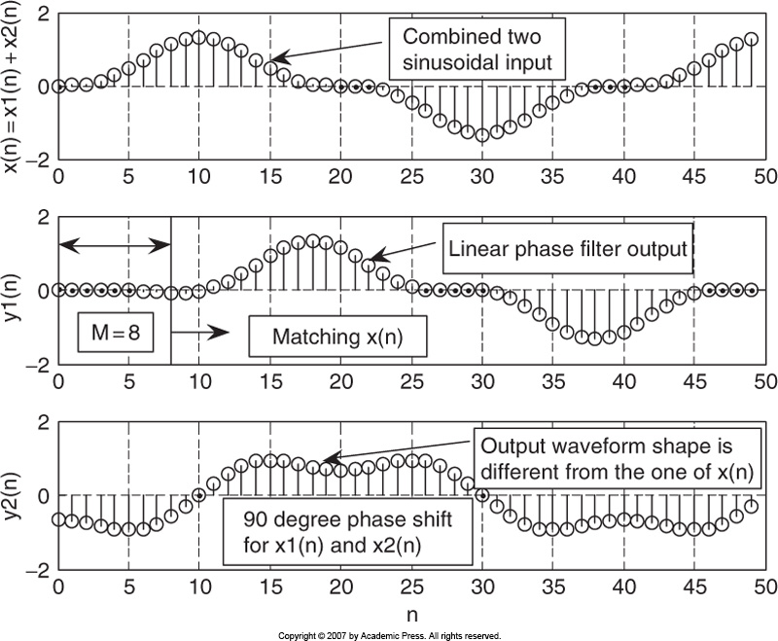

**The FIR filter has a good phase property, but it does not give an acceptable magnitude frequency response. The result with an 17-tap lowpass filter is also shown below.**

**There are oscillations (ripple) in the passband (main lobe) and stopband (side lobe) of the magnitude frequency response. This is due to Gibbs oscillations, originating from the abrupt truncation of the infinite impulse response of the lowpass filter.**

**This behavior can be avoided with the help of windowing.**



**Figure 7.5: Magnitude and Phase Frequency responses of the ideal lowpass FIR filters with 3-coefficients (dashed lines) and 17 coefficients (solid lines)**

**Example 7.2**

1. **Calculate the filter coefficients for a 5-tap FIR bandpass filter with a lower cutoff frequency of 2000 Hz and an upper cutoff frequency of 2400 at a sampling rate of 8000 Hz.**
2. **Determine the transfer function and plot the frequency responses with MATLAB.**

**Solution**

**Part (a): We first determine the normalized cutoff frequencies**

${\text{Ω}}_{L}=\frac{2πf_{L}}{f_{s}}=2π×\frac{2000}{8000}=0.5π$**radians**

$Ω_{H}=\frac{2πf_{H}}{f_{s}}=2π×\frac{2400}{8000}=0.6π$**radians**

**In this case $2M+1=5$, therefore, from Table7.1**

$$h\left(n\right)=\left\{\begin{matrix}\frac{Ω_{H}-Ω_{L}}{π}, & n=0 \\ \frac{sin\left(Ω_{H} n\right)}{n π}-\frac{sin\left(Ω_{L} n\right)}{n π}, & -2≤n≤2\end{matrix}\right.$$

**The non-causal FIR coefficients are**

$$h\left(0\right)=\frac{Ω_{H}-Ω_{L}}{π}=\frac{0.6π-0.5π}{π}=0.1$$

$$h\left(1\right)=\frac{sin\left(Ω_{H}×1\right)}{π×1}-\frac{sin\left(Ω_{L}×1\right)}{π×1}=\frac{sin\left(0.6π\right)}{π}-\frac{sin\left(0.5π\right)}{π}=-0.01558$$

$$h\left(2\right)=\frac{sin\left(Ω_{H}×2\right)}{π×2}-\frac{sin\left(Ω_{L}×2\right)}{π×2}=\frac{sin\left(1.2π\right)}{2π}-\frac{sin\left(1.0π\right)}{2π}=-0.09355$$

**Using the symmetry property**

$$h\left(-1\right)=h\left(1\right)=-0.01558$$

$$h\left(-2\right)=h\left(2\right)=-0.09355$$

**Thus the filter coefficients are obtained by delaying by $M=2$ samples, as**

$$b_{0}=h\left(0-2\right)=h\left(-2\right)=-0.09355$$

$$b_{1}=h\left(1-2\right)=h\left(-1\right)=-0.01558$$

$$b_{2}=h\left(2-2\right)=h\left(0\right)=0.1$$

$$b_{3}=h\left(3-2\right)=h\left(1\right)=-0.01558$$

$$b_{4}=h\left(4-2\right)=h\left(2\right)=-0.09355$$

**Filter Coefficients**

**Part (b): Therefore, the transfer function in this case is**

$$H\left(z\right)=b_{0}+b_{1}z^{-1}+b_{2}z^{-2}+b_{3}z^{-3}+b_{4}z^{-4}=-0.09355-0.01558 z^{-1}+0.1z^{-2}-0.01558z^{-3}-0.09355 z^{-4}$$

**The difference equation is**

$$y\left(n\right)=-0.09355 x\left(n\right)-0.01558 x\left(n-1\right)+0.1 x\left(n-2\right)-0.01558 x\left(n-3\right)-0.09355 x\left(n-4\right)$$

**Part (c): The frequency response of the filter is**

$$H\left(e^{jΩ}\right)=-0.09355-0.01558 e^{-jΩ}+0.1{ e}^{-2jΩ}-0.01558 e^{-3jΩ}-0.09355 e^{-4jΩ}$$

**It can be written as**

$$H\left(e^{jΩ}\right)=e^{-2jΩ}\left(-0.09355 e^{2jΩ}-0.01558 e^{jΩ}+0.1-0.01558 e^{-jΩ}-0.09355 e^{-2jΩ}\right)=e^{-2jΩ}\left(0.1-0.01558 \left(e^{jΩ}+ e^{-jΩ}\right)-0.09355 \left(e^{2jΩ}+ e^{-2jΩ}\right)\right)=e^{-2jΩ}\left(0.1-0.01558 \left(2cos\left(Ω\right)\right)-0.09355 \left(2cos\left(2Ω\right)\right)\right)=e^{-2jΩ}\left(0.1-0.03116 cos\left(Ω\right)-0.1871 cos\left(2Ω\right)\right)$$

**Thus, the magnitude frequency response is and the phase response are computed by the MATLAB program shown below and are the plots are shown in the figure below.**

**[response, w] = freqz([-0.09355 -0.01558 0.1 -0.01558 -0.09355], ...**

**[1], 512);**

**magnitude = abs(response);**

**magnitude2 = 20*log10(magnitude);**

**phase2 = 180*unwrap(angle(response))/pi;**

**figure,**

**subplot(2,1,1); plot(w, magnitude2,'LineWidth',2); grid on;**

**xlabel('Frequency (rad)');**

**ylabel('Magnitude response(dB)');**

**subplot(2,1,2); plot(w, phase2,'LineWidth',2); grid on;**

**xlabel('Frequency (rad)');**

**ylabel('Phase response(degrees)');**



**Figure 7.8: Magnitude and Phase Frequency responses of the ideal bandpass FIR filters with 5-coefficients (Example 7.3)**