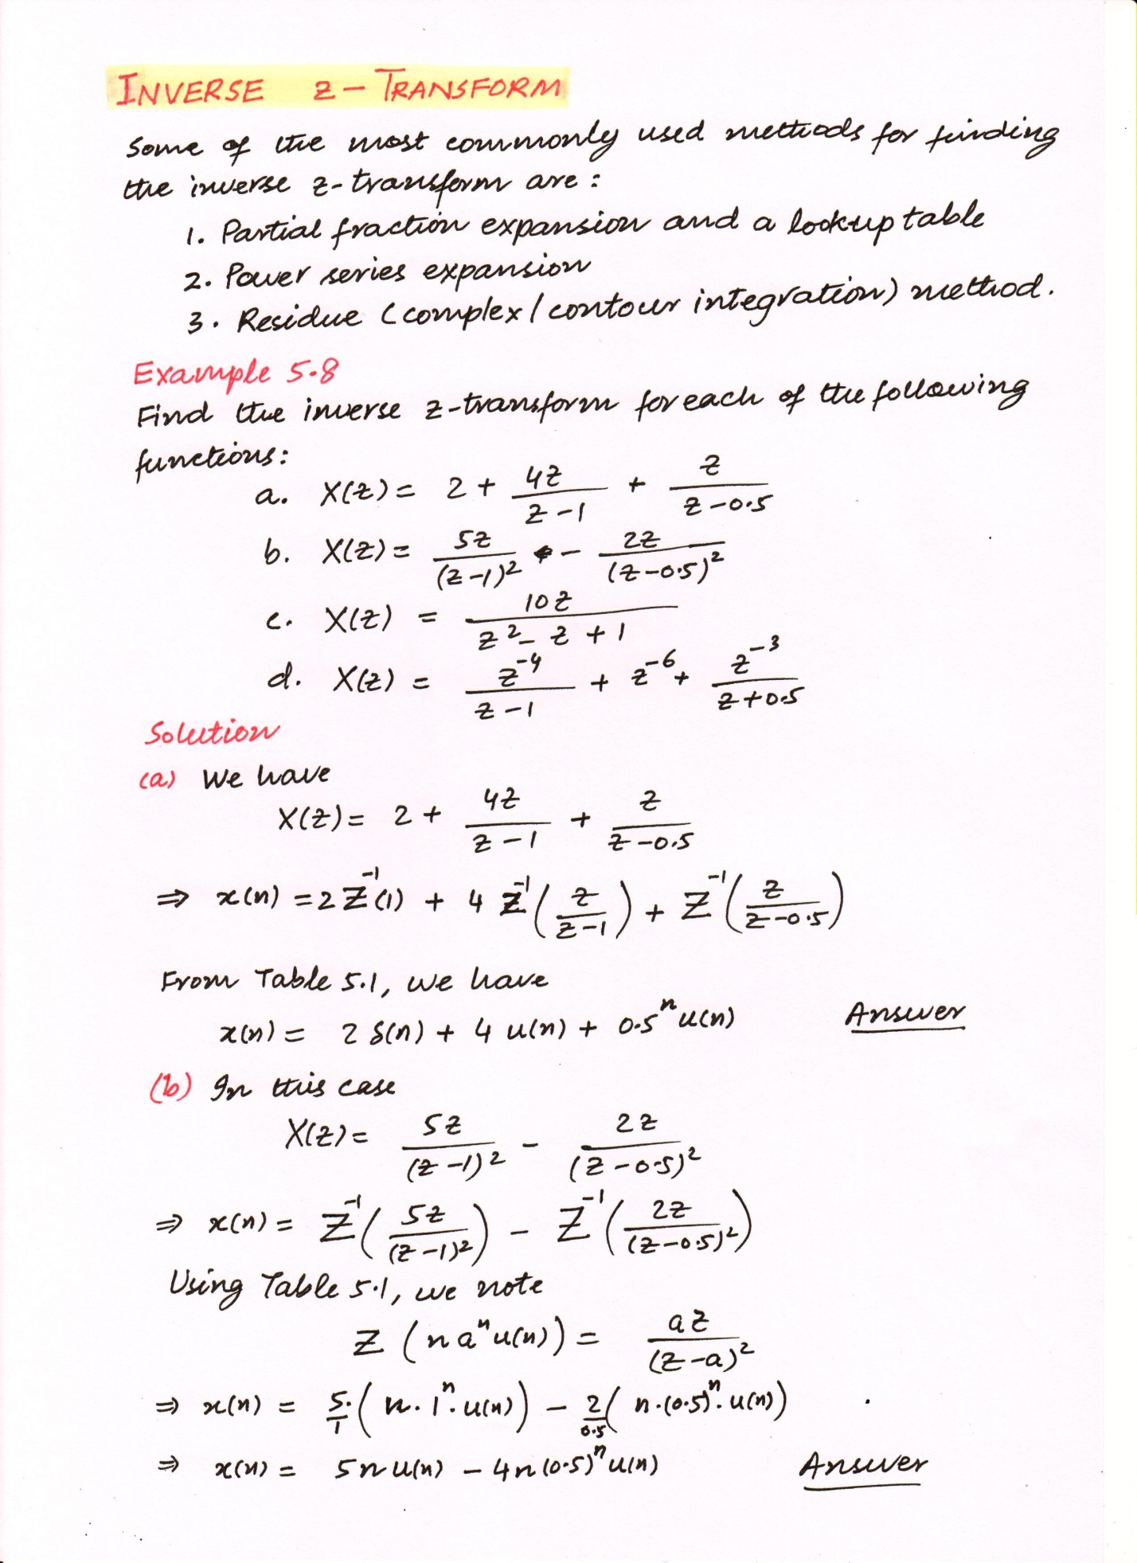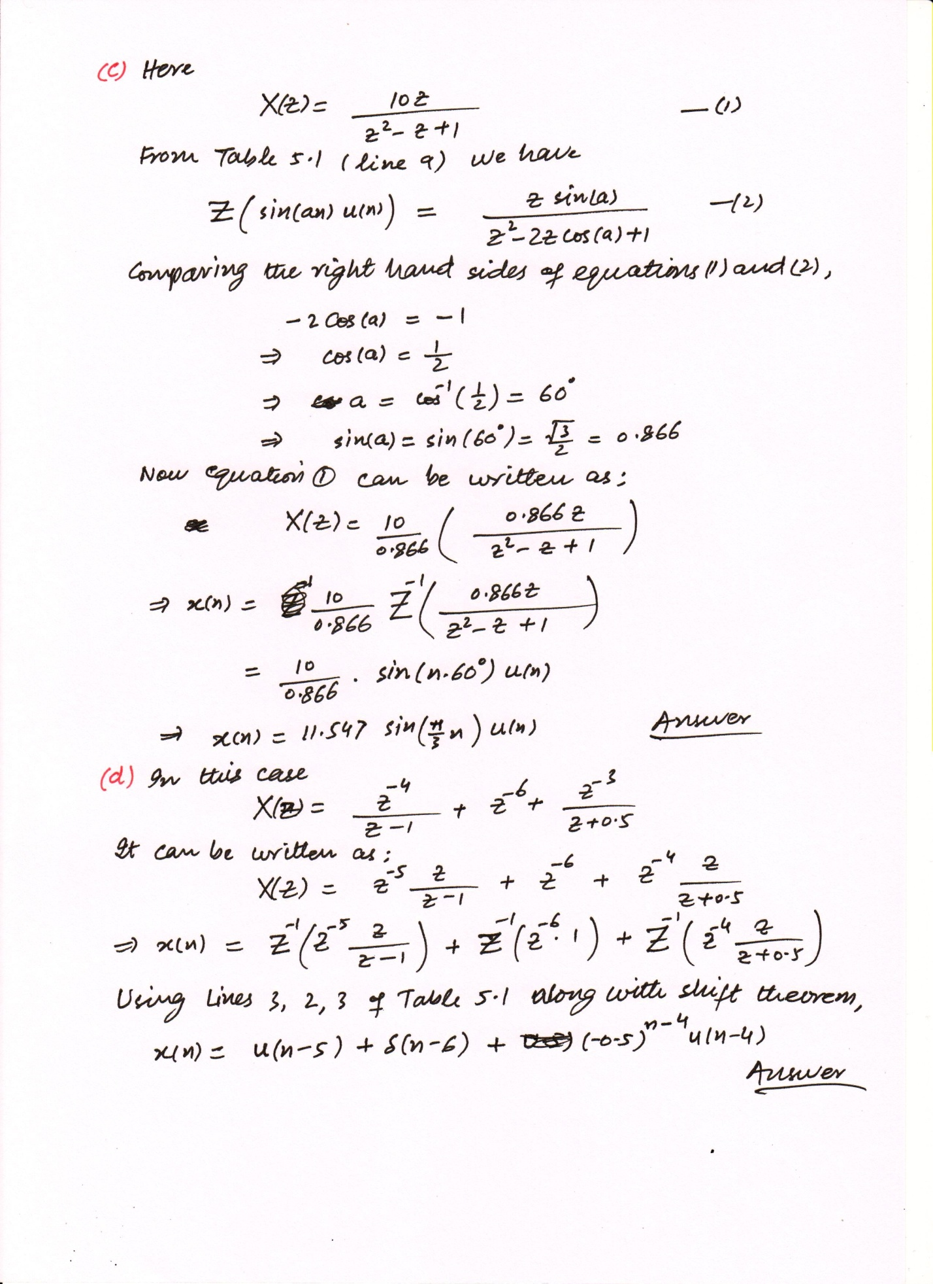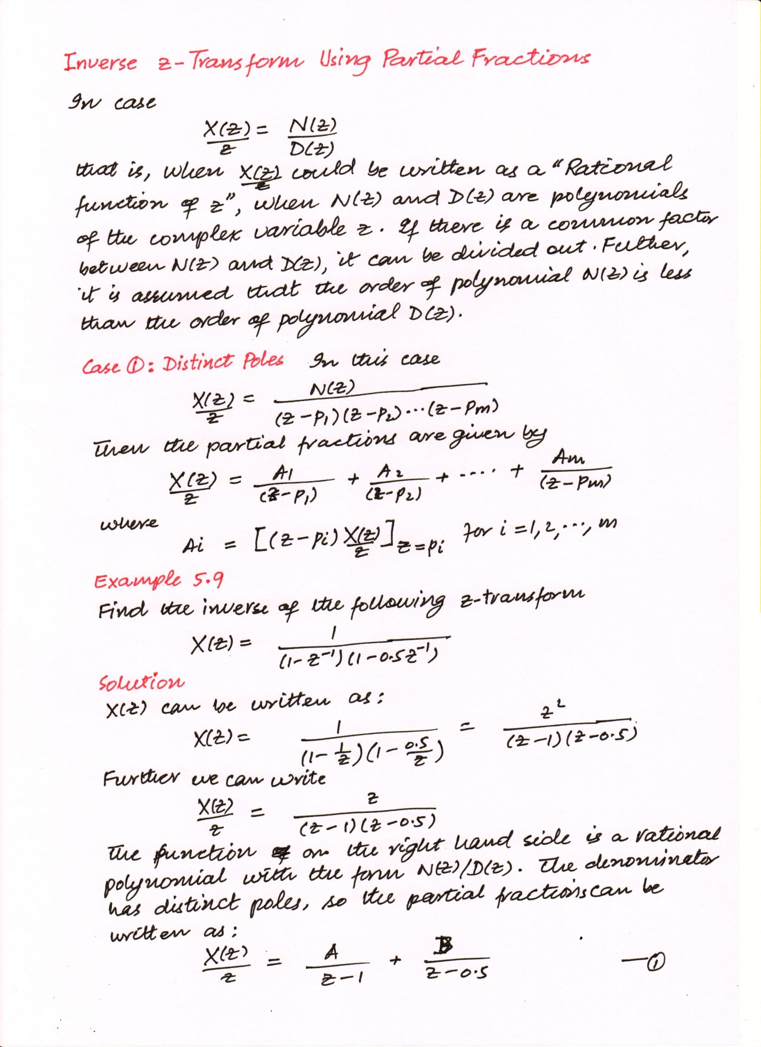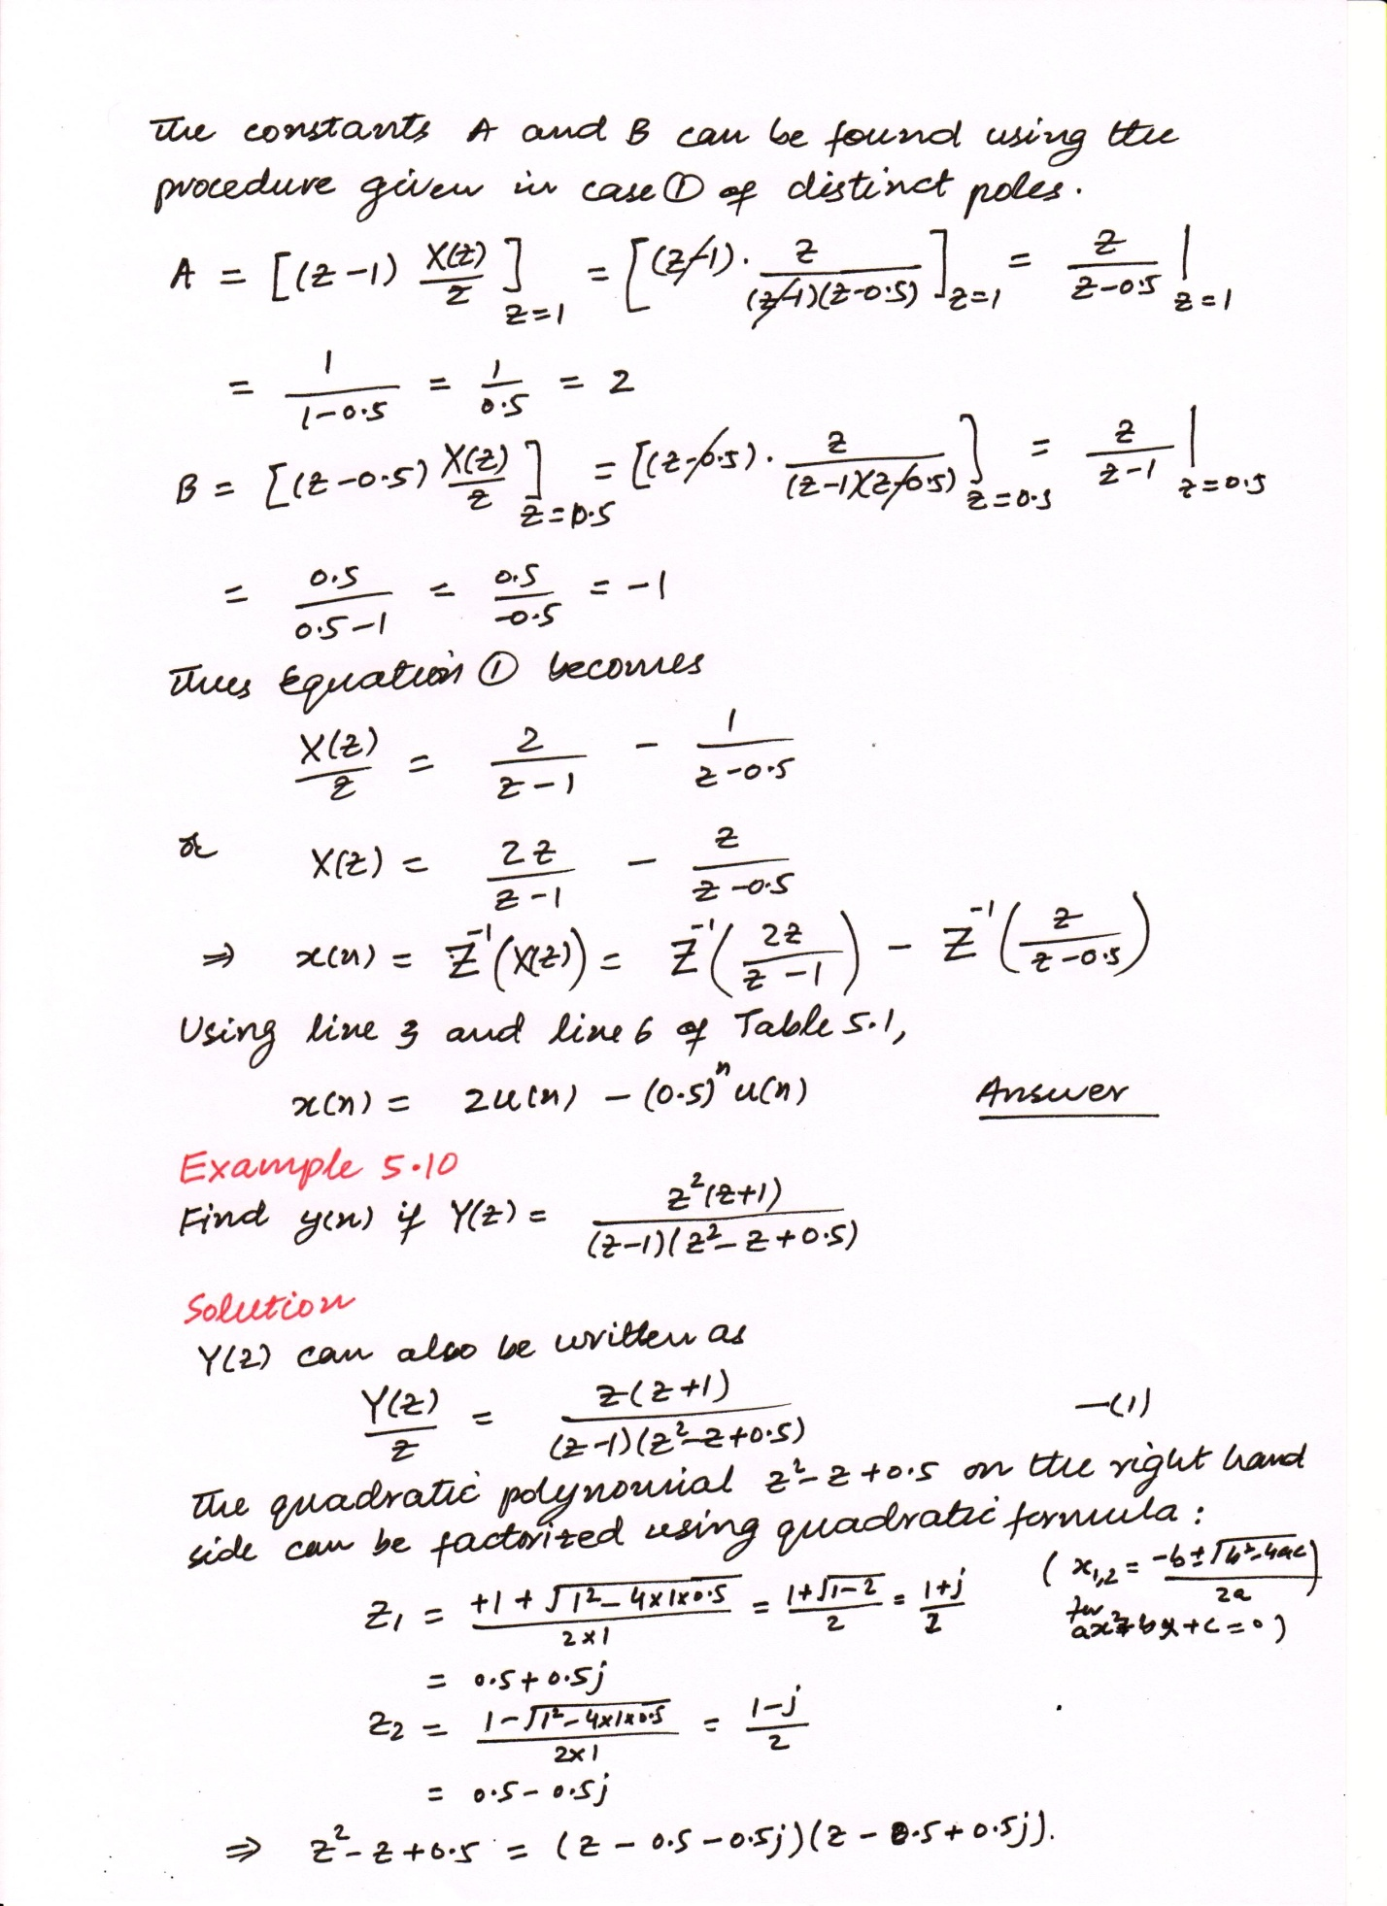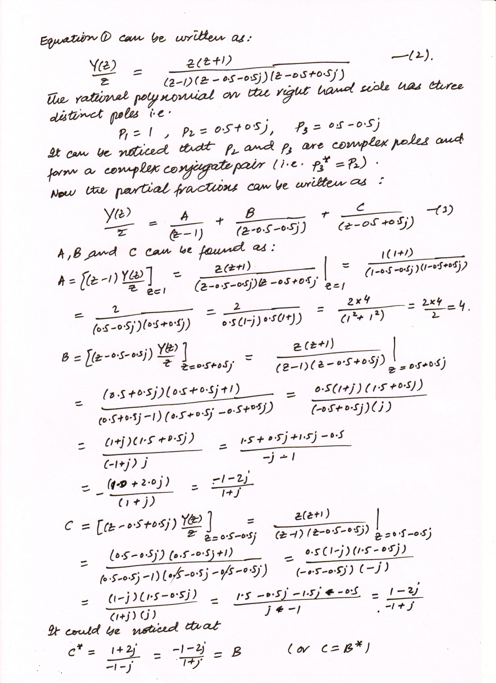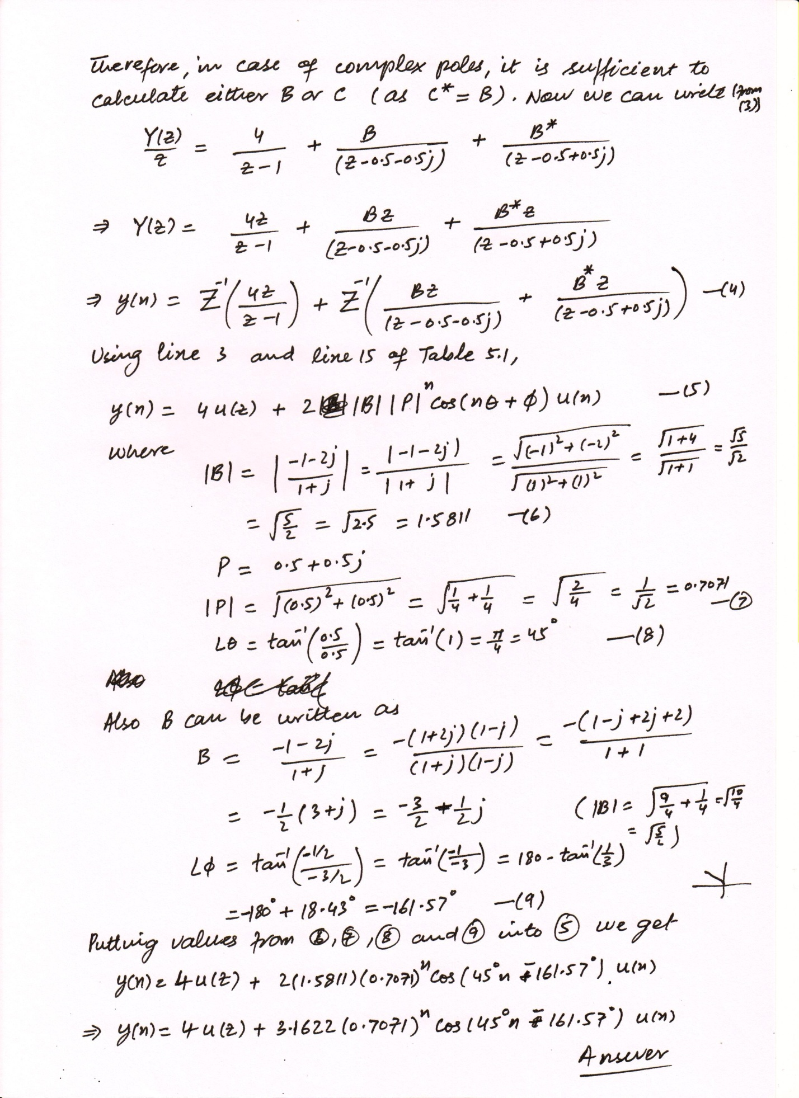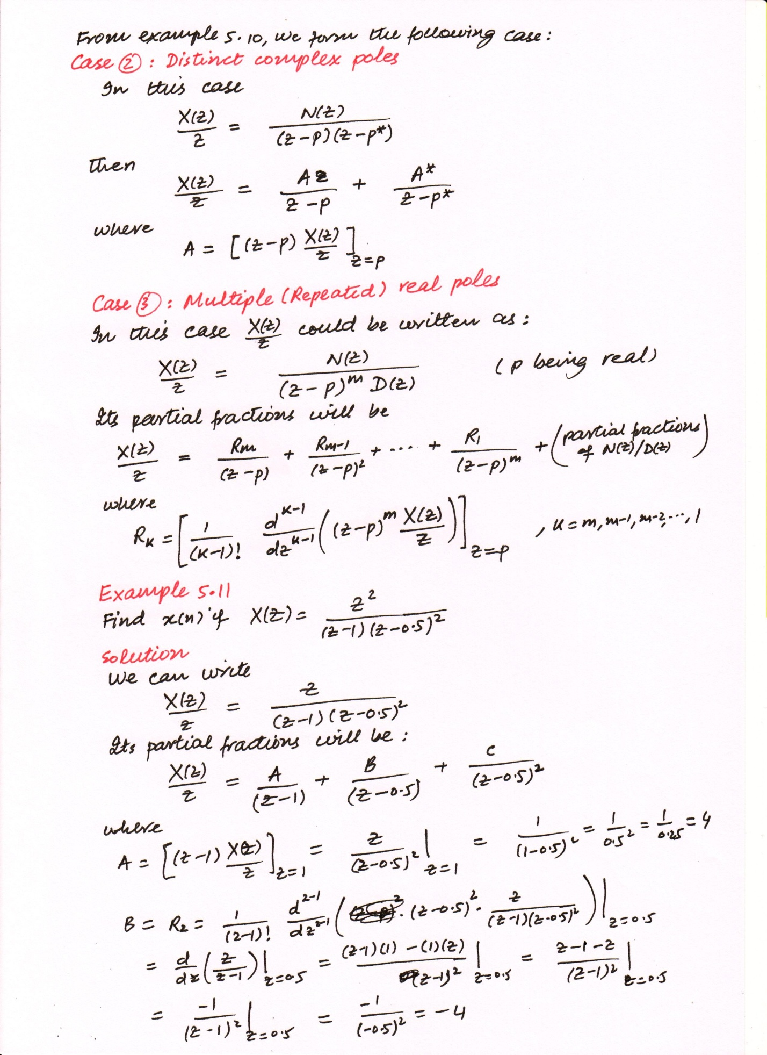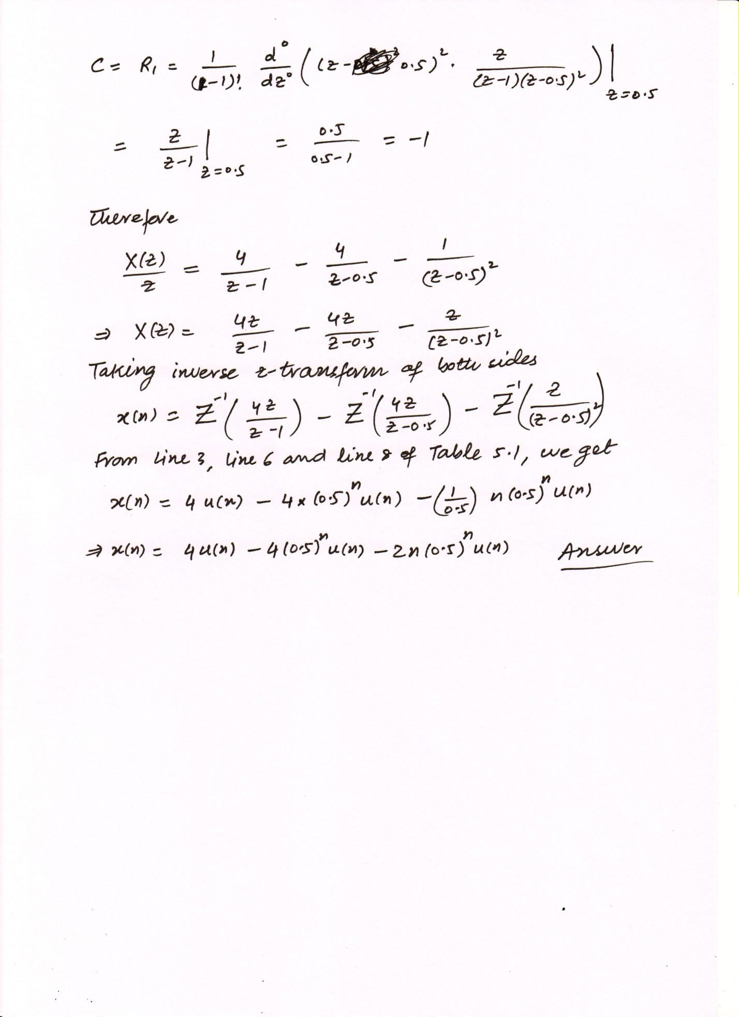Table 5.1 Table of z-transform pairs
Line No. | Signal  $$x\left(n\right), n≥0$$ | z-Transform  $$X(z)$$ | Region of Convergence
1 | $$x(n)$$ | $$\sum_{n=0}^{∞}{x\left(n\right) z^{-n}}$$
2 | $$δ(n)$$ | 1 | Entire z-plane
3 | $$a u(n)$$ | $$\frac{az}{z-1}$$ | $$\left|z\right|>1$$
4 | $$n u(n)$$ | $$\frac{z}{{\left(z-1\right)}^{2}}$$ | $$\left|z\right|>1$$
5 | $$n^{2} u(n)$$ | $$\frac{z(z+1)}{{\left(z-1\right)}^{3}}$$ | $$\left|z\right|>1$$
6 | $$a^{n} u(n)$$ | $$\frac{z}{z-a}$$ | $$\left|z\right|>\left|a\right|$$
7 | $$e^{-na} u(n)$$ | $$\frac{z}{z-e^{-a}}$$ | $$\left|z\right|>e^{-a}$$
8 | $${n a}^{n} u(n)$$ | $$\frac{az}{{\left(z-a\right)}^{2}}$$ | $$\left|z\right|>\left|a\right|$$
9 | $$sin\left(an\right) u(n)$$ | $$\frac{z sin\left(a\right)}{z^{2}-2z cos\left(a\right)+1}$$ | $$\left|z\right|>\left|1\right|$$
10 | $$cos\left(an\right) u(n)$$ | $$\frac{z \left(z-cos\left(a\right)\right)}{z^{2}-2z cos\left(a\right)+1}$$ | $$\left|z\right|>\left|1\right|$$
11 | $$a^{n} sin\left(bn\right) u(n)$$ | $$\frac{ \left[a sin\left(b\right)\right] z}{z^{2}-\left[2a cos\left(b\right)\right]z +a^{2}}$$ | $$\left|z\right|>\left|a\right|$$
12 | $$a^{n} cos\left(bn\right) u(n)$$ | $$\frac{z \left[z-a cos\left(b\right)\right] }{z^{2}-\left[2a cos\left(b\right)\right]z +a^{2}}$$ | $$\left|z\right|>\left|a\right|$$
13 | $$e^{-an} sin\left(bn\right) u(n)$$ | $$\frac{ \left[e^{-a} sin\left(b\right)\right] z}{z^{2}-\left[2e^{-a} cos\left(b\right)\right]z +e^{-2a}}$$ | $$\left|z\right|>e^{-a}$$
14 | $$e^{-an} cos\left(bn\right) u(n)$$ | $$\frac{z \left[{z-e}^{-a} cos\left(b\right)\right] }{z^{2}-\left[2e^{-a} cos\left(b\right)\right]z +e^{-2a}}$$ | $$\left|z\right|>e^{-a}$$
15 | $2\left|A\right|{\left|P\right|}^{n} cos\left(nθ+ϕ\right) u\left(n\right)$ where$P$ and$A$ are complex constants defined by  $P=\left|P\right|∠θ$, $A=\left|A\right|∠ϕ$ | $$\frac{Az}{z-P}+\frac{A^{*}z}{z-P^{*}}$$

Partial Fraction Expansion using MATLAB
The MATLAB function ‘residue’ can be used to determine the partial fractions of a z-transform function. The syntax is given as
[R, P, K] = residue(B, A)
The vectors B and A are made up the coefficients for the numerator and denominator polynomials$B\left(z\right)$ and$A\left(z\right)$, respectively as
$$\frac{X\left(z\right)}{z}=\frac{B(z)}{A(z)}$$
Example 5.12
Find the partial fraction expansion for each of the following z-transform functions:
- $X\left(z\right)=\frac{1}{\left(1-z^{-1}\right)\left(1-0.5z^{-1}\right)}$
- $X\left(z\right)=\frac{z^{2}(z+1)}{\left(z-1\right)\left(z^{2}-z+0.5\right)}$
- $X\left(z\right)=\frac{z^{2}}{\left(z-1\right){\left(z-0.5\right)}^{2}}$
Solution
Part(a) : In this case we have
$$X\left(z\right)=\frac{1}{\left(1-z^{-1}\right)\left(1-0.5z^{-1}\right)}$$
Multiplying both numerator and denominator by$z^{2}$ we get,
$$X\left(z\right)=\frac{z^{2}}{z^{2}\left(1-z^{-1}\right)\left(1-0.5z^{-1}\right)}=\frac{z^{2}}{\left(z-1\right)\left(z-0.5\right)}$$
This can also be written as
$$\frac{X\left(z\right)}{z}=\frac{z}{\left(z-1\right)\left(z-0.5\right)}$$
Using MATLAB function ‘conv’, we have
>> conv([1 -1],[1 -0.5])
ans =
1.0000 -1.5000 0.5000

Therefore,
MATLAB
>> conv([1 -1],[1 -0.5])
ans =
1.0000 -1.5000 0.5000

$$\frac{X\left(z\right)}{z}=\frac{z}{{(1.0)z}^{2}+\left(-1.5\right)z+(0.5)}$$

Now we can use MATLAB command ‘residue’ to find out the partial fractions
MATLAB
>> [R, P, K] = residue([1 0],[1 -1.5 0.5])
R =
2
-1
P =
1.0000
0.5000
K =
[]

Therefore,
$$\frac{X\left(z\right)}{z}=\frac{2}{z-1}+\frac{-1}{z-0.5}$$
Or
$$X\left(z\right)=\frac{2z}{z-1}-\frac{z}{z-0.5}$$
Part(b) : In this case we have
$$X\left(z\right)=\frac{z^{2}(z+1)}{\left(z-1\right)\left(z^{2}-z+0.5\right)}$$
This can also be written as
$$\frac{X\left(z\right)}{z}=\frac{z(z+1)}{\left(z-1\right)\left(z^{2}-z+0.5\right)}$$
Using MATLAB function ‘conv’, we have
>> conv([1 -1],[1 -1 0.5])
ans =
1.0000 -2.0000 1.5000 -0.5000
Therefore,
$$\frac{X\left(z\right)}{z}=\frac{(z^{2}+z)}{{(1.0)z}^{3}+\left(-2.0\right)z+\left(1.5\right)z+(-0.5)}$$
MATLAB
>> conv([1 -1],[1 -1 0.5])
ans =
1.0000 -2.0000 1.5000 -0.5000

Now we can use MATLAB command ‘residue’ to find out the partial fractions
MATLAB
>> [R, P, K] = residue([1 1 0],[1 -2 1.5 -0.5])
R =
4.0000
-1.5000 - 0.5000i
-1.5000 + 0.5000i
P =
1.0000
0.5000 + 0.5000i
0.5000 - 0.5000i
K =
[]

Therefore,
$$\frac{X\left(z\right)}{z}=\frac{4}{z-1}+\frac{-1.5-0.5j}{z-0.5-0.5j}+\frac{-1.5+0.5j}{z-0.5+0.5j}$$
Or
$$X\left(z\right)=\frac{4z}{\left(z-1\right)}-\frac{\left(1.5+0.5j\right)z}{\left(z-0.5-0.5j\right)}-\frac{\left(1.5-0.5j\right)z}{\left(z-0.5+0.5j\right)}$$
Part(c) : In this case we have
$$X\left(z\right)=\frac{z^{2}}{\left(z-1\right){\left(z-0.5\right)}^{2}}$$
This can also be written as
$$\frac{X\left(z\right)}{z}=\frac{z}{\left(z-1\right){\left(z-0.5\right)}^{2}}$$
Using MATLAB function ‘conv’, we have
>> conv(conv([1 -1],[1 -0.5]),[1 -0.5])
ans =
1.0000 -2.0000 1.2500 -0.2500
Therefore,
$$\frac{X\left(z\right)}{z}=\frac{z}{{(1.0)z}^{3}+\left(-2.0\right)z+\left(1.25\right)z+(-0.25)}$$
MATLAB
>> conv([1 -1],[1 -1 0.5])
ans =
1.0000 -2.0000 1.2500 -0.2500

Now we can use MATLAB command ‘residue’ to find out the partial fractions
MATLAB
>> [R, P, K] = residue([1 0],[1 -2 1.25 -0.25])
R =
4.0000
-4.0000
-1.0000
P =
1.0000
0.5000
0.5000
K =
[]

Therefore,
$$\frac{X\left(z\right)}{z}=\frac{4}{z-1}+\frac{-4}{z-0.5}+\frac{-1}{{\left(z-0.5\right)}^{2}}$$
Or
$$X\left(z\right)=\frac{4s}{z-1}-\frac{4z}{z-0.5}-\frac{z}{{\left(z-0.5\right)}^{2}}$$

