Chapter 08
Interest Rate Risk I

True / False Questions
1. | The economic insolvency of many thrift institutions during the 1980s was due, at least in part, to unexpected increases in interest rates.  True False

2. | Because of its complexity, small depository institutions rarely use the repricing, or funding gap, model.  True False

3. | When the Fed finds it necessary to slow economic activity, it allows interest rates to fall.  True False

4. | Because the increased level of financial market integration has increased the speed with which interest rate changes are transmitted among countries, control of U.S. interest rates by the Federal Reserve is more difficult and less certain.  True False

5. | The Bank for International Settlements (BIS) requires depository institutions to have interest rate risk management systems.  True False

6. | The repricing gap model is a book value accounting based model.  True False

7. | The maturity gap model estimates the difference between interest earned and interest paid during a given period of time.  True False

8. | In the repricing gap model, assets or liabilities are rate sensitive within a given time period if the dollar values of each are subject to receiving a different interest rate should market rates change.  True False

9. | The repricing model is a simplistic approach to focusing on the exposure of net interest income to changes in market levels of interest rates for given maturity periods.  True False

10. | A positive repricing gap implies that a decrease in interest rates will cause interest expense to decrease more than the decrease in interest income.  True False

11. | The cumulative repricing gap position of an FI for a given extended time period is the sum of the repricing gap values for the individual time periods that make up the extended time period.  True False

12. | When a bank's repricing gap is positive, net interest income is positively related to changes in interest rates.  True False

13. | A bank with a negative repricing (or funding) gap faces reinvestment risk.  True False

14. | A bank with a negative repricing (or funding) gap faces refinancing risk.  True False

15. | One reason to include demand deposits when estimating a bank's repricing gap is because rising interest rates could lead to high withdrawals.  True False

16. | One reason to exclude demand deposits when estimating a bank's repricing gap is because, by regulation, explicit interest cannot be paid on these deposits.  True False

17. | Retail passbook savings accounts should be considered as part of rate sensitive liabilities because the rates on these accounts rarely change.  True False

18. | Runoff in demand deposits in a repricing model is typically lower during periods of falling interest rates.  True False

19. | The gap ratio is useful because it indicates the scale of the interest rate exposure by dividing the gap by the asset size of the institution.  True False

20. | Because the repricing model ignores the market value effect of changing interest rates, the repricing gap is an incomplete measure of the true interest rate risk exposure of an FI.  True False

21. | Defining buckets of time over a range of maturities assures the capture of all relevant information necessary to accurately assess the interest rate risk exposure of an FI.  True False

22. | Defining buckets of time over wider intervals creates greater accuracy in the use of the repricing model because fewer calculations are required.  True False

23. | If the interest rate spread between rate sensitive assets and rate sensitive liabilities increases for a bank, future increases in interest rates will lead to an increase in net interest income.  True False

24. | In general, the interest rate spread (spread effect) between rate sensitive assets and rate sensitive liabilities is positively related to the change in net interest income.  True False

25. | To be more precise in measuring interest rate risk, the runoff component of long-term mortgages should be considered in the time buckets in which the maturities actually occur.  True False

26. | When interest rates increase, banks are more likely to be forced to increase rate-sensitive liabilities to replace decreased balances in demand deposits and savings accounts.  True False

27. | For a given change in interest rates, fixed-rate assets with long-term maturities will have smaller changes in price than assets with shorter maturities.  True False

28. | The market value of a fixed-rate liability will decrease as interest rates rise, just as the market value of a fixed-rate asset will decrease as interest rates rise.  True False

29. | The market value of a fixed-rate liability will increase as interest rates rise, although the market value of a fixed-rate asset will decrease as interest rates rise.  True False

30. | The change in economic value of a fixed-rate liability for a decrease in interest rates is considered to be good news.  True False

31. | For a given change in interest rates, fixed-rate liabilities with longer-term maturities will have smaller changes in price than liabilities with shorter maturities.  True False

32. | For a given change in interest rates, the change in price for each additional year of maturity of a fixed-rate asset is smaller as the maturity increases.  True False

33. | The maturity of a portfolio of assets or liabilities is a weighted average of the maturities of the assets or liabilities that comprise that portfolio.  True False

34. | If the average maturity of assets is 4 years and the average maturity of liabilities is 4 years, then the FI has no interest rate risk exposure.  True False

35. | If the average maturity of assets is 5 years and the average maturity of liabilities is 7 years, then the FI has no interest rate risk exposure.  True False

36. | The maturity gap for a bank is the weighted average maturity of the assets minus the weighted average maturity of the liabilities.  True False

Multiple Choice Questions
37. | The net worth of a bank is the difference between the  A. value of retained earnings and the provision for loan losses.  B. market value of assets and the market value of liabilities.  C. book value of assets and book value of liabilities.  D. rate-sensitive assets and rate-sensitive liabilities.  E. None of the above.

38. | Because of its simplicity, smaller depository institutions still use this model as their primary measure of interest rate risk.  A. The repricing model.  B. The maturity model.  C. The duration model.  D. The convexity model.  E. The option pricing model.

39. | The repricing gap approach calculates the gaps in each maturity bucket by subtracting the  A. current assets from the current liabilities.  B. long term liabilities from the fixed assets.  C. rate sensitive assets from the total assets.  D. rate sensitive liabilities from the rate sensitive assets.  E. current liabilities from tangible assets.

40. | Which of the following observations about the repricing model is correct?  A. Its information value is limited.  B. It accounts for the problem of rate-insensitive asset and liability runoffs and prepayments.  C. It accommodates cash flows from off-balance-sheet activities.  D. It helps to determine an FI's profit exposure to interest rate changes.  E. It considers market value effects of interest rate changes.

41. | When repricing all interest sensitive assets and all interest sensitive liabilities in a balance sheet, the cumulative gap will be  A. zero.  B. one.  C. greater than one.  D. a negative value.  E. infinity.

42. | The repricing gap does not accurately measure FI interest rate risk exposure because  A. FIs cannot accurately predict the magnitude change in future interest rates.  B. FIs cannot accurately predict the direction of change in future interest rates.  C. accounting systems are not accurate enough to allow the calculation of precise gap measures.  D. it does not recognize timing differences in cash flows within the same maturity grouping.  E. equity is omitted.

43. | An FI's net interest income reflects  A. its asset-liability structure.  B. rates of interest when the assets and liabilities were put on the books.  C. the riskiness of its loans and investments.  D. the cost of its deposit and non-deposit sources of funds.  E. All of the above.

44. | A positive gap implies that an increase in interest rates will cause _______ in net interest income.  A. no change  B. a decrease  C. an increase  D. an unpredictable change  E. Either A or B.

45. | If interest rates decrease 50 basis points for an FI that has a gap of +$5 million, the expected change in net interest income is  A. + $2,500.  B. + $25,000.  C. + $250,000.  D. - $250,000.  E. - $25,000.

46. | If interest rates increase 75 basis points for an FI that has a gap of -$15 million, the expected change in net interest income is  A. -$112,500.  B. +$112,500.  C. +$1,125,0000.  D. -$1,125,0000.  E. -$150,000.

47. | If interest rates decrease 40 basis points (0.40 percent) for an FI that has a cumulative gap of -$25 million, the expected change in net interest income is  A. +$100,000.  B. -$100,000.  C. -$625,000.  D. -$250,000.  E. +$250,000.

48. | An FI finances a $250,000 2-year fixed-rate loan with a $200,000 1-year fixed-rate CD. Use the repricing model to determine (a) the FI's repricing (or funding) gap using a 1-year maturity bucket, and (b) the impact of a 100 basis point (0.01) decrease in interest rates on the FI's annual net interest income?  A. $0; $0.  B. -$200,000; +$2,000.  C. -$200,000; -$2,000.  D. +$50,000; -$500.  E. -$200,000; -$1,000.

49. | The gap ratio expresses the reprice gap for a given time period as a percentage of  A. equity.  B. total liabilities.  C. current liabilities.  D. total assets.  E. current assets.

50. | What is spread effect?  A. Periodic cash flow of interest and principal amortization payments on long-term assets that can be reinvested at market rates.  B. The effect that a change in the spread between rates on RSAs and RSLs has on net interest income as interest rates change.  C. The effect of mismatch of asset and liabilities within a maturity bucket.  D. The premium paid to compensate for the future uncertainty in a security's value.  E. The value of an FI to its owners.

51. | If an FI's repricing gap is less than zero, then  A. it is deficient in its required reserves.  B. it is deficient in its capital ratio requirement.  C. its liability costs are more sensitive to changing market interest rates than are its asset yields.  D. its liability costs are less sensitive to changing market interest rates than are its asset yields.  E. the duration of the FI's liabilities exceeds the duration of FI's assets.

52. | A bank that finances long-term fixed-rate mortgages with short-term deposits is exposed to  A. increases in net interest income and decreases in the market value of equity when interest rates fall.  B. decreases in net interest income and decreases in the market value of equity when interest rates fall.  C. decreases in net interest income and increases in the market value of equity when interest rates increase.  D. increases in net interest income and increases in the market value of equity when interest rates increase.  E. decreases in net interest income and decreases in the market value of equity when interest rates increase.

53. | The repricing model measures the impact of unanticipated changes in interest rates on  A. the market value of equity.  B. net interest income.  C. both market value of equity and net interest income.  D. the FI's capital position.  E. the prices of assets and liabilities.

54. | If the chosen maturity buckets have a time period that is too long, the repricing model may produce inaccurate results because  A. as the time to maturity increases, the price volatility increases.  B. price changes will be overestimated.  C. there may be large differentials in the time to repricing for different securities within each maturity bucket.  D. the FI will be unable to accurately measure the quantity of rate sensitive assets.  E. the FI will be unable to accurately measure the quantity of rate sensitive liabilities.

55. | An increase in interest rates  A. increases the market value of the FI's financial assets and liabilities.  B. decreases the market value of the FI's financial assets and liabilities.  C. decreases the book value of the FI's financial assets and liabilities.  D. increases the book value of the FI's financial assets and liabilities.  E. has no impact on the market value of the FI's financial assets and liabilities.

56. | Which of the following describes the condition known as runoff in the repricing model approach to measuring interest rate risk of an FI?  A. Periodic cash flow of interest and principal amortization payments on long-term assets that can be reinvested at market rates.  B. The effect that a change in the spread between rates on RSAs and RSLs has on net interest income as interest rates change.  C. Mismatch of asset and liabilities within a maturity bucket.  D. The relations between changes in interest rates and changes in net interest income.  E. Those deposits that act as an FI's long-term sources of funds.

57. | A method of measuring the interest rate or gap exposure of an FI is  A. the duration model.  B. the maturity model.  C. the repricing model.  D. the funding gap model.  E. All of the above.

58. | The repricing model is based on an accounting world that reports asset and liability values at  A. their market value.  B. their book value.  C. their historic values or costs.  D. All of the above.  E. Answers B and C only.

59. | Which of the following is a weakness of the repricing model to measure interest rate risk?  A. Potential for overaggregation of assets and liabilities within each maturity bucket.  B. It ignores how changes in interest rates affect the market value of assets and liabilities.  C. It ignores the reinvestment of loan interest and principal payments that are reinvested at current market rates.  D. It fails to recognize off-balance-sheet activities that may be rate sensitive.  E. All of the above.

60. | The repricing model ignores information regarding the distribution of assets and liabilities within maturity buckets. This limitation of the model refers to  A. market value effect.  B. overaggregation.  C. runoffs and pre-payments.  D. OBS activities.  E. the spread effect.

61. | An interest rate increase  A. benefits the FI by increasing the market value of the FI's liabilities.  B. harms the FI by increasing the market value of the FI's liabilities.  C. harms the FI by decreasing the market value of the FI's liabilities.  D. benefits the FI by decreasing the market value of the FI's liabilities.  E. benefits the FI by decreasing the market value of the FI's assets.

62. | Which of the following statements is true?  A. An increase in interest rates leads to an increase in the market value of financial securities.  B. Value of longer term securities decreases at a diminishing rate for increases in interest rates.  C. Value of longer term securities increases at an increasing rate for any decline in interest rates.  D. The shorter the maturity of a fixed income asset or liability, the greater the fall in market value for any given interest rate increase.  E. The longer the maturity of a fixed income asset or liability, the greater the fall in market value for any given interest rate decrease.

63. | Can an FI immunize itself against interest rate risk exposure even though its maturity gap is not zero?  A. Yes, because with a maturity gap of zero the change in the market value of assets exactly offsets the change in the market value of liabilities.  B. No, because with a maturity gap of zero the change in the market value of assets exactly offsets the change in the market value of liabilities.  C. Yes, because the maturity model does not consider the timing of cash flows.  D. No, because the timing of cash flows is relevant to immunization against interest rate risk exposure.  E. No, because a representative bank will always have a positive maturity gap.

64. | Which of the following relationships does NOT hold in the pricing of fixed-rate assets given changes in market rate?  A. A decrease in interest rates generally leads to an increase in the value of assets.  B. Longer maturity assets have greater changes in price than shorter maturity assets for given changes in interest rates.  C. The absolute change in price per unit of maturity time for given changes in interest rates decreases over time, although the relative changes actually increase.  D. For a given percentage decrease in interest rates, assets will increase in price more than they will decrease in price for the same, but opposite increase in rates.  E. None of the above.

65. | The average maturity of the liabilities of an FI's balance sheet is equal to  A. the weighted-average of the liabilities where the weights are determined relative to the total liabilities and equity of the FI.  B. the weighted-average of the liabilities where the weights are determined relative to the total liabilities of the FI.  C. the weighted-average of the liabilities where the weights are determined relative to the total assets of the FI.  D. the weighted-average of the liabilities where the weights are determined using market values of liabilities.  E. None of the above.

The balance sheet of XYZ Bank appears below. All figures in millions of US Dollars.
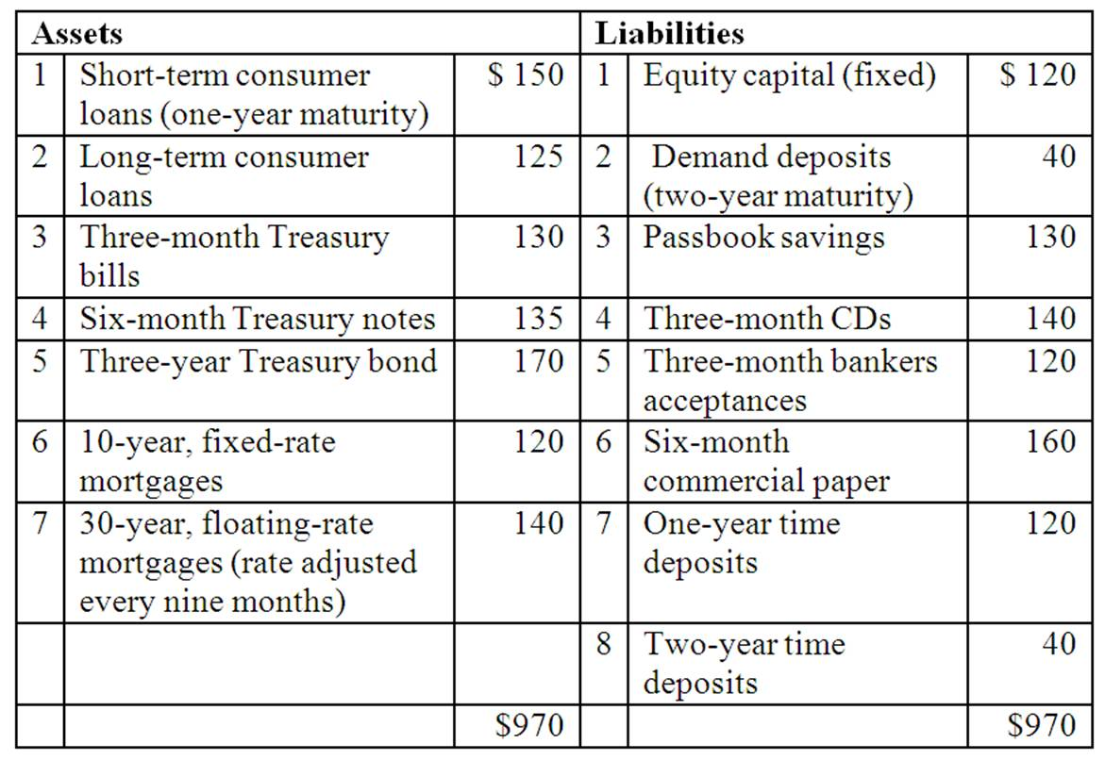

66. | Total one-year rate-sensitive assets is  A. $540 million.  B. $580 million.  C. $555 million.  D. $415 million.  E. $720 million.

67. | Total one-year rate-sensitive liabilities is  A. $540 million.  B. $580 million.  C. $555 million.  D. $415 million.  E. $720 million.

68. | The cumulative one-year repricing gap (CGAP) for the bank is  A. $25 million.  B. $-140 million.  C. $15 million.  D. $-150 million.  E. $-15 million.

69. | The gap ratio is  A. .015.  B. -.015.  C. .025.  D. -.144.  E. .154.

70. | Suppose that interest rates rise by 2 percent on both RSAs and RSLs. The expected annual change in net interest income of the bank is  A. -$300,000.  B. $500,000.  C. -$2,800,000.  D. -$3,000,000.  E. $300,000.

The following are the assets and liabilities of a government security dealer.
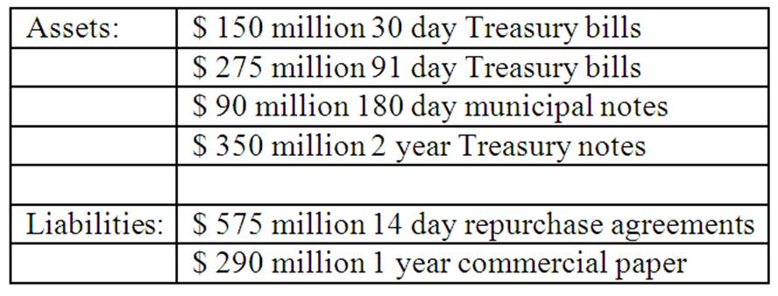

71. | Use the repricing model to determine the funding gap for a maturity bucket of 30 days.  A. -$425 million.  B. -$95 million.  C. -$10 million.  D. -$475 million.  E. +$150 million.

72. | Use the repricing model to determine the funding gap for a maturity bucket of 91 days.  A. -$60 million.  B. -$150 million.  C. $0.  D. -$250 million.  E. -$300 million.

73. | Use the repricing model to determine the funding gap for a maturity bucket of 365 days.  A. +$15 million.  B. -$20 million.  C. -$350 million.  D. -$450 million.  E. -$290 million.

74. | What is the impact over the next 30 days on the dealer's net interest income if all interest rates increase by 50 basis points?  A. Net interest income will decrease by $50,000.  B. Net interest income will decrease by $2.125 million.  C. Net interest income will decrease by $475,000.  D. Net interest income will decrease by $2.375 million.  E. Net interest income will increase by $750,000.

The following information details the current rate sensitivity report for Gotbucks Bank, Inc. ($million).
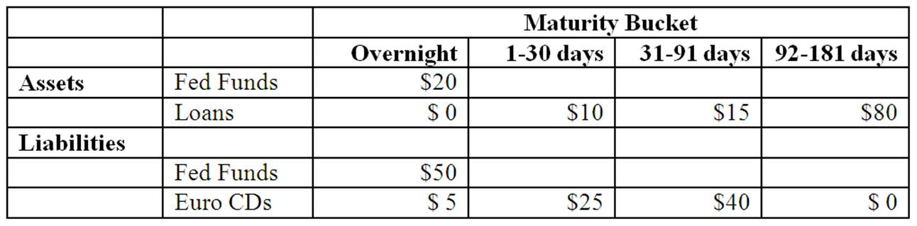

75. | Calculate the funding gap for Gotbucks Bank using (a) a 30 day maturity period and (b) a 91 day maturity period?  A. -$25 and +$80.  B. -$50 and -$75.  C. -$75 and +$5.  D. +$55 and -$40.  E. 0 and 0.

76. | How will a decrease of 25 basis points in all interest rates affect Gotbuck's net interest income over a planning period of 91 days?  A. +$0.1875 million.  B. +$0.1250 million.  C. -$0.1375 million.  D. +$0.0625 million.  E. 0

77. | What does Gotbucks Bank's 91-day gap positions reveal about the bank management's interest rate forecasts and the bank's interest rate risk exposure?  A. The bank is exposed to interest rate decreases and positioned to gain when interest rates decline.  B. The bank is exposed to interest rate increases and positioned to gain when interest rates decline.  C. The bank is exposed to interest rate increases and positioned to gain when interest rates increase.  D. The bank is exposed to interest rate decreases and positioned to gain when interest rates increase.  E. Insufficient information.

The balance sheet of ARGH Insurance shows the following fixed and rate sensitive assets and liabilities.
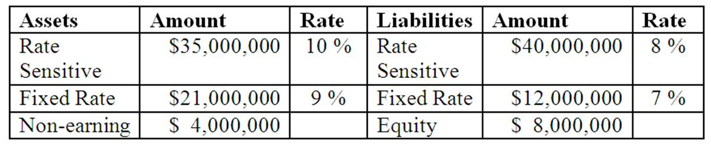

78. | What is the repricing gap for the FI?  A. $0.  B. $5,000,000.  C. $9,800,000.  D. -$5,000,000.  E. -$8,000,000.

79. | What will be the FI's net interest income at year-end if interest rates do not change?  A. $3.20 million.  B. $5.39 million.  C. $4.04 million.  D. $1.89 million.  E. $1.35 million.

80. | Suppose short-term interest rates increase by 1 percent. Calculate the change in net interest income after the interest rate increase.  A. $50,000.  B. $18,900.  C. $40,400.  D. $53,900.  E. $32,000.

The following information is from First Yaupon Savings Association.
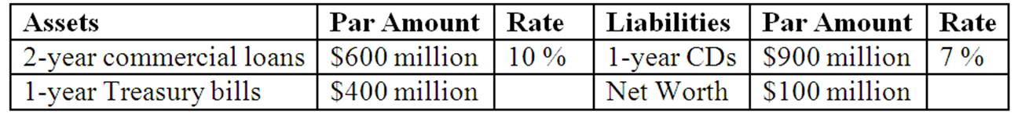

81. | What is the repricing gap over the 1-year maturity bucket?  A. +$100 million.  B. -$500 million.  C. -$100 million.  D. +$500 million.  E. -$900 million.

82. | If all interest rates decrease by 15 basis points, what is the expected impact on the FI's net interest income? (Hint: Use the repricing model to answer this question.)  A. +$150,000.  B. -$150,000.  C. -$750,000.  D. +$750,000.  E. No change.

The following is the balance sheet of Boston Bank. The average maturity of demand deposits is estimated at 2 years.
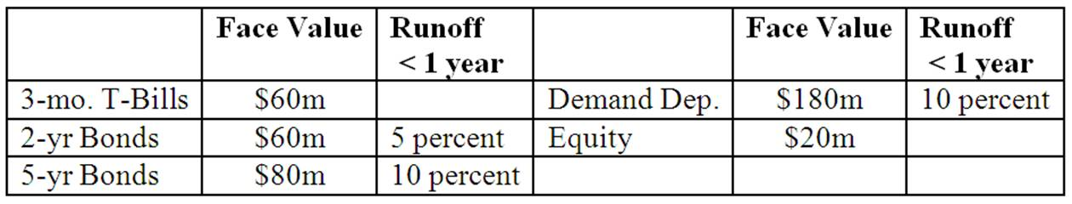

83. | What is the repricing gap if a 0 to 3 month maturity gap is used? Ignore runoffs.  A. $60 million.  B. $40 million.  C. -$80 million.  D. -$120 million.  E. -$180 million.

84. | What is the repricing gap if a 3-year maturity gap is used? Ignore runoffs.  A. $21 million.  B. $44 million.  C. -$80 million.  D. -$60 million.  E. -$120 million.

85. | What is the repricing gap if a 1-year maturity gap is used if runoffs are also considered?  A. -22 million.  B. +$22 million.  C. +$53 million.  D. -$40 million.  E. -$70 million.

86. | What is the impact on net interest income in year two if interest rates increase by 50 basis points at the end of year one? Ignore runoffs.  A. +$0.210 million.  B. +$0.300 million.  C. -$0.300 million.  D. -$0.210 million.  E. +$0.600 million.

Hadbucks National Bank current balance sheet appears below. All assets and liabilities are currently priced at par and pay interest annually.
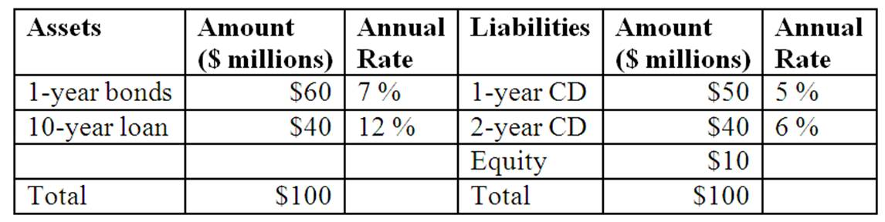

87. | What is the weighted average maturity of assets?  A. 5.50 years.  B. 6.40 years.  C. 5.00 years.  D. 4.60 years.  E. 10.0 years.

88. | What is the weighted average maturity of liabilities?  A. 5.50 years.  B. 6.40 years.  C. 1.44 years.  D. 1.30 years.  E. 1.10 years.

89. | What is this FI's maturity gap?  A. 4.00 years.  B. 4.28 years.  C. 3.16 years.  D. 4.06 years.  E. 5.10 years.

90. | What is market value of the one-year bond if all market interest rates increase by 2 percent?  A. $60.000 million.  B. $60.566 million.  C. $59.444 million.  D. $58.899 million.  E. $61.142 million.

91. | What is market value of the ten-year loan if all market interest rates increase by 2 percent?  A. $40.000 million.  B. $44.916 million.  C. $37.830 million.  D. $42.356 million.  E. $35.827 million.

92. | What is market value of the one-year CD if all market interest rates increase by 2 percent?  A. $49.065 million.  B. $50.481 million.  C. $49.528 million.  D. $50.971 million.  E. $50.000 million.

93. | What is market value of the two-year CD if all market interest rates increase by 2 percent?  A. $40.381 million.  B. $39.626 million.  C. $40.000 million.  D. $38.573 million.  E. $40.769 million.

94. | What is the impact on the FI's equity of a 2 percent overall increase in market interest rates on all fixed-rate instruments?  A. Equity rises by $4.318 million.  B. Equity declines by $2.912 million.  C. Equity rises by $2.060 million.  D. Equity declines by $1.880 million.  E. Equity does not change.

95. | Which of the following statements is true?  A. An increase in interest rates will benefit the FI since the increase in the market value of assets will be greater than the increase in the market value of liabilities.  B. An increase in interest rates will harm the FI since the increase in the market value of assets will be greater than the increase in the market value of liabilities.  C. An increase in interest rates will harm the FI since the decrease in the market value of assets will be greater than the decrease in the market value of liabilities.  D. A decrease in interest rates will harm the FI since the increase in the market value of assets will be greater than the increase in the market value of liabilities.  E. A decrease in interest rates will benefit the FI since the increase in the market value of assets will be smaller than the increase in the market value of liabilities.

96. | Can the FI immunize itself from interest rate risk exposure by setting the maturity gap equal to zero?  A. Yes, because with a maturity gap of zero the change in the market value of assets exactly offsets the change in the market value of liabilities.  B. No, because with a maturity gap of zero, the change in the market value of assets exactly offsets the change in the market value of liabilities.  C. No, because the maturity model does not consider the timing of cash flows.  D. Yes, because the timing of cash flows is not relevant to immunization against interest rate risk exposure.  E. No, because a representative bank will always have a positive maturity gap.

Duration Bank has the following assets and liabilities as of year-end. All assets and liabilities are currently priced at par and pay interest annually.
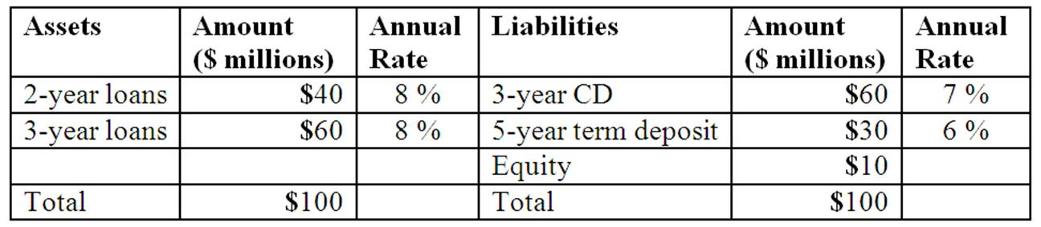

97. | What is the weighted average maturity of the assets of the FI?  A. 2.0 years.  B. 2.3 years.  C. 2.5 years.  D. 2.6 years.  E. 3.0 years.

98. | What is the weighted average maturity of the liabilities of the FI?  A. 3.67 years.  B. 3.30 years.  C. 3.00 years.  D. 5.00 years.  E. 4.33 years.

99. | What is the FI's maturity gap?  A. -2.03 years.  B. -2.50 years.  C. -1.07 years.  D. -0.70 years.  E. -0.40 years.

100. | Is the bank exposed to interest rate increases or decreases and why?  A. Interest rate increases because the value of its assets will rise more than its liabilities.  B. Interest rate increases because the value of its assets will fall more than its liabilities.  C. Interest rate decreases because the value of its assets will rise less than its liabilities.  D. Interest rate decreases because the value of its assets will fall more than its liabilities.  E. Interest rate increases because the value of its assets will fall less than its liabilities.

101. | What is the change in the value of its assets if all interest rates decrease by 1 percent?  A. Approximately $1.613 million.  B. Approximately $2.297 million.  C. Approximately -$1.937 million.  D. Approximately $2.209 million.  E. Approximately $2.524 million.

102. | What is the change in the value of its liabilities if all interest rates decrease by 1 percent?  A. Approximately $2.003 million.  B. Approximately -$2.355 million.  C. Approximately $2.697 million.  D. Approximately $2.906 million.  E. Approximately $3.211 million.

103. | What is the effect on the value of the FI's equity if interest rates decrease by 1 percent?  A. Gain of $0.697 million.  B. Gain of $0.338 million.  C. Loss of $1.622 million.  D. No change in equity.  E. Loss of $0.605 million.

The following question are based on material in Appendix 8B

104. | The term structure of interest rates assumes that  A. the risk of all assets is the same.  B. the time to maturity for all assets is the same.  C. the coupon rate of all assets is the same.  D. The market value of assets is the same.  E. All of the above.

105. | The yield curve  A. relates rates for different maturities of assets.  B. for U.S. Treasury securities is the most commonly reported yield curve.  C. may change shape over time.  D. which is inverted does not last very long.  E. All of the above.

106. | The unbiased expectations theory of the term structure of interest rates  A. assumes that long-term interest rates are an arithmetic average of short-term rates.  B. assumes that the yield curve reflects the market's current expectations of future short-term interest rates.  C. recognizes that forward rates are perfect predictors of future interest rates.  D. assumes that risk premiums increase uniformly with maturity.  E. None of the above.

107. | The liquidity premium theory of the term structure of interest rates  A. assumes that investors will hold long-term maturity assets if there is a sufficient premium to compensate for the uncertainty of the long-term.  B. assumes that long-term interest rates are an arithmetic average of short-term rates plus a liquidity premium.  C. recognizes that forward rates are perfect predictors of future interest rates.  D. assumes that risk premiums increase uniformly with maturity.  E. None of the above.

108. | The market segmentation theory of the term structure of interest rates  A. assumes that investors will hold long-term maturity assets if there is a sufficient premium to compensate for the uncertainty of the long-term.  B. assumes that the yield curve reflects the market's current expectations of future short-term interest rates.  C. assumes that market rates are determined by supply and demand conditions within fairly distinct time or maturity buckets.  D. fails to recognize that forward rates are not perfect predictors of future interest rates.  E. assumes that both investors and borrowers are willing to shift from one maturity sector to another to take advantage of opportunities arising from changing yields.

109. | Which theory of term structure posits that long-term rates are a geometric average of current and expected short-term interest rates?  A. The unbiased expectations theory.  B. The liquidity premium theory.  C. The loanable funds theory.  D. The market segmentation theory.  E. None of the above.

110. | Which theory of term structure states that long-term rates are equal to the geometric average of current and expected short-term rates plus a risk premium that increases with the maturity of the security?  A. The unbiased expectations theory.  B. The liquidity premium theory.  C. The loanable funds theory.  D. The market segmentation theory.  E. None of the above.

111. | Which theory of term structure argues that individual investors have specific maturity preferences?  A. The unbiased expectations theory.  B. The liquidity premium theory.  C. The loanable funds theory.  D. The market segmentation theory.  E. None of the above.

