Geomorphology1

Whats the Difference Between Weathering And Denudation?

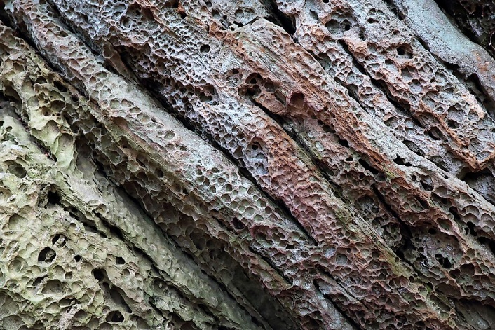

What Is Weathering?
Weathering a process that involves the breaking down of rocks into smaller particles. The process occurs near the surface of the Earth, and there are three primary forms of weathering: organic weathering, physical weathering, and chemical weathering. Organic weathering refers to the breaking down of rocks caused by living organisms, such as through the release of acidic compounds by plants and animals. Physical weathering, also known as mechanical weathering, is the decomposition of a rock’s physical structure, while chemical eathering involves changes in the chemical structure of rock, making it more brittle. An example of chemical weathering is when the acid in rainwater removes calcium from limestone. Additionally, chemical weathering usually occurs before the physical weathering of rocks.

What Is Denudation?
Denudation refers to processes that lead to the chemical and physical disintegration of rocks, which eventually results in the wearing away of the Earth’s surface. There are three denudation processes: erosion, weathering, and mass wasting. While weathering involves the decomposition of rocks, erosion refers to the removal of soil particles, rocks, and other earth materials from one location to another caused by wind and water. Mass movement is the movement of soil, sand, rock, and residue down a slope driven by gravitational force. In most cases, there are also debris flows and mudflow during mass wasting.

Differences Between Weathering and Denudation
- Weathering is a short-term process, while denudation is a long-term process that takes years to occur.
- The weathering process causes the disintegration of rock, while denudation results in the wearing of all parts of the Earth's surface.
- Weathering is just one part of the denudation process, along with erosion and mass wasting, and can be considered as the first stage of denudation.
- Weathering is caused by temperature changes, wind, rain, bacteria, and plants, whereas denudation is caused by volcanoes, earthquakes, and plate tectonics.

Honeycomb Weathering Logic

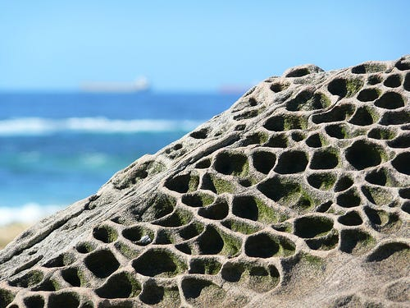
Honeycomb weathering, also known as fretting, cavernous weathering, alveoli/alveolar weathering, stone lattice, stone lace or miniature tafoni weathering (Mustoe, 1982) is a form of salt weathering common on coastal and semi-arid granites, sandstones and limestones.
For honeycomb weathering to occur, a source of salt is needed because the basic mechanism for this kind of weathering is salt heaving. Salt is deposited on the surface of the rock by saltwater spray or by wind.
Moisture must be present to allow for the salt to settle on the rocks so that as the salt solution evaporates the salt begins to crystallize within the pore-spaces of the rock. Permeable rock is also needed so that there are pore-spaces for the salt to crystallize within. These salt crystals pry apart the mineral grains, leaving them vulnerable to other forms of weathering. It takes prolonged periods for this weathering to become visible, as the rock goes through cycles of wetting and drying.
This type of honeycomb weathering is limited in its growth by the rate of evaporation from the sun. Once the depressions have grown large enough that the sun cannot evaporate all of the water left in the gap by the retreating wave, the holes are as large as they will get, because the salt cannot dry out and wedge grains apart any longer.

