Microsoft Office Project

To download the application please do the following steps :
Download Link
http://en.kioskea.net/download/download-1521-microsoft-office-project-standard
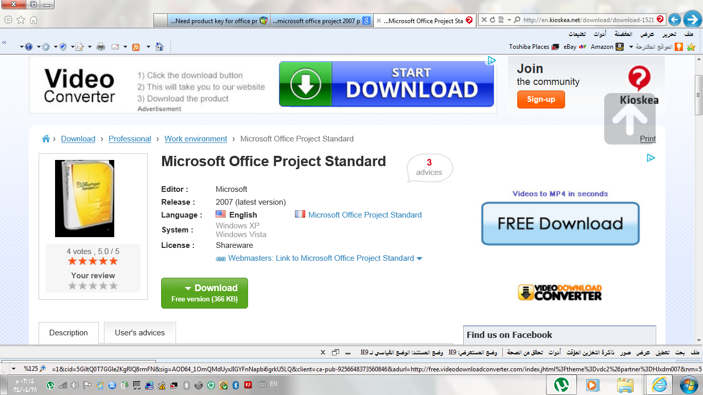

After finishing the download process, you will be asked about the product key
Product key
G2XT7-K47QK-BFVXC-83T9M-8Y63Q

Now you are ready to start

Regards
Abeer bin Humaid

