***Chapter 2***

***Insurance and Risk***

After studying this chapter, the student has to able to answer the following questions:

* What is the definition of insurance?
* what do you mean Adverse Selection and Insurance
* Explain the comparison between Insurance and Gambling
* Explain the comparison between Insurance and Hedging
* Explain, in detail, what are the requirements of risk in order to be insurable?
* Explain, in detail the different types of insurance?
* What is difference between private insurance and social insurance?
* Discuss the difference types of property and liability insurance.
* What are the benefits of insurance?
* Define Reinsurance, and then indicate its benefits and its types in detail.

**2.1-** **Definition of insurance**

Insurance is *a complicated and intricate mechanism* and it is consequently difficult to define because many authors have concerned with insurance. So, there is no single definition of insurance but there are many definitions for example.

* **Vaughan E. and Vaughan** have defined insurance "An economic device whereby the individual substitute ***a small certain cost*** (premium) for ***a large uncertain financial loss (***the contingency الحادثinsured against) that would exist if it were not for the insurance."
* **Rejda. G:** has defined insurance *"****The pooling of fortuitous losses*** *by transfer of such risks to insurers, who agree to* ***indemnify insureds for such losses****,* ***to provide other pecuniary benefits*** *on their occurrence, or* ***to render services*** *connected with the risk".*
* **Crane, F.G**: has defined insurance "***A system of handling risk*** by combining ***many loss exposures units***, with ***the costs of losses*** being shared by all of ***the participants***."

A brief survey of the previous definitions reveals differences of opinion among authors concerning how the insurance should be defined. The definition of insurance should take into consideration the following elements:

* The general form of insurance as a **system**.
* The main purpose of insurance. That is, **reducing risks**.
* The essential mean for realizing the main purpose of insurance. That is, **paying indemnification** if a loss occurs.
* **The parties of insurance contract** i.e. **insurer and insured**.

Hence, from ***our viewpoint*** : **Insurance** may be defined as *"****A system of handling risks is designed* by insurer *for reducing risks by combining( pooling ) many loss exposure unites and to agrees to indemnify the insureds' losses in exchange of the premiums that are paid by* insured*s***(participants in the system)  *"*

**2-2 Basic Characteristics of Insurance**

Based on the preceding definition, insurance has 4 characteristics, they are

* + 1. **Pooling of losses:** Pooling or the sharing of losses is ***heart of insurance***
  + Pooling involves spreading losses نشر أو توزيع الخسائرincurred by the few over the entire group, so that ***average loss*** is for ***Actual loss***.
  + *In addition*, pooling involves the grouping of a large number of exposure units, so that the Law of Large Numbers can operate to provide a substantially accurate prediction of future losses.
  + Risk reduction is based on the Law of Large Numbers

*What the meaning of Law of Large Numbers*

Law of Large Numbers means, the greater the number of exposures, the more closely will the actual results approach the probable (expected) results that are expected from an infinite number of exposures.

Example in class?

***Notice*** : large numbers of exposure units in Pooling should be similar , but not identical , and subject to the same Perils

Pooling implies 1- sharing of losses by the entire group

2- Prediction of future losses with the some accuracy based on *the law of large numbers*

* ***The purpose of Pooling*** is to reduce the variation in possible outcomes as measured by ***the standard deviation*** as indicated in the following example :-
* ***Example of Pooling: (Explain ?)***
  + Two business owners own identical buildings valued at $50,000
  + There is a 10 percent ( 10 % ) chance each building will be destroyed by a peril in any year( i.e. fire)
  + Loss to either building is an independent event

1. Now we can calculate both ***Expected value*** and ***standard deviation*** of the loss for ***each owner (****one individual)* as follows: -

Solution

1. Without pooling





That is for *one individual*

1. With pooling

As well , both Expected value and standard deviation of the loss for ***2 owners (****2 individual)* ***can be calculated*** as follows: -

1. **But**, for *2 individuals(* ***2 Buildings****)*
   1. If the owners instead decide to ***make a pool*** (combine) their loss exposures, and each agrees to pay *an equal share of any loss* that might occur:
   2. As additional individuals are added to the pool, *the standard deviation continues to decline* while the expected value of the loss remains unchanged , by looking this scenario ( 4 probabilities) i.e no building destroyed, one destroyed from 2 , and 2 building destroyed





So,

* + As **additional individuals** are added to **the pool**, the standard deviation continues to decline while the expected value of the loss remains unchanged

***Conclusion***

**Hence**, ***the pool reduce the variation in possible outcomes*** as measured by the standard deviation

***2-2-2 Payment of fortuitous losses ( تصادفية اى غير متوقعة)*** fôrˈto͞oədəs

A fortuitous loss is one that is unforeseen, unexpected, and occur as a result of chance. ***That is,*** loss must be accidental. Insurance is based on the law of large numbers, and this law is based on the assumption that losses are accidental and occurs randomly. Consequently, the losses would be fortuitous.

***2-2-3- Risk transfer***

***Risk transfer*** means that a pure risk is transferred from the insured to the insurer, who typically is in **a stronger financial position** to pay loss than the insured.

*Example* premature death, disability, theft ------ etc

***2-2-4- Indemnification = compensation***

***Indemnification*** means that, the insured is restored to his or her approximate financial position prior to the occurrence of the loss

*Example If your home burns in a fire, and you have homeowner policy. That policy will indemnify you or restore you to your previous position.*

**2-3-** **Characteristics of an Ideally Insurable Risk (Requirements of an Insurable Risk)**

**Private insurers** insure only pure risks. However, some pure risks are not insurable. So, we ask this question. *Are all* *pure risks insurable by insurance companies?*

*The answer* in effect, insurance is not always available as a method of handling risk. **That is**, some risks are insurable but others are not. We have already seen that ***only pure risks*** can be covered by insurance but ***other speculative risks*** are not insurable. So, may be some persons ask this question. ***What are the requirements that distinguish insurable from non-insurable risks?***

The answer, the requirements(**Characteristics )** that must generally be met if a risk is to be insurable in ***the private insurance market*** are:

* The number of similar loss exposure unit *must be large*

*That is,* There must be Large number of exposure units, to ***predict average loss*** based on the law of large numbers

* The loss that occurred must be *fortuitous*

*That is,* the loss should be accidental and unintentional, to assure random occurrence of events

* The loss must be *definite*, *measurable*, and *important*

*That is,* the loss should be Determinable and measurable, to determine how much should be paid

* The loss must *not be catastrophe*

*That is,* the large of exposure units should not occur at the same time, to allow the pooling technique to work

*Notice* : **Exposures to catastrophic loss** can be managed or solved by using 1- reinsurance, 2- dispersing coverage انتشار التغطية over a large geographic area, or using financial instruments, such as ***catastrophe bonds***

* *The probability distribution of losses* must be *determinable. That is, chance* of loss should ***Calculable*** *,* *In other words****,* insurance company** should be able to calculate both ***frequency of loss*** and ***severity of loss of future losses*** with some accuracy. This requirement is very necessary for ***calculating a proper premium***.

The latter should be **sufficient** to pay all claims and expenses besides a profit for insurance company

* The premium should be *economically feasible*

*That is ,* The insured must be able to pay premium . In other words, For insurance to be an attractive purchase, the premiums paid must be substantially less than the face value, or amount of the policy because in this case the people can afford to purchase the policy

***In conclusion***, all **pure risks** (personal risks, property risks, liability risks) can be insured by insurance companies, because the ideal requirements for insurability generally can be met. ***In contrast*** market risks (i.e. fluctuations of prices- Change in consumer tastes); political risks (i.e. war) and financial risks are usually uninsurable by insurance companies or in other words, they are difficult to insure.

In order to understand more clearly you can look at **the previous requirements** for ***risk of fire*** as an Insurable Risk as indicated in the following figure 2.1

Figure 2.1 Risk of fire as an Insurable Risk

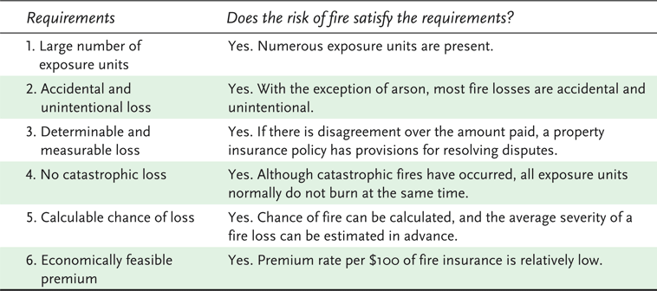

As well, look at the previous requirements for ***risk of unemployment*** as an Insurable Risk as indicated in the following figure 2.2, you will find the risk of unemployment does not completely meet requirements because of the different types of unemployment and labour .

Figure 2.2 Risk of unemployment as an Insurable Risk 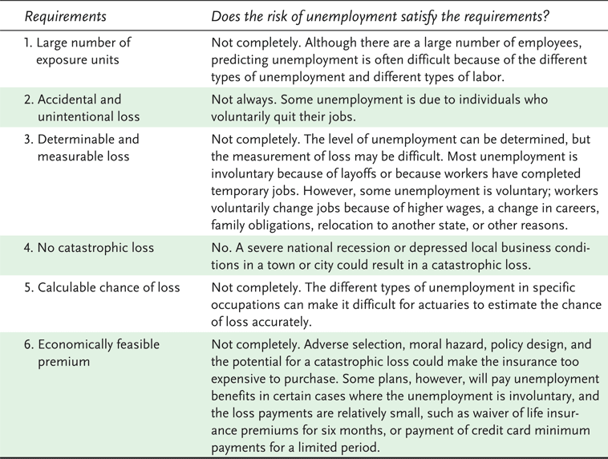

***2-4- Adverse Selection and Insurance***

When the insurance is sold, insurers must deal with the problem of ***Adverse Selection*** *. So what is Adverse Selection****?***

The answer is : “*Adverse selection* is *the tendency of persons* with *a higher-than-average chance of loss* to seek insurance at standard rates “

Examples

1. High risk drivers who seek auto insurance at standard rates
2. Persons with serious health problems who seek life or health insurance at standard rates
3. Business firms that have been repeatedly robbed or burglarized seek crime insurance at standard rates .

So this problem (adverse selection) ,If not controlled by underwriting, will results in *higher-than-expected loss levels.*

Hence, insurance companies try to control Adverse selection by:

* + careful underwriting (selection and classification of applicants for insurance)
* policy provisions (e.g., suicide clause in life insurance)

***2-5- Insurance and Gambling compared***

In order to make comparison between *Insurance and Gambling listen to this Example in class ? Explain*

*Gambling Two horses (or camels)*

*Insurance Fire insurance*

*After that, we can explain the confusion* between *Insurance and Gambling by the following comparison*

**Insurance**

* Insurance is a technique for handing an already existing pure risk( i.e. fire risk)
* Insurance is always socially productive ,because both parties have a common interest in the prevention of a loss
* Insurance restore the insured financially in whole or in part if a loss occur

**Gambling**

* Gambling creates a new speculative risk
* Gambling is not socially productive ,because The winner’s gain comes at the expense of the loser
* Gambling generally never restore the loser to his former financially position.

**2-6- Insurance and Hedging compared**

We can make comparison between ***Insurance*** *and* **Hedging as follows:-**

**Insurance**

* Pure Risk is transferred by a contract because the characteristics of insurable risk generally can be met.
* Insurance involves the transfer of pure risks(insurable)
* Insurance can *reduce the objective risk* of an insurer by application of the Law of Large Numbers

**Hedging**

* Risk is transferred by a contract, but the risk here is a speculative risk, that may be uninsurable ( i.e. protection against a decline in the price of agricultural product )
* Hedging involves risks that are typically uninsurable i.e a speculative risk
* Hedging *does not result in reduced risk where* the risk of adverse price fluctuations is transferred to speculators who believe they make a profit because of superior knowledge of market conditions.

***2-7- Types of Insurance***

Some of institutions for insurance are **private** organizations and some others are **governmental** organizations. Consequently, insurance may be classified into many classifications. **So**, there are **several ways** in which the various kinds of insurance can be classified, they are:

*The first method*: Insurance may be divided into *personal* or *commercial* insurance depending on protecting individuals or protecting organization.

*The second method*: Insurance can be divided into *voluntary* or *involuntary*, depending upon whether or not it *is required by law.*

*The third method*: Insurance may be divided into *types that protect against loss of income*. That is life – health insurance (such as death, or disability, or unemployment) and the *types that pay for damage to property*. That is property and liability insurance.

***The fourth method***: Insurance can be classified into **private insurance** or **governmental insurance** (i.e. social insurance).

***In fact***, the previous classifications of insurance may differ from country to other. So, there is no single criterion that can be used to distinguish private insurance from governmental insurance.

*For example*. In United States of America, some types of insurance are sold by government and not all compulsory is governmental insurance (i.e. social insurance).

From ***our viewpoint***,

**The practical classification of insurance** can be classified as indicated in figure (2.3).

**Figure (2.3) classification of insurance**

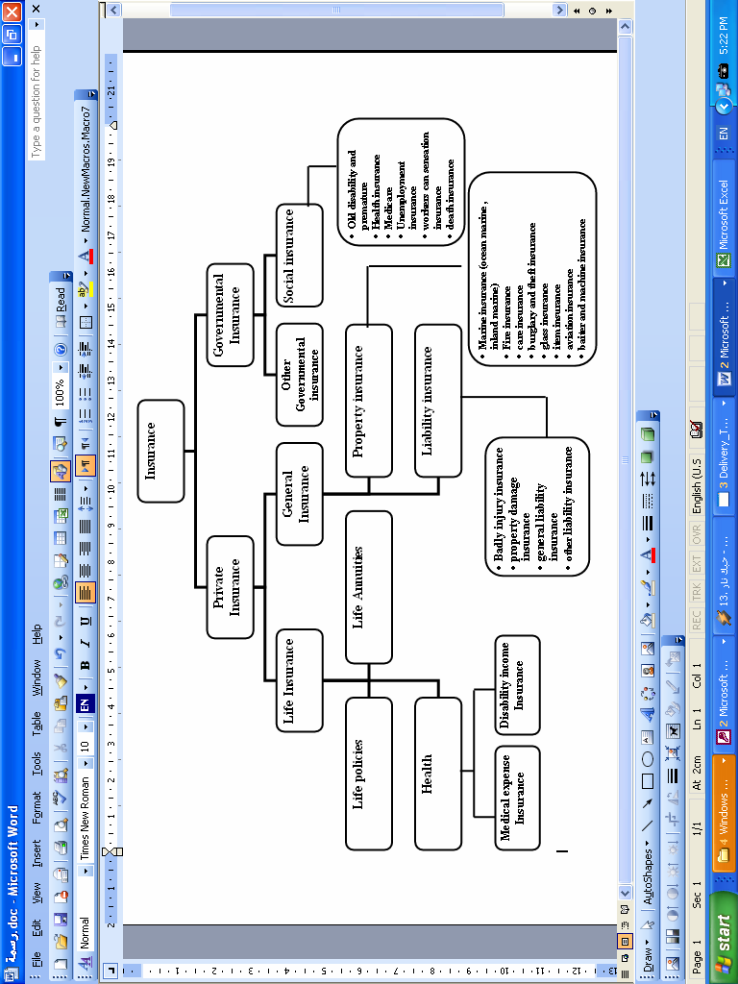

**Hence**, we can shed light upon the preceding classification in brief as follows:-

**2.7.1-Private insurance** is insurance which is furnished by insurance companies, as shown by figure (2.3). It consists of two main fields; they are *life insurance* and *general insurance* which called *Property and liability insurance* or *Property and casuality insurance.* These fields are available to individuals and organizations, so, they are voluntary.

***Insurance companies*** provide two types of coverage *life insurance* and *Property and liability insurance* ( *Property and causality insurance* )

**2.7.1**.1 ***Life insurance*** comprises two coverages life insurance policies and life annuities policies

**2.7.1**.1 *Life insurance policies* deal with death risk of insured died. Upon the death of insured person, insurance company pays **a sum insured** to a designed person called the *beneficiary*. Furthermore, the death benefit may be designed to pay for *funeral expenses*, *uninsured medical bills* and *other expenses* because of death.

**2.7.1**.2 *Life insurance annuities policies* concern the risk of living to an **old age.** This policies cover **survival risk** either for *a limited period* (for example, up to age of pension) or *over life time*.

**2.7.1**.3 *Health insurance*: This type of insurance covers medical expenses from sickness. These expenses include doctor hospital bills, the cost of medicines, private nursing care. Health insurance may also pay the income that an insured person is unable to earn during period of disability.

**2.7.1**.2- *Property and liability insurance* (*Property and casuality insurance*)

Property insurance indemnifies *property owners* against the loss or damage of real or personal property

Liability insurance covers the insured’s legal liability arising out of property damage or bodily injury to others

Casualty insurance refers to insurance that covers whatever is not covered by fire, marine, and life insurance

***Property and liability insurance***consists of two main types the first is property insurance and the second is liability insurance. These two types are further divided into lines or classes. The major types of property insurance that are listed in figure (2.3) can briefly be discussed as follows:

* *Marine insurance* is a broad line divided into ocean marine and inland marine. Ocean marine covers ships or vessels and their cargo. But inland marine covers *goods being carried* on land to and from ocean ports. Moreover, *inland marine* covers cargo being shipped by air, truck or rail. In addition this field has expanded to include a variety of other risks relate to transportation. In addition, **inland marine** covers personal property range from common household articles such as jewellery, furs to computer systems.
* *Fire insurance* covers the loss or damage to real estate (house – factory – store) and personal property because of fire, lightning. Moreover, fire insurance may comprise other risks such as hail, vandalism and windstorm. In addition, *fire insurance* may cover *indirect loss* including rent and profit and extra expenses because of loss from interruption of business.
* *Car insurance* is considered the largest line in property insurance. Under the car insurance, the available coverages include *protection against legal liability claims*, *payment of medical expenses*, *payment for theft* or *damage to insured cars* and *protection against uninsured motorists*.
* *Burglary and theft insurance*: this insurance covers the loss of property, money, because of burglary, robbery, larceny.
* *Home insurance*: This insurance covers a lot of risks of the home such as fire, lightning, explosion, windstorm, theft, riot, civil commotion … etc.
* *Glass insurance*: This insurance covers *glass breakage* in insured buildings and stores.
* *Boiler and machinery insurance*: This insurance covers boiler turbines, generators, and other power machines … etc.
* *Aviation insurance*: This insurance provides protection for all types of aircraft and the passengers, besides cargoes being shipped by these aircrafts.

**Finally** , ***Property and casuality insurance* coverages** can be grouped into ***two*** ***major categories*** as indicated in figure 2.4

* ***Personal lines***: coverages that insure the real estate and personal property of individuals and families or provide protection against legal liability
* ***Commercial lines***: coverages for business firms, nonprofit organizations, and government agencies

*Property and casualty insurance* coverage (figure 2.4)

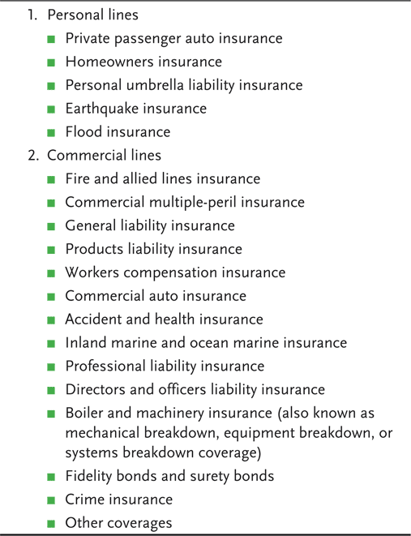

2.7.2-**Governmental insurance** is insurance which is written by governmental institutions.. The governmental insurance may be classified into two types they are: Social insurance and other governmental insurance( i.e Pension Institution)

* **2.7.2-.1 *Social insurance* Programs**
* These programs are financed entirely or in large part by contributions from employers and/or employees
* Benefits are heavily weighted in favor of low-income groups
* Eligibility and benefits are prescribed by statute
* ***Examples***: Social Security, Unemployment, Workers Compensation.

It is worthwhile to mention that ***Major social insurance programs*** include the following:

* Old age, Disability and premature death insurance.( i.e pension program)
* Health insurance
* Medicare
* Unemployment insurance
* Workers compensation insurance

The preceding social insurance programs may be shown in brief as follows:-

* Old age, Disability and premature death insurance: This insurance provides ***pension*** for worker or employee if he or she arrived *at age 60 years old,* besides *disability* benefits for disabled workers, if they expose to disability. Also, *pension for survivors of deceased workers*.
* Health insurance: The difference between health insurance under private insurance program and its counterpart under social insurance program is to be the first is *voluntary* but the latter is *involuntary*. The benefits may be similar. ***Health insurance*** covers ***losses*** caused by either ***accident*** or ***illness.***
* Medicare: This covers medical expenses of motherhood and childhood.
* Unemployment insurance: This insurance provides benefits to eligible workers who experience short-term involuntary unemployment.
* Workers compensation insurance: This insurance covers workers against a job-related accident or disability or disease.

2.7.2-.2 ***Other Government Insurance Programs***

The government provides a variety of other forms of insurance in particular, for poor people. ***For example***, the *governmental assistance* for emergency accidents (i.e. Flood in Jeddah ), and purchasing Vaccines for treating all people inside Saudi Arabia.( i.e Vaccines for treating from CORONA)

***2.8-Benefits of insurance***

In effect, the insurance has an ***essential benefit***. It is the ***cooperation among insureds*** that who expose to the same risk by sharing losses. Moreover, ***many other benefits are provided by insurance***. Some of these benefits are ***social*** and some others are ***economic benefits***. These benefits can be summarized in the following points:

1. *Reduction of uncertainty and worry*: By insurance, the worry and fear may be reduced whether before or after a loss:
   * Persons insured for long-term disability do not have to *worry about the loss of earnings if a serious illness or accident occurs.*
   * Homeowners who are insured *enjoy greater peace* *of mind* because they know; they are covered if a loss occurs.
   * Family heads who have *adequate* ***sum insured*** *of life insurance policy*, they are less worry about the financial security of their dependents in the event if premature death.

***As a result***, a service is provided by insurance. It is reimbursing insureds for economic aspects of losses.

1. *Prevention of loss*: In all forms of insurance, increasing emphasis is placed on prevention of loss. Through improved construction, installation of safeguards and rehabilitation, **insurance companies** have made material contributions to society. *Everyday insurance companies employ a wide variety of loss prevention including safety engineers and specialists in fire prevention, occupational safety and products liability* *السلامة المهنية والمسؤولية عن المنتجات*

Hence, we can say the prevention of loss in first instance is really the greatest insurance as **Benjamin Franklin** mentioned "An ounce of prevention is worth a pound of cure".

Property and liability insurers are ideally situated to pursue *prevention of loss activities.* Some of these important activities include

* Prevention of Auto thefts
* Prevention of boiler explosions
* Fire prevention
* Educational program on loss prevention
* Prevention and detection of arson losses.

***Hence***, *many activities are made by insurers, through prevention services*, to make the need for indemnification as small as possible. So, these activities reduce both the direct and indirect or consequential losses.

1. *Indemnification for loss*: In many forms of insurance, particularly in property and liability *indemnification permits, individual, families*, *business firms* and society *to restored to their former financial position* after a loss occurs. *Examples*:
   * If the individuals and families have insurance policies, they can maintain their financial security if they have indemnification because they are restored either in part or in whole after a loss occurs. Moreover, they are less likely to apply for public assistance or to seek financial assistance from relatives and friends.
   * If the business firms collected indemnification. It also permits firms to remain in business and employees to keep their jobs.
   * Suppliers of firms will continue to receive orders and customers can still receive the goods and services they desire.

**Hence**, ***the indemnification for loss*** contributes greatly to individuals, family and business firm's ***stability*** and therefore is considered one of the most important social and economic benefits of insurance.

1. *Insurance is a source of investment funds*: It is worthwhile to mention that insurance industry is an important source of funds for capital investment and accumulation. That is due to *premiums, which are collected in advance* of loss and funds not needed to pay immediate losses. **Consequently,** a lot of these funds are invested in different business.

For *Example*: (Rejda: 2001, P. 29)

* Structure of hospital and factories
* Housing developments
* Purchasing new machines and equipment

**Hence**, the investment funds *increase society's stock of capital goods* and *promote economic growth* and *full employment*. Moreover insurance companies, also invest in social investments, such as housing, banking, tourist companies and other economic projects …. etc.

1. *Enhancement of credit for persons and firms*: In effect, *insurance enhances a person's credit and as well firms' credit*. Insurance permits person or firm to **borrow a loan** because it gives ***greater assurance*** that the loan will be repaid. For example
   * When a person purchases a house, the bank requires property insurance policy on the house before ***the mortgage loan*** is granted. The property insurance policy protects the bank if the house is damaged or destroyed.
   * When business firm seeking *a temporary loan* for seasonal business may be required to insure its inventories before the loan is made.
   * When *a person purchases a car* and financed by a bank. The latter requires physical damage insurance on the car before the loan is made.

***2.9-Reinsurance***

As we have already mentioned the insurance is a system for reducing the risk for insured. Also, *Reinsurance* is a system for reducing the risk for an insurer, particularly, natural disaster, and commercial airline disasters. Hence, reinsurance is a method by virtue of it an insurer transfer (buys insurance) rather than charges risk (sell insurance). In effect, reinsurance expands risk sharing and makes the insurance business more safety for both the original insurer and the original consumer (insured).

The following questions may be raised about reinsurance:

* 1. *What is reinsurance system and how reinsurance work?*
  2. *What are the benefits of reinsurance?*
  3. *What are the kinds of reinsurance?*

2.9*.1-Definition of reinsurance*

Reinsurance is "an arrangement by which an insurance company transfer or shift all or a part of its risk (insurance originally written) under a contract (or contracts) of insurance to another insurance company.

The company transferring the risk is called *the ceding company* or accepting company and the company that accepts part or all risk (from the ceding company) is called *reinsurer*.

By contemplating the arrangement between the ceding company and the reinsurer company we notice that:

* The first company purchases insurance protection from the second company.
* The second company assumes responsibility for part of losses under an insurance contract or may be assume full responsibility for the original insurance contract.
* Reinsurance involves risk transfer from party to another.
* Reinsurance distributes the losses between two parties (the ceding company and reinsurer).

**Notice**: The amount of insurance retained by the ceding company is called *the net retention* or retention limit. But, the amount of insurance ceded to the reinsurer is called the cession.

2.9*.2-Benefits of reinsurance*

In effect, reinsurance has many benefits whether for companies (ceding company – reinsurer) or original insured or agent. These benefits may be summarized as follows:

1. Reinsurance increases the financial stability of insurer by spreading risk and therefore the insurer will be able to pay its claims.
2. Reinsurance facilitates placing large exposure unit with one company and consequently, it reduces the time spent for seeking insurance and it eliminates the needs for numerous policies to cover one exposure unit.
3. Reinsurance help small insurance companies to stay and to continue in business, thus increasing competition in insurance industry.
4. Reinsurance increases insurance company's underwriting capacity.
5. Reinsurance stabilizes profits because; the insurer may wish to avoid large fluctuations (as a result of social and economic conditions, and disasters) in annual financial results.
6. Reinsurance provides financial protection against a catastrophic loss because of natural disaster, industrial explosions, commercial air lines disasters … etc.

2.9*.3-Kinds of reinsurance*

In fact, Reinsurance may be classified into *three* kinds (see figure 3.2). They are

1. Facultative reinsurance
2. Treaty reinsurance
3. facultative treaty reinsurance

Furthermore any type of the previous three types may be further classified as proportional or no proportional.

1-Facultative reinsurance

Facultative reinsurance is an arrangement between the original insurer (the ceding company) and the reinsurer by which every party retains full decision making powers with respect to each insurance control. That is, for each insurance contract is issued, the original insurer decides whether or not to seek reinsurance and in the same time, the reinsurer retains the flexibility to accept or refuse each application for reinsurance on a case by case basis.

By contemplating the Facultative reinsurance, we may say it has some advantages and some disadvantages, they are:

*Advantages of Facultative reinsurance:*

* It is used when a larger amount of insurance is desired.
* It has flexibility because a reinsurance contract can be arranged to fit any case.

*Disadvantages of Facultative reinsurance:*

* It is uncertain because the ceding company does not know in advance, if the reinsurer will accept any part of the insurance.
* It needs time, because, the policy will not be issued until reinsurance is obtained.

2-Treaty reinsurance

Treaty reinsurance is an arrangement between the original insurer (the ceding company) and the reinsure by which, the original insurer is obligated *automatically* to reinsure any new underlying insurance contract and the reinsurer is obligated to accept certain responsibilities for specified insurance.

By contemplating the treaty reinsurance, we may say it has some advantages and some disadvantages.

*Advantages of Treaty reinsurance:*

* It is automatic and no uncertainty or delay, in particular to the ceding company.
* It does not need time, so there no delay for writing the treaty between the ceding company and reinsurer.

*Disadvantages of Treaty reinsurance:*

* It is unprofitable to the reinsurer, in particular, if the ceding company has written bad business and then reinsures it.
* The premium received by the reinsurer may be inadequate, in particular, if the ceding company has accepted risks by inadequate rates.

Treaty reinsurance can be arranged by several types, including:

* *Quota-share treaty*: by virtue of this treaty both the ceding company and reinsurer agree to share premiums and losses based on a prespecified percentage (for example 60%).
* *Surplus-share treaty*: by virtue of this treaty the reinsurer agrees to accept amount of insurance in excess of the ceding insurer's retention limit, up to some maximum

**For example**: Given that ABC insurance company has homeowner policy at sum insured 500000 S.R and it has surplus –share treaty with Spanish reinsurance company. Assume that ABC insurance company has *retention limit* 100,000 S.R (retention limit = line = 100,000). It takes the first 100,000 S.R of homeowner insurance policy or one fifths and Spanish reinsurance company takes the remaining 400,000 S.R or four –fifths.

So, if the premium income equals 5000 S.R and the loss 10,000 S.R. According to the surplus share treaty the premiums and losses can be distributed as follows:

500,000 S.R policy

ABC insurance company 100,000 (on line) = (1/5)

Spanish reinsurance company 400,000 (4 on line) = (4/5)

5,000 S.R premium income

ABC insurance company 1,000

Spanish reinsurance company 4,000

10,000 S.R loss

ABC insurance company 2000 (1/5)

Spanish reinsurance company 8000 (4/5)

* *Excess of loss treaty*: By virtue of this treaty, the reinsurer is required to accept amount of insurance that exceed the ceding insurance company's retention limit

***For example:***

Given that Misr insurance company wants protection for all Egyptian airline disaster losses in excess of 5 million Egyptian pounds. Assume that *excess of loss treaty* is written with Swiss reinsurance company to cover single occurrences during one year. According to this treaty, Swiss Reinsurance Company agrees to pay all losses exceeding 5 Million Egyptian pounds, but only to a maximum of 10 Million L.E. Hence, if an Egyptian aircraft had exposed to crash and loss 20 Millions ; Swiss Reinsurance Company will pay 5 Million L.E

* *Reinsurance Pool*: By virtue of this treaty, two or more than two insurers may agree altogether to establish an organization of insurers for underwriting insurance on a joint basis.

This reinsurance pool can be formed, if there is a group of insurers would like to combine their financial resources to obtain the necessary capacity.

**For example:**

A reinsurance pool for aviation insurance can provide the necessary capacity for covering the hull of aircraft and liability loss on a commercial jet that exceed 600 million S.R if the jet should crash. Also a reinsurance pool for marine insurance can provide the necessary capacity for covering vessels and their cargo loss, if vessel exposed to drowning.

**A notice**: Sharing losses and premiums varies depending on the type of reinsurance pool.

3-Facultative treaty reinsurance

By virtue of this treaty, the ceding company is obligated to reinsure specified contract (like treaty) while the reinsurer has freedom to decide whether to accept or reject reinsurance on each contract (like the facultative). Alternatively, this treaty as well, means the ceding company may give the option to reinsure but the reinsurer should automatically accept all contracts offered for reinsurer.

Figure (2.5) Kinds of Reinsurance

[dr.mohamedosman2005@yahoo.com](mailto:dr.mohamedosman2005@yahoo.com)