CH 8 ( Chapter 22 in Textbox)

***Auto insurance***

After studying this chapter, the student has to able to answer the following questions:

* What are the different automobile insurance coverage?
* What is Personal Automobile Policy (PAP)?
* Who are eligible to buy PAP policy?
* What are Contents of Personal Automobile Policy(PAP)
* What is the meaning declaration in Personal Automobile Policy (PAP)?
* Explain, in detail, the different Parts in Personal Automobile Policy (PAP)?
* Do you think PAP cover Motorcycles and Other Vehicles

***22-1- Introduction***

The automobile is the most widely owned major asset in all countries in the world. It is one of the chief sources of economic loss. *The ownership or operation of an automobile exposes the individual to many sources of loss*. For example, a person may be killed, injured, or struck by a car, resulting in medical expenses and loss of income. In addition, the person (owner of the car) may be held legally liable for injuries to others or for damage to the property of others.

Hence, the automobile insurance coverage is classified into four coverages, they are :

*1- Automobile liability insurance* : It protects the insured against loss arising from legal liability when his or her automobile injures someone or damages another’s property. (Formerly called compulsory insurance (

*2- Automobile Medical Payments Coverage:* It reimburses the insured and members of the insured`s family for *medical expenses* that result from automobile accidents.

*3- Automobile damage Coverage* : It insures against loss of the policyholder`s own automobile . This coverage covers collision for the insured automobile regardless of fault (formerly called comprehensive insurance).



*4- Uninsured Motorist Coverage* : Under this coverage, the insurance companies agree to pay to the insured, up to specific limits, the amount the insured could have collected from a negligent driver who causes injures when the driver( MOTORIST) is uninsured or is guilty of hit and run.

***22-2- Personal Automobile Policy***

This policy (PAP) is widely used throughout U.S.A. It is only one of several auto forms currently use. PAP was introduced in 1977 and was written in a simplified terminology. The policy has been revised several times. It is complicated of all insurance contracts because it is ***a package policy*** where provides a coverage against three types of losses ( legal liability – damage to or loss of automobile itself - injury of the insured or members of the insured`s family). So, the following question may be raised. *Who are eligible to buy PAP policy?*

*The answer* PAP is available to certain classes of persons and to cover specified types of vehicles ( auto owned by an individual or by a husband and wife who are resident in the same household . But, (auto owned by partnerships, corporations or by two or more individual who are not resident relatives of the same household are *not eligible .*

***Notice :*** PAP may be used to provide coverage on pickup , van, motorcycles ---etc

* Hence, we conclude *the Eligible vehicles* **by PAP** include:
  + A four-wheeled motor vehicle owned or leased by the insured for at least six consecutive months
  + A pick-up or van with a gross vehicle weight rating of 10,000 pounds or less
* In other words, **Autos covered** by the PAP policy include:
  + Any auto shown in the declarations
  + A newly acquired auto ( pickup or van ) if it is acquired by the named insured during the policy period
  + A trailer owned by the named insured
  + A temporary substitute vehicle, which is a nonowned auto or trailer used temporarily because of mechanical breakdown, repair, servicing, loss, or destruction of a covered vehicle.

***22-3- Contents of Personal Automobile Policy(PAP)***

The PAP policy consists of *a declaration page*, *a definitions section*, and the following *six parts*:

*Part A:* Liability Coverage

*Part B:* Medical Payments

*Part C:* Uninsured Motorists Coverage

*Part D:* Coverage for Damage to Your Auto

*Part E:* Duties after an Accident or Loss

*Part F:* General Provisions

Hence**, PAP policy** may be illustrated as follows:

* ***Definition*** PAP is an automobile insurance contract purchased by most individuals to :

- Meet financial responsibility laws

- Protect against the costs associated with auto accidents

* ***Declarations :*** It means a portion of policy in which information is stated such information as *the person and property insured* - *period and amount of insurance coverage* – *premiums charged* - *the limits of liability of coverages and garaging address.*

***Part A: Liability Coverage***

Liability coverage (Part A) is the most important part of the PAP .It means *third party coverage*, that is, ***a payment*** will be paid to ***a third party*** rather than the insured. So, we can understand part A, by the answer of 3 questions, they are:

*The first question : What is agreement of insurance coverage under part A ?*

*The answer*

* + It protects a covered person against a suit or claim arising out of the ownership or operation of a covered vehicle
  + The coverage is usually written in ***split limits***, where the amounts of insurance for *bodily injury liability* and *property damage liability* are stated separately. ***For example*** , split limits of $250,000/$500,000/$100,000 mean $250000 for bodily injury liability coverage , $250000 *for each injured person* – and $500,000 is a maximum of bodily injury liability coverage *for each accident*. But , $100,000 is a maximum for property damage liability coverage. *In other words* , ***Split limits*** of 250000/500000/100 000 mean that you have bodily injury coverage of $250,000 for each person, a maximum of $500,000 of bodily injury coverage per accident, and a maximum of $100,000 for property damage liability

***Notice :*** *Liability coverage can also be written with* ***a single limit*** *by adding an appropriate endorsement to the policy ,where single limit applies to both bodily injury and property damage liability : the total amount of insurance applies to entire accident without a separate limit for each injured person . For example, a single limit of $* ***5,600,000*** *would apply to both bodily injury and property damage liability.*

*The second question : What are* ***the insured persons*** *under coverage in part A ?*

*The answer*

* *Liability coverage* applies to:
  + The named insured and any resident family member
  + Any person using the named insured’s covered auto with permission
  + Any person or organization legally responsible for *any insured’s use of a covered auto* on behalf of that person or organization
  + Any person or organization legally responsible for the named insured’s or family members’ use of any auto or trailer (other than a covered auto or one owned by the person or organization)
* The insurer also agrees to provide *defense* and pay *all legal defense costs* for claims covered by the policy
* The policy also allows for ***certain supplementary payments*** including:
  + The cost of a bail bond ($250/day) - تكلفة سند الكفالة (250 دولار في اليوم)
  + Premiums تكلفة الكفالة في حالة الاستئناف on appeals bonds
  + Interest accruing الفوائد المستحقهafter a judgment
  + Loss of earnings ($200/day)
  + Other reasonable expenses

*The third question : What are the Exclusions to the coverage* *in part A ?*

*The answer*

* *Exclusions to the coverage* include:
  + Intentional injury or damage
  + Property owned خبطت سياره أخرى تمتلكهاor transported
  + Property rented, used, or in the insured’s care
  + Bodily injury to an employee
  + Use as a public livery or conveyance
  + Vehicles used in the auto business
  + Vehicles with fewer than four wheels
  + Vehicle furnished for the insured’s regular use
  + Racing vehicle

***Notice:*** If an accident occurs ***in another state***, *and the financial responsibility law* in that state has *higher liability limits* than shown in the declarations, the PAP automatically provides the higher limits.

* If more than ***one liability policy*** covers a loss, ***that is***, applies ***to an owned vehicle*** the insurer pays its *pro rata share* of the loss for an owned vehicle . But, if liability insurance policy applies to ***a nonowned vehicle*** the insurer`s insurance coverage is ***excess*** over any other collectible insurance as indicated in figure 22.1

***Figure 22.1 Primary and Excess Insurance***

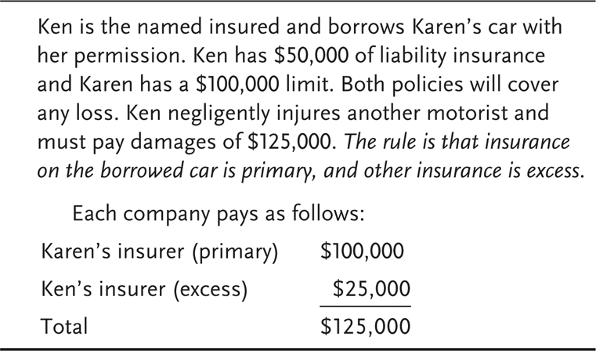

***Part B: Medical Payments Coverages***

Medical payments are paid ***without regard to fault.*** In order to understand part B, we have to know the answer of 3 questions, they are

***The first question*** *: What is agreement of insurance coverage under part B ?*

*The answer*

* Under part B “Medical payments coverage “ insurance company covers all reasonable medical and funeral expenses incurred by an insured in an accident . Covered expenses include medical ,surgical X-ray dental and funeral expenses . All benefits apply to each insured who injured in the accident and medical payments is not based on fault.

***The second question****:What are* ***the insured persons*** *under coverage in part B ?*

*The answer*  : Two groups, they are

* The named insured and family members are covered if they are injured
  + While occupying any motor vehicle, or are injured
  + As pedestrians when struck by a motor vehicle designed for use mainly on public roads
  + Other persons occupying a covered auto are covered while occupying a covered auto ,But not covered in a nonowned vehicle

***Notice :*** *Covers medical services rendered within* ***three years*** *from the date of the accident*

***The third question*** *: What are* ***the Exclusions*** *to the coverage* *in part B ?*

*The answer:* Medical payments coverage has numerous exclusions as follows

* Exclusions to the coverage include *injuries sustained*:
  + While occupying a vehicle with fewer than four wheels
  + While operating the vehicle as a public livery or conveyance
  + When the vehicle is used as a residence
  + When the vehicle is used without a reasonable belief of permission
  + When the vehicle is competing in a race

***Notice : If more than one auto policy covers a loss***:

* + The insurer pays its pro rata share of the loss for an owned vehicle
  + The insurance coverage is excess over any other insurance for a nonowned vehicle

***Part C: Uninsured Motorists Coverage***

Uninsured motorists coverage pays ***for the bodily injury and property damage in some states) caused by an uninsured motorist,*** **by a hit-and-run driver**, or by a negligent driver whose insurance company is **insolvent**. In order to understand part c, we have to know the answer of 3 questions , they are

*The first question : What is agreement of insurance coverage under part c ?*

*The answer* Under part C **insurer agree** to pay *compensatory damages* that an insured is legally entitled to receive from the owner or operator of an uninsured motor vehicle because of bodily injury caused by an accident. But, some points must be emphasized with respect to this coverage .i.e

* + The coverage applies only if the uninsured motorist is legally liable
  + The insurer`s maximum limit of liability for any single accident is the amount shown in the declaration.
  + If the insured and insurer disagree over the amount of damage, the claim is subject to arbitration.

*The second question:What are* ***the insured persons*** *under Uninsured Motorists coverage in part C ?*

*The answer*  Three groups are covered under Uninsured *Motorists coverage in part C* , they are

- The named insured and family members if they are injured by

Uninsured Motorists

- Another person while occupying a covered auto

- Any person legally entitled to recover damages

*The third question : What are the Exclusions to the coverage* *in part C ?*

*The answer:* Uninsured Motorists coverage has numerous exclusions as follows

* Coverage does not apply when:
  + An insured is injured in, or by, a vehicle owned by the named insured, but not insured under the policy
  + There is primary coverage under another policy
  + The vehicle is used as a public livery or conveyance
  + When workers compensation benefits are applicable
  + The vehicle is used without a reasonable belief of permission

**Figure 22.2-Estimated Percentage of Uninsured Motorists in the United States in 2009**

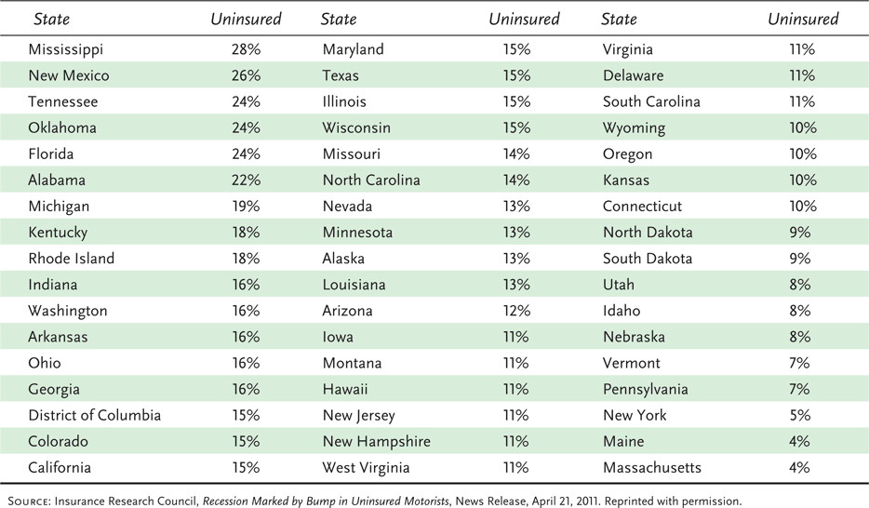

***Notice 1 :*** There are several limitations when more than one uninsured motorist coverage provision applies to a loss

* + If an insurer provides coverage on a vehicle not owned by the named insured, the insurance provided is *excess* over any collectible insurance provided on *a primary* basis
  + The maximum amount paid is limited to the highest limit of any polices that provide uninsured motorists coverage.
  + If there are more than policy provide uninsured motorist coverage, each policy pays its pro rata share of loss.

***Notice 2 :*** Underinsured motorists coverage can be added to the PAP to provide more complete protection

* + In general, the maximum amount paid is the underinsured motorist’s coverage limit stated in the policy less the amount paid by the negligent driver’s insurer
  + Coverage is typically added as an endorsement
  + Some states make coverage mandatory, while others make it optional

***Part D: Coverage for Damage to Your Auto( your Car)***

*Under this part,* ***the coverage*** *provides for damage or theft of an automobile. Hence,* we can understand part D, by the answer of three *questions*, they are:

*The first question : What is agreement of insurance coverage under part D ?*

*The answer :* Under the coverage for damage to your auto, the insurer agrees to pay for any direct and accidental loss to a covered auto or any nonowned auto. **Two optional coverages** are available 1- collision coverage 2- other than collision coverage (also called comprehensive).

- **A collision** is defined as **the upset** of your covered auto or nonowned auto or its impact with another vehicle or object, اضطراب سيارتك المغطاة أو السيارة غير المملوكة أو تأثيرها مع مركبة أو جسم آخر

*for example* your car hits another car, a telephone pole, a tree, or a building.

- Collision losses are paid *regardless of fault*, that is, if you cause the accident, your insurer will pay for the damage for your car, less any deductible. If the other driver damages your car, you can either collect from the negligent driver (or from his or her insurer) or look to your insurer to pay the claim, but you must give up subrogation rights to him

* ***As well ,under Part D*** the PAP policy covers other-than-collision loss which means a loss due to the following perils:
  + - Missiles or falling objects
    - Hail, water, flood, fire, windstorm
    - Riot or civil commotion
    - Malicious mischief or vandalism
    - Contact with a bird or animal
    - Theft
    - Glass breakage
    - Explosion or earthquake

***Part D*** also pays for *temporary transportation expenses*, e.g., for train, bus, taxi expenses, but, the expense must be the result of a covered loss

And the Coverage is subject to a daily and total limit. The expenses includes charges from a rental car company for loss of daily rental

*The second question : What are the Exclusions to the coverage* *in part D ?*

*The answer:* ***under Part D*** the PAP policy has numerous exclusions can be summarized as follows

* + Use the vehicle as a public livery or conveyance
  + Damage from wear and tear البلى , freezing
  + , and mechanical or electrical breakdown
  + Radioactive contamination or war
  + Certain electronic equipment
  + Tapes, records, and disks
  + Government destruction or confiscation
  + Trailer, camper body, or motor home
  + Racing vehicle or rental car
* *The third question : What are the* ***the limits of liability*** *under the coverage* *in part D ?*
* *The answer:* ***under Part D*** *the limits of liability* can be summarized as follows

1. ***For a total loss***, the policy pays the actual cash value less the deductible
2. ***For a partial loss***, the policy pays only the amount necessary to repair or replace the damaged property of like kind and quality
3. If the car damaged its value reduced after repair , Insurers can add a clarifying *endorsement* to exclude coverage for diminution in value from a direct and accidental physical damage loss

***Notice (1*** *): The insurer has option of paying for a physical damage loss in money or repairing or replacing the damaged or stolen property*

***Notice (2*** *): If more than one auto policy covers a physical damage loss,the insurer pays its* ***pro rata share of the loss*** *for an owned vehicle*

***Notice (3*** *):If the vechicle is a* ***nonowned vehicle****, the insurance coverage is excess over any other insurance .*

The following question may be raised about *appraisal of damaged vehicle*. *How can evaluate the* damaged vehicle*? The answer is indicated in PAP policy. That is ,*the policy includes *an appraisal provision* for handling disputes over the amount of physical damage loss , where in this case , either party can demand an appraisal of the loss . Each party selects a competent and impartial appraiser. The two appraiser then select an umpire and umpire`s expenses are shared equally.

***Part E: Duties After an Accident or Loss***

There are some obligations should be done if you have an accident or loss, because some of them are required by law and some others required by the provisions of PAP policy. So, ***after an accident***, the insured is required to perform certain duties, such as:

* + Promptly notify the insurance company or agent
  + Cooperate with the insurer in the investigation
  + Send the insurer copies of any legal notices received in connection with an accident
  + Take a physical examination at the insurer`s expense , if required
  + You must submit a proof of loss at the insurer`s request.

***In addition to the previous duties***, there are ***some additional duties*** are imposed on you (the insured) like:

- The police must be notified if a hit-and-run driver is involved

- The insurer is allowed to inspect your vehicle if you are seeking coverage under Part D

*- The insurer can deny coverage only if failure to comply is prejudicial ضار أو مؤذى to the insurer*

- You must protect the vehicle from further damage after accident

***Part F: General Provisions***

This section (part F) contains a lot of provisions, some of them can be illustrated as follows:

1. ***Policy Period and Territory***

The PAP policy provide coverage just only inside U.S.A and, US territories, Puerto Rico, and Canada. Outside U.S.A, you are not covered

1. ***Termination of PAP***

An important provision applies to termination of insurance by either the insured or insurer. There are 4 parts to this provision

1. *Cancellation provision*: The named insured can cancel at any time by returning the policy to the insurer or providing *written notice*. As well ,the insurer has the right of cancellation .If a policy has been in force for more than 60 days, the insurer can cancel by sending *a cancellation notice* to the named insured only if:
   * The premium has not been paid
   * The driver’s license of any insured has been suspended, or
   * The policy was obtained through material misrepresentation

***Notice:*** *All states restrict the insurer’s right to cancel or nonrenew coverage*

1. *Nonrenewal*: if an insurer decides to discontinue coverage, the insured must be given notice at least 20 days before the end of the policy period
2. *Automatic termination*: a policy is automatically terminated if the insured does not accept the insurer’s offer to renew.

***Insuring Motorcycles and Other Vehicles***

**The PAP** excludes coverage for motorcycles, mopeds, motorscooters and similar vehicles. However, a miscellaneous-type vehicle endorsement *can be added to the PAP* to insure motorcycles, mopeds, motorscooters, golf carts, motor homes, dune buggies and similar vehicles -- etc.

***Notices*  1-** snowmobiles is accepted, because requires a separate endorsement to PAP.

2- Some points should be known if the miscellaneous-type vehicle endorsement is added to the PAP, they are:

* + The liability coverage does not apply to a nonowned vehicle
  + A passenger hazard exclusion can be elected, which excludes liability for bodily injury to any passenger on a motorcycle
* يمكن اختيار استبعاد مخاطر الراكب ، والذي يستبعد المسؤولية عن الإصابة الجسدية لأي راكب على دراجة نارية
  + The amount paid for any physical damage losses to the motorcycles is limited to the lowest of 1- The stated amount shown in the endorsement 2- The actual cash value, or

3- The amount necessary to repair or replace the property.

*** Risk retention results in cost savings if actual losses are more than the cost of insurance.

Answer false

true is actual lossess are less---------