BCH 447- Lab 7
Oral glucose tolerance test (GTT)

 | Plasma | Standard | dH2O | DNS reagent
Test (a1) (Fasting plasma) | 0.1 | ـــــ | ـــــ | 2 ml
Test (a2) (Fasting plasma) | 0.1 | ـــــ | ـــــ | 2 ml
Test (b1) Tow- hour | 0.1 | ـــــ | ـــــ | 2 ml
Test (b2) Tow- hour | 0.1 | ـــــ | ـــــ | 2 ml
Standard (1) | ـــــ | 0.1 | ـــــ | 2 ml
Standard (2) | ـــــ | 0.1 | ـــــ | 2 ml
Blank | ـــــ | ـــــ | 0.1 | 2 ml
- Method-
cool the tubes for 1-3 min
Read absorbance at 540 nm

Mix the contents of each tube and cover each tube by Aluminum foil

Boiling water bath for 5 minutes

Cool the tubes for 1-3 min Read absorbance at 540 nm
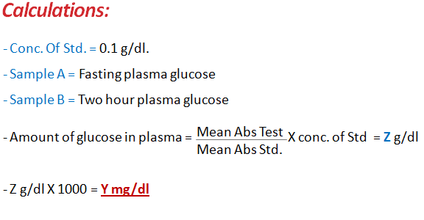
- Result:
Tubes | Absorbance at 540 nm
Test (a1)
Test (a2)
Test (b1)
Test (b2)
Standard (1)
Standard (2)

