**CHS 224**

**Measures of population: (1)- marriage and divorce**

**(2)** **Fertility and its measurements**

**(1) Measures of Marriage and Divorce:**

**Indicators of Marriage**

Let M =Number of marriages

P = Mid-year population

P15+ = Mid-year population age 15 and older

Pm15+ = Number of men age 15 and older

Pf15+ =W15+ = Number of women age 15 and older

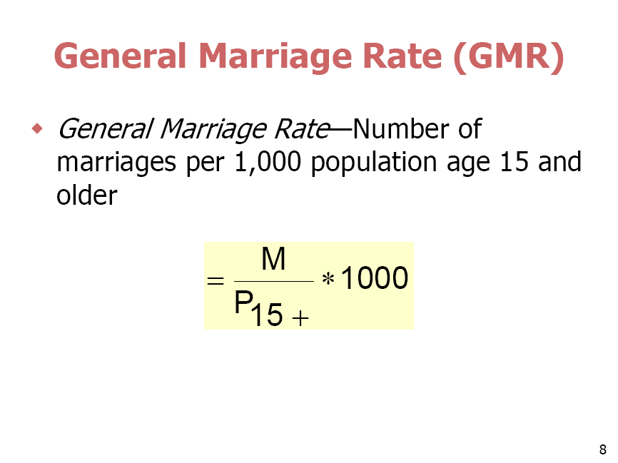

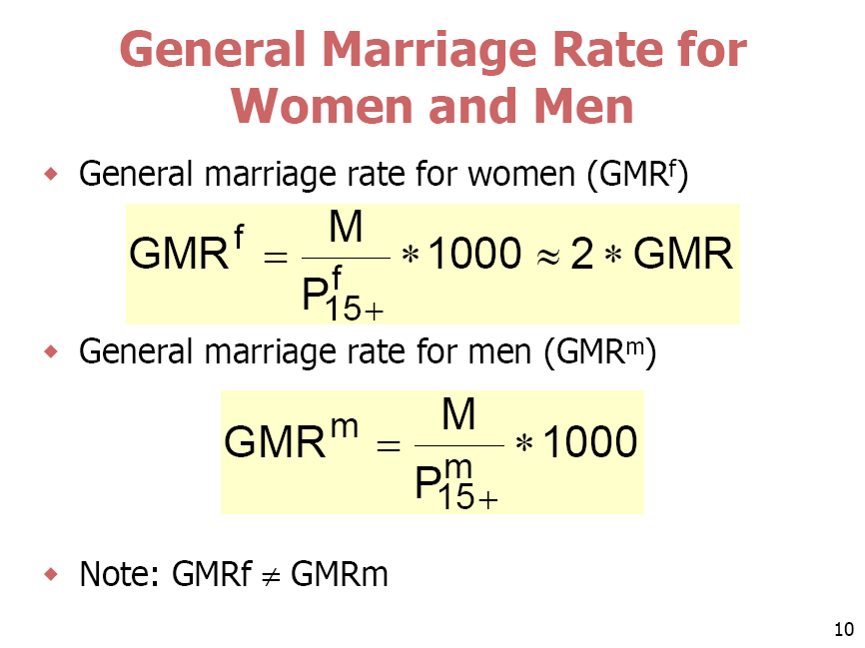

**Indicators of Divorce**

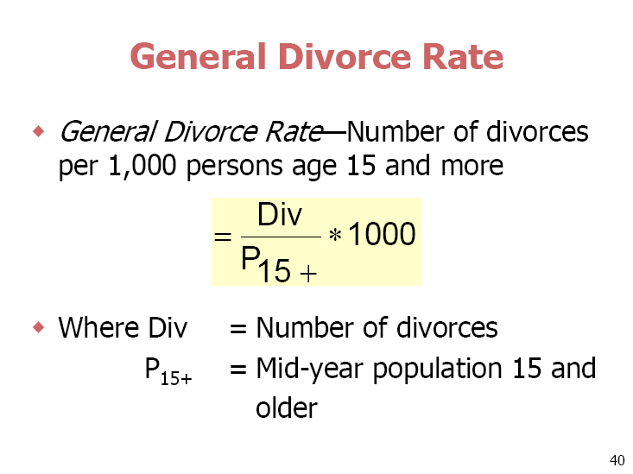

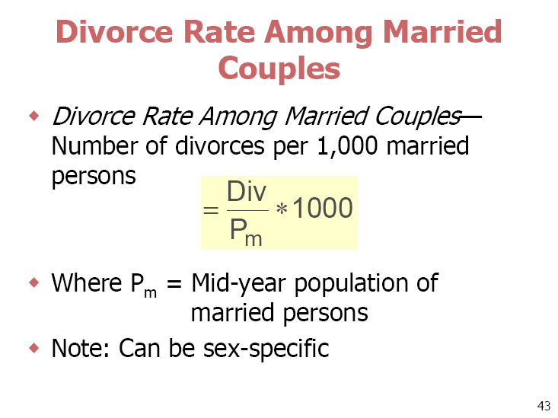 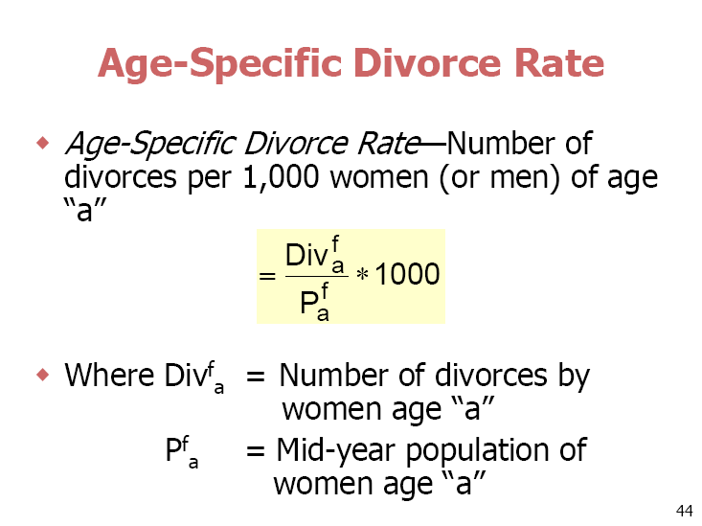

**(2) Fertility:**

**Definitions:**

**Fecundity**—Physiological capacity to conceive

**Infecundity (sterility)**—Lack of the capacity to conceive

**Primary sterility**—Never able to produce a child

**Secondary sterility**—Sterility after one or more children have been born

**Gravidity**—Number of pregnancies a woman has had

**Parity—**Number of children born alive to a woman

**Fertility data are collected from**

Vital statistics (civil registration), censuses, or surveys

**Vital statistics** principally provide birth statistics

**Censuses** provide the following:

* Data on births and fertility
* Statistics on children by family status of the parents
* Population data on fertility-related variables
* Population bases for calculating various types of fertility measures

**Surveys** provide the following:

–Same type of data as censuses

–Additional detailed data on special aspects of fertility, including number and timing of births, marriages, pregnancies, birth intervals, and birth interval components

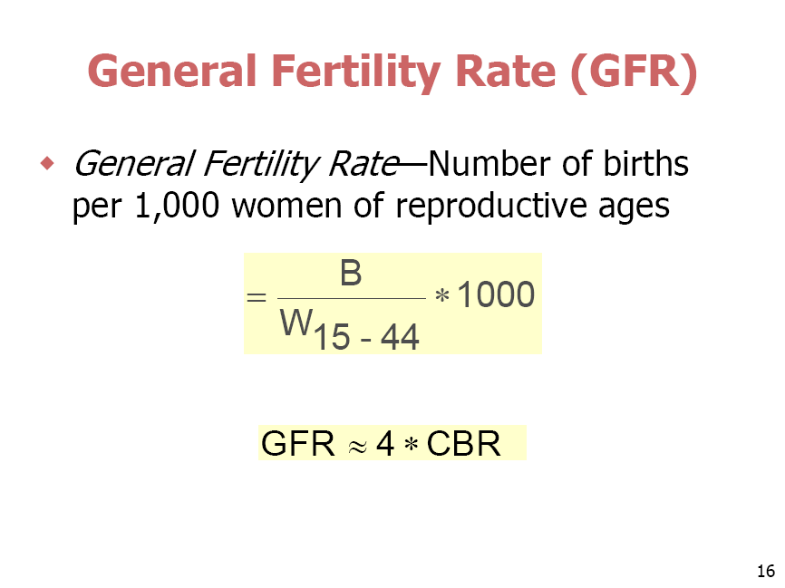



Workshop:

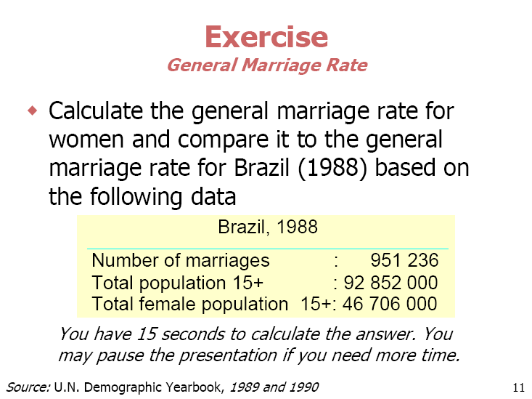

Comment on the result 