EXPRIMENT 7
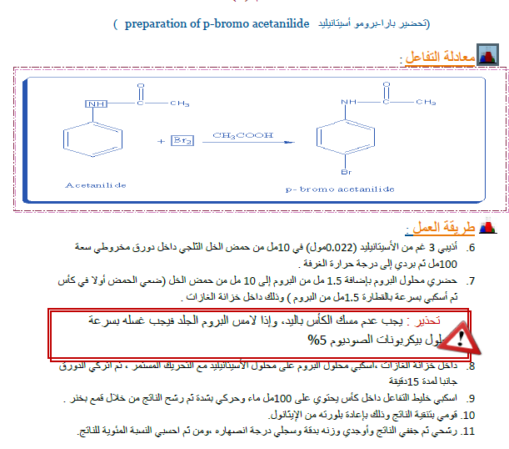

EXPRIMENT 8

TRANSESTERIFICATION REACTION

(Synthesis of biodiesel)
Introduction:
This experiment focuses on synthesis of diesel fuel from vegetable oil. The mechanism involves a transesterification reaction, the process of transforming one type of ester into another type of ester.
Green Reaction:
Vegetable oil Glycerol Biodiesel
Chemicals Required:
Vegetable oil - 100 ml
Methanol - 20 ml
Sodium hydroxide - 3 pellets
Green Procedure:
The finely ground anhydrous NaOH was added into pure (99% or higher purity) methanol (20 ml) in a 250 ml Erlenmeyer flask and stirred vigorously until all the NaOH was dissolved. The pure vegetable oil (100 ml) was warmed to about 40 ºC in a 250 ml beaker. The warmed up oil was poured into the methoxide solution with continuous stirring. At first the mixture would become cloudy, but should soon two layers would separate. This was stirred for 15-20 minutes. The contents of the flask were transferred into a 250 ml separatory funnel. The mixture will separate into two different layers. The glycerol will fall to the bottom, and the methyl ester (biodiesel) will float to the top. Allow the experiment to sit for an hour. The stopcock of the separatory funnel was opened and the glycerol was Green Context:
This lab experiment demonstrates three key green principles: the use of renewable feedstock, catalysis and design for degradation. Vegetable oil is a renewable starting material as it is derived from growing plants, rather than irreplaceable material like the earth’s petroleum and natural gas supplies. The reaction is catalyzed by NaOH making this process economically viable for the industrial scale production of biodiesel. Biodiesel is an excellent product as it is environmentally friendly.
Safety:
􀂙 Methanol: Flammable and poisonous. Dispose excess by allowing it to evaporate in the fume hood.
􀂙 NaOH: Very corrosive. Causes severe burns. May cause permanent eye damage. Very harmful by ingestion.

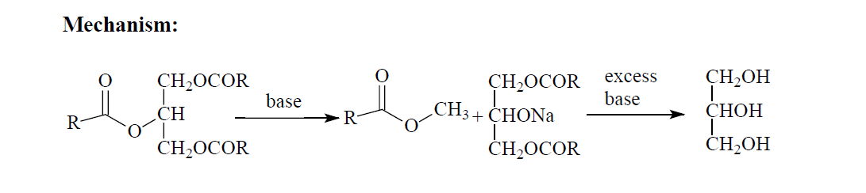

J. E. Thompson. Greener Education Material for Chemists (http://greenchem.uoregon.edu/gems.html)

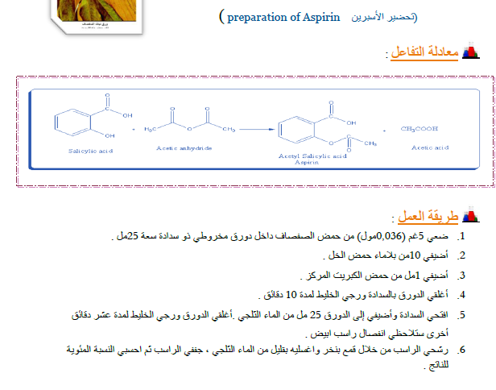
EXPRIMENT 9

EXPRIMENT 10
A Synthesis of Methyl Orange
In this experiment the azo dye methyl orange is prepared by a electrophilic substitution with arenediazonium salts (diazo coupling).

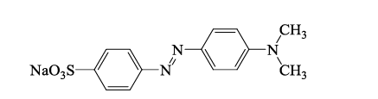

re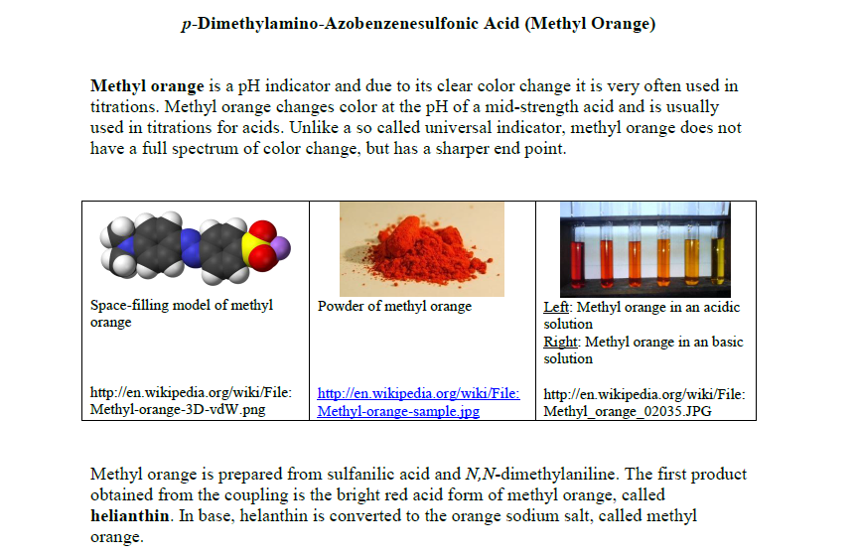
Experimental Procedure

Preparation of the diazonium ion of Sulfanilic acid

- Dissolve 0.6 g anhydrous Na₂CO₃ with 5 ml DI H₂O in a 25-ml Elementary flask.
- Add 0.2 g anhydrous sulfanilic acid, and heat solution with
a hot water bath until dissolved.
- After all of the sulfanilic acid dissolves completely, remove the Elementary flask and allow to cool to room temperature on the bench top.
- Add 0.08 g NaNO₂and transfer to the cooled elementary flask, stir the solution until the solid dissolves.
- Cool 25-ml Elementary flask in an ice-water bath for 10 min.
- Add 5 drop conc. HCl to 25-ml Elementarywhile it remain in the ice bath.
Keep the suspension in the ice bath untile needed in step 2 Below
Preparation of the diazo Dye Methyl Orange.

1- add four drops of N,N-dimethyl Anilne and tow drops of glacial acetic acid to small test tube.
2-Transfer the solution of N,N-dimethyl Anilne from step 1to the 25-ml Elementary flask in an ice-water bath .Keep the Erlenmeyer flask in the ice bath
3- Keep the Elementaryflask in the ice bath for 10 min.
4- Slowly add of 15% NaOH. Check pH of aqueous phase.Add additional NaOH solution, if necessary, until basic.
5- Allow theElementary flask in the ice bath for 10 min. After crystallizations is complete , collected on pre weighed filter paper in a Buchner funnel.
6- Allow theResidum to dry in filter paper , and then re-weigh the filter paper to determine the yield.

EXPRIMENT 11
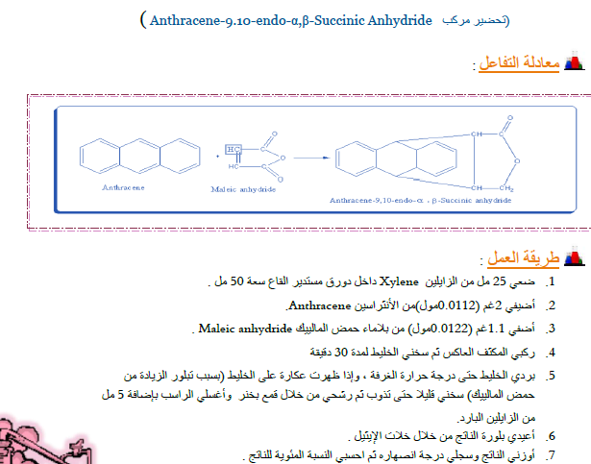

Target:

Equipment / Material and Hazers

HAZERD | FW ( g/l) | MP( BP) | Denisty | COMPOUND

PROCEDURE

Yiled

