CHS 224
Population composition (3)
Social standards

Social standards:
Socioeconomic data used to determine the social standards include :

- the individual's education
- the individual's occupation
- family income
- education of parents
- crowding index
- sanitary condition

These data are scored and used to classify social standards into low, middle and high

Education:
Important variable in accounting for demographic behavior

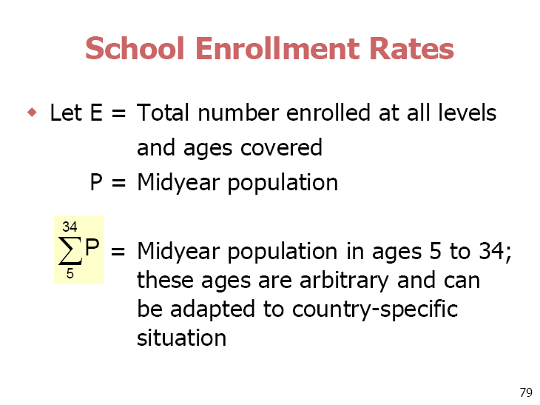

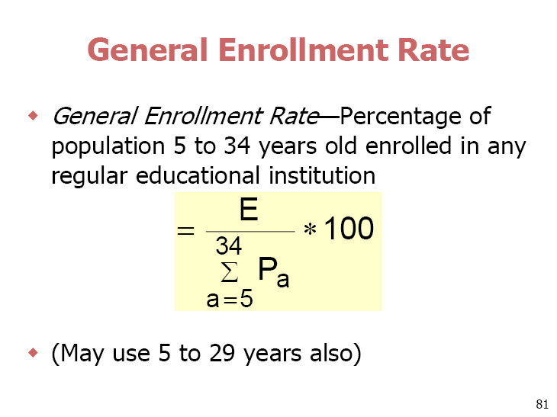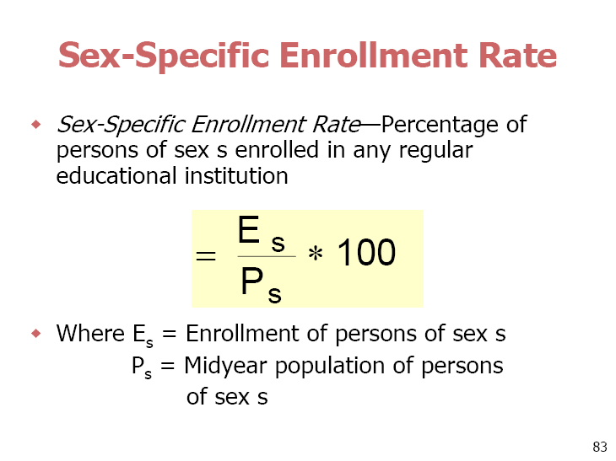

Literacy

Literacy—Ability of a person to both read and write, with understanding, a short statement on his everyday life (United Nations)

An illiterate person may not read and write at all, or may read and write only figures and his/her own name, or may only read and write a ritual phrase which has been memorized

Income:
Personal Income—One of the best measures of economic well-being;
No international standard definition and sometimes difficult to collect
In principle, income from all sources should be counted, both cash income and income in kind
Household Income—Income data collected for each person in the household may be added to produce total for the household

Crowding index=
Number of family members living together/ Number of rooms of the house (including the hall)

Workshop
1-Socioeconomic data used to determine the social standards include:

1-……………………………………………………………
2-……………………………………………………………..
3-…………………………………………………………….
4-……………………………………………………………
5-………………………………………………………….
6-………………………………………………………..

2- Literacy is defined as …………………………………………………………….
…………………………………………………………………………………………..

3- A family composed of the parents, 4 children and the grandfather are living together in a house composed of 5 rooms and a hall; the crowding index of this family is………………………………………………………………………….
………………………………………………………………………………………………………

4- Calculate sex specific school enrollment rate for females in México city in 1966, knowing that the mid year population was 3.666.500; female population equals 2,100,456 among them only 150,000 females were enrolled in regular educational institutions.

