Lab.

351 chem.

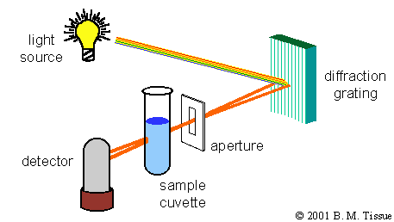

**Prepared by: Wedad Alonazi**

**Introduction:**

Classification of Analytical Methods

**Types of some Instrumental Methods:**

**Property Example Method**

Radiation emission Emission spectroscopy - fluorescence,

phosphorescence, luminescence

Radiation absorption Absorption spectroscopy -

spectrophotometry, photometry, nuclear

magnetic resonance, electron spin

resonance

Radiation scattering Turbidity, Raman

Radiation refraction Refractometry, interferometry

Radiation diffraction X-ray, electron

**Spectroscopy** is the study of the interaction between [matter](http://en.wikipedia.org/wiki/Matter) and [radiated energy](http://en.wikipedia.org/wiki/Radiation).

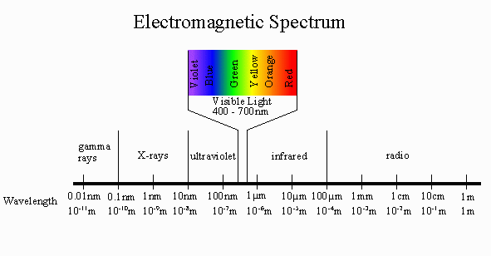

**Ultraviolet Spectroscopy**

UV/Vis spectroscopy is routinely used in [analytical chemistry](http://en.wikipedia.org/wiki/Analytical_chemistry) for the [quantitative](http://en.wikipedia.org/wiki/Quantitative_analysis_(chemistry)) determination of different analytes, such as [transition metal](http://en.wikipedia.org/wiki/Transition_metal) ions, highly [conjugated](http://en.wikipedia.org/wiki/Conjugated_system) [organic compounds](http://en.wikipedia.org/wiki/Organic_compound), and biological macromolecules. the UV spectrum ranges from 100 to 400 nm.

A UV-Vis spectrophotometer measures the amount of light absorbed at each wavelength of the UV and visible regions of the electromagnetic spectrum.

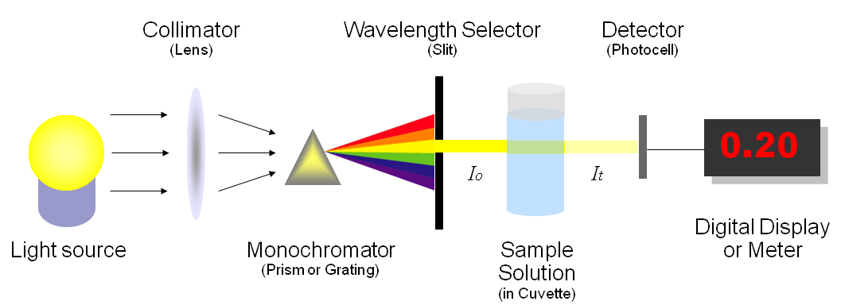

In a standard UV-Vis spectrophotometer, a beam of light is split; one half of the beam (the sample beam) is directed through a transparent cell containing a solution of the compound being analyzed, and one half (the reference beam) is directed through an identical cell that does not contain the compound but contains the solvent. Intensities of the two beams as it scans over the desired region of the wavelengths.

If the compound absorbs light at a particular wavelength, the intensity of the sample beam *(IS)*will be less than that of the reference beam *(IR)* .The intensity of the absorption band is measured by the percent of the incident light that passes through the sample:

% Transmittance = (I / I0) * 100%

where:

I = intensity of transmitted light

I 0 = intensity of incident light

Absorption of radiation by a sample is measured at various wavelengths and plotted by a recorder to give the spectrum which is a plot of the wavelength of the entire region versus the absorption (A) of light at each wavelength.



**Beer-Lambert Law**

The wavelength of absorption is usually reported as λ max which represents the wavelength at the highest point of the curve. The absorption of energy is reported as absorbance. The absorbance at a particular wavelength is defined by the equation:

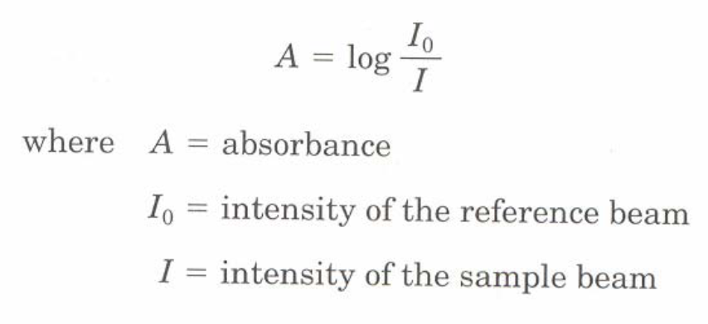

The absorbance by a compound at a particular wavelength increases with an increasing number of molecules undergoing transitions. Therefore, the absorbance depends on the electronic structure of the compound and also upon the concentration of the sample and the length of the sample cell.

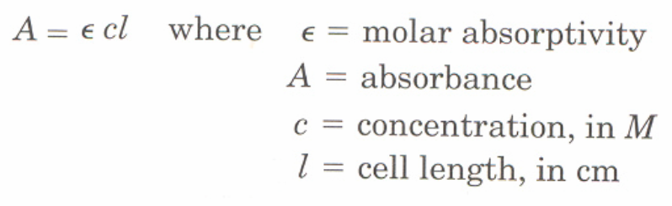

The relationship ***A =*** Cl indicates that the amount of absorption by a sample at a certain wavelength is depe ndent on its concentration. ***A =*** ε***Cl***

**The calibration curve:**

a **calibration curve** is a general method for determining the concentration of a substance in an unknown sample by comparing the unknown to a set of standard samples of known concentration. The calibration curve is a plot of how the instrumental response, the so-called **analytical signal**, changes with the concentration of the [analyte](http://en.wikipedia.org/wiki/Analyte) (the substance to be measured).

**SPECTROPHOTOMETRIC DETERMINATION OF IRON**

**I N T R O D U C T I O N:**

In this procedure, iron is, firstly, reduced to Fe2+ with, Hydroxylamine and then complexed with o-phenanthroline to form an intensely colored complex.

2 Fe3+ + 2 NH2OH + 2 OH- → 2 Fe2+ + N2 + 4 H2O

Fe2+ + 3 phen → Fe(phen)3

2+

The intensity of the color is independent of pH in the range 2 to 9. The complex is very stable and the color intensity does not change appreciably over long periods of time. Beer's law is obeyed.

The pH is adjusted to a value between 6 and 9 by addition of ammonia or sodium acetate.

**R E A G E N T S:**

*Hydroxylamine:* Freshly prepared solution containing 10 g/L in water.

*Soduim acetat:* 10 g/L in water.

*o-Phenanthroline*

*Standard Fe:* Prepare by dissolving a Fe+3 salt of reagent grade in water so that the concentration calculated is for 10ppm.

**Part 1: Obtain absorption spectrum of complex and determine λmax**

**P R O C E D U R E:**

* 1-Prepare 1.5 ppm of standard Fe solution(10 ppm) into 25 mL volumetric flask,

2- Add 0.25ml of Hydroxylamine ,And 1.25 ml of 1,10 –Phenanthroline, Then waite till the complex produced.

* 3- Add 2ml of Soduim acetate As a puffer, to adjust the pH.
* 4- Dilute the solution to the 25mL marks with D water and allow them to stand for 10 minutes.
* 5- Using the blank as a reference and one of the iron solutions prepared above , measure the absorbance at different wavelengths in the interval from 450 to 550 nm. Take reading about 10 nm apart.
* 6-. Plot the absorbance vs. wavelength and connect the points to from a smooth curve. Select the proper wavelength to use for the determination of iron with 1,10-phenanthroline.

**Part II- Construct Beer’s Law Plot (A vs. C) and calculate Fe concentration in sample .**

.

* Prepare the following iron calibration solutions by pipetting the indicated amounts of the Iron standard solution and from the sample into labeled 25 mL volumetric flasks. The first flask is a

blank containing no iron.

Concentration of Fe Volume to pipet

0.00 ppm -

0. 5 ppm -

1.00 ppm -

1.5 ppm -

2.00 ppm -

- 3ml(from the sample)

* . Using a graduated cylinder, add 0.25 mL of hydroxylamine And

1.25 mL of 0.3% o-phenanthroline solution to each volumetric flask.

* Swirl and allow the mixture to stand for 10 minutes.
* Add 2ml of Soduim Acetate
* 7. Dilute each flask to the mark with distilled water and mix well by inverting and shaking the capped volumetric flasks several times.
* . Measure the absorbance of all four standard solutions and the unknown solutions versus the blank solution(5ml water then add all the reagents axcept the iron) at the selected wavelength.
* Calculate the Concentration of Iron in the Sample.

**Determination Of Manganese In Steel**

**Introduction**

Manganese is a minor constituent found in many steels.

You will first dissolve the sample in an acidic solution and then oxidize the colorless Mn2+ to form the purple permanganate ion (MnO4-). Once this has been done, it is possible to measure the absorbance of this solution and use Beer´s Law (A = εbc) to determine the concentration of the permanganate ion. You will be using potassium periodate to oxidize the Mn2+.

The reaction equations are as follows:

**3 Mn2 + + 2 NO3- + 8 H+ → 3 Mn+2 + 2 NO+4H2O**

**2 Mn2 + + 5 IO4− + 3 H2O → 2 MnO4− + 5 IO3− + 6 H+**

During dissulotion NO2 and NO are produced these may interfare later in expermint by reducing Perodic acid , hence they are removed by boiling

**Procedure**:

1-IN Six Conical flask transfer the following volume from the standard solution and the sample solution*:*

N0.of Flask Volume(ml)

1 0.6 (from the Standard solution500 ppm)

2 0.8

3 1

4 1.2

5 0.9 ( from the Sample solution)

6 1 0ml of water(as blank)

*2*- Add 10 ml of water to the first five flasks

3- Add 0.5 ml of H2SO4 to all the Flasks

4-Add 0.25 g of potassium periodate, the heating all the flasks for short period of time

5-Transfer the solutions to the 25 volumetric flasks then diluted to the mark by distilled water

6- by the 1ml of standard solution and the blank solution measure the absorbance at different wavelengths in the interval from 510 to 550 nm. Take reading about 5nm.

7-Plot the absorbance vs. wavelength and connect the points to form a smooth curve. Select the proper wavelength .

8- Measure the absorbance of all four standard solutions and the unknown solutions versus the blank solution(5ml water then add all the reagents except the iron) at the selected wavelength.

9-Calculate the Concentration of manganese in the Sample.

**SPECTROPHOTOMETRIC ANALYSIS OF A PERMANGANATE - DIACHROMATE MIXTURE**

In this experiment, you will quantitatively determine the concentrations of permanganate and dichromate ions in a mixture. Because of the overlap of spectra, it is not feasible to generate a calibration curve of one ion and then the other and use a straight forward Beer`s Law approach to determine each concentration. The problem is that each ion has significant absorbance at the other`s .. max. Diachromate is normally quantified at a wavelength of 440 nm. Permanganate is measured at 545 nm. These wavelengths correspond, more or less, to wavelengths where the absorbance is not changing much over a range of wavelengths. Hence, deviations in measurement wavelength do not affect the measured absorbance.

A**λ1 = €λ1 bC(Cr2O7-2) + €λ2 bC**(MnO4-)

A**λ2 = €λ2 bC(Cr2O7-2) + €λ2 bC**(MnO4-)

**Part I: Construction the calibration curve of KMnO4 at 440 and 545 nm , and determination the slope of the curves at two wavelengths.**

* Prepare a set of solutions (0.0002 , 0.0004 , 0.0006 , 0.0008 M ) of (0.004) KMnO4 in 25 ml volumetric flasks.
* Add in each flasks 5ml of dil. H2SO4 , then complete to the marks by distilled water
* Measure the absorbance for these solutions at 440 and 545 nm against the blank solution .
* Form the slope , calculate the molar absorbtivities for each wavelength.

**Part II.: Construction the calibration curve of K2Cr2O7 at 440 and 545 nm , and determination the slope of the curves at two wavelengths.**

* Prepare a set of solutions (0.0015, 0.003, 0.0045 , 0.006 M ) of (0.02) K2Cr2O7 in 25 ml volumetric flasks.
* Add in each flasks 5ml of dil. H2SO4 , then complete to the marks by distilled water
* Measure the absorbance for these solutions at 440 and 545 nm against the blank solution .
* Form the slope , calculate the molar absorbtivities for each wavelength.

**Determination of Concentration of KmnO4 and K2Cr2O7 in mixture**

**Procedure:**

1-Pippete 6.5 ml of mixture in 25 ml volumetric flask

2- Add 5ml of H2SO4 by sylinder then diluted the solution to the mark by distilled water

3- measure the absorbance of the mixture solution at 440 and 525 nm versus blank solution ( 5ml H2SO4 in 25ml Volumetric flask then diluted to the mark by distilled water)

4- repate the steps 1-3 and take the Average of the Absorbance value at the two wave length

5- Calculate the Concentration of KmnO4 and **K2Cr2O7**

**Atomic absorption spectroscopy**

## Atomic absorption spectroscopy (AAS) is a spectroanalytical procedure for the qualitative and quantitative determination of chemical elements employing the absorption of optical radiation (light) by free atoms in the gaseous state. In analytical chemistry the technique is used for determining the concentration of a particular element (the analyte) in a sample to be analyzed. AAS can be used to determine over 70 different elements in solution or directly in solid samples

## Principles.

## The technique makes use of absorption spectrometry to assess the concentration

## of an analyte in a sample. It requires standards with known analyte content to establish the relation between the measured absorbance and the analyte concentration and relies therefore on [Beer-Lambert Law](http://en.wikipedia.org/wiki/Beer-Lambert_Law). In short, the electrons of the atoms in the atomizer can be promoted to higher orbitals (excited state) for a short period of time (nanoseconds) by absorbing a defined quantity of energy (radiation of a given [wavelength](http://en.wikipedia.org/wiki/Wavelength)). This amount of energy, i.e., wavelength, is specific to a particular electron transition in a particular element. In general, each wavelength corresponds to only one element, and the width of an absorption line is only of the order of a few picometers (pm), which gives the technique its elemental selectivity. The [radiation flux](http://en.wikipedia.org/wiki/Radiation_flux) without a sample and with a sample in the atomizer is measured using a detector, and the ratio between the two values (the absorbance) is converted to analyte concentration or mass using Beer-Lambert Law

Instrumentation

In order to analyze a sample for its atomic constituents, it has to be atomized. The atomizers most commonly used nowadays are flames and electrothermal (graphite tube) atomizers. The atoms should then be irradiated by optical radiation, and the radiation source could be an element-specific line radiation source or a continuum radiation source. The radiation then passes through a [monochromator](http://en.wikipedia.org/wiki/Monochromator) in order to separate the element-specific radiation from any other radiation emitted by the radiation source, which is finally measured by a detector.

## [Description: File:AASBLOCK.JPG](http://upload.wikimedia.org/wikipedia/commons/0/08/AASBLOCK.JPG)

Atomic absorption spectrometer block diagram

### Atomizers

Although other atomizers, such as heated quartz tubes, might be used for special purposes, the atomizers most commonly used nowadays are (spectroscopic) flames and electrothermal (graphite tube) atomizers.

#### Flame atomizers

The oldest and most commonly used atomizers in AAS are flames, principally the air-acetylene flame with a temperature of about 2300 °C and the nitrous oxide (N2O)-acetylene flame with a temperature of about 2700 °C. The latter flame, in addition, offers a more reducing environment, being ideally suited for analytes with high affinity to oxygen.

Liquid or dissolved samples are typically used with flame atomizers. The sample solution is aspirated by a pneumatic nebulizer, transformed into an [aerosol](http://en.wikipedia.org/wiki/Aerosol), which is introduced into a spray chamber, where it is mixed with the flame gases and conditioned in a way that only the finest aerosol droplets (< 10 μm) enter the flame. This conditioning process is responsible that only about 5% of the aspirated sample solution reaches the flame, but it also guarantees a relatively high freedom from interference.

On top of the spray chamber is a burner head that produces a flame that is laterally long (usually 5–10 cm) and only a few mm deep. The radiation beam passes through this flame at its longest axis, and the flame gas flow-rates may be adjusted to produce the highest concentration of free atoms. The burner height may also be adjusted, so that the radiation beam passes through the zone of highest atom cloud density in the flame, resulting in the highest sensitivity.

The processes in a flame include the following stages:

* Desolvation (drying) – the solvent is evaporated and the dry sample nano-particles remain;
* [Vaporization](http://en.wikipedia.org/wiki/Vaporization) (transfer to the gaseous phase) – the solid particles are converted into gaseous molecules;
* Atomization – the molecules are dissociated into free atoms;
* [Ionization](http://en.wikipedia.org/wiki/Ionization) – depending on the ionization potential of the analyte atoms and the energy available in a particular flame, atoms might be in part converted to gaseous ions.

**Determination of Calcium in milk By Atomic Absorption Spectroscopy**

Milk contains high concentrations of calcium. It occurs in two forms, a free ionic form, and calcium associated with milk proteins (caseins). The latter association is called colloidal calcium phosphate. The milk contain proteins and fats they usually precipitated by Tri chloro acetic acid then the sample filtrated and analyzed by AAS.

During the sample treatment, LiCl3 is used to liberate Calcium from the calcium –phosphate complex by forming staple lithium- phosphate complex .

**Part I: Prepare the standard curve for the standard solution of Calcium**

**Procedure**

1-Prepare from the standard solution of Calcium the following concentrations in 25 ml Volumetric flasks 5 , 10, 15, 20 ppm

2-Add 1ml of LaCl3 then diluted to the marks by deionized water

3-Measure the Absorbance at 422 nm