[1] Fill in each sentence with an appropriate plural-form noun from the box below:
Shears –physics - scissors

1- My favorite subject in school was ………………………………
2- In order to cut these papers, you need to get a pair of ………………………………
3- “Get me this pair of ……………………………… because my garden needs a bit of trimming”.

[2] Give the word or the phrase for each definition below.
- ………………………….. a disease usually caught because of mosquito bites.
- ………………………….. a house that is joined to several houses to form a row. 3- …………………………... a person who runs the office day –to – day.

[3] Match the idioms in column A with their meanings in column B.
Column A | Answers | Column B
- Over the top |  | - Say it briefly.
- To put it in a nutshell |  | - Very sick/ ill.
- At death’s door |  | - Very exaggerated in behavior.

[4] Write the adjective that has the opposite connotation of the following words.
direct ……………….. stingy ………………..
innocent ……………….. confident ………………..

[5] Label the following pictures: (3 pts.)
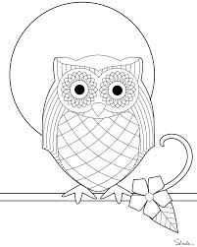
_______________________ _________________________

[6] Write (True) if the statement is true and (False) if it is false.
1- You can park your car in the hallway. | ( )
2- Being a scientist is a great profession for me. | ( )
3- A pessimistic is someone who always look on the bright side. | ( )

[7] Which is the odd word out in each group?

Poetry drama dance novels
2 – branch bough twig stem

