KING SAUD UNIVERSITY
COLLEGE OF COMPUTER AND INFORMATION SCIENCES
COMPUTER SCIENCE DEPARTMENT
CSC215 | Lab2  C Basics | 2nd Semester 1436-1437

Write a complete c program that converts temperatures either from Fahrenheit to Celsius or from Celsius to Fahrenheit for given city according to the user’s choice. Your program should read the name of city , day and temperature, then display the temperature as the following format: the first 3 characters of the day , city and converted temperature as shown in sample run.

Note: Formula to convert from Celsius to Fahrenheit: [°F] = 9/5 [°C] + 32. If the choice entered by the user is not 1 or 2 , the program should display “Wrong choice “message. Use the string functions for concatenate the name city and day in one string separated by ‘,’

Sample run:
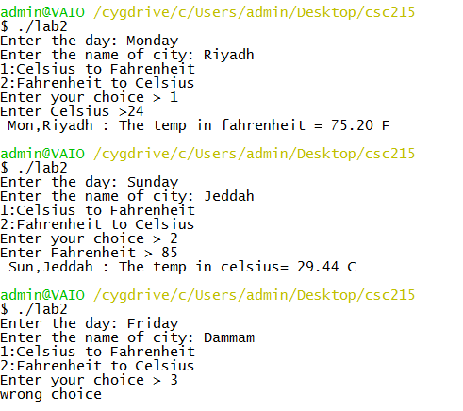

Name your file using the following naming convention:
- “Lab2_YourFirstName_YourLastName.c"
- Don’t forget to move to your own directory
- Compile your code and execute it.
- Show the program to your lab instructor before you leave.

Answer:
#include <stdio.h>
#include <string.h>

int main() {
float cel, fah;
int choice;
char city[20];
char day[20];
char str[50]; // for combining day and city

printf("Enter the day: ");
scanf("%s", day);
printf("Enter the name of city: ");
scanf("%s", city);

printf("1:Celsius to Fahrenheit\n");
printf("2:Fahrenheit to Celsius\n");
printf("Enter your choice > ");
scanf("%d", &choice);

strncpy(str, day, 3);
str[3] = '\0';
strcat(str, ",");
strcat(str, city);
if (choice == 1)
{

printf("Enter Celsius >");
scanf(" %f", &cel);

fah = 9.0 / 5 * cel + 32;
printf(" %s : The temp in fahrenheit = %.2f F\n", str, fah);
}
else if (choice == 2)
{
printf("Enter Fahrenheit > ");
scanf("%f", &fah);
cel = 5.0 / 9 * (fah - 32);
printf(" %s : The temp in celsius= %.2f C\n", str, cel);
}
else
printf("wrong choice\n");
return 0;
}

