CHS 224 (Demography)
Introduction
Demography is the statistical study of human population. It encompasses the study of the size, structure and distribution of these populations, changes in them in response to birth, migration, aging and death.

Population characteristics in KSA (see the map)
Measurements of population:
Ratio:
- Value obtained by dividing one quantity by another
- Indicates the relative magnitude of a numerator and a denominator
- Examples
- Sex ratio
- Dependency ratio (population aged under 15 or over 64 divided by the population aged 15 to 64 and multiplied by 100)
Rate:
- Measure of the frequency with which an event occurs in a defined population during a given length of time
- Numerator: Count of events that occur during a period
- Denominator: Midpoint population, or person-years, or other person-time units of exposure for the same period as the numerator
- Rates are special cases of a ratio
Examples:
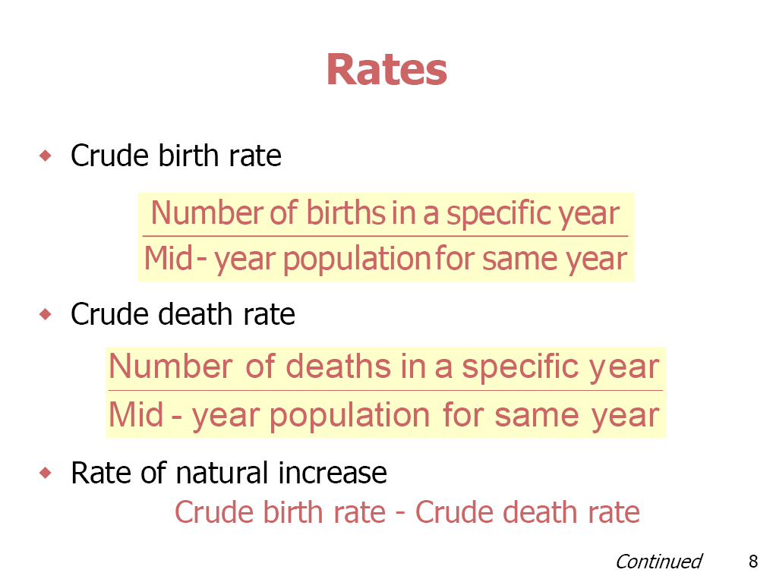
Population Dynamics:
Dynamics is a field of life sciences related to the changes in population growth, whether it is an increase or decrease in the population number over time.
Populations can change through three processes: fertility, mortality, and migration
Fertility involves the number of children that women have and is to be contrasted with fecundity (a woman's childbearing potential)
Mortality is the study of the causes, consequences, and measurement of processes affecting death to members of the population.
Migration refers to the movement of persons from an origin place to a destination place across some pre-defined, political boundary
Migration researchers do not designate movements 'migrations' unless they are somewhat permanent. Thus demographers do not consider tourists and travelers to be migrating
- Types of Migration:
- Internal Migration:
Moving to a new home within a state, country, or continent.

- External Migration:
Moving to a new home in a different state, country, or continent.

- Migration affects four major areas of a society:
- Population
- Economics
- Culture
- Language

To know the impact of migration on language we must know first the differences between language and accent in term of their definitions.
Language is a communication system consisting of a lexicon (a collection of words with agreed meaning) and a grammar (a set of rules for how words are combined to form utterances). While an accent is the unique way that speech is pronounced by a group of people speaking the same language. It should also be stressed that accents are NOT a speech or language disorder.
Activity
Workshop
A) Complete:
1- Population changes through three processes:
1-
2-
3-
2- Migration refers to …………………………………………………………………………………………….
………………………………………………………………………………………………………………………………….
…………………………………………………………………………………………………………………………………..
3- Migration researchers do not designate movements 'migrations' unless they are somewhat permanent. Thus demographers do not consider …………………..
……………….and……………………………… to be migrating .

4- Differentiate between language and accent in term of their definitions

Calculate the sex ratio in a city with mid year population count 14000 individuals in 2004, with 8600 males and 5400 females

Calculate the sex ratio at birth during 2001 in a town with midyear population count 12000 individuals in 2001, Number of female borne infant that year was 250 and male borne infant in the same year was 190.

Calculate the rate of natural increase in 2008 in a city with mid year population equals 150,000 individuals in that year, with 560 deaths and 1400 births in the same year.

