Question#1:
Purchase Ticket by Check Main success scenario:
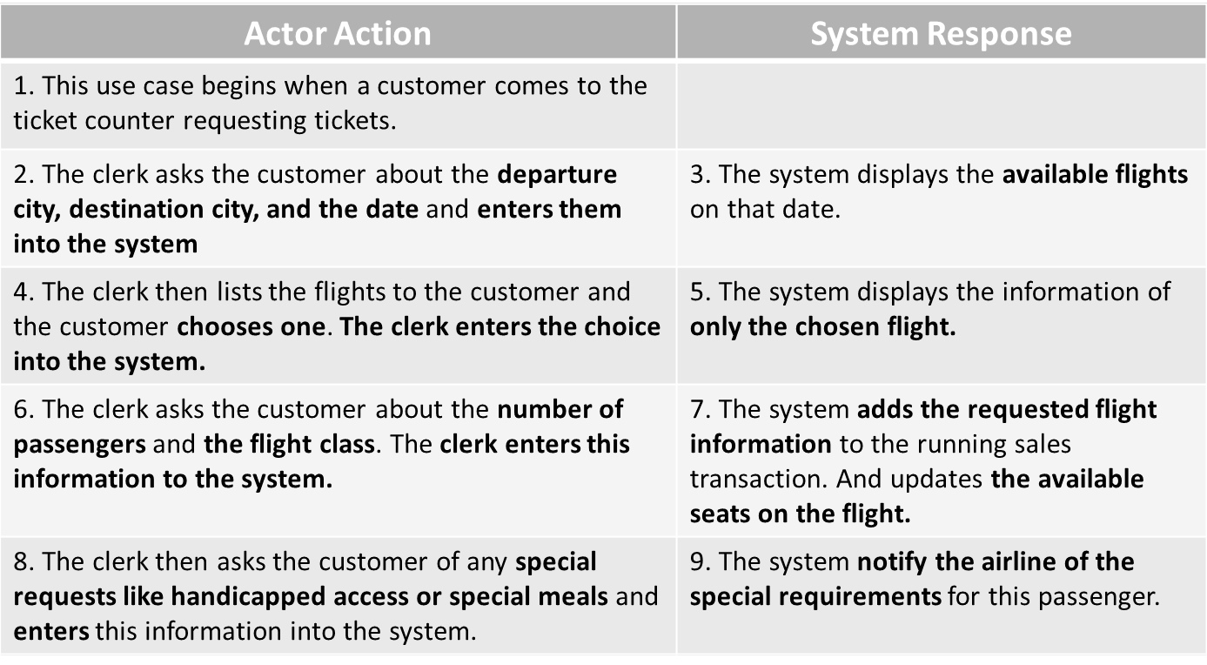
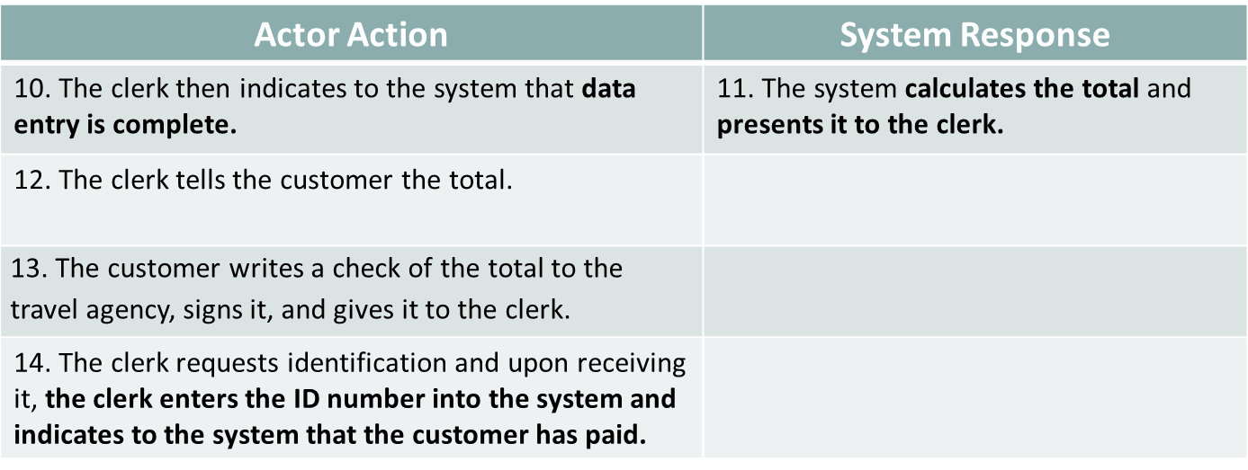
Draw the system sequence diagram.

Question#2

Draw the Sequence Diagram for the following use case:
Withdraw Money from ATM
The user asks the ATM controller to withdraw money; the bank computer will check the user’s balance and display it on the screen. The ATM controller will decrement the money from the bank computer and will ask the money dispenser to dispense the right amount of money. The ATM controller will print the receipt using the printer.

