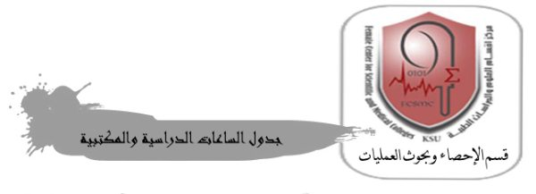
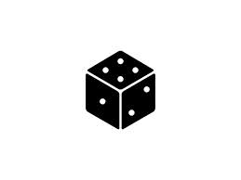
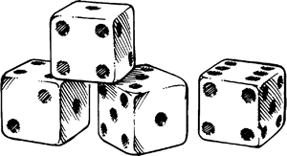

Name: teacher Nashmiah Al-Shammari
The second semester of the academic year 1436/1435 AH

 | 9 - 8 | 10 - 9 | 11 – 10 | 12 - 11 | 12-1 | 1-2 | 2-3
Sunday |  |  |  |  |  | STAT 106 exercises  05 1 104 (05 G lab 92)  38909
Monday | STAT 106 exercises  05 1 70 (05 G lab 96)  38903 |  | STAT 324 exercises  06 G 47  28120 |  |  | STAT 324 exercises  06 G 47  28116
Tuesday | STAT 600
Wednesday
Thursday

