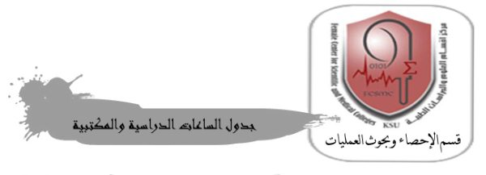
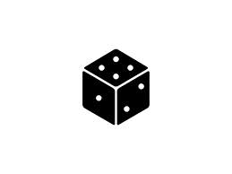

Name: teacher Nashmiah Al-Shammari
The first semester of the academic year 1436/1435 AH

 | 9 - 8 | 10 - 9 | 11 – 10 | 12 - 11 | 12-1 | 1-2 | 2-3
Sunday |  |  |  |  |  | STAT 106 exercises  05 G A 58  7604
Monday | STAT 106 exercises  05 G A 42  29654
Tuesday
Wednesday
Thursday

